Note on Manifold-Constrained Hyper Connection and Muon
by Bhairav | Charles H. Martin, Linkedin 1/9/2026

Lots of chatter about Manifold-Constrained Hyper-Connections (mHC). My 2 cents:

At a high level, mHC treats hyper-connections not as generic weight matrices, but as routing operators living on a constrained manifold (e.g. stochastic or doubly-stochastic).

This is related to Muon, which constrains weight updates to a Stiefel manifold (i.e. orthogonality), enforcing rotational symmetry and bounding the spectral norm. Muon’s manifold constraint stabilizes dynamics by effectively fixing the RG gauge, removing redundant directions in SGD-momentum updates. This allows a more direct flow toward the SETOL RG fixed surface (albeit still slowly due to critical slowing down)

Viewed through the same theoretical lens, mHC instead induces a dissipative RG-like flow, where the effective dynamics live on the Liouvillian generator of a Markov semigroup. In this sense, mHC is naturally interpreted as a Mori–Zwanzig projection with a Markovian closure.

Crucially, mHc, a layer–layer (inter-layer) method, is distinct from the layer-wise (intra-layer) Muon. Muon implements RG gauge fixing on the training dynamics, whereas mHC imposes RG field constraints that alter the flow itself, placing learning in a different, dissipative RG universality class.

Finally, I can offer a prediction from these observations. Because RG dynamics exhibit a critical slowing down as the system approaches its fixed point, I predict that to obtain the best performing LLMs, engineers should implement some form of RG fixed point acceleration in the later stages of training.

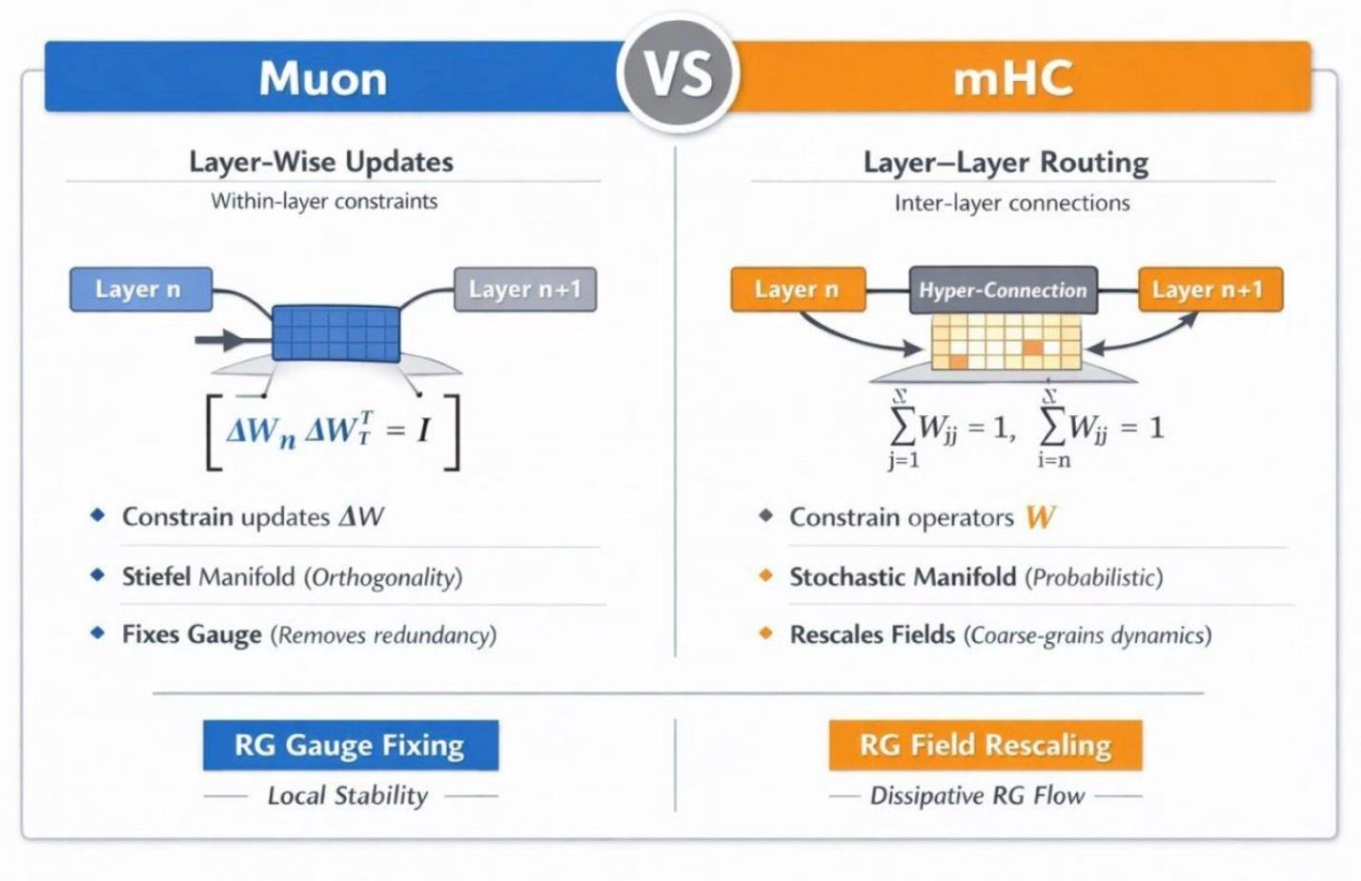

References
[1] Linkedin post by Bhairav, 1/9/2026
[2] SETOL

