Note on Temporal Dynamics as Inductive Bias paper
By Xia Chen, TMU, 1/5/2026

Conventional deep learning prioritizes unconstrained optimization, yet biological systems operate under strict metabolic constraints. We propose that these physical constraints shape dynamics to function not as limitations, but as a temporal inductive bias that breeds generalization. Through a phase-space analysis of signal propagation, we reveal a fundamental asymmetry: expansive dynamics amplify noise, whereas proper dissipative dynamics compress phase space that aligns with the network's spectral bias, compelling the abstraction of invariant features. This condition can be imposed externally via input encoding, or intrinsically through the network's own temporal dynamics. Both pathways require architectures capable of temporal integration and proper constraints to decode induced invariants, whereas static architectures fail to capitalize on temporal structure. Through comprehensive evaluations across supervised classification, unsupervised reconstruction, and zero-shot reinforcement learning, we demonstrate that a critical "transition" regime maximizes generalization capability. These findings establish dynamical constraints as a distinct class of inductive bias, suggesting that robust AI development requires not only scaling and removing limitations, but computationally mastering the temporal characteristics that naturally promote generalization.

Can constraints actually boost AI generalization? Introducing Temporal Dynamics as an Inductive Bias. 🧠⏳
Modern Deep Learning often equates performance with unconstrained scaling: more parameters, more data, fewer limits. But biological brains operate under strict metabolic constraints and yet generalize effortlessly.
In our latest paper, "Constraint Breeds Generalization", we ask: What if these physical constraints are not obstacles, but features?
🚀 Key Insight: We propose that dissipative constraints function as a fundamental temporal inductive bias. By analyzing the phase-space of signal propagation, we discovered a critical "Transition Regime" poised between chaotic expansion and static dissipation.
This regime forces the system to abstract invariant features from noisy streams, leading to:
- Robust Representation: Generalizing to unseen dynamical encodings.
- Emergent Structure: Spontaneously inducing structured receptive fields (without explicit sparse penalties!).
- Behavioral Transfer: Achieving Zero-Shot Reinforcement Learning transfer to new physical environments in robotic control tasks.
This work suggests that robust AI might not just come from scaling up, but from mastering the temporal dynamics that shape the learning landscape.
💭 Personal Note
I find something deeply poetic in these results. We proved that for a system to learn, it must be constrained. It must let go of the immediate at every step (dissipate) to survive in the long run (generalize).
It seems that on both biological and computational levels, Memory and Forgetting are not opposites, they are two sides of the same dynamical coin. The constraint breeds the capability.
As Ilya Prigogine said: "Time is constructive."
Such truth moments motivates me, a lot.

Comment by Charles H. Martin:

A dissipative renormalization group universality class, where the invariant manifold acts as gauge fixing / field rescaling, allowing a more direct route to the RG fixed point, where generalization is optimal.

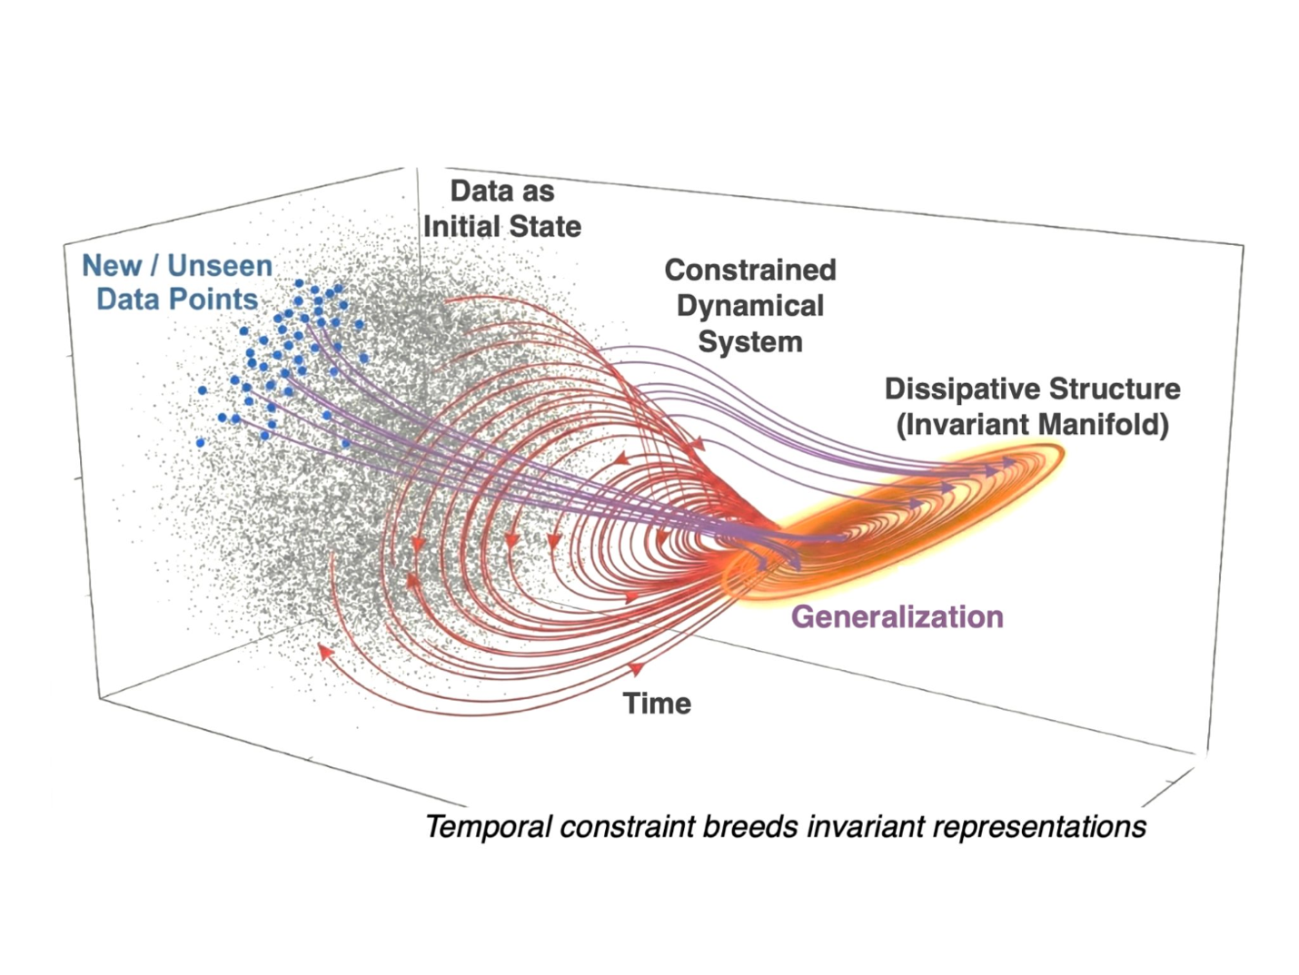

References
[1] Constraint Breeds Generalization: Temporal Dynamics as an Inductive Bias, Xia Chen, 2025
[2] https://github.com/chenxiachan/Constraint-breeds-generalization
[3] Linkedin discussion, 1/5/2026

