Note on Manifold-Constrained Hyper Connections and Muon
by Bhairav | Charles H. Martin, Linkedin 1/9/2026

Bhairav wrote:

Lots of chatter about Manifold-Constrained Hyper-Connections ($m$HC). My 2 cents:

At a high level, $m$HC treats hyper-connections not as generic weight matrices, but as routing operators living on a constrained manifold (e.g. stochastic or doubly-stochastic).

This is related to Muon, which constrains weight updates to a Stiefel manifold (i.e. orthogonality), enforcing rotational symmetry and bounding the spectral norm. Muon’s manifold constraint stabilizes dynamics by effectively fixing the RG gauge, removing redundant directions in SGD-momentum updates. This allows a more direct flow toward the SETOL RG fixed surface (albeit still slowly due to critical slowing down)

Viewed through the same theoretical lens, $m$HC instead induces a dissipative RG-like flow, where the effective dynamics live on the Liouvillian generator of a Markov semigroup. In this sense, $m$HC is naturally interpreted as a Mori–Zwanzig projection with a Markovian closure.

Crucially, $m$HC, a layer–layer (inter-layer) method, is distinct from the layer-wise (intra-layer) Muon. Muon implements RG gauge fixing on the training dynamics, whereas mHC imposes RG field constraints that alter the flow itself, placing learning in a different, dissipative RG universality class.

Finally, I can offer a prediction from these observations. Because RG dynamics exhibit a critical slowing down as the system approaches its fixed point, I predict that to obtain the best performing LLMs, engineers should implement some form of RG fixed point acceleration in the later stages of training.

Mitch Haile replied:

Your 2 cents, or someone else's?

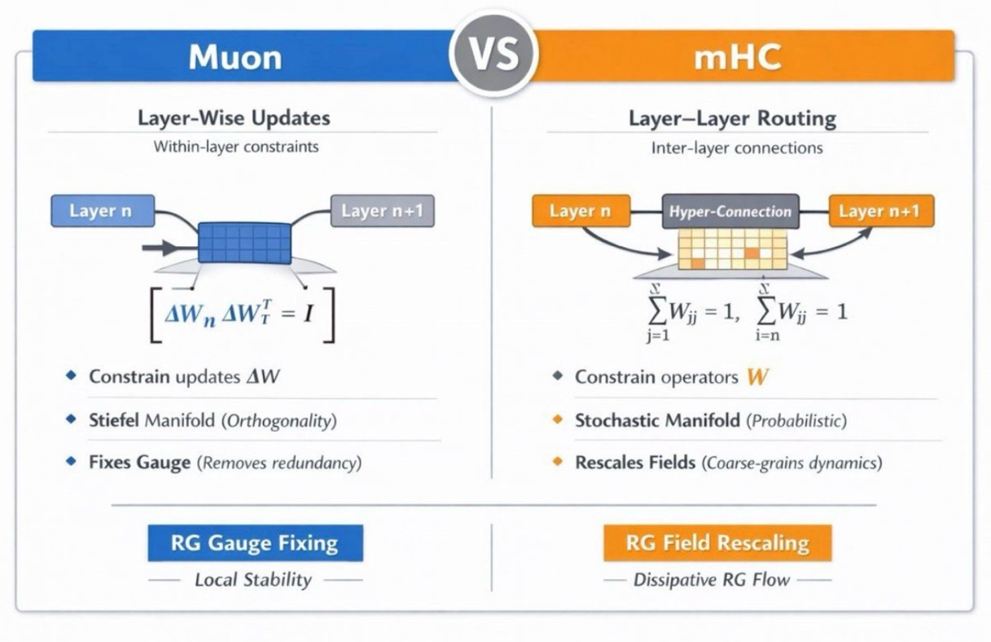

References
[1] Linkedin post by Bhairav, 1/9/2026
[2] Muon: An optimizer for hidden layers in neural networks, December 8, 2024, Keller Jordan blog
[3] Muon is scalable for LLM Training, J. Liu et al, 2025
[4] $m$HC: Manifold-Constrained Hyper Connections, Z. Xie et al, DeepSeek AI, 2026
[5] SETOL: A Semi-Empirical Theory of Deep Learning, Charles H. Martin et al, 2025
[6] Introduction to Renormalization, Joao Melo, U of Cambridge, 2019
[7] Introduction to Renormalization Group Method, Roland Bauerschmidt, David C. Brydges, and Gordon Slade, 2019
[8] Why does deep and cheap learning work so well? Henry W. Lin, Max Tegmark, David Rolnick, (accepted) 2017
[9] Comment on “Why does deep and cheap learning work so well?”, David Schwab, Pankaj Mehta, 2016

