Indexing and Retrieval for Semantic Search of Github Repos
Compiled by D.Gueorguiev, from Damien Beneviste’s lecture material, 10/5/2025

Indexing happens in the backend, in module backend/app/indexing/indexer.py.
We start with some parsed data ( code, markdown ) and we need to derive a vector of it.
The vector representation needs to be captured by some metric e.g. cosine similarity, Euclidean distance, $l_{2}$ norm, etc.

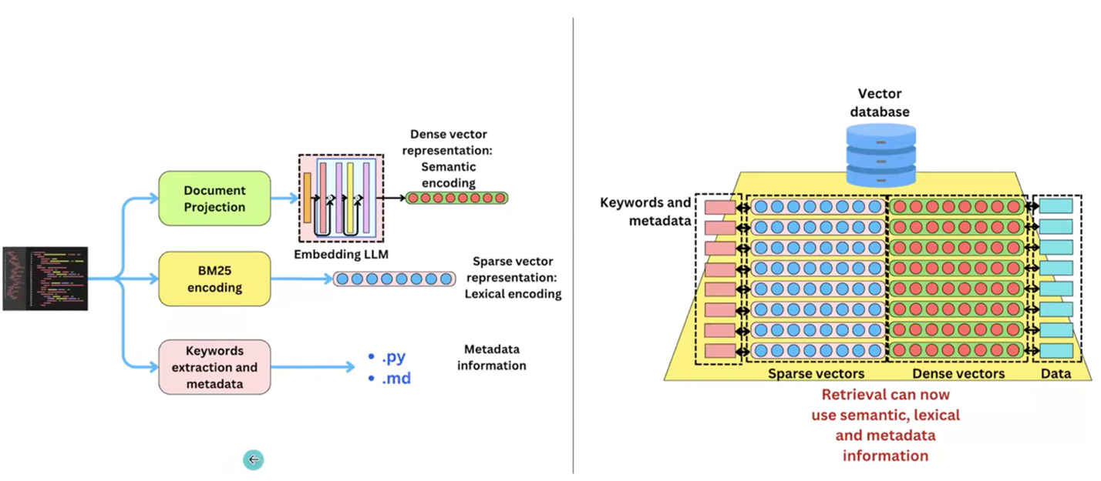

Figure : depicted are the 3 possible ways to index the data

The first way to project the parsed code into a vector representation is via dense vector representation. For obtaining this dense vector representation of the code fragment we are going to use LLM.
Besides using dense representation for vector embeddings we can use sparse representations which are useful in capturing specific tokens. Thus, the sparse representation is used to augment the dense representation of vector embeddings. In the dense representation we get a vector for the whole sentence while in the sparse representation we get vectors capturing specific tokens semantics. BM25 provides us with sparse representation of the text. SPLADE ([see [4]) is using LLM to extract sparse representation which is more flexible in terms of capturing values for the different tokens; it also captures synonyms gracefully.
On the right side of the Figure above we see the organization of the indexed data in the DB. We have metadata – strings we can use to filter further our data. For example we have dates and we want to filter the data by dates. In our specific implementation the metadata will be the file extension (*.md, *.py) which will allow us to chose between code file, documentation file or both.
Note: the data which you use to index does not need to be the data we will retrieve.
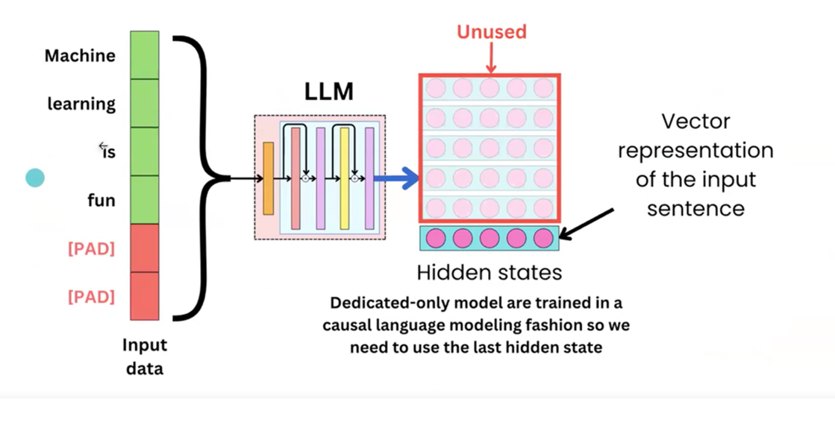

Figure : Vector Representation with causal language models

We will use LLM to generate embeddings (dense vector representation) for our data as shown on the Figure above.

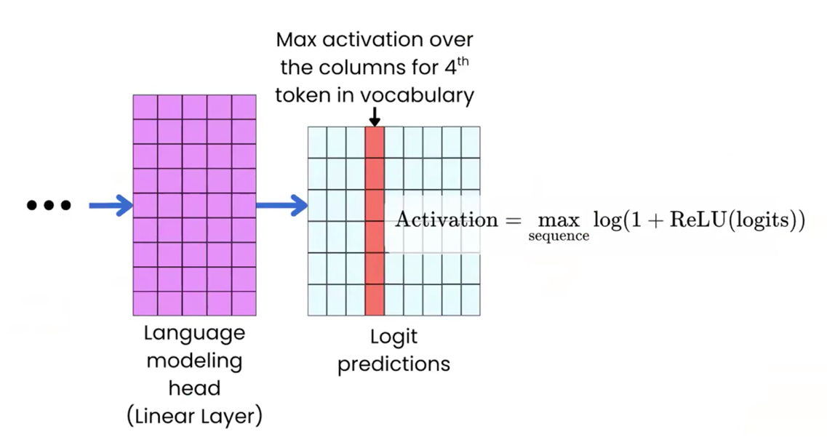

Figure: Encoder Model for SPLADE

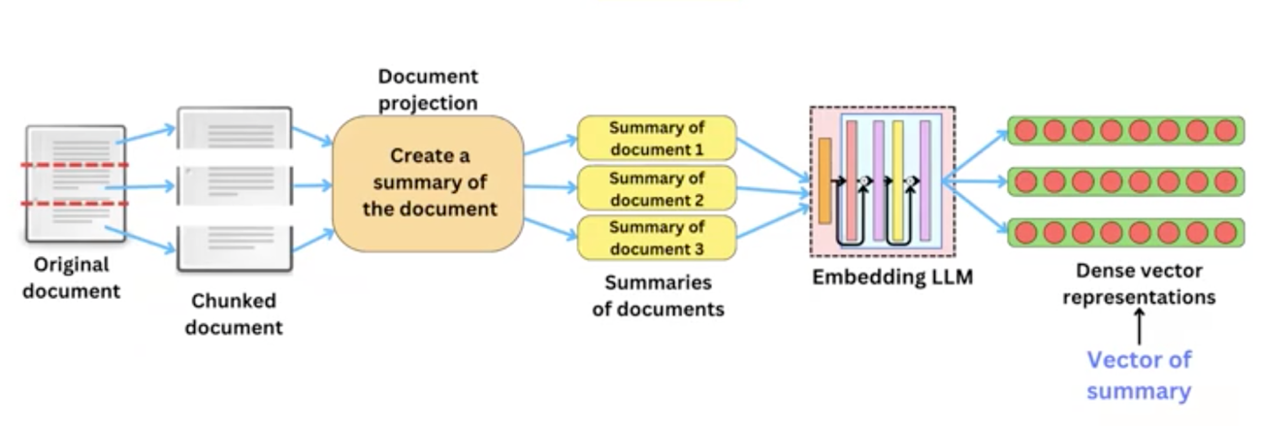
Figure : Finding better vector representations – the documents are indexed by a vector representation of their summaries

We are going to implement metadata filtering and additionally we are going to look into document projection.
So here is what we are going to do – we are going to create summaries of the code , like a textual description of the code, and then we are going to use that textual description to index the data.
The question is what the best way is to index the data – we are going to retrieve the data based on similarities to user queries. For example:
“Show me the forward function of the Llama 4 model”
-or-
“Show me the loss function of the Llama 4 model”
Assume there is a way to project a python code to a text representation that is going to be more similar to the way you could query the vector DB.
Question 1: What is the best way to take the text we have to build an index from it that is going to be good to retrieve the right data based on some query on that database.
We typically use cosine similarity to retrieve data.
Question 2: If we do cosine similarity between chat history and python code can we expect a good cover, that is the cosine similarity to capture the “right” semantics ?

On the Figure below we see a proposed ranker-based algorithm for typical two-step document selection.
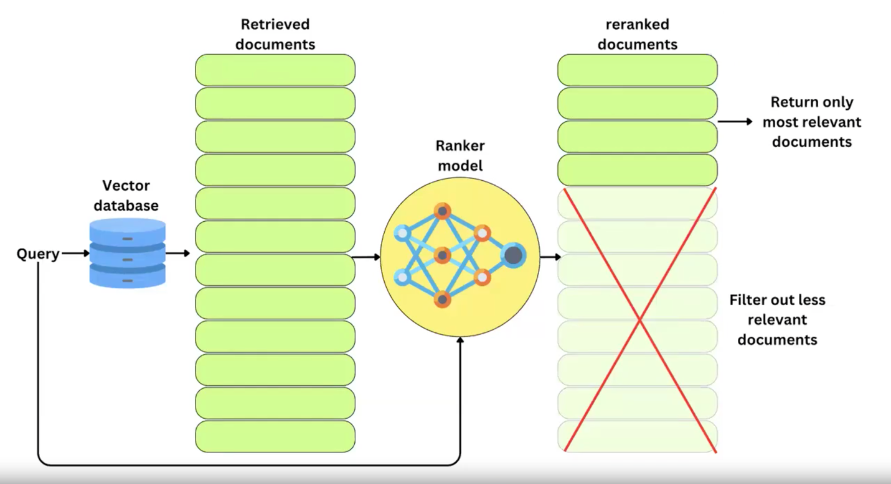
Figure: Document Selection with Ranker Model

Generate prompt by using an LLM in this case GPT-5:

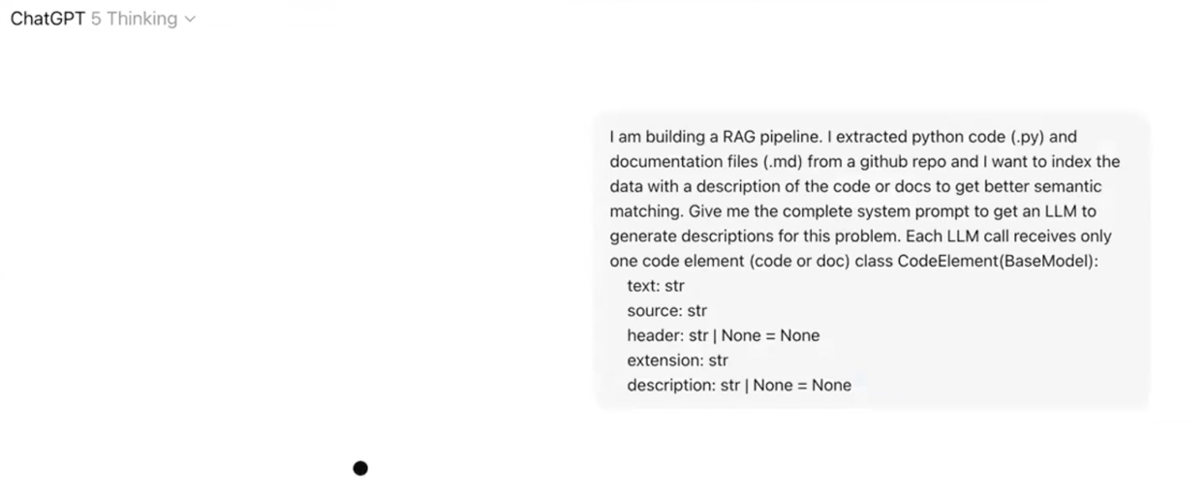
And here is the resulting prompt provided by GPT-5:

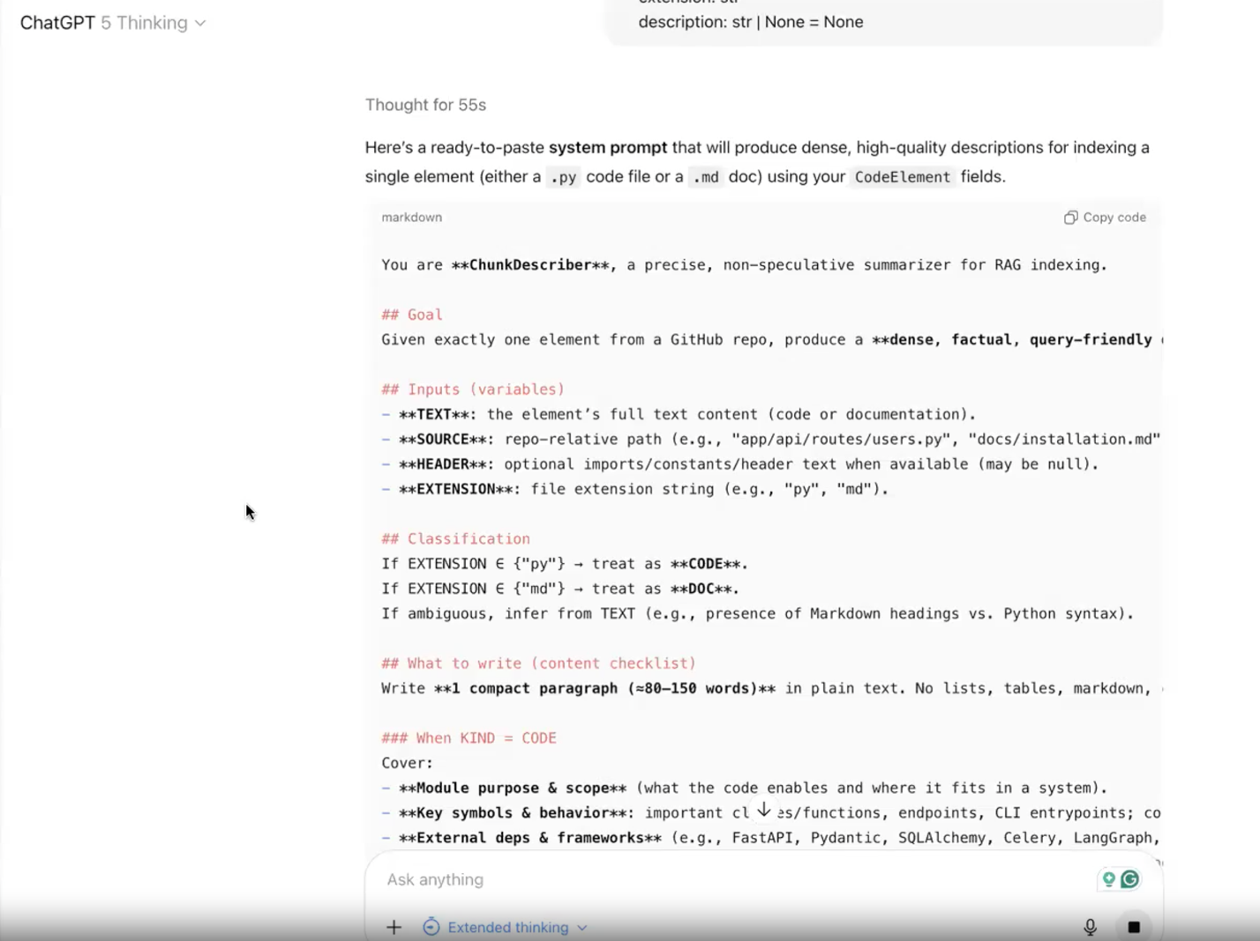

References
[1] Foundations of Vector Retrieval, S. Bruch, 2024
[2] Natural Language Processing for Semantic Search, Pinecone, James Briggs
[3] Dense Vectors: Capturing Meaning with Code, Chapter 1 of Pinecone online course, James Briggs
[4] SPLADE: Sparse Lexical and Expansion Model for First Stage Ranking, T. Formal et al, 2021
[5] An Approximate Algorithm for Maximum Inner Product Search over Steaming Sparse Vectors, S. Bruch et al, Pinecone, 2023
[6] https://python.langchain.com/docs/concepts/embedding_models/
[7] https://platform.openai.com/docs/guides/embeddings
[8] Distributed Representations of Words and Phrases and their Compositionality, Thomas Mikolov et al, Google, 2013
[9] Efficient Estimation of Word Representations in Vector Space, Thomas Mikolov et al, Google, 2013

Appendix

Sparse vs Dense Representations of Vector Embeddings

Sparse embeddings are a type of embedding where the majority of values in the vector are zeros. These embeddings are generally high-dimensional, with most dimensions inactive or zero. Sparse embeddings were among the earliest forms of word representation in NLP, seen in techniques like one-hot encoding and bag-of-words models.

Key Characteristics of Sparse Embeddings
-High Dimensionality: involve vectors with thousands and even millions of dimensions.
-Locality: represent each word independently; there is little or no overlap , shared information between embeddings for different words
-Interpretability: each dimension usually represents specific feature e.g. presence or absence of specific word

Techniques involving sparse embeddings
-One-hot encoding: a simple form of sparse embedding where each word in the vocabulary is represented as a vector composed of single-unit in the position of the word with rest filled with zeros
-Bag-of-Words (BoW): each document is represented as a sparse vector, with each dimension corresponding to the count of particular word in a document
-Term Frequency-Inverse Document Frequency (TD-IDF): enhances BoW by assigning weights to words based on their frequency in a document relative to their frequency across all documents. The resulting vectors are still sparse but more informative than simple BoW vectors

Advantages of sparse embeddings
-Interpretability: each dimension corresponds to a specific feature or word
-Exact Representation: capture exact presence or absence of features without approximations
-Good for High Dimensional Data: more memory efficient with large vocabularies because storage is efficient with sparse matrix representations

Limitations of Sparse Embeddings
-High Dimensionality
-Lack of Semantic Information: do not capture inherently semantic relationships between words. For example, “king” and “queen” would be represented as orthogonal vectors with no indication that they are semantically related.
-Poor Generalization: do not generalize well to unseen words or documents, making them not effective in tasks requiring semantic understanding.

Dense embeddings, in contrast, represent data as lower-dimensional vectors where every value is non-zero (or near-zero). These embeddings are compact and encode more complex relationships between data points. Dense embeddings are related to the approaches of word2vec, GloVe, and transformer-based models like BERT and GPT.

Key Characteristics of Dense Embeddings

-Low Dimensionality: much lower in dimensionality compared to sparse embeddings, often ranging from 50 to 1,000 dimensions.

-Distributed Representations: Unlike sparse embeddings, where each dimension represents a distinct feature, dense embeddings distribute information across all dimensions. Each dimension captures some aspect of the data’s meaning.

-Semantic Relationships: capture semantic relationships between data points. In word embeddings, words that are similar in meaning will have vectors that are close in embedding space.

Techniques Involving Dense Embeddings

word2vec: learns dense embeddings by predicting the context of words in a corpus (Skipgram, see [9]) or by predicting a word given its context (CBOW, see [8])

GloVe (Global Vectors for Word Representation): captures global word co-occurrence statistics and produces dense embeddings that reflect the relationships between words.

BERT: uses transformer networks to generate dense contextual embeddings, where the meaning of a word depends on its surrounding context

Advantages of Dense Embeddings
-Compact Representations: require fewer dimensions, making them more memory-efficient and faster to process than sparse embeddings.

-Semantic Richness: capture nuanced relationships between words, such as analogies (e.g. “king” is to “queen” what a “man” is to a “woman”)

Vector Embeddings offered through OpenAI

