Notes on Chain-of-Thought (CoT), ReAct, Reflection and DSPy Techniques for Eliciting Reasoning and Obtaining More Robust and More Correct Inferences with Agentic Workflows
Compiled by D. Gueorguiev, 11/1/2025

Introductory Remarks
//TODO:

//TODO: finish the introductory remarks section

Chain-of-Thought prompting
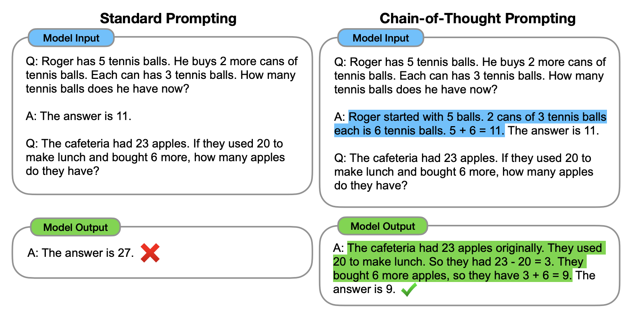
Figure 1: Chain-of-thought prompting enables LLMs to tackle more involved arithmetic and reasoning
tasks. The CoT reasoning sequence is highlighted with green

We compose the problem into intermediate seps and solve each before giving the final answer:

“After Jane gives 2 flowers to her mom she has 10 ... then after she gives 3 to her dad she will have 7 ... so the answer is 7.”

Sufficiently large LMs can generate chains of thought if demonstrations of chain-of-thought reasoning are provided in the exemplars for few-shot prompting. The Figure above shows an example of a model producing a CoT to solve a math word problem that it would have otherwise resulted in incorrect inference. The CoT in this case resembles a solution and can be interpreted as one.
Properties of CoT as a technique which facilitates reasoning:

-CoT represents a decomposition of a multi-step problem into intermediate steps where more intermediate steps are generated for problems which require more intermediate steps
-CoT provides interpretable window into the behavior of the model, suggesting how it might have arrived at a particular answer and providing opportunities to debug where the reasoning path went wrong

//TODO: finish the section on the CoT prompting

ReAct: Synergy of Reasoning and Acting improves the Robustness of the Inferences

Reflection and Self-Reflection :

References
[1] Chain-of-Thought Prompting Elicits Reasoning in Large Language Models, J. Wei et al, 2023
[2] ReAct: Synergizing Reasoning and Acting in Language Models, S. Yao et al, 2023
[3] Reflexion: Language Agents with Verbal Reinforcement Learning, Noah Shinn et al, 2023
[4] LLMs can learn self-restraint through iterative self-reflection, Alexandre Piche et al, 2024
[5] Self-Reflexion in LLM Agents: Effects on Problem Solving Performance, Matthew Renze, 2024
[6] DSPy: Compiling Declarative Language Model Calls into Self-Improving Pipelines, Omar Khattab et al, 2023
[7] DSPy Assertions: Computational Constraints for Self-Refining Language Model Pipelines, A. Singhvi et al, 2024

