Notes on Proximal Policy Optimization Algorithms by John Schulman et al
Compiled by D. Gueorguiev 2/16/2024

Introduction

Some Preliminaries

Problem Setup
RL Training happens when there is an entity which will be called agent that takes actions within an environment.
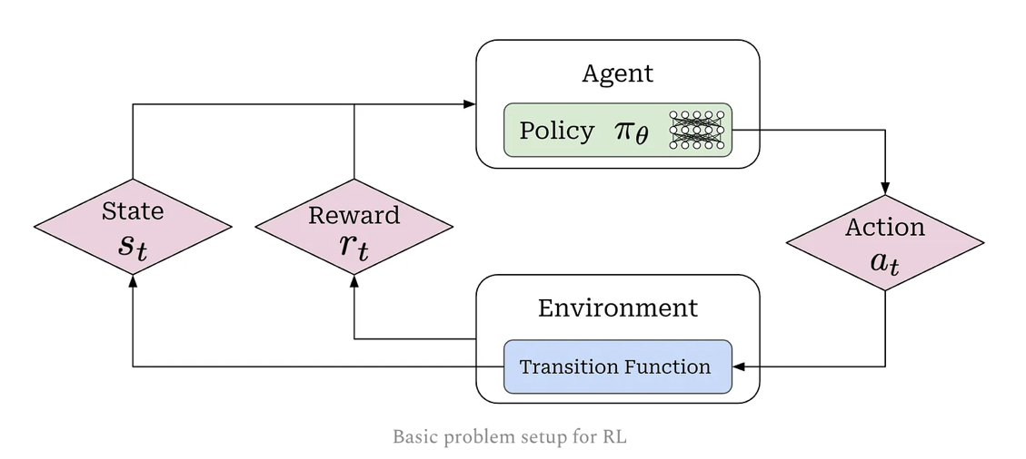
The actions of the agent are influenced by the policy of the agent. For example, the policy is the LLM itself in the context of training the LLM.

Literature

[1] PPO for LLMs: A Guide for Normal People, Cameron Wolfe, Substack, Oct 25th, 2025
[2] Human-level control through deep reinforcement learning, Volodymyr Mnih et al, Nature, 2015
[3] Asynchronous methods for deep reinforcement learning, Volodymyr Mnih et al, Google DeepMind, 2016
[4] Trust Region Policy Optimization, John Schulman et al, OpenAI, 2017
[5] Proximal Policy Optimization Algorithms, John Schulman et al, OpenAI, 2017
[6] Reinforcement Learning - An Introduction, Second Edition, Richard Sutton, Andrew Barto, 2020
[7] https://docs.agilerl.com/en/latest/tutorials/gymnasium/index.html
[8] https://github.com/AgileRL/AgileRL/
[] Tutorial with code: Acrobot with PPO using AgileRL (latest semver doc)

[] Tutorial with code: Policy Optimization (PPO) Tutorial with Gym Environment (deprecated), PyLessons, March 25, 2020
[] Tutorial with code: LunarLander-v2 with Proximal Policy Optimization with Gym Environment (deprecated), PyLessons, Nov 13, 2020
[] Tutorial with code: BipedalWalker-v3 with Continuous Proximal Policy Optimization with Gym Environment (deprecated), PyLessons, Nov 23, 2020

