Symmetries in Physics: Understanding U(1), SU(2), SU(3), and SO(3,1)
compiled by D.Gueorguiev, 12/26/2025

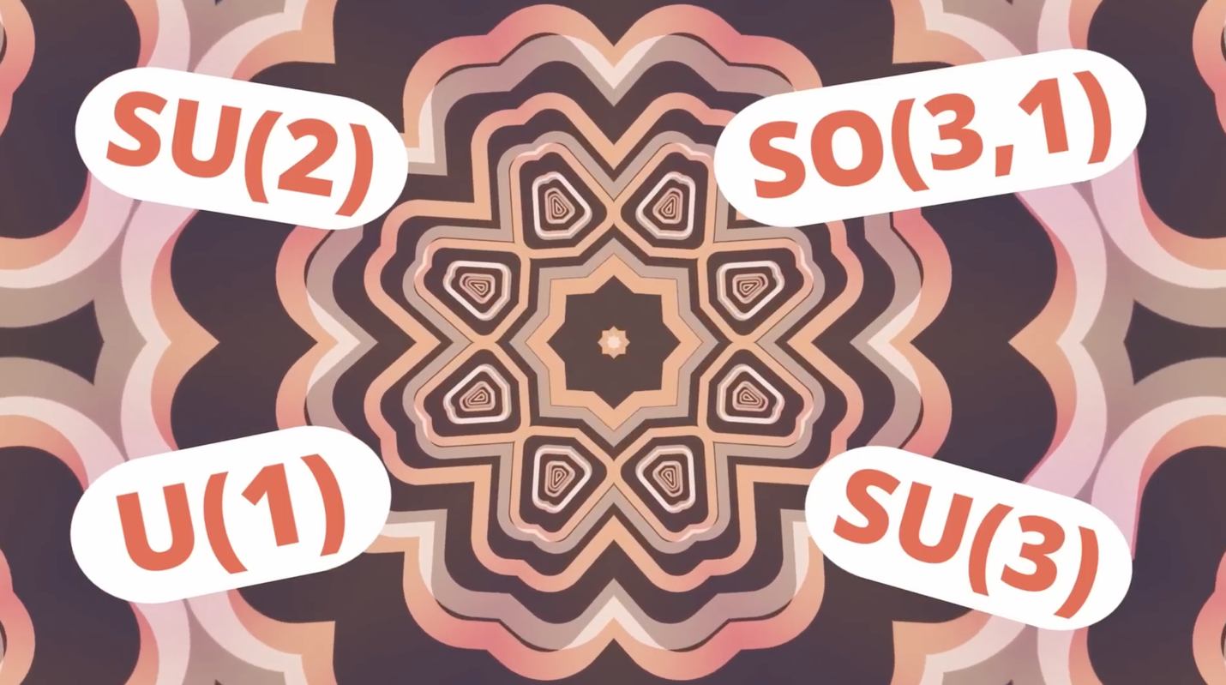

(picture credited to Sabine Hossenfelder)

References
[1] New Experiment Sees Order Emerge from Chaos, Sabine Hossenfelder, Dec 25, 2025 (youtube video)

