Simple RAG Architecture using LangChain/LangGraph
Compiled by D.Gueorguiev on 2/26/2026 using Cursor AI with Opus 4.6

Overall Architecture
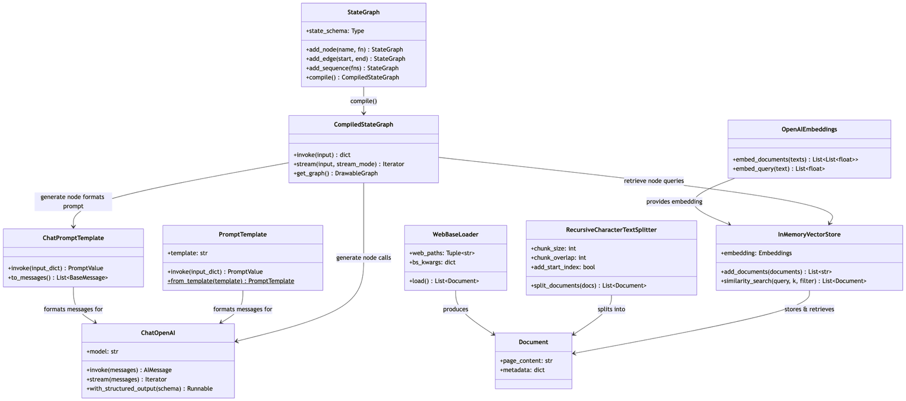

References
[1] src/examples/langgraph/simple_rag/rag.ipynb

[2] src/examples/langgraph/simple_rag/rag_diagrams.md

[3]

Appendix

