Jacobi metric and Geodesics in Riemannian Geometry
Compiled with Claude Sonnet, 4/20/2026

Quick Intro

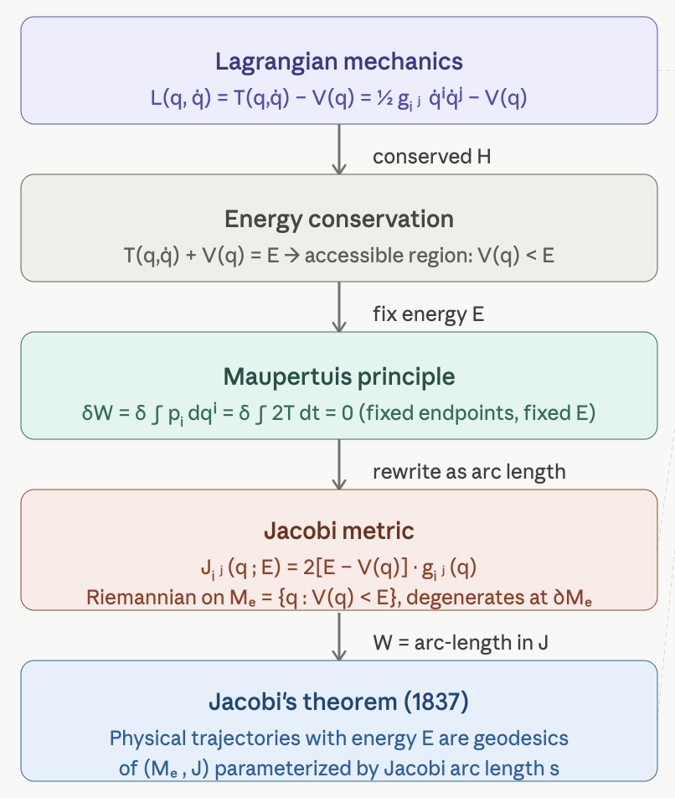
The Jacobi metric is one of the most beautiful bridges between classical mechanics and Riemannian geometry — it reframes the dynamics of a conservative system as pure geometry, turning every physical trajectory at fixed energy into a geodesic. Here is a structured development with definitions, derivations, and illustrative figures.

Classical Setup

Let $M$ be a smooth n-dimensional manifold (the configuration space) equipped with a Riemannian metric $g=\left(g_{ij}\right)$

