Notes on LayerNorm-after-step applied to SPLM
Compiled by D.Gueorguiev, 4/26/2026

LayerNorm placement in transformers : Post-LN vs Pre-LN

The LayerNorm-after-step refers to the Post-LN (Post-Layer Normalization) design — the original arrangement from Attention Is All You Need (Vaswani et al., 2017). It's worth contrasting it directly with the now-dominant Pre-LN variant to understand the architectural choice clearly.
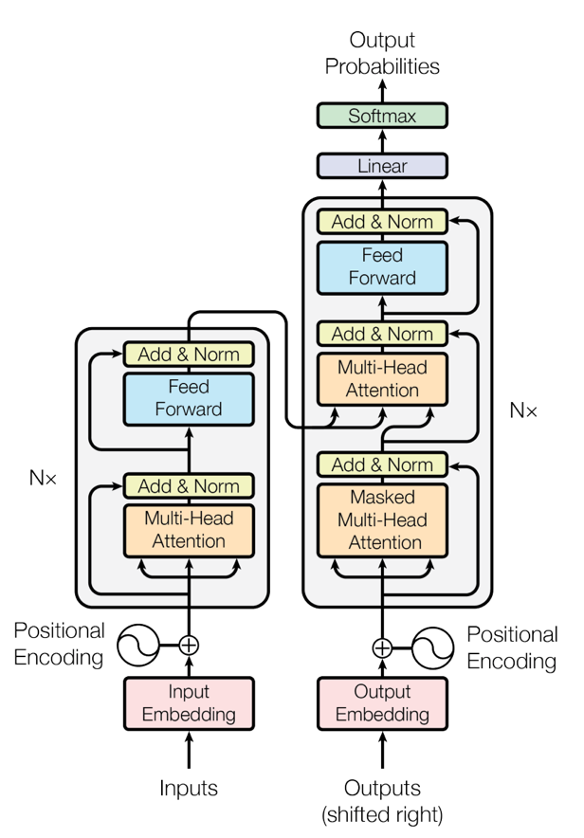
Figure : The Transformer architecture from [1]

The Encoder in [1]: The encoder is composed of a stack of $N = 6$ identical layers. Each layer has two sub-layers. The first is a multi-head self-attention mechanism, and the second is a simple, position wise fully connected feed-forward network. A residual connection [2] around each of the two sub-layers, followed by layer normalization [1]. That is, the output of each sub-layer is LayerNorm(x + Sublayer(x)), where Sublayer(x) is the function implemented by the sub-layer itself. To facilitate these residual connections, all sub-layers in the model, as well as the embedding layers, produce outputs of dimension dmodel = 512.

The Decoder in [1]: The decoder is also composed of a stack of $N = 6$ identical layers. In addition to the two sub-layers in each encoder layer, the decoder inserts a third sub-layer, which performs multi-head attention over the output of the encoder stack. Similar to the encoder, we employ residual connections around each of the sub-layers, followed by layer normalization. We also modify the self-attention sub-layer in the decoder stack to prevent positions from attending to subsequent positions. This masking, combined with fact that the output embeddings are offset by one position, ensures that the predictions for position $i$ can depend only on the known outputs at positions less than $i$.

References
[1] Attention Is All You Need, Vaswani et al, Google Brain, 2017
[2] Deep residual learning for image recognition, Kaiming He et al, 2016

