Jacobi metric and Geodesics in Riemannian Geometry
Compiled with Claude Sonnet, 4/20/2026

Quick Intro

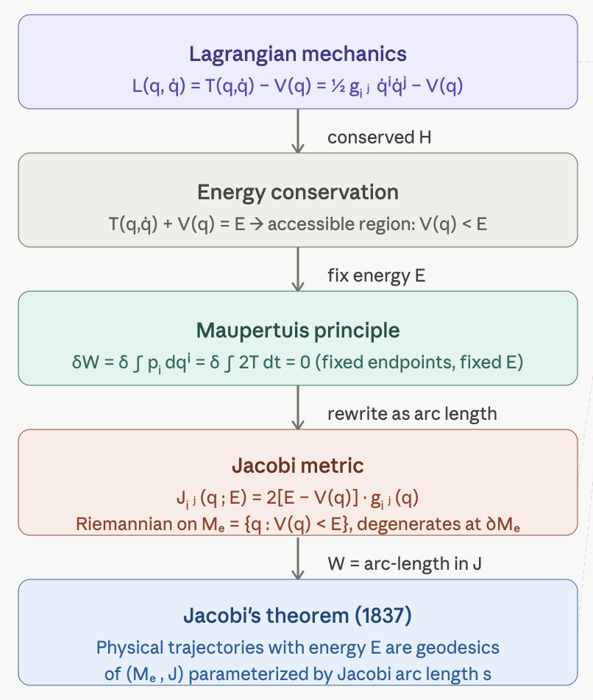
The Jacobi metric is a bridge between classical mechanics and Riemannian geometry — it reframes the dynamics of a conservative system as pure geometry, turning every physical trajectory at fixed energy into a geodesic. Here is a structured development with definitions, derivations, and illustrative figures.

Classical Setup

Let $M$ be a smooth $n$-dimensional manifold (the configuration space) equipped with a Riemannian metric $g=g_{ij}\left(q\right)$.

Appendix

Riemannian Metric in Riemannian Geometry

Definition Riemannian space (manifold)
Informally, Riemannian space is a smooth space equipped with a Riemannian metric, which acts as a locally varying tape measure for calculating lengths, angles, and volumes directly on a curved surface without embedding it in high-dimensional space.
Formally, a Riemannian manifold ($M,g$) consists of two components:
1 ) The Manifold $M$ : a topological space that locally resembles flat Euclidean space $R^{n}$
2 ) The Metric Tensor $g$ : a choice of an inner product $g_{p}$ on the tangent space $T_{p}M$ at each point $p∈M$ that varies smoothly from point to point.
For any two tangent vectors $u, v∈T_{p}M$, the metric $g_{p}\left(u,v\right)$ returns a real number satisfying three properties:

- bilinear in both arguments i.e. $g_{p}\left(u_{1}+u_{2},v\right)=g_{p}\left(u_{1},v\right)+g_{p}\left(u_{2},v\right)$ $∧g_{p}\left(u,v_{1}+v_{2}\right)=g_{p}\left(u,v_{1}\right)+g_{p}\left(u,v_{2}\right)$
- symmetric : $g_{p}\left(u,v\right)=g_{p}\left(v,u\right)$
- positive-definite: $g_{p}\left(u,u\right)>0$ for any non-zero vector $u$

In a local coordinate chart $\left(x^{1},x^{2},…,x^{n}\right)$, the metric tensor is expressed as a symmetric matrix $g_{ij}$:

$g_{ij}\left(x\right)=g\left(\frac{∂}{∂x^{i}},\frac{∂}{∂x^{j}}\right)$

The infinitesimal line element ${ds}^{2}$ tracks how distance changes along any coordinate direction:

${ds}^{2}=\sum_{i,j}{g_{ij}{dx}^{i}{dx}^{j}}$

What the Metric Induces?

Vector Norms and Angles
The length of a vector $u$ Is given by $\left\|u\right\|=\sqrt{g_{p}\left(u,u\right)}$ and the angle $θ$ between two vectors $u$ and $v$ is found via $\cos{θ}=\frac{g_{p}\left(u,v\right)}{\left\|u\right\|∙\left\|v\right\|}$.

Arc Length of Curves
The length $L$ of a smooth curve $γ\left(t\right)$ for $t∈\left[a,b\right]$ is computed by integrating its speed:

L

More on Topological Spaces

Definition second-countable
There exists a countable collection of open sets $B=\left\{U_{1},U_{2},U_{3},…\right\}$ such that every open set in the space can be written as a union of elements from $B$.

Definition Hausdorff ($T_{2}$)

Definition second-countable Hausdorff space
A topological space that has a countable base for its topology (second-countable) and in which distinct points can be separated by disjoint open sets (Hausdorff).

