Pairwise Potentials in PARFLM – Theory and Design
Compiled by D. Gueorguiev, 6/21/2026

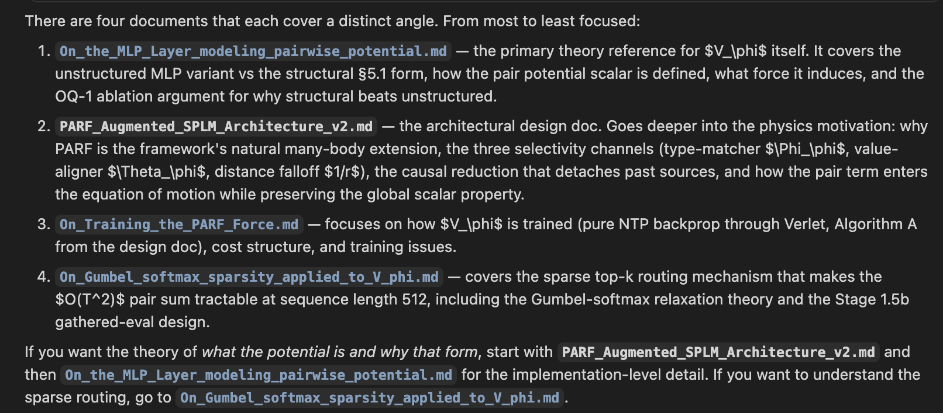

Why PARF in a language model?

