Diving into Attention implementations via well-constructed toy examples
Compiled by D.Gueorguiev on 3/2/2026 with Claude Opus 4.6

Introduction

Basic Attention Mechanism – Principle of Operation

Let us consider a toy encoder-decoder example with attention as shown on the Figure below.
The Encoder portion (denoted with E) is implemented as single cell RNN e.g. gated recurrent unit (GRU).

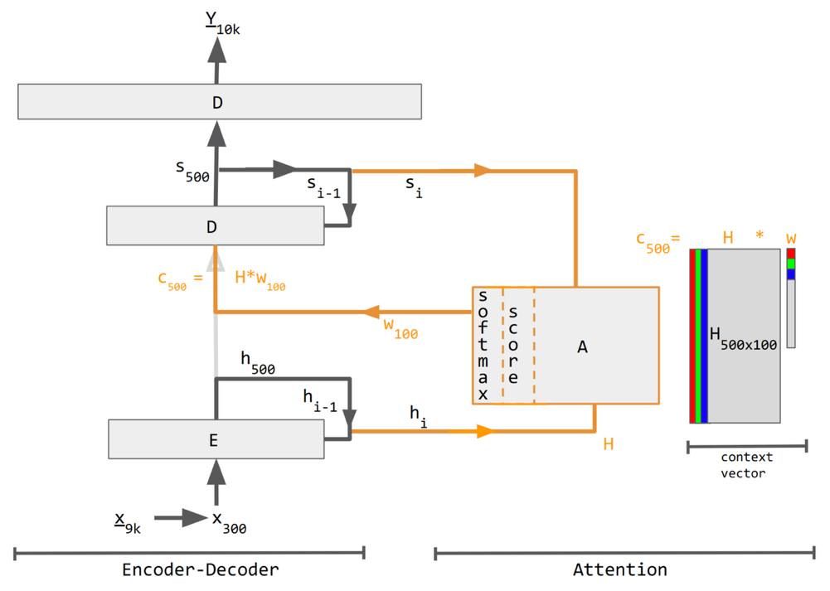
Figure 1: Encoder-decoder with attention. Numerical subscripts (100, 300, 500, 9K, 10K) indicate vector sizes while lettered subscripts $i$ and $i-1$ indicate time steps.

Here is what happens in the encoding phase:

Figure 2:
The first word “I” arrives. It gets embedded from a 9K one-hot vector into 300 dim vector: $x_{9k}→x_{300}$. The encoder cell E receives an embedding plus an initial hidden state $h_{0}$ which typically contains all-zeros. It produces $h_{1}$, the new hidden state, after reading the first word. The $h_{1}$ flows right toward the $H$ matrix.

Note: The encoder cell E is represented by a single Gated Recurrent Unit (GRU) in this toy example. See the Vanila Gated Recurrent Unit (GRU) in the Appendix for details.
At each time step $i$, E computes the new hidden state $h_{i}$ from two inputs: the previous hidden state $h_{i-1}$ and the current token embedding $x_{i}$.
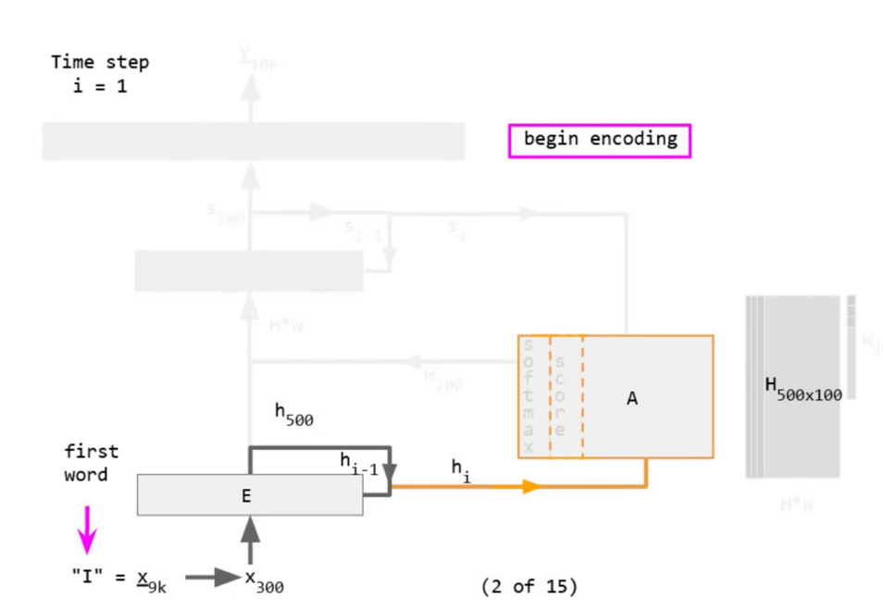
Figure 2: Encoder-Decoder with attention : begin encoding

Figure 3: The hidden state $h_{1}$ has been stored as the first column of the $H$ matrix. The red column pointed to by the magenta arrow labeled with `encoded “I”`.

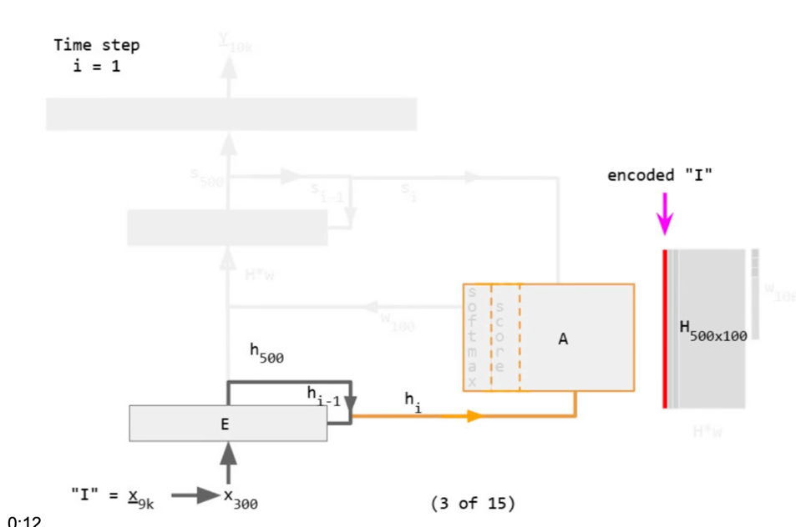

Figure 3: Encoder-Decoder with attention : encoding “I”

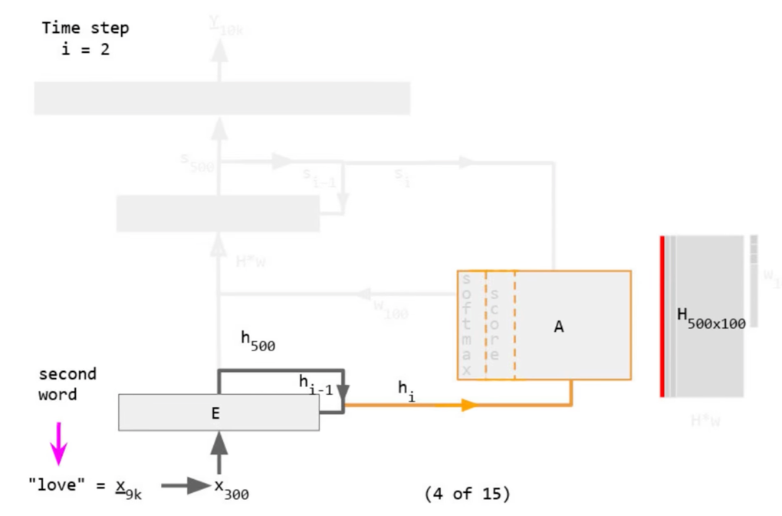

Figure 4: Encoder-Decoder with attention: encoding second word “love”

The Attention formula from first principles

Let us consider Encoder-Decoder architecture with Bahdanau-style attention mechanism. The encoder processes source tokens through an embedding layer and GRU, producing hidden states used as keys/values for attention. The decoder generates output tokens auto-regressively, attending over encoder states at each step.
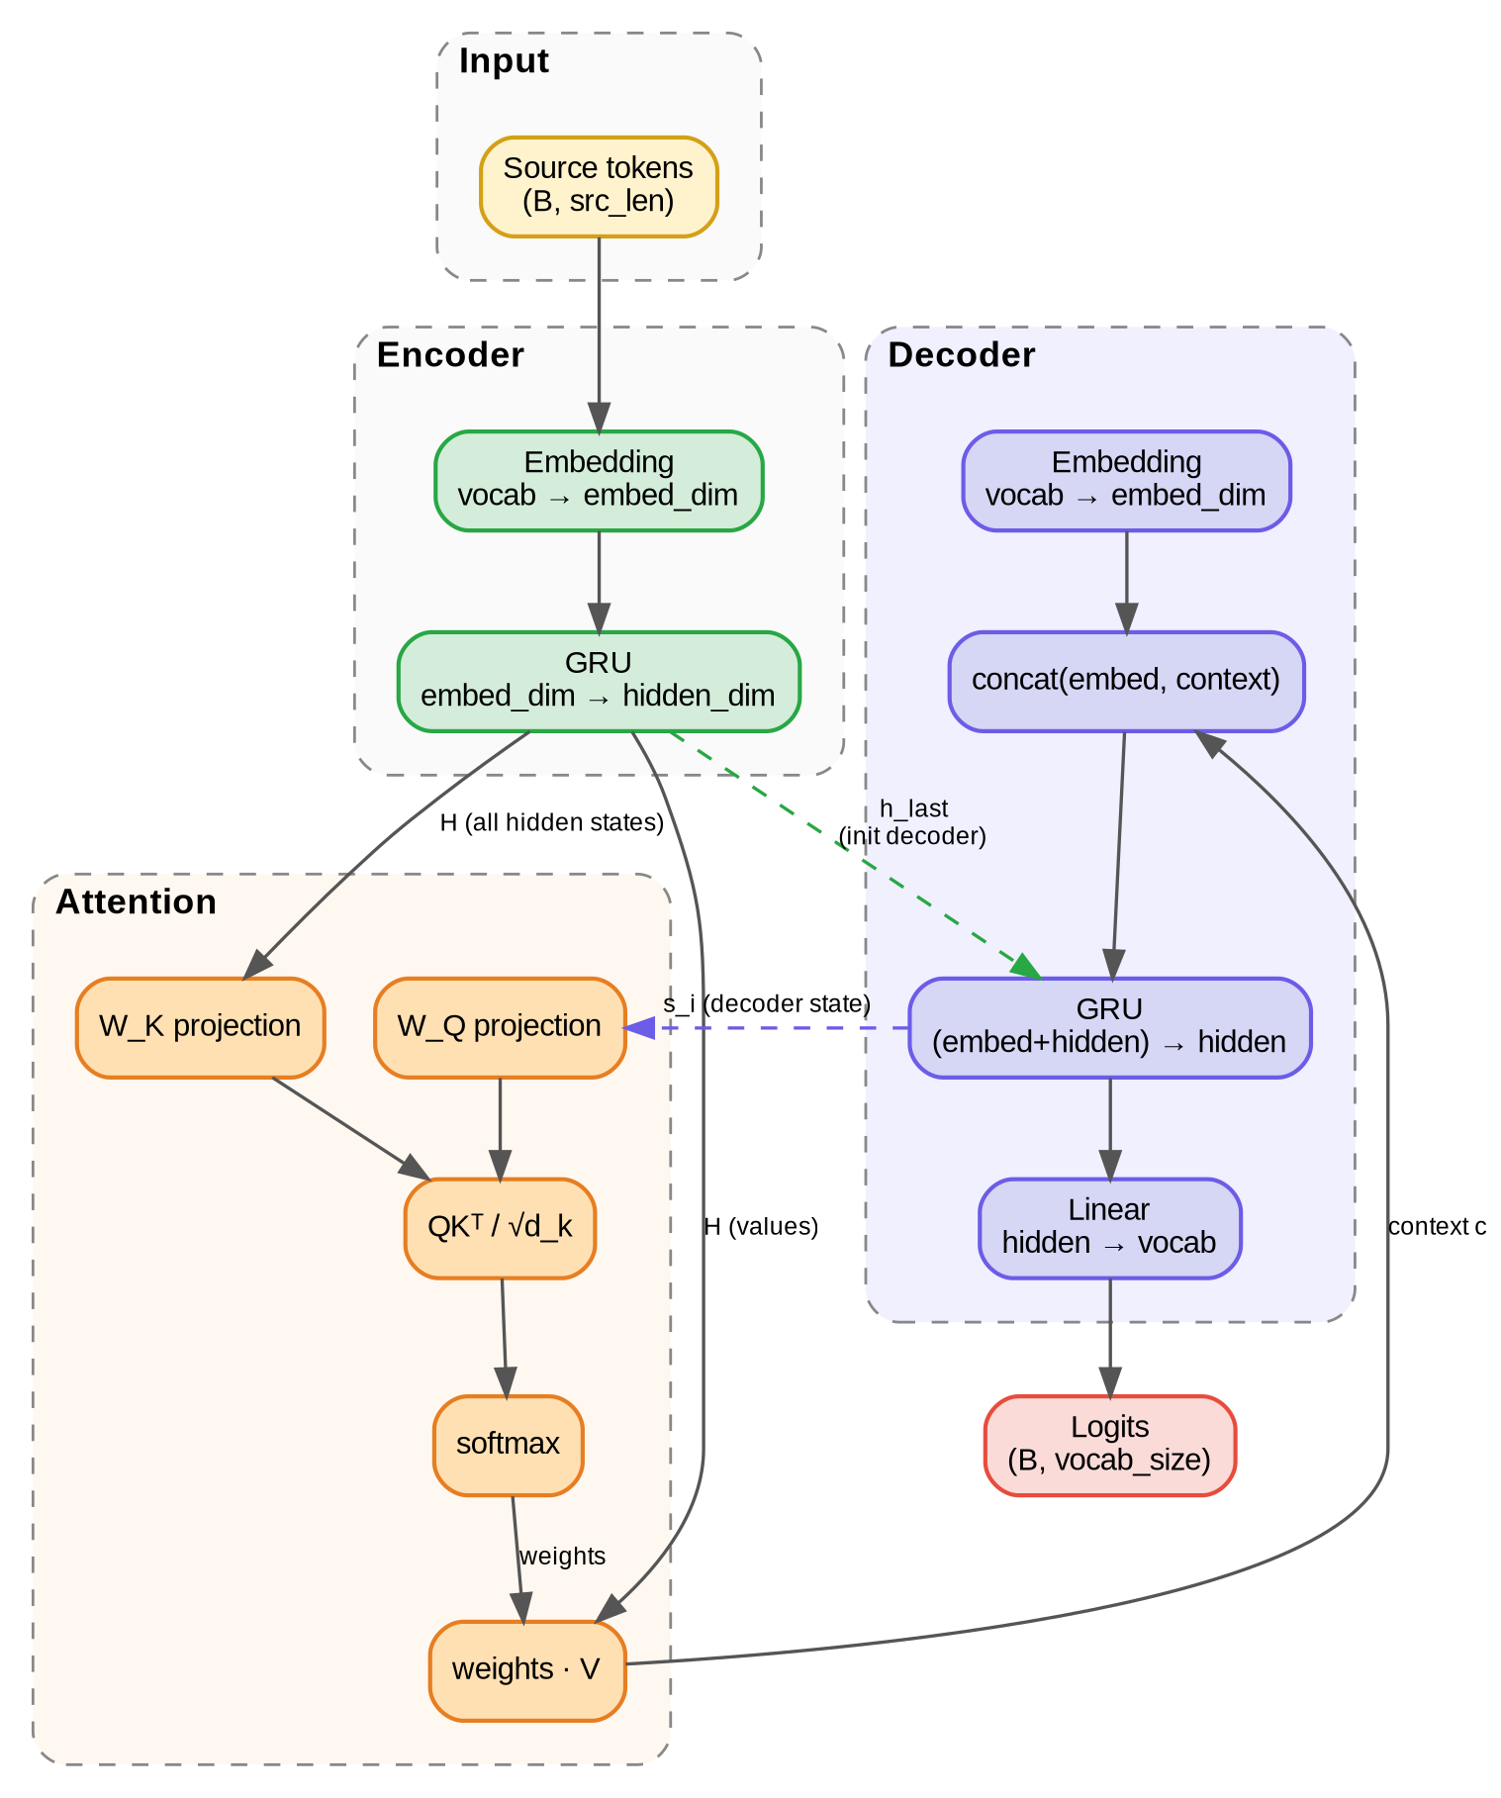
Figure : seq2seq with attention-style architecture

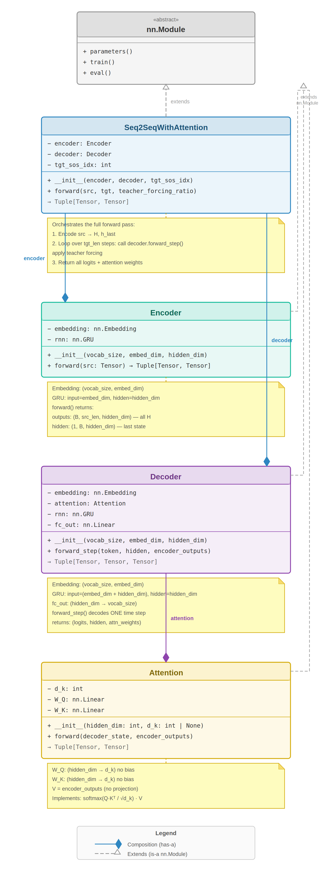
Figure: Static Class Diagram

References
[1] Attention in Machine Learning, Wikipedia
[2] notebooks/attention/encoder_decoder_with_attention_demo.ipynb
[3] notebooks/attention/encoder_decoder_with_attention_demo.md
[4]

Appendix

Vanila Gated Recurrent Unit (GRU)
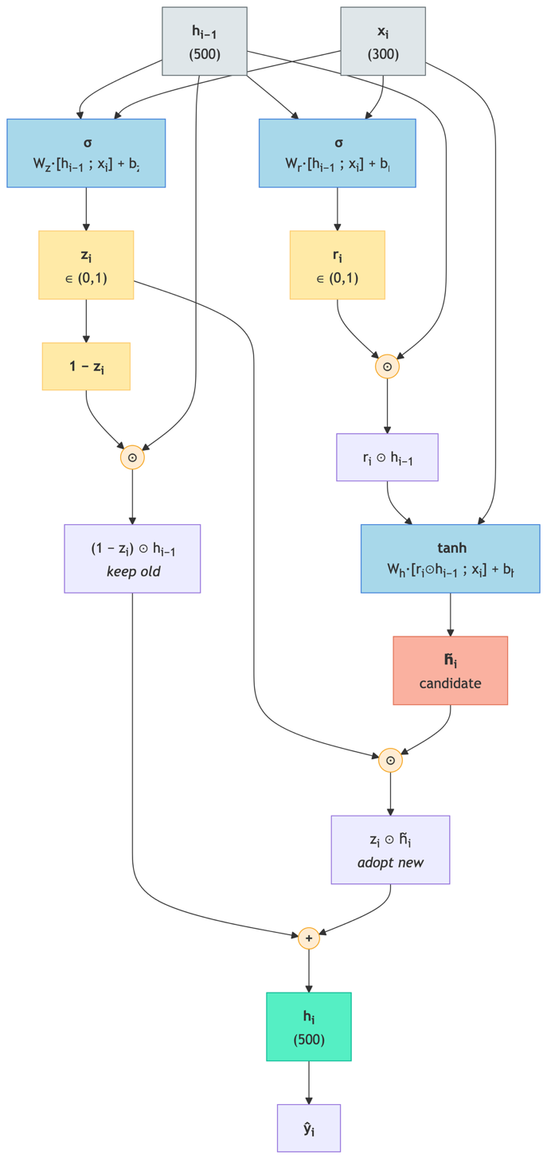

Figure A.1 : Gated Recurrent Unit in its vanilla form

A plain RNN would compute the hidden state with a single equation:

$h_{i}=tanh\left(W_{hh}h_{i-1}+W_{xh}x_{i}+b\right)$

The $b$ is the bias vector — a learnable parameter of the same dimension as the hidden state (500 in the diagram's notation).

This is easy to understand but suffers from vanishing gradients — after many time steps the model forgets early tokens. That's why the notebook example [2] uses a GRU instead.

What does GRU (as implemented by nn.GRU) actually computes?

The GRU adds two gates that control information flow. At each time step $i$:

1. Reset gate — decides how much of the previous hidden state to forget before forming a candidate:

$r_{i}=σ\left(W_{r}\left[\begin{matrix}h_{i-1} \\ x_{i}\end{matrix}\right]+b_{r}\right)$

2. Update gate — decides the mix between keeping the old state and adopting the new candidate:

$z_{i}=σ\left(W_{z}\left[\begin{matrix}h_{i-1} \\ x_{i}\end{matrix}\right]+b_{z}\right)$

3. Candidate hidden state — a proposed new state, where the reset gate can zero out parts of $h_{i-1}$:

${\tilde{h}}_{i}=tanh\left(W_{h}\left[\begin{matrix}r_{i}⊙h_{i-1} \\ x_{i}\end{matrix}\right]+b_{h}\right)$

4. Final hidden state — a gated interpolation between old and new:

$h_{i}=\left(1-z_{i}\right)⊙h_{i-1}+z_{i}⊙{\tilde{h}}_{i}$

Where:

$σ$ is the sigmoid function (outputs in $[0,1]$)
$⊙$ is element-wise multiplication
$\left[h_{i-1};x_{i}\right]$ means concatenation of the two vectors

What the gates do intuitively:

Gate | Value near 0 | Value near 1
Reset $r_{i}$ | Ignore previous hidden state $→$ candidate is based mostly on the current input $x_{i}$ | Let previous state flow through to candidate
Update $z_{i}$ | Keep old hidden state $h_{i-1}$ as is (skip this input) | Replace with new candidate ${\tilde{h}}_{i}$

The update gate is the key to long-range memory: when $z_{i}≈0$ the hidden state passes through unchanged, allowing information from early tokens to survive across many time steps — which is exactly what the encoder needs before the attention mechanism even gets involved.

Thus, on Figure 1 the arrow h_{i-1} going back into E and the arrow x_i coming in from below correspond to the two inputs that appear in every equation above. The output h_i (flowing right toward the H matrix) is the result of equation 4. After processing all source tokens, the H matrix contains every h_i, and the attention mechanism scores the decoder state against all of them.

Reading the diagram on Figure A.1 from top to bottom:
1. Two inputs arrive: the previous hidden state $h_{i-1}$ (500-dim) and the current token embedding $x_{i}$ (300-dim). They get concatenated into an 800-dim vector.
2. Reset gate (yellow) — A linear transform + sigmoid produces $r_{i}$ in $(0,1)$. This is element-wise multiplied with $h_{i-1}$ to selectively erase parts of the old memory before forming the candidate. When $r_{i}≈ 0$ for some dimension, that dimension of the previous state is wiped — the candidate sees only the current input there.
3. Update gate (blue) — A separate linear transform + sigmoid produces $r_{i}$ in (0,1). This controls the final interpolation: how much to keep from the old state vs. adopt from the candidate.
4. Candidate state (red) — The reset-gated previous state r_i ⊙ h_{i-1} is concatenated with x_i, passed through a linear transform + tanh, producing h̃_i — a proposal for what the new hidden state could be.
5. Final state (green) — The output h_i is a weighted blend: $\left(1 - z_{i}\right) ⊙ h_{i-1} + z_{i} ⊙ {\tilde{h}}_{i}$. When $z_{i} ≈ 0$ the old state passes through unchanged (long-term memory); when $z_{i} ≈ 1$ the candidate replaces it (the cell is "writing" new information).
The resulting h_i then does double duty: it feeds back as h_{i-1} for the next time step, and it gets stored as column i in the H matrix that the attention mechanism will later score against.

Figure A.2 : Diagram of the Gated Recurrent Unit (GRU) computation happening inside the Encoder E
It shows how a single GRU cell computes the new hidden state h_i from the two inputs h_{i-1} and x_i.

Reading from top to bottom:

1 ) Inputs (top, grey) — h_{i-1} (500-dim previous hidden state) and x_i (300-dim current token embedding) enter and fan out to three parallel paths.

