Structured Scalar Potential : Design and Theory
compiled by D. Gueorguiev, 6/14/2026

Motivation

Semantic Attractor Extraction Algorithm

The Semantic Simulation framework asserts that a trained Scalar Potential Language Model does not just predict the next token; it learns a semantic landscape – a scalar field $V_{θ}\left(ξ,h\right)$ over the joint space of contexts $ξ$ and hidden states $h$ – whose local minima correspond to coherent semantic configurations.

This is a strong claim. Attention transformers have no analogue of it : their next-token logits are produced by a single matrix multiplication, not by an energy minimization, so they cannot, even in principle, expose a basin structure of “topics the model has internalized”. If the SPLM picture is right , we should be able to :

1. Fix a content $ξ$ (e.g. the cumulative mean of an English prefix)
2. start from many random hidden states $h_{0}$
3. follow the gradient $-∇_{h}V_{θ}\left(ξ,h\right)$ to convergence
4. read out the converged $h^{*}$ through the tied LM head

The following experiment was conducted in order to extract semantic attractors

We use two trained SPLM checkpoints from the Tiny-Shakespeare run with vocabulary = GPT-2 BPE, $d = 128$, mass-mode = logfreq.

name | integrator | $$L$$ | $$∆t$$ | Val PPL
Euler L=8 | Semi-implicit Euler (SARF-mass)

//TODO: finish from [2]

Potential Wells and the Concept of Temperature

$$V_{θ}=-τ\log{\sum_{k}{}}$$
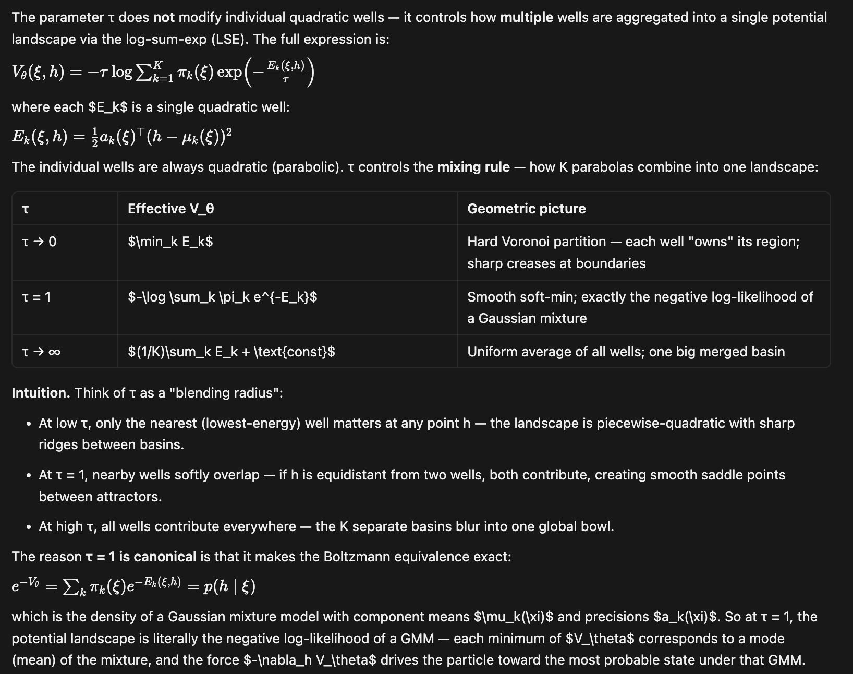
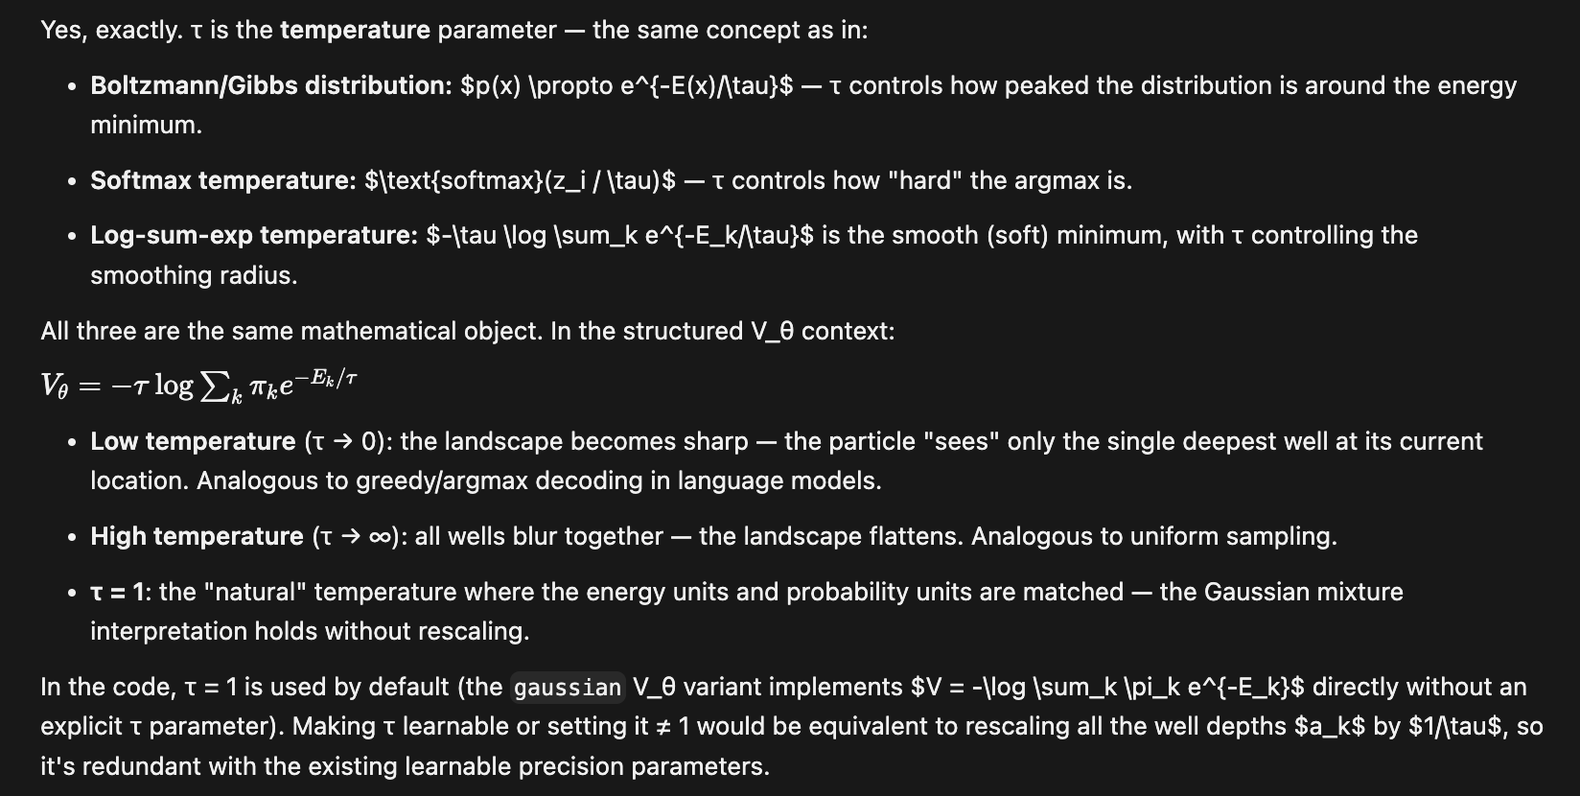
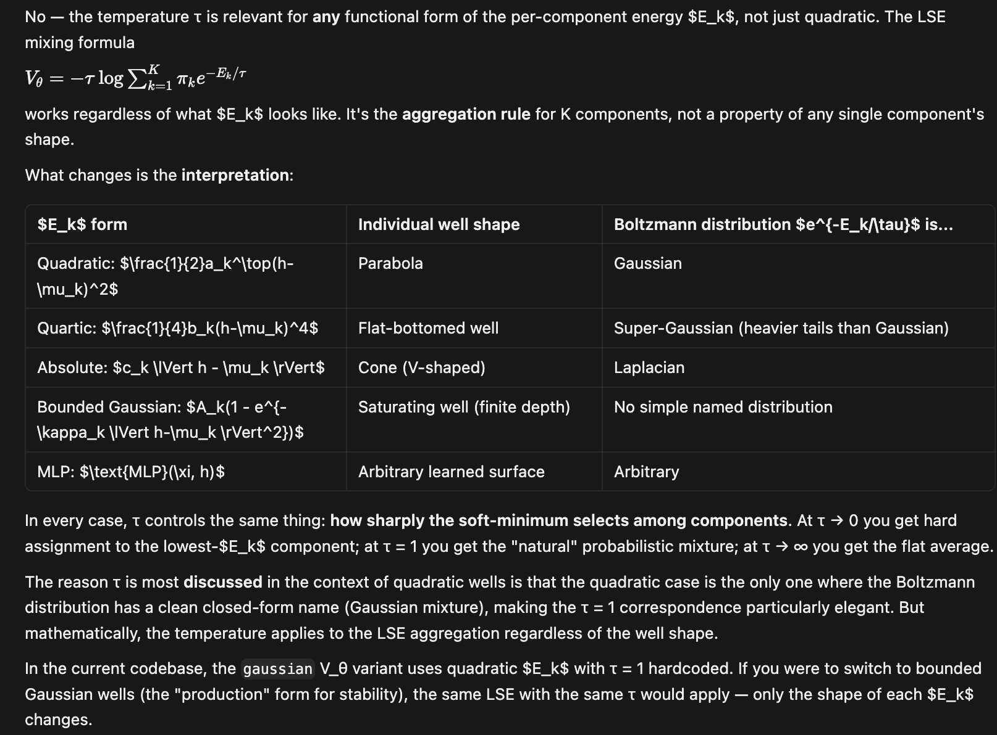

Quadratic and Gaussian Potential Wells

Difference between Quadratic and Gaussian Potential Wells
Quadratic and Gaussian potential wells are closely related concepts

//TODO: finish the introductory paragraph showing the similarity in asymptotic behavior for quadratic and Gaussian wells.

Quadratic Wells

Let us consider a scalar potential well of the form:

$E_{k}\left(ξ,h\right)=\frac{1}{2}{a_{k}\left(ξ\right)}^{T}{\left(h-μ_{k}\left(ξ\right)\right)}^{2}$
Here the subscript $k$ denotes the $k$-th well on the semantic energy landscape. Note that this is a quadratic function of $h$.
This is a conceptual point worth unpacking carefully. The short answer is that “quadratic well” and “Gaussian well” are two names for the same object, seen from two different perspectives.

The equivalence
Consider a single SQ1 component:
$$E_{k}(ξ,h)=\frac{1}{2}a_{k}(ξ)^{⊤}(h-μ_{k}(ξ))^{2}$$
This is a quadratic function of $h$ — a parabola in each coordinate. Now consider the corresponding Boltzmann weight:
$$p_{k}(h∣ξ)∝e^{-E_{k}(ξ,h)}=exp\left(-\frac{1}{2}a_{k}^{⊤}(h-μ_{k})^{2}\right)$$
That exponential of a negative quadratic is exactly a (diagonal) Gaussian with mean $μ_{k}(ξ)$ and precision $a_{k}(ξ)$. So:
• From the dynamics side: the potential is a quadratic well (parabolic energy surface).
• From the probabilistic side: the same object is a Gaussian well (the stationary distribution of the damped flow is Gaussian).
The two phrases describe the same mathematical shape — one in energy language, one in probability language.

Why SQ3 recovers the Gaussian mixture
At temperature $τ=1$, the SQ3 potential is:
$$V_{θ}=-log\sum_{k=1}^{K}{π_{k}(ξ)e^{-E_{k}(ξ,h)}}$$
Rearranging:
$$e^{-V_{θ}}=\sum_{k=1}^{K}{π_{k}(ξ)e^{-E_{k}(ξ,h)}}$$
So $e^{-V_{θ}}$ is proportional to the density of a Gaussian mixture model. Equivalently, $V_{θ}=-logp(h∣ξ)$ up to a constant, which is the negative log-likelihood of that GMM. The minima of $V_{θ}$ are the modes of the mixture — the Gaussian well centres $μ_{k}(ξ)$.

The parameter τ (temperature) in the quadratic well design

What τ controls
$τ$ | Behaviour of $V_{θ}$
$τ→0$ | $V_{θ} → \min_{k}{E_{k}}$ — hard assignment to deepest basin; sharp, non-smooth
$τ=1$ | V_θ = −log Σ_k π_k e^{−E_k} — exact negative GMM log-likelihood
$τ→∞$ | V_θ → (1/K) Σ_k E_k + const — uniform average of wells; single effective basin

$τ=1$ is the canonical choice because it connects SQ3 directly to the Gaussian mixture motivation of Section 4 of the paper [1].

The practical punchline
The SPLM paper motivates $V_{θ}$ as governing a landscape of Gaussian wells (semantic attractor basins). SQ3 is that landscape, by construction. You are not approximating Gaussian wells with quadratics — you are writing them down directly in their exact mathematical form, then mixing them with a log-sum-exp (which is the soft generalisation of the minimum over the $K$ components). The “quadratic” and “Gaussian” labels are just two ways to say the same thing.
The labels SQ1 / SQ3 / SQ5 refer to the structured $V_{θ}$ sweep from Section 17 of [2] (Semantic_Attractor_Extraction.md).
Label | $V_{θ}$ form
SQ1 | K=1 diagonal quadratic well (planned, not yet run)
SQ3 | K=4 mixture of diagonal quadratic wells (the main result)
SQ5 | Unconstrained MLP reference

A single SQ1 component (subscripted by $k$) is one diagonal quadratic energy well:
$$E_{k}(ξ,h)=\frac{1}{2}a_{k}(ξ)^{⊤}(h-μ_{k}(ξ))^{2}$$
where $μ_{k}(ξ)∈R^{d}$ is the context-dependent centre of the well (where the potential is minimised), and $a_{k}(ξ)∈R_{>0}^{d}$ is the context-dependent diagonal precision (sharpness / stiffness along each coordinate). Both $μ_{k}$ and $a_{k}$ are produced by small MLPs that take the EMA context vector $ξ$ as input.
This quadratic energy is exactly the negative log of a diagonal Gaussian. The Boltzmann weight
$$p_{k}(h∣ξ)∝e^{-E_{k}(ξ,h)}=exp\left(-\frac{1}{2}a_{k}^{⊤}(h-μ_{k})^{2}\right)$$
is a Gaussian with mean $μ_{k}(ξ)$ and diagonal covariance $diag(1/a_{k}(ξ))$. In dynamics language this is a parabolic potential well that attracts hidden states toward $μ_{k}(ξ)$ with stiffness $a_{k}(ξ)$; in probability language it is a Gaussian distribution over $h$ conditioned on $ξ$.
SQ3 achieved a perplexity of 184.5, matching the MLP baseline. It is defined as a log-sum-exp of $K=4$ such components, resulting in a mixture of $K$ Gaussian wells. This matches the MixtureGaussianVTheta architecture trained at scale in the fock_gaussian_sarf Phase 5 run.

Gaussian Wells

The previous subsection derived the well energy $E_{k}$ purely as a quadratic form. The production V_theta modules used across the Fock-PARFLM / SPLM codebase (model_gaussian_vtheta.py) do not evaluate the log-sum-exp mixture potential of the previous subsection directly. Instead they implement the corresponding Gaussian-well potential as a sum of structurally bounded negative Gaussian bumps, replacing SQ3 for exactly this reason: the log-sum-exp mixture’s force is unbounded, while a sum of bumps has both potential and force bounded by construction. Two variants of this bump potential exist side by side in the codebase — an isotropic variant, in which the precision $a_{k}$ is diagonal (every well is an axis-aligned ellipsoid), and an anisotropic variant, in which a learned low-rank correction is added to the diagonal precision so that each well can tilt into a non-axis-aligned ellipsoid. Both are given below with their closed-form gradients and the code that implements them.

Isotropic implementation: MixtureGaussianVTheta

The isotropic well bank keeps the diagonal precision $a_{k}$ of the quadratic well defined above, and turns it into a bounded potential by summing negative Gaussian bumps rather than taking a log-sum-exp:

$${V_{θ}}^{iso}\left(ξ,h\right)=-\sum_{k=1}^{K}{w_{k}\left(ξ\right)exp\left(-E_{k}\left(ξ,h\right)\right)}$$
where $w_{k}\left(ξ\right)$ are softmax mixture weights and $E_{k}\left(ξ,h\right)$ is the same diagonal quadratic energy defined above. Because every bump $w_{k}\left(ξ\right)exp\left(-E_{k}\right)$ is non-negative and bounded above by $w_{k}\left(ξ\right)$, the total potential is bounded by construction, unlike the unbounded-force log-sum-exp mixture of the previous subsection. Differentiating term-by-term gives the per-well gradient:

$$∇_{h}{V_{k}}^{iso}\left(ξ,h\right)=w_{k}\left(ξ\right)a_{k}\left(ξ\right)⊙\left(h-μ_{k}\left(ξ\right)\right)exp\left(-E_{k}\left(ξ,h\right)\right)$$
summed over $k=1,…,K$ for the total force. This is exactly class MixtureGaussianVTheta in model_gaussian_vtheta.py (repository path notebooks/conservative_arch/parf/model_gaussian_vtheta.py):

model_gaussian_vtheta.py, class MixtureGaussianVTheta, lines 122–154:

def _components(self, xi: torch.Tensor):
lead = xi.shape[:-1]
mu = self.mu_proj(xi).view(*lead, self.K, self.d)
a = (F.softplus(self.a_proj(xi)) + 1e-4).view(*lead, self.K, self.d)
w = F.softmax(self.w_proj(xi), dim=-1) * self.w_scale # (..., K)
return mu, a, w
def forward(self, xi: torch.Tensor, h: torch.Tensor) -> torch.Tensor:
mu, a, w = self._components(xi)
h_e = h.unsqueeze(-2)
diff = h_e - mu
exponent = -0.5 * (a * diff * diff).sum(dim=-1)
bumps = w * torch.exp(exponent)
V = -bumps.sum(dim=-1, keepdim=True)
return V
def analytical_grad(self, xi, h):
mu, a, w = self._components(xi)
h_e = h.unsqueeze(-2)
diff = h_e - mu
exponent = -0.5 * (a * diff * diff).sum(dim=-1)
g = w * torch.exp(exponent)
per_comp = a * diff * g.unsqueeze(-1)
return per_comp.sum(dim=-2)

Reading the code against the equations above: a_proj produces the diagonal precision $a_{k}\left(ξ\right)$ (softplus keeps it positive), exponent is $-E_{k}\left(ξ,h\right)$, bumps is the summand $w_{k}\left(ξ\right)exp\left(-E_{k}\right)$, and per_comp before the final sum is exactly the per-well gradient term $a_{k}\left(ξ\right)⊙\left(h-μ_{k}\left(ξ\right)\right)g$ derived above (the code omits the optional precision_max and force_norm_max clamps for brevity; both are stability safeguards, not part of the closed-form gradient itself).

Anisotropic implementation: diagonal + low-rank precision

The isotropic well’s precision $a_{k}$ is diagonal, so every well is an axis-aligned ellipsoid in $h$-space. AnisotropicMixtureGaussianVTheta (used in the Fock-PARFLM scale-up sweeps) replaces the diagonal precision with a diagonal-plus-low-rank correction:

$${Σ_{k}\left(ξ\right)}^{-1}=diag\left(a_{k}\left(ξ\right)\right)+B_{k}\left(ξ\right){B_{k}\left(ξ\right)}^{⊤},B_{k}\left(ξ\right)∈ℝ^{d×r}$$
with rank $r$ (r=4 by default — ANISO_RANK in the implementation). The $B_{k}{B_{k}}^{⊤}$ term lets each well tilt into a non-axis-aligned ellipsoid; its energy is

$$E_{k}^{aniso}\left(ξ,h\right)=\frac{1}{2}\left[{a_{k}\left(ξ\right)}^{⊤}{\left(h-μ_{k}\left(ξ\right)\right)}^{2}+{\left\|{B_{k}\left(ξ\right)}^{⊤}\left(h-μ_{k}\left(ξ\right)\right)\right\|}^{2}\right]$$
and the bounded bump potential and gradient take exactly the same form as the isotropic case, with $E_{k}$ replaced by $E_{k}^{aniso}$:

$${V_{θ}}^{aniso}\left(ξ,h\right)=-\sum_{k=1}^{K}{w_{k}\left(ξ\right)exp\left(-E_{k}^{aniso}\left(ξ,h\right)\right)}$$
$$∇_{h}{V_{k}}^{aniso}\left(ξ,h\right)=w_{k}\left(ξ\right)\left[a_{k}\left(ξ\right)⊙\left(h-μ_{k}\left(ξ\right)\right)+B_{k}\left(ξ\right)\left({B_{k}\left(ξ\right)}^{⊤}\left(h-μ_{k}\left(ξ\right)\right)\right)\right]exp\left(-E_{k}^{aniso}\left(ξ,h\right)\right)$$
The additional $B_{k}\left(ξ\right)\left({B_{k}\left(ξ\right)}^{⊤}\left(h-μ_{k}\left(ξ\right)\right)\right)$ term is exactly the low-rank correction to the force; it vanishes when $B_{k}=0$, recovering the isotropic gradient above term-for-term. Implementation (colab_fock_aniso_gaussian_fockreg_tinystories.ipynb, Cell 4: “Anisotropic Gaussian V_theta”):

def forward(self, xi, h):
mu, a, w, B = self._components(xi)
h_e = h.unsqueeze(-2)
diff = h_e - mu
diag_term = (a * diff * diff).sum(dim=-1)
Bt_diff = torch.einsum('...kd,...kdr->...kr', diff, B)
lr_term = (Bt_diff * Bt_diff).sum(dim=-1)
exponent = -0.5 * (diag_term + lr_term)
bumps = w * torch.exp(exponent)
return -bumps.sum(dim=-1, keepdim=True)
def analytical_grad(self, xi, h):
mu, a, w, B = self._components(xi)
h_e = h.unsqueeze(-2)
diff = h_e - mu
diag_term = (a * diff * diff).sum(dim=-1)
Bt_diff = torch.einsum('...kd,...kdr->...kr', diff, B)
lr_term = (Bt_diff * Bt_diff).sum(dim=-1)
exponent = -0.5 * (diag_term + lr_term)
g = w * torch.exp(exponent)
grad_diag = a * diff
grad_lr = torch.einsum('...kdr,...kr->...kd', B, Bt_diff)
per_comp = (grad_diag + grad_lr) * g.unsqueeze(-1)
return per_comp.sum(dim=-2)

Here diag_term is the isotropic energy ${a_{k}}^{⊤}{\left(h-μ_{k}\left(ξ\right)\right)}^{2}$, lr_term is the added low-rank term ${\left\|{B_{k}}^{⊤}diff\right\|}^{2}$, and grad_lr implements $B_{k}\left({B_{k}}^{⊤}diff\right)$ via the same low-rank factor B used in the forward pass — exactly the additional force term derived above. The base _components method is identical to the isotropic bank’s, extended with one more learned projection, B_proj: in_d → K * d * rank, that produces $B_{k}\left(ξ\right)$.

Empirical comparison

On a controlled TinyStories run ($d=256$, identical routing, gradient clipping, $γ=0.3$, WSD schedule, same seed), the isotropic Gaussian V_theta trails the unconstrained MLP baseline, but the anisotropic variant with Fock coupling regularisation closes that gap and reverses it:

V_theta variant | Best val PPL | Notes
MLP (ScalarPotentialMultiXi) | 9.70 | Unconstrained; unbounded force
Isotropic Gaussian (MixtureGaussianVTheta) | ~13 (projected) | Diagonal precision; bounded force
Anisotropic Gaussian + Fock-reg | 9.14 | Diagonal + rank-4 precision; bounded force

The anisotropic well recovers the directional structure (ridges and saddles between wells) that the purely diagonal, axis-aligned isotropic well cannot represent, while retaining the same closed-form gradient, bounded force, and Lipschitz regularity the isotropic variant was introduced for — the properties the CfC propagator, BAOAB integrator, and Langevin O-step upgrades all require. The structural constraint of a Gaussian V_theta is therefore not a strictly weaker choice than the unconstrained MLP: with sufficient force-landscape complexity (anisotropy) and the Fock coupling regulariser that keeps the mechanism engaged, it is the stronger model on raw perplexity as well as the only one compatible with the closed-form integrator upgrades.

References
[1] Semantic Simulation: A Prescriptive Lagrangian Framework for Efficient Semantic Inference, D.Gueorguiev, 2026
[2] Semantic Attractor Extraction from $V_{θ}$, companion note to [1]
[3] Structured $V_{θ}$: Theory, Derivation, and Analysis, companion note to [1]
[4] Training Instabilities in Fock-PARFLM v2.1 with Structured $V_{θ}$, companion note to [1]
[5] Fock-PARFLM vs GPT-2 on OpenWebText: Predicted Results and Next Steps, companion note to [1]
[6] $ξ$-Bottleneck Diagnosis: Multi-$ξ$ Fock-PARFLM v2.1 on OpenWebText, companion note to [1]

Appendix

Note on logit $l$ and embedding matrix $E$ in SPLM

A logit $l$ is the raw, unnormalized score that the model assigns to each token before converting it to probability.
Concretely, for a hidden state $h^{*}∈R^{d}$ of the final layer (denoted by superscript * or alternatively by subscript $L$ as $h_{L}$ depending on the context) and embedding matrix $E∈R^{V×d}$, the logit for token $v$ is:

$l_{v}=h^{*}∙e_{v}∈R$ (log.1)

where $e_{v}∈R^{d}$ is the embedding vector of token $v$. Here obviously $e_{v}≡E_{v,*}$. This is just a dot product – a single scalar measuring how aligned $h^{*}$ is with that token’s direction in the $d$-dimensional space.

We can make the token position explicit by subscripting $h^{*}$ explicitly with the sequence position $t$:
$l_{t,v}=h_{t}^{*}∙e_{v}∈R$ (log.2)

So both $l_{v}$ and $l_{t,v}$ denote the same scalar score (the logit) for vocabulary token $v$ after position $t$ in the sequence.
Both $h^{*}$ and $h_{t}^{*}$ denote the hidden state of the final layer at token position $t$ in the sequence.
We will use both notations to denote the same quantity depending on the context where the token position can be omitted or should be made explicit.

The full logit matrix for one forward pass is then just all these dot products stacked:

$l_{t,v}=h_{t}^{*}∙e_{v}∈R$ for all $t∈\left\{1,…,T\right\}$, $v∈\left\{0,…,V-1\right\}$ (log.3)

or equivalently in matrix form

$L = H^{*}∙E^{T}∈R^{T×V}$ (log.4)

We get one such number for every token in the vocabulary, so the full logit vector is:

$\vec{l}≡l_{*,v}=h^{*}∙E^{T}∈R^{V}$ (log.5)

These raw scores have no direct probabilistic meaning yet – they can be any real number, positive or negative, and they do not sum to $1$. The word “logit” comes from statistics where it refers to the log-odds of probability, but in deep learning it has been adopted more loosely to mean any pre-softmax score. To turn logits into proper probability distribution we apply softmax:

$P\left(v\right)=\frac{\exp{l_{v}}}{\sum_{v^{'}}{\exp{l_{v^{'}}}}}$ (lpr.1)

In this context the term top token is the token our model considers most likely which is $\underset{v}{argmax}{l_{v}}$.
In the attractor extraction context, the expression read out through the tied LM head means computing these logits for the converged $h^{*}$ and then looking at which tokens have the highest scores – those are the tokens the attractor represents semantically.

Note on SARF-faithful mass

The term “SARF-faithful mass” denotes two separate implementations of semantic mass which are related to the Semantic Simulation framework descriptive part.

Component 1: SARF-faithful $ξ$ ( Section 15.16 of [1] )

In the baseline SPLM, the context vector $ξ_{t}$ (causal cumulative mean of the embedding sequence) is computed once from the input embeddings before the integration loop and held fixed for all $L$ Euler steps. The SARF-faithful variant re-derives $ξ$ from the current hidden states at every integration step $l$:

$ξ^{\left(l\right)}=CausalMean\left(h_{1}^{\left(l\right)},…,h_{t}^{\left(l\right)}\right)=\frac{1}{t}\sum_{s=1}^{t}{h_{s}^{\left(l\right)}}$ (avg.1)

$CausalMean$ guarantees that each token at position $t$ sees only the mean of itself and all preceding tokens – never future tokens. This literally realizes the time-dependent reinforcement field with force $\vec{f}\left(h,t\right)$ from Section 6 of [1].
In this context the reinforcement field force is simply

$\vec{f}\left(h,l\right)=-∇_{h}V_{θ}\left(ξ,h\right)$ (rif.1)

In the multi-channel $ξ$ variant the simple mean is replaced by exponential moving averages with different decay rates $α_{k}$:

$ξ_{t,k}^{\left(l\right)}=α_{k}∙ξ_{t-1,k}^{\left(l\right)}+\left(1-α_{k}\right)∙h_{t}^{\left(l\right)}$ (ema.1)

Each channel $k$ has its own decay $α_{k}$ (from the logs of a currently running experiment $[0.027, 0.420, 0.588, 0.857, 0.974]$), giving different memory horizons:

Channel | $$α_{k}$$ | Effective Window | What it captures
0 | 0.027 | ~ 1 token | Nearly instantaneous (current token)
1 | 0.420 | ~ 2 tokens | Very recent context
2 | 0.588 | ~ 2-3 tokens | Short-range context
3 | 0.857 | ~ 7 tokens | Medium-range context
4 | 0.974 | ~ 38 tokens | Long-range context

The effective window is approximately $\frac{1}{1-α_{k}}$. The full context vector ${\vec{ξ}}_{t}^{\left(l\right)}$ is the concatenation of all channels:

${\vec{ξ}}_{t}^{\left(l\right)}=\left[ξ_{t,1}^{\left(l\right)};ξ_{t,2}^{\left(l\right)};…;ξ_{t,K}^{\left(l\right)}\right]∈R^{K×d}$

Component 2: logfreq per-token mass (as in Section 15.17 of [1])

The Euler-Lagrange integrator has inertial mass term $m$ that controls how strongly the forces accelerate the hidden state.

“SARF-mass” is the combination of two orthogonal ablations stacked on top of the basic SPLM — both documented in the paper (§14.13 and §14.14) and the best standalone-SPLM configuration in the paper.

Component 1 — SARF-faithful ξ (§14.13)
In the baseline SPLM, the context vector $ξ_{t}$ (causal cumulative mean of the embedding sequence) is computed once from the input embeddings before the integration loop and held fixed for all $L$ Euler steps. The SARF-faithful variant re-derives $ξ$ from the current hidden states at every integration step $l$:
$$ξ^{(l)}=CausalMean(h_{1}^{(l)},…,h_{t}^{(l)})$$
This literally realises the time-dependent reinforcement field from §6 of the theory (layer $l$ plays the role of time). The only code change is one extra line inside the integration loop — the force is still $-∇_{h}V_{θ}(ξ,h)$, nothing else changes. On Tiny Shakespeare, this single change gives −33% val PPL at identical parameter count.

Component 2 — logfreq per-token mass (§14.14)
The Euler–Lagrange integrator has a kinetic prefactor $m$ (inertial mass):
$$v_{i}=\frac{v_{i-1}+Δt·f/m}{1+Δt·γ}$$
The baseline SPLM uses a single global scalar $m$. The logfreq variant makes this per-token and information-theoretically grounded:
$$m_{t}=softplus\left(b_{m}+α·(-\log{\hat{p}(x_{t})})\right)+ϵ$$
$\hat{p}(x_{t})$ is the add-one-smoothed unigram frequency on the training corpus (precomputed once, frozen). The only new learnable parameter is the scalar scale $α$. This makes rare / surprising tokens heavier — they resist being pushed away from their initial position by the force field, which is exactly what the Lagrangian framework prescribes for semantically loaded tokens.
The “SARF” in “SARF-mass” signals that this mass variant was tested on top of the SARF-faithful $ξ$. An alternative Variant A (learned linear projection from the token embedding to a scalar mass) was also tested but underperforms logfreq by ~27% on Tiny Shakespeare, because at this data scale the frozen informational shape wins over a learned shape that has to discover both shape and scale from scratch.

Combined result (§4.4 of Training_and_Inference_with_SPLM.md)
variant | val ppl | Δ vs baseline
Fixed-ξ SPLM | 287.4 | —
SARF-faithful only | 192.2 | −33%
SARF + embed-head mass (A) | 222.9 | −22%
SARF + logfreq mass (B) | 160.6 | −44%

This is the §14 flagship: one extra scalar parameter $α$ plus a frozen vocabulary-sized surprisal tensor, reducing the gap to the matched GPT-2 baseline from ~2.0× to ~1.13×.

Note on learning in Fock-PARFLM using structured $V_{θ}$ energy landscape

Fock-PARFLM set up in an energy landscape composed by structured $V_{θ}$ wells learns in a variety of ways-

For example let us consider Gaussian wells with learned anchors. The code defining the mixture of Gaussian wells with learned anchors is in the class MixtureGaussianVTheta. The optimized anchors are learned linear function of the context $ξ$:

model_gaussian_vtheta.py, lines 93-95:

self.mu_proj = nn.Linear(in_d, K * d)
self.a_proj = nn.Linear(in_d, K * d)
self.w_proj = nn.Linear(in_d, K)

So $μ_{k}\left(ξ\right)=$ self.mu_proj(xi), $a_{k}\left(ξ\right)=$ F.softplus(self.a_proj(xi)), $w_{k}\left(ξ\right)=$ F.softmax(self.w_proj(xi))
The centres move with every token context. Note that in class SARFGaussianVTheta , corresponding to fixed Gaussian well anchors, we have an alternative implementation where the anchors are frozen buffers and only log_sigma + w_proj are learned. So in this scenario of fixed anchors $V_{θ}$’s learnable parameters are the weights and biases of those three projections – not the well positions directly.

While the model learns through a semantic energy landscape, the Gaussian wells ($V_{θ}$) represent only a small fraction of the total learnable parameters. In the specific run mentioned, the model has approximately 33.9 million parameters in total, dominated by tied token embeddings, the pairwise term ($V_{ϕ}$), and the Fock register machinery.

Clarification on “optimised anchors”
In the MixtureGaussianVTheta variant the centres are a learned linear function of the context $ξ$. Implementation (model_gaussian_vtheta.py, lines 93–95):
self.mu_proj = nn.Linear(in_d, K * d)
self.a_proj = nn.Linear(in_d, K * d)
self.w_proj = nn.Linear(in_d, K)
$$μ_{k}(ξ)=mu_proj(ξ)$$
$$a_{k}(ξ)=softplus(a_proj(ξ))$$
$$w_{k}(ξ)=softmax(w_proj(ξ))$$
Because these parameters are functions of $ξ$, the centres move with every token’s context. By contrast, SARFGaussianVTheta uses a fixed anchor set: anchors is a frozen buffer, and only log_sigma and w_proj are learned. The learnable $V_{θ}$ parameters are therefore the weights and biases of those projection layers, rather than the direct positions of the wells themselves.

What else in the model is learnable ?
Everything which carries gradients is learnable. So the question becomes which quantities carry gradients.

Token embedding E – nn.Embedding(vocab, d), the largest single block ( $\sim 19M$ at vocab $V=50257, d=384$)

model_parf.py, lines 1064-1078

def compute_logits(self, h_L: torch.Tensor) -> torch.Tensor:
"""Project final hidden state to vocab logits via the read-out head.

Uses the dedicated W_out when untied, else the tied E^T, and adds the
optional learned output bias. Diagnostics that reconstruct logits by
hand should call this (rather than `h_L @ E.weight.T`) so the bias /
untied head are respected.
"""
if self.lm_head is not None:
logits = self.lm_head(h_L)
else:
logits = h_L @ self.E.weight.T
if self.out_bias is not None:
logits = logits + self.out_bias
return logits

The token embedding E learns both the input placement h_0 and the decoding of h_L.

What else carries gradients (everything in this list is trainable)
1. Token embedding $E$: nn.Embedding(vocab, $d$). The largest single block (~19 million parameters for vocabulary 50,257 and $d=384$). It is tied to the output head via $logits=h_{L}@E.weight.T$. $E$ learns both the input placement of $h_{0}$ and the decoding of $h_{L}$.
2. Positional embedding $P$: nn.Parameter(max_len, $d$).
3. The $ξ$ module (MultiChannelXi): the learnable raw_alpha parameter, which maps to the EMA decay coefficients seen in logs (e.g. $α=[0.145,…,0.989]$). These coefficients learn the context timescales that condition the wells.
4. $V_{θ}$ (Gaussian wells): mu_proj, a_proj, and w_proj — the energy landscape.
5. $V_{ϕ}$ (pairwise PARF interaction): the two-body force. MLP / structural kernels and routing projections such as $W_{l}$, $W_{θ}$, and theta_w_q/s/d. A substantial block; architecturally the SARF/PARF-style force, distinct from $V_{θ}$.
6. Fock register machinery (v2.1): register_embed ($M×d$ learned register initialisation); creation and destruction gates; per-register query, key, and value projections $(W_{Q},W_{K},W_{V})$; per-register $\log{τ}$; the reverse channel $(W_{Q,rev},W_{K,rev},W_{V,rev})$ and reverse_channel_scale.
7. Dynamics scalars: raw_m_bias and raw_gamma (learnable when learn_mgamma is enabled); raw_logfreq_alpha (surprisal-mass scale); raw_v_phi_scale. (In the phase-5 log, $γ=0.300$ is constant, so $γ$ appears fixed for that specific run.)
8. LayerNorm affine parameters — specifically those for ln_after_step.

How exactly the token embedding learns those?

When the LM head is tied, a single matrix $E∈R^{V×d}$ participates in the computation graph at two distinct points and receives gradients from both.

Forward pass – two uses of the same parameter:

- Input path: h_0[t] = E[x_t] + P[t] (row lookup, no matmul)
- Output path: logits = h_L @ E.T (full matmul against all $V$ rows)

Backward pass – two gradient contributions that get summed:

PyTorch’s autograd accumulates gradients. Because E.weight appears in two places in the computation graph, its .grad after loss.backward() is the sum of two terms :

1 ) from the output path (decoding $h_{L}$)

${\left.\frac{∂L}{∂E_{v}}\right|}_{output}=\sum_{t}{\frac{∂L}{∂h_{t,v}}}∙h_{t}^{*}$ (out.1)

That pushes each row $E_{v}$ of the embedding matrix $E$ to be a good linear classifier of the final hidden state – in other words row $v$ should have high dot product $h_{L}$ (aka $h^{*}$) when $v$ is the correct next token. This gradient flows through the entire Verlet dynamics (all L layers of $V_{θ}$ and $V_{ϕ}$ before reaching $E$), so it is the “deep” gradient.

Clarification: $E$ refers to the token embedding ($E∈R^{V×d}$); the positional embedding $P$ is a separate component.
When the LM head is tied, the matrix $E$ is used in two places:
• Input path: $h_{0}[t]=E[x_{t}]+P[t]$. This is a simple row lookup, not a matrix multiplication.
• Output path: $logits=h_{L}@E^{T}$. This is a full matrix multiplication of the final hidden state against all $V$ rows of the embedding matrix.
Because $E.weight$ appears in two places, its total gradient after loss.backward() is the sum of two distinct contributions.
Contribution 1 — from the output path (decoding $h_{L}$):
$$\frac{∂L}{∂E_{v}}|_{output}=\sum_{t}{\frac{∂L}{∂{logit}_{t,v}}·h_{L,t}}$$
This gradient pushes each row $E_{v}$ to act as a good linear classifier for the final hidden state. Specifically, row $v$ should have a high dot product with $h_{L}$ when token $v$ is the correct next token. Because this gradient flows back through the entire Verlet dynamics (all $L$ layers of $V_{θ}$ and $V_{ϕ}$), it is a “deep” gradient.
Contribution 2 — from the input path (placement of $h_{0}$):
$$\frac{∂L}{∂E_{v}}|_{input}=\sum_{t:x_{t}=v}{\frac{∂L}{∂h_{0,t}}}$$
This gradient pushes row $E_{v}$ to position the initial hidden state $h_{0}$ at a specific location in $R^{d}$ from which the downstream dynamics (Verlet integration through $V_{θ}$, $V_{ϕ}$) can most effectively evolve it toward the correct prediction. Like the output path, this gradient is also “deep” as it flows through all $L$ layers via backpropagation through the integrator.

The tension
Each row $E_{v}$ must simultaneously satisfy:
• As input direction: when token $v$ appears at position $t$, place $h_{0,t}$ so the dynamics can steer it toward the correct next token.
• As output direction: the dot product $h_{L}·E_{v}$ should be high when $v$ is the target and low otherwise.
These are different objectives sharing the same parameter. For frequent tokens, both gradients are strong and consistent — the row gets plenty of signal from both paths and can find a compromise. For rare tokens, the input gradient fires rarely (the token barely appears in training batches), so the output gradient dominates — but the output gradient itself is weak because the rare token is almost never the correct target. The row $E_{v}$ for a rare token ends up under-trained from both directions.
This is exactly the root cause the D0.4 diagnostic exposed: rare tokens have CE above the uniform baseline ($\ln{V}$), meaning the model actively assigns them less probability than a uniform prior would. The output bias (Fix 1) and untied head (Fix 2) break this tension:
Setup | Input role | Output role | Rare-token problem
Tied (baseline) | $E_{v}$ | $E_{v}$ | Both roles fight over the same under-trained row
Tied + bias (Fix 1) | E_v | E_v + b_v | Bias carries the unigram prior; E_v only needs to encode contextual deviation
Untied (Fix 2) | E_v | W_out,v | Completely independent parameters; each is trained by only one gradient source

In the current multi-head run (TIE_EMBEDDINGS=True, USE_OUTPUT_BIAS=True), the bias $b_{v}=\log{p_{unigram}(v)}$ absorbs the frequency prior at step 0, so $E$ no longer needs to encode “how common is token $v$” in its geometry — it can focus on encoding semantic placement for the input and contextual discrimination for the output.

Note: distinction between “deep” and “shallow” gradient

Let us trace the full path of the gradient in (out.1) to make this statement concrete.

The computation graph from E to the loss (output path):

E[x_t] $→$ h_0[t] = E[x_t] + P[t]
$↓$
Verlet layer 1 (V_theta, V_phi, xi, m, gamma, ...)
$↓$
Verlet layer 2
$↓$
...
$↓$
Verlet layer L
$↓$
h_L[t]
$↓$
logit_{t,v} = h_L[t] $∙$ E[v]^T $←$ E appears again here
$↓$
softmax $→$ cross-entropy $→$ L

When loss.backward() runs, PyTorch computes $\frac{∂L}{∂E_{v}}$ by summing contributions from every node in this graph where E was used as eq. (out.1) indicates. This term is “deep” because h_{L,t} (aka $h_{t}^{*}$) itself depends on E (through the input path h_0 = E[x_t] + P[t] ). So the full chain rule for this contribution passes through:

$$E\underset{→}{embed}h_{0}\underset{→}{layer 1}h_{1}\underset{→}{layer 2}⋯\underset{→}{layer L}h_{L}\underset{→}{E^{T}}l (logits)\underset{→}{CE}L$$

So that’s $L$ Verlet integration steps in the backward path. Each Verlet step involves V_theta, V_phi, xi, m, gamma - the gradient flows backward through all of them. For comparison let us consider the “shallow” gradient (the input-path comparison, discussed in the previous paragraph) :

${\left.\frac{∂L}{∂E_{v}}\right|}_{input}=\sum_{t: x_{t}=v}{\frac{∂L}{∂h_{0,t}}}$ (in.1)

In eq. (in.1) the gradient arrives at E via the logits = h_L @ E^T path and then backpropagates through all L layers to reach h_0, and then from h_0 to E – which is just a single row-selection (no matmul). But the gradient L/h_{0,t} still had to travel through all L layers to get there.
The “deep” gradient is the one that trains E’s rows to be good output classifiers – it pushes E[v] to align with h_L whenever token v is the correct next token. This gradient carries information about what the dynamics did across all L layers (because it flows through them), which means:

1 ) It is the gradient that couples E to V_theta, V_phi, and all the dynamical parameters. Changes to the potentials affect h_L, which changes how E needs to orient its rows.

2 ) It is more susceptible to gradient pathologies (vanishing, exploding) because it passes through L sequential nonlinear transformations. This is exactly why the Plummer softening, gradient clipping, and the stability hierarchy matter – a 1/r spike in V_phi at any layer can amplify this gradient.

3 ) With a tied head, this same E that receives this deep gradient is also the embedding used to create h_0. So the deep gradient (which wants E[v] to be a good decoder of h_L) and the input-path gradient (which wants E[v] to be a good initial placement for token v) are pulling on the same parameters – creating the tension that the untied-head and output-bias fixes address.

Note: gradient of the semantic mass
Gradients are computed for the semantic mass parameters as described below:
The mass is learnable ( learn_mgamma=True is the default in PARFConfig ). There are two trainable parameters involved:

1 ) raw_m_bias – a scalar nn.Parameter that sets the baseline mass. It is stored in a “raw” (unconstrained) space; the actual mass is recovered via softplus(raw_m_bias) + 1e-3 to guarantee positivity.

2 ) raw_logfreq_alpha – a scalar that controls how strongly token frequency modules mass. With mass_mode = ‘logfreq’ the per-token mass is computed as:

m(x, t) = softplus(raw_m_bias + alpha * surprisal[x_t]) + 1e-3

where alpha = softplus(raw_logfreq_alpha) and surprisal[x_t] is precomputed log-frequency surprisal for token type x_t. Rare tokens get higher surprisal, and if alpha is positive, they get heavier mass – making them change direction more slowly in the Verlet dynamics (physical intuition: rare tokens are harder to push around).

Both raw_m_bias and raw_logfreq_alpha have requires_grad=True, so they participate fully in the backward pass and receive gradient updates from AdamW like every other parameter.

What the gradient “means” for mass-

The mass $m$ enters the Verlet update as the denominator of the acceleration. Schematically,

$h^{\left(l+1\right)}=h^{\left(l\right)}+v∙dt+\frac{F}{m}∙dt^{2}$

So L/m tells the optimizer – “if you made this token heavier (harder to move), would the loss go up or down?” If a rare token is being pushed too aggressively by V_phi/V_theta forces and overshooting, the gradient will push its mass upward. If a token is too sluggish and not reaching a good attractor, the gradient pushes mass downward.

However, note that gamma (the damping coefficient) is controlled by the same learn_mgamma flag. In the current experiment, the logs show gamma=0.300 is constant – but that’s because it converged to that value, not because it is frozen. Both mass and gamma are free to learn.

model_parf_sparse.py, lines 456-457
if _has_analytical_grad(self.V_theta):
f_theta = -self.V_theta.analytical_grad(xi_now, h_in) # (B, T, d)

The conceptual point
The force the integrator actually follows is the sum of two terms. In code (model_parf_sparse.py, lines 456–457):
if _has_analytical_grad(self.V_theta):
f_theta = -self.V_theta.analytical_grad(xi_now, h_in) # (B, T, d)
$$f=-∇_{h}V_{θ}-∇_{h}V_{ϕ}$$
The trajectory the loss is computed on depends on: where $E$ places $h_{0}$; what context $ξ$ (learned EMAs) feeds the wells; the pairwise $V_{ϕ}$ forces; which Fock particles get spawned or destroyed; the mass/damping parameters that set the integration; and the tied $E$ that decodes $h_{L}$. Gradients from the NTP loss flow back through all of these components.
The semantic energy landscape is the distinctive and interpretable component that defines single-particle attractor basins. It is not the sole locus of learning. The model would “learn only through the wells” only if everything else was frozen — specifically the embedding, $V_{ϕ}$, Fock gates, $ξ$, and mass/$γ$. The fock_gaussian_sarf phase-5 configuration does not freeze these elements.

Note on Why Tied LM Head worsens the Perplexity score

The Problem: Tied head forces the dynamics to encode the frequency prior

For details refer to D0 free-diagnostics discussed in Section 8 and proposed fix presented in Section 9 of [6].
So with tied embeddings the logit for token $v$ at position $t$ is:

$l_{v}=h_{L}∙e_{v}$
where $e_{v}$ is the same row of the embedding matrix $E$ used for both input lookup and output scoring.
This creates two compounding problems

This is about the D0.4 long-tail diagnostic finding. With tied embeddings (TIE_EMBEDDINGS=True), the logit for token $v$ at position $t$ is
$${logit}_{v}=h_{L}·e_{v}$$
where $e_{v}$ is the same row of the embedding matrix $E$ used for both input lookup and output scoring, and $h_{L}$ is the hidden state at the final layer.

The problem: tied head forces the dynamics to encode the frequency prior
This creates two compounding problems:
1. Encoding the frequency prior in $h_{L}$. To predict frequent tokens as more likely than rare ones (even without context), the model must rotate $h_{L}$ toward a “frequent-token direction” — the direction having a high dot product with the embeddings of frequent tokens. This conflicts with the direction $h_{L}$ needs to encode semantic or contextual information. The model is forced into a compromise.
2. Double duty for undertrained rare-token embeddings. Rare tokens appear infrequently, so their rows in $E$ receive very few gradient updates. Because embeddings are tied, the same poorly trained vector $e_{v}$ must serve two roles: the input representation (when token $v$ is in the input) and the scoring direction (when the model predicts $v$ as output). Consequence: the model cannot distinguish a rare token $v$ from a semantically different but equally rare token $u$ within the output space.

D0.4 evidence
Quintile | Mean CE (nats) | Reading
Q0 (rarest) | 13.16 | Worse than uniform (ln V = 10.83)
Q1 | 11.49 | Worse than uniform
Q2 | 10.69 | ~uniform
Q3 | 8.16 | Slightly better
Q4 (most frequent) | 4.54 | Where all real learning lives

Everything outside the top quintile is at or above uniform-prior loss — the model assigns rare targets less than $1/V$ probability. The dynamics have learned something useful, but the tied head is destroying that signal for 80% of the vocabulary.

Why untying fixes it
With TIE_EMBEDDINGS=False, the model allocates a separate $W_{out}$ ($V×d$) for the output:
$${logit}_{v}=h_{L}·W_{out}[v]+b_{v}$$
Now $W_{out}[v]$ only needs to point in the direction of $h_{L}$ when the context predicts token $v$ — it does not also have to serve as the input representation for $v$. The input embedding $E$ and the output projection $W_{out}$ receive independent gradients, so rare tokens can develop well-conditioned output directions even with few training occurrences.
The output bias $b_{v}$ (initialised to log-unigram-frequency) is the cheap first step — it absorbs the frequency prior so the dynamics stop wasting capacity on it. Untying is the deeper fix: it decouples the rare-token output directions from their undertrained input embeddings entirely. The full diagnostic is in [6] (companion_notes/Xi_Bottleneck_Diagnosis_Phase5.md), sections 8.4 and 9.1–9.3.
Here is a self-contained mathematical analysis of why the tied head is structurally suboptimal for our architecture.

1. Setup and notation
Symbol | Meaning
$V$ | vocabulary size ($50,257$)
$d$ | hidden dimension (384), $d ≪ V$
E ∈ R^{V×d} | input embedding matrix
h_L ∈ R^d | final hidden state from the conservative dynamics
v* | target token at a given position
p(v | c) | true conditional distribution given context c

Tied head: logits $z=Eh_{L}$, so $z_{v}=e_{v}·h_{L}$.
Untied head: logits $z=Wh_{L}+b$, where $W∈R^{V×d}$ is a separate output matrix and $b∈R^{V}$ is a bias.

2. The column-space bottleneck
Both tied and untied logit vectors live in a $d$-dimensional subspace of $R^{V}$. Specifically, the set of realisable logit vectors is:
$$Z_{tied}=col(E)=\{E_{h}:h∈R^{d}\}$$
$$Z_{untied}=col(W)=\{W_{h}:h∈R^{d}\}$$
Both are $d$-dimensional (assuming full rank). The difference is which $d$-dimensional subspace they span. With tying, the subspace is dictated by the input embedding objective. With untying, it is free to be optimised purely for the output objective.

3. The optimal logit vector and the projection error
For context $c$, let the Bayes-optimal logit vector be:
$$z^{*}(c)=\log{p(·∣c)}+const∈R^{V}$$
(The constant cancels in the softmax.) The model’s cross-entropy excess over Bayes-optimal is, to second order around the optimum:
$$CE_{excess}(c)≈\frac{1}{2}(z^{*}-\hat{z})^{⊤}diag(p^{*})(z^{*}-\hat{z})$$
where $\hat{z}$ is the model’s logit vector and $p^{*}=softmax(z^{*})$. This is the Fisher-weighted squared error — the cost of logit mis-specification is proportional to the weighted projection error of $z^{*}$ onto the model’s realisable subspace.
Decompose $z^{*}$ using the SVD of the embedding matrix. Let $E=UΣQ^{⊤}$ (thin SVD: $U∈R^{V×d}$, orthonormal columns). Then the projection of $z^{*}$ onto $col(E)$ is $UU^{⊤}z^{*}$, and the residual is:
$$r_{E}(c)=z^{*}(c)-UU^{⊤}z^{*}(c)=(I-UU^{⊤})z^{*}(c)$$
This residual is irreducible for the tied head — no choice of $h_{L}$ can reduce it. For the untied head with its own SVD $W=\tilde{U}\tilde{Σ}{\tilde{Q}}^{⊤}$:
$$r_{W}(c)=(I-\tilde{U}{\tilde{U}}^{⊤})z^{*}(c)$$
Since $W$ is trained purely to minimise output CE, it will orient $col(W)$ to minimise $E_{c}[‖r_{W}(c)‖_{p^{*}}^{2}]$, the average Fisher-weighted residual. But $col(E)$ is a compromise — it must also serve the input representation objective, so in general:
$$E_{c}[‖r_{E}(c)‖_{p^{*}}^{2}]≥E_{c}[‖r_{W}(c)‖_{p^{*}}^{2}]$$
The tied head pays a subspace alignment penalty: it cannot rotate its $d$ output directions to best capture the variation in $z^{*}(c)$ across contexts.

4. Decomposition: frequency prior + contextual signal
The optimal logit vector decomposes as:
$$z^{*}(c)=\log{p_{unigram}(v)}+log\frac{p(v∣c)}{p_{unigram}(v)}=f+δ(c)$$
The first term $f=\log{p_{unigram}(v)}∈R^{V}$ is a fixed vector (context-independent). The second term $δ(c)∈R^{V}$ is the contextual correction — where the semantic content lives.
Without an output bias, the model represents both components via the product $Eh_{L}$:
$$Eh_{L}(c)≈f+δ(c)$$
$h_{L}$ must allocate some of its $d$ dimensions to encode $f$ via the projection $E^{†}f$ (where $E^{†}$ is the pseudoinverse). Because $f$ has significant energy outside the column space of $E$, this encoding is lossy.
With output bias $b=f$: the bias absorbs $f$ exactly. The dynamics only need $Eh_{L}(c)≈δ(c)$. All $d$ dimensions can then serve semantic content.
Let $f_{∥}=UU^{⊤}f$ be the component of $f$ in the column space of $E$, and $f_{⟂}=f-f_{∥}$ the residual. The model loses $‖f_{⟂}‖_{p^{*}}^{2}$ as irreducible error and uses $rank({proj}_{f_{∥}})$ effective dimensions of $h_{L}$ to encode the frequency prior, reducing capacity for contextual information.
On OpenWebText with a Zipfian distribution, $f$ has a high dynamic range (~14 nats). Its projection onto the top singular vectors of $E$ (which capture semantic directions, not frequency) is poor, making $‖f_{⟂}‖$ large and the capacity cost significant.

5. Gradient conflict for rare tokens
For a token $v$ with corpus count $n_{v}$, the embedding row $e_{v}$ receives two types of gradient.
Input gradient (when $v$ appears at input position $s$):
${\left.\frac{∂L}{∂e_{v}}\right|}_{input}=\frac{∂L}{∂h_{0}^{(s)}}(\text{backprop through the dynamics})$
This pulls $e_{v}$ toward a good starting point for the conservative dynamics — it wants tokens with similar contexts to have similar embeddings.
Output gradient (when $v$ is the target at position $t$):
${\left.\frac{∂L}{∂e_{v}}\right|}_{output}=-(1-p_{t}(v))h_{L}^{(t)}$
This pulls $e_{v}$ toward alignment with $h_{L}^{(t)}$ — it wants the embedding to point in the direction the dynamics produce when $v$ should be predicted.
The total gradient for $e_{v}$ over a training epoch is:
$$∇_{e_{v}}L=\sum_{s:x_{s}=v}{\frac{∂L}{∂e_{v}}|_{input}+\sum_{t:y_{t}=v}{\frac{∂L}{∂e_{v}}|_{output}}}$$
Frequent tokens ($n_{v}$ large): both sums have many terms, the compromise direction is statistically well-determined, and the cosine similarity between the input-optimal and output-optimal directions averages out to something workable.
Rare tokens ($n_{v}$ small): both sums have few terms. The input gradient and output gradient point in essentially unrelated directions (one is determined by the dynamics Jacobian, the other by the final hidden state). Their sum is a noisy, poorly determined compromise. The resulting $e_{v}$ is suboptimal for both roles.
Quantitatively: the effective gradient signal-to-noise ratio (SNR) scales as $\sqrt{n_{v}}$. For the rarest quintile Q0 on OpenWebText, the median token count is ~229 over 200M tokens, while the most frequent quintile Q4 has median count ~180,000:
$$\frac{{SNR}_{Q4}}{{SNR}_{Q0}}\sim \frac{\sqrt{180000}}{\sqrt{229}}≈28×$$

6. A lower bound on the excess CE from tying
The Q0 embeddings are ~28× noisier than Q4, and this noise propagates to both the input representation quality and the output scoring quality simultaneously.
With untied $W_{out}$, the output row $w_{v}$ receives only the output gradient — no interference from the input role. Even with the same small $n_{v}$, the gradient direction is unambiguous (always some scalar times $h_{L}^{(t)}$), so the embedding converges to a clean output direction despite few updates.
Combining the above, the expected excess cross-entropy from tying can be bounded as:
$$ΔCE_{tie}=CE_{tied}-CE_{untied}≥Δ_{subspace}+Δ_{freq}+Δ_{noise}$$
where:
$$Δ_{subspace}=\frac{1}{2}E_{c}\left[‖r_{E}(c)‖_{p^{*}}^{2}-‖r_{W}(c)‖_{p^{*}}^{2}\right]≥0$$
$$Δ_{freq}=\frac{1}{2}‖f_{⟂}‖_{p^{*}}^{2}·1[\text{no bias}]$$
$$Δ_{noise}∝\sum_{v∈rare}{p(v)·\frac{Var[∇_{input}]}{n_{v}}}$$
The first two terms are deterministic geometry; the third is a statistical penalty that grows as $1/n_{v}$ for rare tokens.

7. Why this is worse for Fock-PARFLM than for transformers
Standard transformers have high per-layer capacity through multi-head attention and feed-forward networks, allowing the hidden state $h_{L}$ to adapt to multiple roles. In contrast, Fock-PARFLM is constrained by conservative scalar potentials where a single scalar function is shared across all layers,
$$F=-∇_{h}V_{θ}$$
leaving less “slack” in the hidden state and a larger frequency-prior encoding burden ($Δ_{freq}$). Furthermore, the use of gathered $V_{ϕ}$ with a small top_k (= 8) limits context visibility compared to transformers.

8. Connection to D0.4
The diagnostic measured CE by frequency quintile:
Quintile | Mean CE | vs ln V = 10.83 | Interpretation
Q0 (rarest) | 13.16 | +2.33 above uniform | Δ_noise dominates
Q1 | 11.49 | +0.66 above uniform | Δ_noise + Δ_freq
Q2 | 10.69 | ~uniform | break-even
Q3 | 8.16 | below uniform | gradient signal adequate
Q4 | 4.54 | well below | strong signal, but Δ_subspace still present

The Q0 result, where $CE>lnV$, is the signature of noise error ($Δ_{noise}$). Rare-token embeddings become noisy due to gradient interference, causing the model to assign less than uniform probability to them. This is mathematically impossible with a dedicated output direction, as any weight vector $w_{v}$ with a weak positive correlation to the hidden state $h_{L}$ (when $v$ is the target) should perform better than uniform. The tied head’s gradient conflict is the sole mechanism for this worse-than-uniform calibration.

In the attractor extraction context, the expression read out through the tied LM head means computing these logits for the converged $h^{*}$ and then looking at which tokens have the highest scores – those are the tokens the attractor represents semantically. For details see Appendix.

