Inside GPT-2 model
Compiled with Claude Sonnet, 4/19/2026

GPT-2 Architecture

GTP-2 is a decoder-only transformer: it stacks N identical blocks, each containing causal multi-head self-attention followed by a position-wise feed-forward network. Every sub-layer is preceded by layer normalization (Pre-LN layout) and wrapped by a residual connection. The key invariant is that the residual stream always has dimension $d_{model}$.
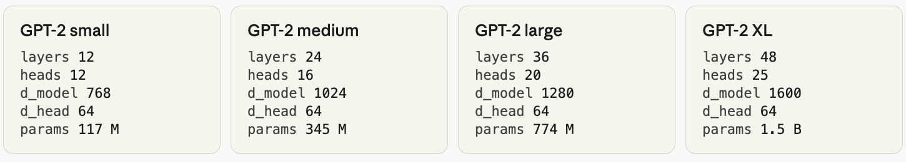

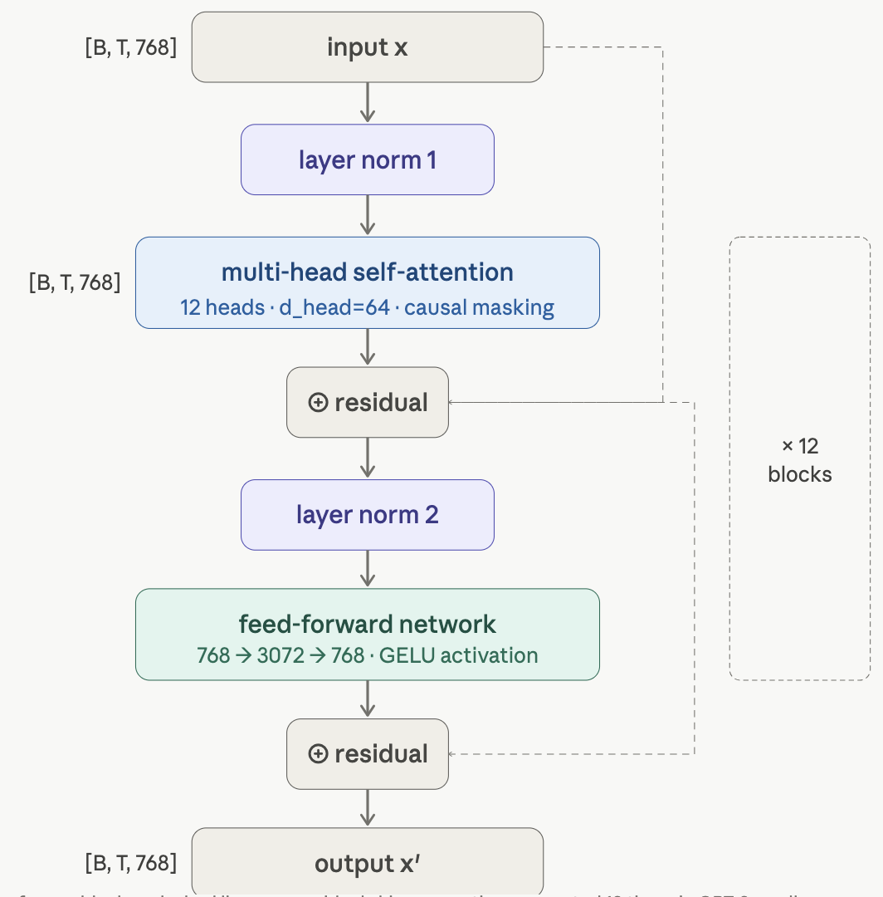

Figure 1: one transformer block – dashed lines are residual skip connections repeated 12 times in GPT-2 small

@dataclass
class GPT2Config:
block_size: int = 1024 # max context (sequence) length
vocab_size: int = 50257 # BPE token vocabulary
n_layer: int = 12 # number of transformer blocks
n_head: int = 12 # attention heads per block
n_embd: int = 768 # embedding / residual stream dim
dropout: float = 0.1
bias: bool = True # c_attn and c_proj use bias

# d_head = n_embd // n_head = 768 // 12 = 64 (same across all model sizes)

Layer Normalization in DNNs

What is Layer Normalization and why GPT-2 needs it?
As a signal flows through many stacked transformer blocks, the scale and distribution of activations can drift – some dimensions explode to very large values, others collapse near zero. This internal covariate shift makes gradients unstable and training slow or impossible at depth. Layer normalization re-centers and re-scales every feature vector to have zero mean and unit variance before it enters a sub-layer. It is applied independently to each token at each layer.

Unlike Batch Normalization (which normalizes across the batch dimension), LayerNorm normalizes across feature dimension of a single token. This makes it independent of batch size and well-suited to variable-length sequences – both critical properties for a language model.
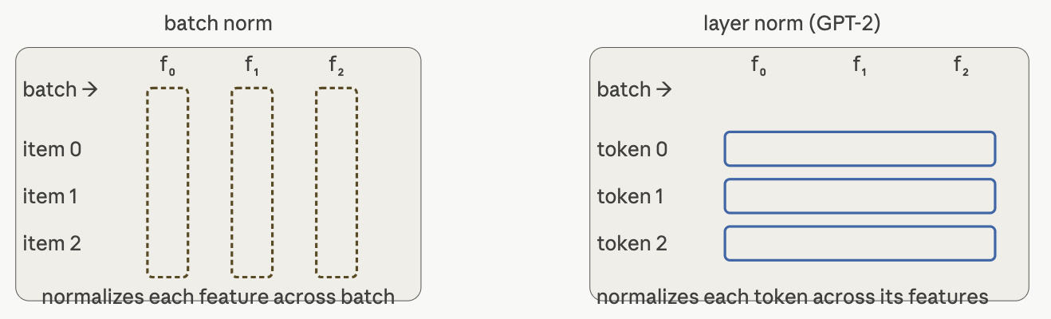

Figure 1: LayerNorm treats each token’s 768-dimensional embedding vector as the population to normalize – batch size is irrelevant.

Key property: for a given token position, LayerNorm pools statistics across all 768 feature dimensions. The result is that before entering the attention or FFN sub-layer, every tooken’s feature vector has mean = 0 and variance = 1, regardless of what came out of the previous layer.

The LayerNorm formula

Given a token’s feature vector $x∈R^{768}$, layer normalization proceeds in four sequential steps. Steps 1-2 are related to computing statistical indicators, Step 3 is the normalization, Step 4 restores expressive capacity through learned parameters.

$LN\left(x\right)=γ∙\left[\frac{\left(x-μ\right)}{\sqrt{σ^{2}+ε}}\right]+β$
$μ$ - mean over 768 features, $σ^{2}$ – variance, $γ,β∈R^{768}$ are learned , $ε={10}^{-5}$ (numerical stability)

1 ) Compute mean $μ$
Average of all 768 feature values for this single token: $μ=\frac{1}{768}∙\sum{x_{i}}$ ; $x=\left\{\begin{matrix}x_{1} \\ \begin{matrix}x_{2} \\ ⋮ \\ x_{d}\end{matrix}\end{matrix}\right\}$
2 ) Compute variance $σ^{2}$

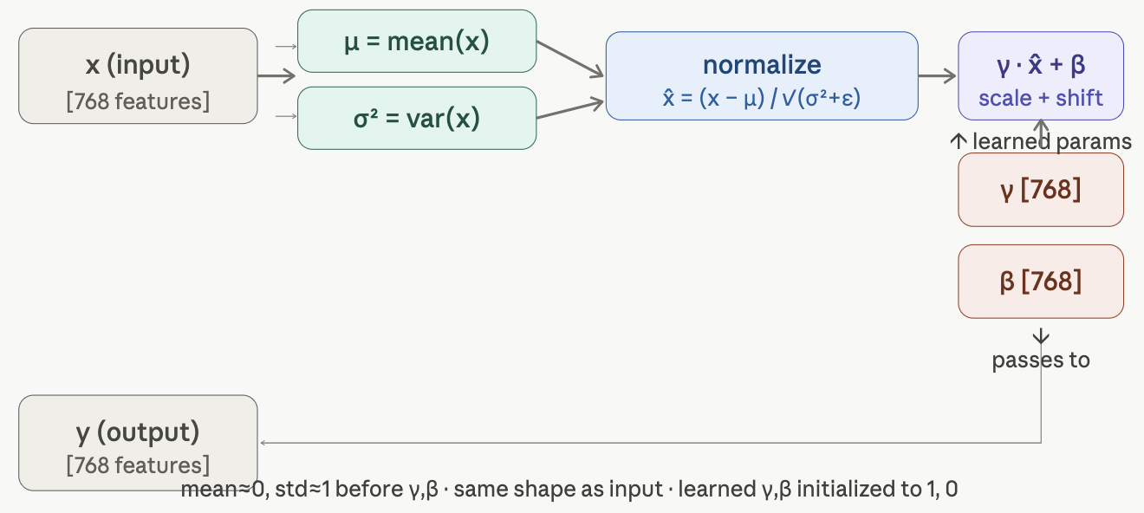
Figure 2: $μ$ and $σ^{2}$ are statistics computed on-the-fly – no running averages, no batch dependence

//TODO: finish the paragraph on the LayerNorm formula

//TODO: finish the subsection on Layer Normalization

Residual Connections in Transformer Architecture

A residual connection is a forward skip: the input tensor x that enters a sub-layer (attention or FFN) is added element-wise to that sub-layer’s output before passing to the next stage. The sub-layer only needs to learn the difference – the residual – between what came and what should come out.
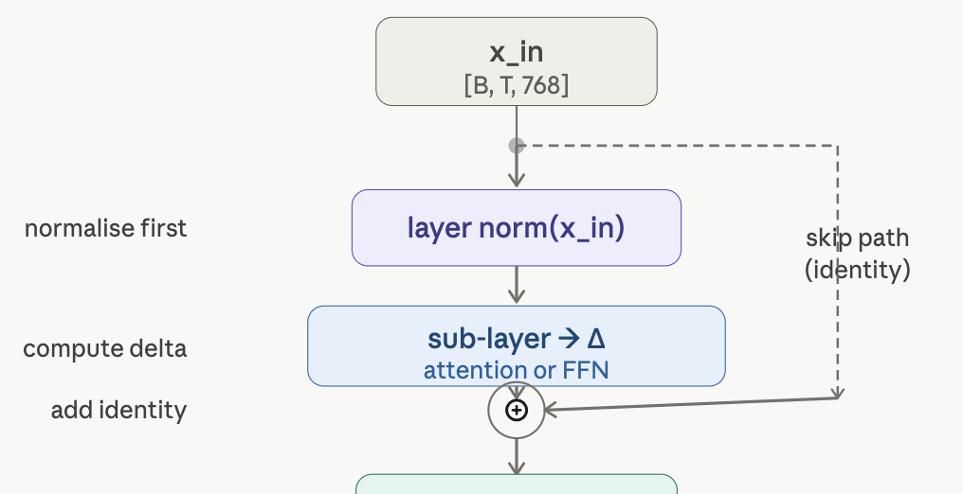

Figure 3: the skip path carries $x_{in}$ unmodified – no weights , no transformations, no parameters at all

Key insight:

//TODO: finish the subsection on residual connection

QKV Projection

Preliminary: Batched Tensor Notation

[B, T, 768] is PyTorch’s way of describing a 3-dimensional array, where each axis has a specific meaning:

B – batch size. A GPU is most efficient when it works on many independent examples at once rather than one at a time. Each sentence is completely independent - they do not interact at all – but they share the same weight matrices. During training B is typically 8-64; during inference (e.g. you are typing a prompt) $B$ is usually 1.

T – sequence length (the “time” dimension). This is the number of tokens in the input. “The cat sat on the mat” has 6 tokens, so $T=6$. GPT-2 supports up to $T=1024$. Every position $t_{0},t_{1},t_{2},…$ has its own $768$-dimensional vector in the tensor – that’s why we need axis. The word “time” comes from the historical use of transformers for time-series data; for text, it just means “left to right position in the sequence”.

$768$ – the feature dimension ($d_{model}$). Every one of the 768 numbers encodes something about that token’s meaning and context.

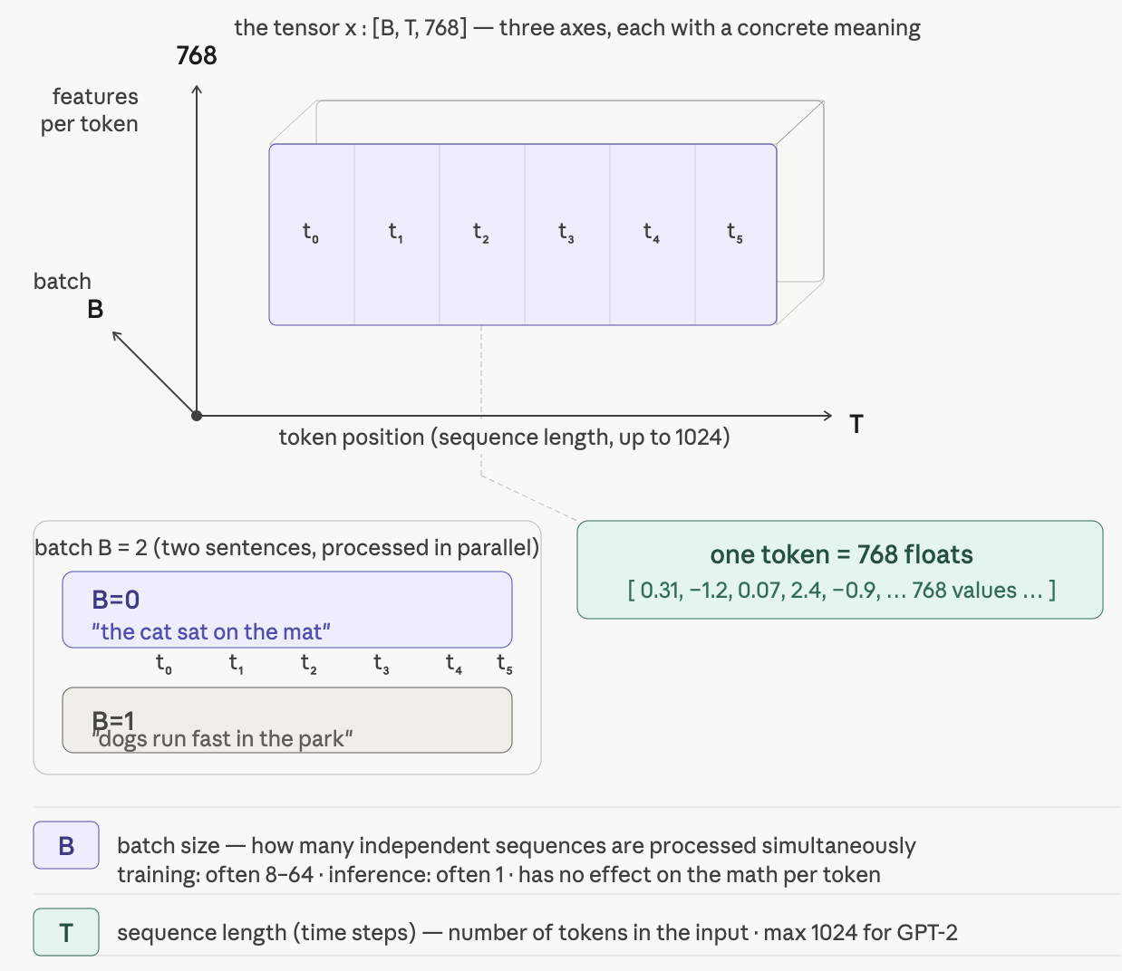

Figure : Batched Tensor notation

QKV Projection: Computing queries, keys, and values

The first operation inside every attention block is projecting the normalized residual stream $x$ into three separate matrices: $Q$ (queries), $K$ (keys), and $V$ (values). GPT-2 fuses all three projections into a single linear layer $c_{attn}$ with output dimension $3×d_{model}$ , then slices it – this is faster than three separate matmuls.

$Q = x ∙W_{Q}$ ; $K = x∙W_{K}$ ; $V = x∙W_{V}$

Implemented as $\left[Q|K|V\right]=x∙W_{QKV}$ where $W_{QKV}∈R^{768×2304}$
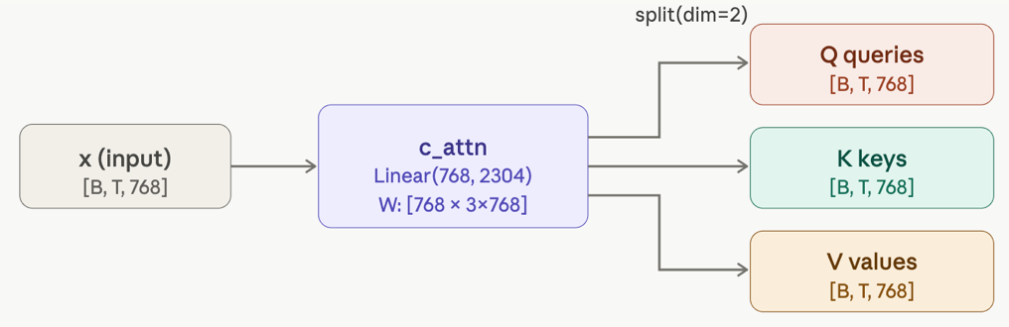

Figure : single matmul emits 2304 features which are sliced into three 768-dimensional tensors

class CausalSelfAttention(nn.Module):
def __init__(self, config):
super().__init__()
# One fused linear: x → [Q, K, V] in a single matmul
self.c_attn = nn.Linear(config.n_embd, 3 * config.n_embd, bias=config.bias)
self.c_proj = nn.Linear(config.n_embd, config.n_embd, bias=config.bias)
self.n_head = config.n_head # 12
self.n_embd = config.n_embd # 768

def forward(self, x):
B, T, C = x.size() # batch=B, seq_len=T, d_model=C=768

# Project and split: (B,T,768) → (B,T,2304) → three × (B,T,768)
q, k, v = self.c_attn(x).split(self.n_embd, dim=2)

Scaled Dot Product Attention: Computing Attention Weights

After $Q/K/V$ split, each tensor is reshaped from $[B, T, 768]$ into $[B, 12, T, 64]$ – one 64-dimensional slice per head. The attention score between position $i$ and $j$ is the dot product of the $i$-th query with the $j$-th key, divided by the $\sqrt{d_{head}}$ to keep the gradients well-scaled. The resulting $T×T$ score matrix is masked, normalized to a probability distribution via softmax, then used to compute a weighted average of the values.

$Attention\left(Q,K,V\right)=softmax\left(Q∙K^{T}/\sqrt{d_{k}}\right)∙V$

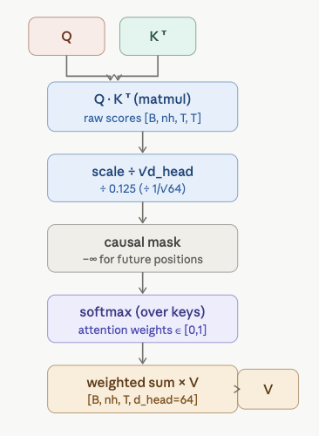

# Reshape [B,T,768] → [B,12,T,64]
hs = C // self.n_head # head size = 64
k = k.view(B, T, self.n_head, hs).transpose(1, 2)
q = q.view(B, T, self.n_head, hs).transpose(1, 2)
v = v.view(B, T, self.n_head, hs).transpose(1, 2)
# Each: [B, 12, T, 64]

# --- scaled dot-product ---
scale = 1.0 / math.sqrt(hs) # 0.125
att = (q @ k.transpose(-2, -1)) * scale
# att shape: [B, 12, T, T]
# q @ k.T: [B,12,T,64] × [B,12,64,T]
# = [B, 12, T, T]

The line computes the scaled dot-product attention from the query and key values and scale those:
att = (q @ k.transpose(-2, -1)) * scale
computes the attention $T×T$ matrix.

q (Query): Represents the token (word) that is currently "looking" for information.

k (Key): Represents all tokens in the sequence that could provide information.

@ (Matrix Multiplication): This performs a dot product between the query and every key. In geometric terms, this measures the similarity or "affinity" between tokens.

k.transpose(-2, -1): This flips the last two dimensions of the Key matrix. Transposing is necessary so that the dimensions of q and k align for matrix multiplication.

scale: This is typically $\sqrt{d_{k}}$ (where $d_{k}$ is the dimension of the keys). It prevents the dot product values from growing too large, which would cause the subsequent softmax layer to "saturate" and lead to vanishing gradients during training

The transpose shifts the head dimension before the sequence dimension, so each head independently computes a $T×T$ attention matrix. The division by $\sqrt{64}$ is crucial: without it, for large $d_{head}$ the dot products grow large in magnitude, pushing softmax into a region where gradients vanish.

# Why scale by 1/√dₖ?
# If q, k ~ N(0,1), then qᵢ·kⱼ ~ N(0, dₖ)
# Variance = dₖ → std = √dₖ → divide to restore unit variance
# Without this, softmax saturates: exp(large) / Σexp(large) → one-hot

Causal Masking: Enforcing Autoregressive Generation

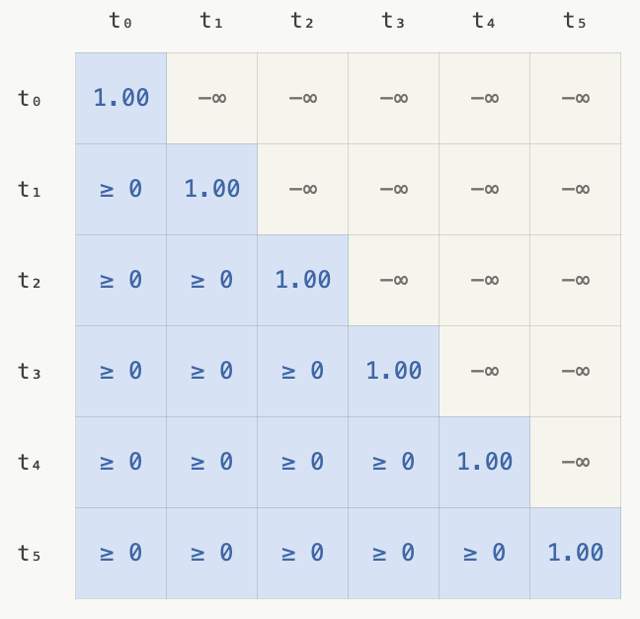
GPT-2 is a language model: at generation time, token $i$ must predict token $i+1$ using only positions $0…i$. This is enforced during training by zeroing out attention to future positions. The mechanism is elegant: before softmax, replace the upper-triangular entries of the $T×T$ score matrix with $-∞$. After softmax, $e^{-∞} = 0$, so future positions contribute nothing to the weighted sum.

Figure : $q_{0}$ can only attend to itself, $q_{5}$ can attend to all 6 positions

def __init__(self, config):
# ... (projection layers above) ...
# Causal mask: lower-triangular matrix of ones, stored as a buffer
# (not a parameter — not updated by optimizer)
self.register_buffer(
"bias",
torch.tril(torch.ones(config.block_size, config.block_size))
.view(1, 1, config.block_size, config.block_size)
)

def forward(self, x):
# att: [B, nh, T, T] — raw scaled scores
att = att.masked_fill(
self.bias[:, :, :T, :T] == 0, # True where mask is 0 (upper triangle)
float('-inf') # set those positions to −∞
)
att = F.softmax(att, dim=-1) # e^−∞ → 0; rows sum to 1.0
att = self.attn_dropout(att)

torch.tril is a PyTorch function that returns the lower triangular part of an input tensor.
The function sets all elements above a specified diagonal to zero while keeping the elements on and below that diagonal unchanged. It is widely used in deep learning for creating masks, particularly in Transformer architectures to prevent "looking ahead" at future tokens.

Note on Attention Dropout
Let us look closer at the line att = self.attn_dropout(att)
This line of code applies dropout to the attention weight matrix as a regularization technique to prevent the model from overfitting.
In a standard attention mechanism (like in Transformers), this typically occurs after the softmax operation has normalized the attention scores into probabilities.
Functional breakdown
- Random masking: the attn_dropout function (usually an instance of nn.Dropout) randomly selects a fraction of the attention weights to zero during each training step.
Preventing over-reliance: by dropping specific attention connections, the model is forced to find multiple redundant pathways for information rather than relying on a single specific token-to-token relationship.

