Execution of Semantic Structures
D. Gueorguiev 5/6/2022

Execution Space
Execution Space is a metric space which in general has different number of dimensions than that of Semantic Space. All execution structures reside in Execution Space. Each executable semantic structure is mapped to a target point in execution space which is adorned with a semantic signature and mass. Each target point in execution space serves as a point of attraction to the relevant Execution Particles which will form a final Execution Structure converging around the target point.

Definition: Target point: a point in Execution Space which is mapped to a centroid of a Semantic Structure in Semantic Space. It will be denoted to with the Greek letter $τ$ with appropriate subscript (from Greek στόχος). Each target point has a mass in execution space $m_{τ}$ and semantic signature represented by its semantic signature matrix $ssig\left(τ\right)$.

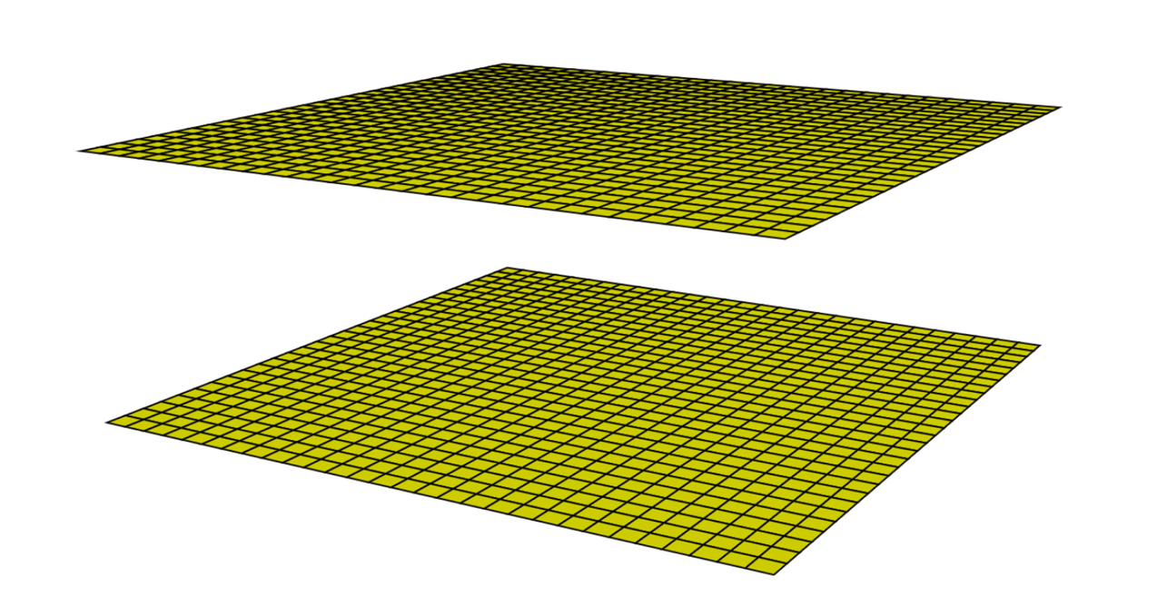
Semantic Space $Σ$
Execution Space $Ε$
$$τ$$
$$S$$

Executive Particles and Executive Structures
Execution of semantic structure is achieved through aggregation of Executive Particles around a target point. Every structure in execution space can be represented as an $n$-arry tree rooted in a target point.
Executive particles can be primitive or compound ones. Every compound executive particle is an executive structure, and it can be expressed as a tree of primitive executive particles.
Every primitive executive particle can be represented as a tree of primitive executive atoms as shown on the figure below. The structures in Execution Space will be denoted with small cap Greek letters. The primitive executive particles will be denoted with the letter $ε$ with appropriate subscript (from Greek εκτελώ execute). The executive atoms (or $e$-atoms) will be denoted with the letter $α$ with an appropriate subscript (from Greek άτομο).

$ε_{1}$

$τ_{0}$
$α_{1}$--- o --- $α_{2}$
/ | \
$α_{3}$ $α_{4}$ $α_{5}$_
/ \ | \
$α_{6}$ $α_{7}$ $α_{8}$ $α_{9}$
|
$α_{10}$

Each arc connecting two executive atoms is assigned executive significance vector $\vec{σ}$ (Greek σημασία)
with appropriate subscript.

${\vec{σ}}_{1,2}$
$α_{1}$------ $α_{2}$

//TODO

Executive Atoms

Each Executive Atom $α$ is represented by the tuple $\left(μ,I,S,E,δ\right)$ where:
$μ$ is the semantic latch (Greek for μάνταλο for latch) of the atom (also atom key),
$I$ is the inference template of the atom – hence the fraktur $I$ symbol.
$S$ is the template transferring the result to semantic space a.k.a. semantic transfer template – hence the fraktur $S$ symbol
$E$ is the template transferring the result to executive space feeding it to associated action $δ$; a.k.a. executive transfer template – hence the fraktur $E$ symbol.
$δ$ (Greek δράση for Action) is an Action associated with the result of the application of $E$. The Action $δ: E→N$ is integer valued semantic function.

Let us have two atoms $α_{1}$ and $α_{2}$ such that the former is a parent of the latter. Let the pair $\left(μ_{1},I_{1},S_{1},E_{1},δ_{1}\right)$ is associated with the parent and $\left(μ_{2},I_{2},S_{2},E_{2},δ_{2}\right)$ is associated with the child atom. Let us denote the semantic input for $α_{1}$ with $I_{1}$. Note that $I_{1}$ is either the result of the application of the semantic template of a parent of $α_{1}$ or it is the semantic structure of the root $τ$ of the executive particle to which the atoms $α_{1}$ and $α_{2}$ belong.

TODO: connection between Action Code and Action. Therefore, each atom can be thought of as a sequence of executive actions performed atomically. Recall in the discussion on the concept of Semantic Aspect we mentioned that the semantic aspect is mapped to a (length, direction) pair in Semantic Space. We denoted the length as Aspect type and the $K-1$ coordinates which are encoding its direction as Aspect value. We allowed the semantic Aspect Types and Values to be continuous and we introduced Aspect Type and Value Matching functions $Φ$ and $Θ$ which allow us to establish closeness between semantic aspects. Through the concept of Semantic Aspect we have defined a continuum of semantic meanings and can establish closeness which is necessary for inferring new semantic structures and performing semantic parsing. The problem is that we cannot afford the convenience of continuum when dealing with executive structures. Every executive structure will be shown to be equivalent to a non-deterministic Turing machine.

Mapping of the output of Executive Transfer Template to Executive Action

S
Execution Space $E$
$δ_{1}$, $E_{1}\left(I_{1}\right)$
$δ_{0}$, $E_{0}\left(I_{0}\right)$

//TODO

Creation of Execution Structures

Creation of Primitive Execution Particle
Let us consider a target point $τ_{0}$ in Execution Space represented by its mass $m_{τ_{0}}$ and semantic signature matrix $ssig\left(τ_{0}\right)$. From all already constructed atoms we select the one with the largest attraction force toward $τ_{0}$.

$ε_{1}$

$τ_{0}$
$α_{1}$--- o --- $α_{2}$ <----------- $α_{11}$
/ | \
$α_{3}$ $α_{4}$ $α_{5}$_
/ \ | \
$α_{6}$ $α_{7}$ $α_{8}$ $α_{9}$
|
$α_{10}$

//TODO

Inference in Execution Space

//TODO

