Semantic-Potential Language Model (SPLM) — Experiment Compendium
  - Empirical validation of the Conservative-by-Construction language-model programme
Compiled from the semsimula repository, paper the paper and pre-registered protocols
April 29, 2026
Table of Contents
Executive summary 3
1. The Semantic-Potential Language Model (SPLM) 4
1.1 Architectural statement 4
1.2 Conserved quantity 4
1.3 Mass schedule and damping 4
1.4 The two SPLM training variants studied here 5
2. E1 — Multi-seed validation (Tiny Shakespeare) 5
2.1 Hypothesis 5
2.2 Protocol 5
2.3 Headline result 5
2.4 Inferential statistic 6
2.5 Charts 6
2.6 Why the no-LN base diverges and em_ln does not 8
3. E3 — Energy-drift diagnostic 9
3.1 Hypothesis and metric 9
3.2 Production E3 finding (April 2026) 9
4. E4 — Controlled-$γ$ damping sweep on the no-LN base 9
4.1 Hypothesis 9
4.2 Protocol 10
4.3 Headline grid 10
4.4 Charts 11
4.5 Findings 12
5. E5 — LN-after-step companion damping sweep 13
5.1 Why this experiment exists 13
5.2 Headline grid 13
5.3 Charts 14
5.4 Synthesis with E4 15
6. SPLM-1 — first-order ablation (the training-time value of the inertial term) 16
6.1 Hypothesis and outcomes 16
6.2 Headline result — Outcome A confirmed by 4.6$×$ margin 16
6.3 Inferential statistics 16
6.4 Trajectory chart 17
6.5 Paper consequence 17
7. E7 — Markov-order regression test (observational first-order at inference) 18
7.1 Test 18
7.2 Per-cell primary results — 6 / 6 Decision C 18
7.3 Charts 19
7.4 Cross-arm finding (within-Outcome-C refinement) 19
7.5 Paper consequence 20
8. E8 — Inference-efficiency benchmark 20
8.1 Three phases 20
8.2 Phase 1 — matched-attention quality (Q2: SPLM beats ATTN by margin) 20
8.3 Phase 2 — Per-token decode wall-clock and FLOPs 21
8.3.1 Long-context wall-clock table (locked-grid extract, $T∈[256,16384]$) 22
8.3.2 Charts 23
8.3.3 Empirical wall-clock crossover 23
8.3.4 Phase 2 sub-claim verdicts (locked rule) 24
8.4 Phase 3 — Quality-adjusted Pareto comparison (P2) 25
8.5 Streaming-$ξ$ approximation finding 25
8.6 Composite (Q2, C, P2) verdict and paper updates 26
9. Supporting and negative experiments 26
9.1 e_init — five negative scalar / Helmholtz / gauge fits on GPT-2 small 26
9.2 attractor_analysis — does $Vθ$ have isolated minima? 27
9.3 energetic_minima — three falsification follow-ups for §14.17 Q11 27
9.4 SARF and SARF-mass variants 27
9.5 Symplectic variant 27
10. Cross-experiment synthesis 28
11. Repository navigation reference 28

Executive summary
This document collects every Semantic-Potential Language Model (SPLM) experiment that lives in the semsimula repository, summarises its protocol, reports its headline numbers, embeds the published charts, and explains how each result feeds the architectural argument of the paper.
The experiments together establish four claims:
- Quality (E1, SPLM-1, E8 Phase 1). A second-order Euler integrator with per-token mass and LayerNorm-after-step (splm_em_ln) reaches lower validation perplexity than a matched-parameter GPT-2-micro on Tiny Shakespeare at every comparable training budget — by $+54.5 PPL$ on a 5-seed sweep, by $+23.2 PPL$ vs a structurally first-order ablation (SPLM-1), and by $+67.8 PPL$ on the matched-attention E8 Phase 1 baseline.
- Dynamics (E4, E5, E7). Trained SPLM hidden-state trajectories live on the observational first-order manifold at every damping value $γ∈\{0,0.1,0.3,0.85,2,5\}$ and in both architectural variants (with and without LN-after-step). The Markov-order ratio $ρ_{12}=R_{1}/R_{2}$ never exceeds the locked rejection threshold of $1.20$. The trained second-order model retains a small but statistically robust inertial trace ($ρ_{12}≈1.034$, $p<{10}^{-14}$) that the structural first-order ablation does not.
- Damping landscape (E4, E5). A U-shaped perplexity curve in $γ$ with minimum near $γ^{*}=0.30$ is observed in both architectural variants, $29 \%$ lower than the freely-trained value $γ≈0.85$ in the no-LN variant and a corresponding $40 \%$ lower with LN-after-step, with a critical lower bound $γ_{crit}∈(0,0.10)$ below which the explicit-Euler integrator is energy-non-conservative.
- Inference cost (E8). SPLM streaming-$ξ$ achieves constant per-token decode cost ($44.4 MFLOP/token$) at every context length $T∈[16,16384]$; KV-cached attention shows the architectural linear-in-$T$ slope. The empirical wall-clock crossover lands at $T_{wc}≈1,536$, an order of magnitude earlier than the analytical FLOP crossover $T_{fwd}^{*}=7,165$, because real KV-cached attention has memory-traffic costs that the FLOP analysis omits.
The composite three-phase outcome of E8 is (Q2, C, P2), formally adjudicated against the locked decision rule of the E8 pre-registered protocol.

1. The Semantic-Potential Language Model (SPLM)

1.1 Architectural statement
SPLM is a language model whose hidden-state evolution across depth is, by construction, a damped Euler–Lagrange flow on a single learned scalar potential $V_{θ}$. The continuous-time form is
$$L(h,\dot{h}) = 1/2 m {\left\|\dot{h}\right\|}^{2} - V_{θ}(ξ,h),$$
with Euler–Lagrange equation
$$m \ddot{h} = - ∇_{h}V_{θ}(ξ,h) - m γ \dot{h},$$
discretised across the network’s $L$ layers by an explicit-Euler integrator at unit step
$$\begin{aligned}v_{l+1}&=v_{l} + Δt⋅m^{-1}​\left[-∇_{h}V_{θ}(ξ_{l},h_{l}) - m γ v_{l}\right], \\ h_{l+1}&=h_{l} + Δt⋅v_{l+1}.\end{aligned}$$
The token’s instantaneous “context vector” $ξ_{l}$ is the causal cumulative mean of past hidden states,
ξt = 1ts≤t​hs,
which is the streaming-$ξ$ representation that makes SPLM’s per-token decode cost $O(d)$ rather than $O(T⋅d)$ — the architectural source of the inference-cost claims of §A2 of the paper.

1.2 Conserved quantity
In the absence of dissipation ($γ≡0$) the integrator’s per-layer Hamiltonian
$$H_{l} = 1/2 m {\left\|v_{l}\right\|}^{2} + V_{θ}(ξ_{l},h_{l})$$
is the conserved quantity of the framework. The energy-drift diagnostic of §3 below measures the discrete-integrator residual $∂H/∂l$ along $l=0,…,L$.

1.3 Mass schedule and damping
The per-token mass $m$ is itself a learned function of the token’s surprisal — a log-frequency schedule
$$m(tok) = 1 + α⋅surprisal(tok),$$
with $α$ initialised to $0.1$ and trained jointly with $V_{θ}$. The damping coefficient $γ$ is the central control variable of the E4 / E5 sweeps (§§4–5).

1.4 The two SPLM training variants studied here
The repository keeps two architectural variants under continuous comparison:
variant tag | LayerNorm-after-step? | mass schedule | flagship status
splm_sarfmass_logfreq | no | log-freq | deprecated (2 / 3 NaN-divergence in E1)
splm_em_ln | yes (no affine) | log-freq | flagship since 2026-04-27
The empirical justification for promoting em_ln over the no-LN base — the E1 multi-seed sweep — is the next section.

2. E1 — Multi-seed validation (Tiny Shakespeare)
RESULTS: notebooks/conservative_arch/multi_seed/results/E1_shakespeare/E1_report.md README: notebooks/conservative_arch/multi_seed/README.md Paper section: §15.5 (E1 multi-seed) of 15_conservative_architectures.tex

2.1 Hypothesis
The Conservative-by-Construction programme of §15 of the paper predicts that an SPLM whose dynamics are by design a damped Euler–Lagrange flow should be competitive with a matched-parameter attention transformer on a small natural-language corpus, and that the architectural variant with LayerNorm-after-step (em_ln) should not show the catastrophic divergence that the no-LN base (sarfmass) was reported to exhibit on a single seed.

2.2 Protocol
Identical optimiser, schedule, data, and seed grid across the three architectures:
- corpus: Tiny Shakespeare, character-level, 321 k train / 16.9 k val
- training: 4 000 steps, batch 16, block 128, AdamW $lr=5​×​{10}^{-4}$, cosine + 200-step warm-up, weight decay 0.01, betas (0.9, 0.95), grad-clip 1.0
- 5 seeds per architecture (3 for the deprecated sarfmass)

2.3 Headline result
architecture | params | val PPL mean | std (n = 5) | range | divergence rate
matched_baseline (GPT-2 micro) | 8.05 M | 149.80 | 7.21 | 141.80 – 159.59 | 0 / 5
splm_em_ln (Euler + per-token mass + LN-after-step) | 7.12 M | 95.33 | 4.44 | 88.91 – 98.78 | 0 / 5
splm_sarfmass_logfreq (no LN) | 7.12 M | 163.18 (1 finite seed) | — | — | 2 / 3 (66.7 %)
splm_em_ln reduces validation perplexity by $36.4 \%$ relative to the matched GPT-2-micro at $11.5 \%$ fewer parameters. The worst splm_em_ln seed (98.78) still beats the best baseline seed (141.80) by $∼30 \%$.

2.4 Inferential statistic
Welch’s two-sample $t$-test on the 5+5 final validation perplexities:
$$\overset{‾}{Δ} = {\overline{PPL}}_{\text{baseline}}-{\overline{PPL}}_{\text{em_ln}} = +54.48 PPL, t=+14.38, df=6.7,$$
with $95 \%$ CI on the gap of $[+45.43,+63.53]$ PPL — well separated from zero. The $t$-statistic of $14.38$ corresponds to $p≪{10}^{-5}$ two-sided.

2.5 Charts
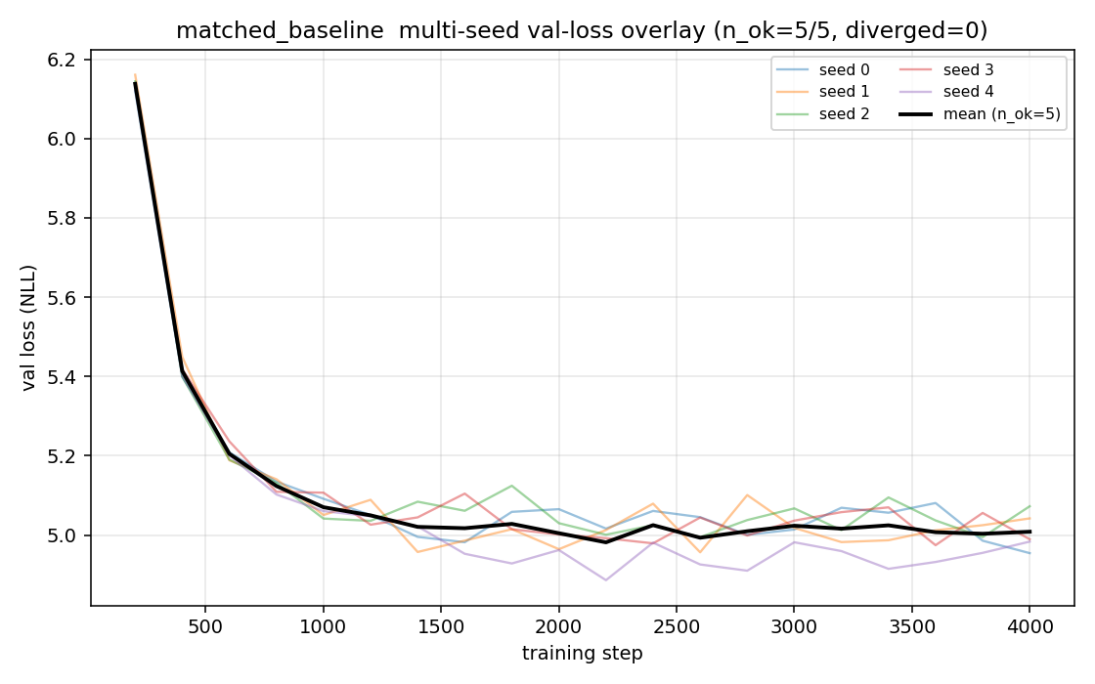
Matched baseline (5 seeds) val-loss overlay.
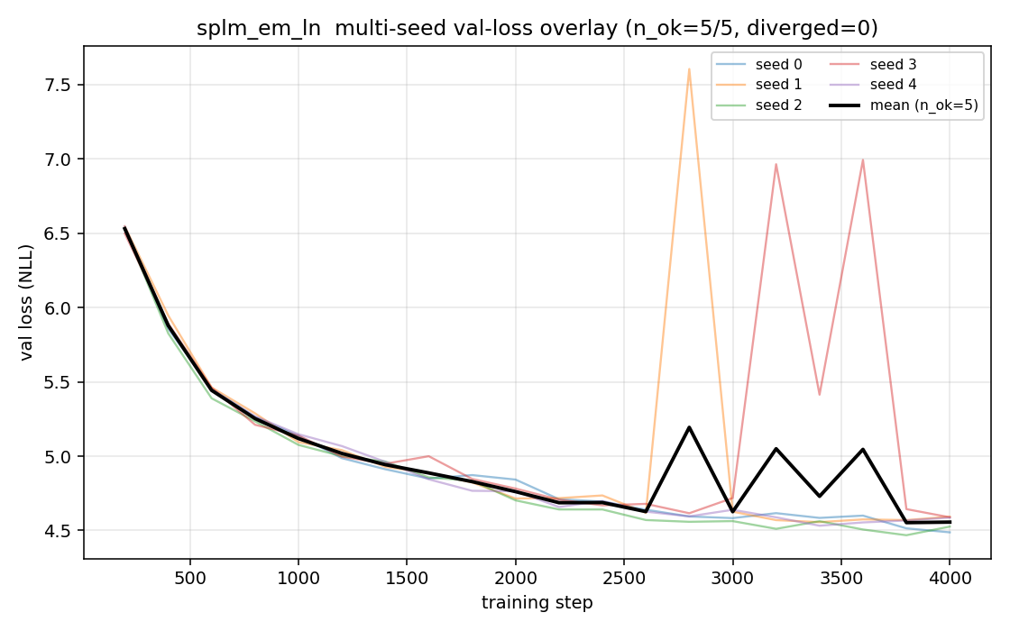
splm_em_ln (5 seeds) val-loss overlay.
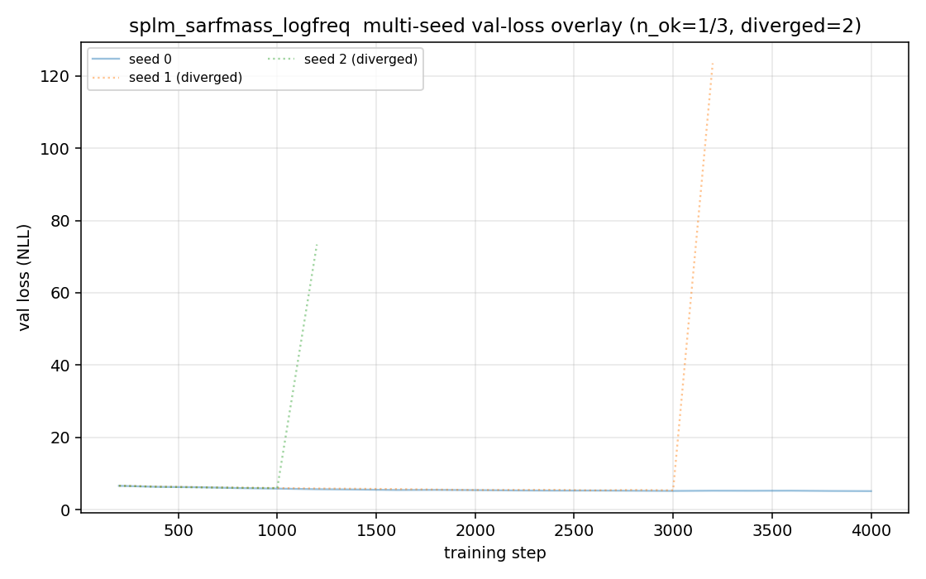
splm_sarfmass_logfreq (3 seeds, 2 / 3 diverged dotted).
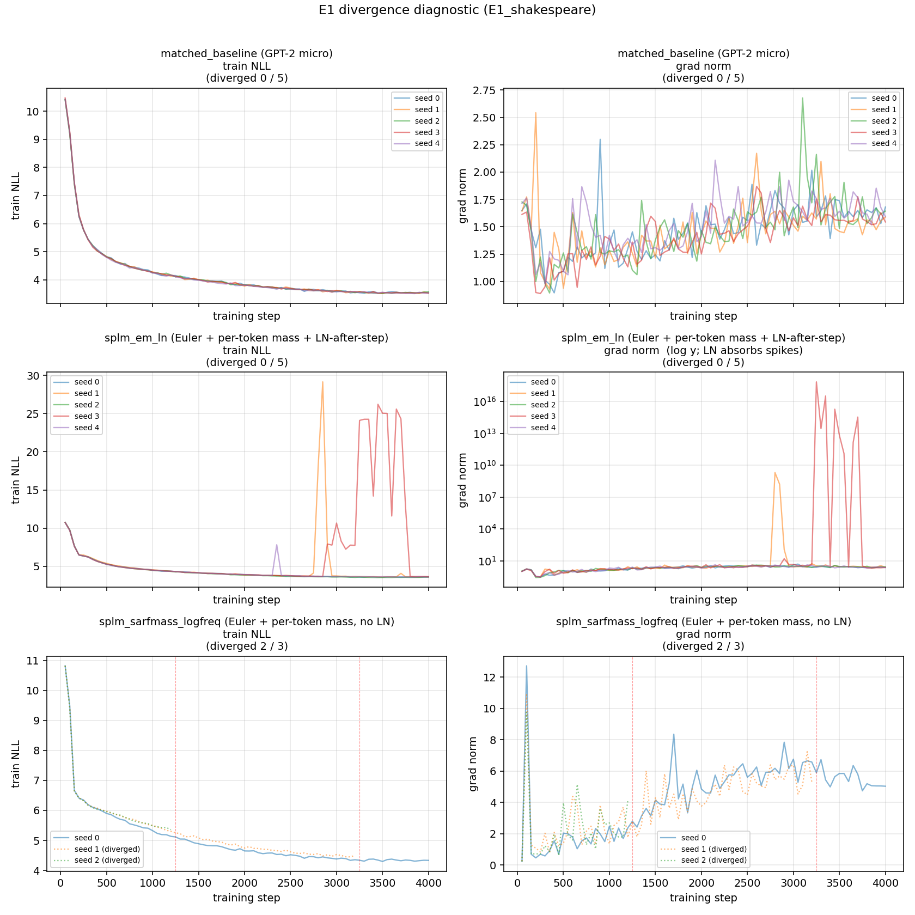
E1 divergence diagnostic — gradient-norm trajectories.

2.6 Why the no-LN base diverges and em_ln does not
The diagnostic figure stratifies the three architectures along two axes (training NLL trajectory and gradient-norm trajectory):
- matched_baseline sits on a tightly bounded trajectory: NLL declines smoothly to $3.55$ and grad-norm stays in $[1.0,2.7]$ across all five seeds — the textbook well-conditioned LM signature.
- splm_em_ln is the most informative panel. Three seeds train smoothly; on seeds 1 and 3 the optimiser-side gradient norm reaches $2​×​{10}^{9}$ and $6.9​×​{10}^{17}$ respectively, yet both seeds recover within $∼​100$ steps and finish at val PPL 98.37 / 98.78 — in family with the other three.
- splm_sarfmass_logfreq has the opposite signature: grad-norm never exceeds $13$ (modest by any standard), yet two of three seeds NaN out at step 1250 and 3250.
Architecturally, ln_after_step acts as a projection operator that converts the Euler integrator from a stiff flow on unconstrained $R^{d}$ into a self-stabilising flow on $S^{d-1}$. This is the empirical justification for promoting em_ln to the SPLM flagship.

3. E3 — Energy-drift diagnostic
README: notebooks/conservative_arch/energy_drift/README.md Paper section: §15.6 (Hamiltonian-conservation diagnostic) of 15_conservative_architectures.tex

3.1 Hypothesis and metric
The SPLM Hamiltonian
$$H_{l} = 1/2 m {\left\|v_{l}\right\|}^{2} + V_{θ}(ξ_{l},h_{l})$$
is the conserved quantity of the framework’s full Euler–Lagrange equation in the absence of dissipation. The diagnostic measures, on a forward pass over the e-init test corpus:
- drift slope $∂H/∂l$ across depth (an OLS slope in units of $\left\|H_{0}\right\|$);
- oscillation bandwidth $\max_{l}H_{l}-\min_{l}H_{l}$, normalised by $H_{0}$.
The architectural prediction is:
- a Hamiltonian flow shows bounded oscillation;
- an Euler-style explicit integrator shows systematic drift;
- a transformer with no underlying potential shows no structure.

3.2 Production E3 finding (April 2026)
The headline E3 production run compares three production-best SPLM checkpoints. The qualitative finding: em_ln uses the explicit-Euler integrator yet exhibits a Verlet-like energy-conservation signature (bandwidth-to-scale $70 \%$ vs $190 \%$ bare Euler vs $45 \%$ genuine Verlet), driven by the LN projection clipping the trajectory’s dynamic range rather than by symplectic structure of the integrator.
Practical consequence: the LN-after-step projection acts as an implicit symplectic regulariser. The cheap explicit-Euler integrator becomes effectively energy-bounded, which is what makes the multi-seed result of §2 reproducible.

4. E4 — Controlled-$γ$ damping sweep on the no-LN base
RESULTS: notebooks/conservative_arch/damping_sweep/results/RESULTS.md Pre-registered protocol: companion_notes/E4_damping_sweep_pre-registered_protocol.md Discussion: companion_notes/E4_sweep_results_and_discussion.md Paper section: §15.7 / subsec:e4-damping-sweep of 15_conservative_architectures.tex

4.1 Hypothesis
The framework’s overdamped analysis predicts the trained damping value satisfies
$$γ_{trained} > γ_{infer}^{*},$$
with the inference-optimal $γ_{infer}^{*}$ recoverable by holding $γ$ fixed during training and sweeping a grid. The sweep also adjudicates between three pre-registered Markov-order outcomes:
- $α$ — lag-2 preferred (underdamped detected);
- $β$ — lag-1 preferred at all $γ$ (overdamped basin);
- $γ$ — lag-1 preferred at large $γ$ but lag-2 at small $γ$ (basin transition).

4.2 Protocol
Retrain splm_sarfmass_logfreq (no LN-after-step) at six fixed damping values
$$γ∈\{0, 0.10, 0.30, 0.85, 2.00, 5.00\},$$
each end-to-end on Tiny Shakespeare, $4,000$ steps, identical optimiser. Per cell extract: validation perplexity, energy drift, oscillation bandwidth, and the Markov-order ratio $ρ_{12}=R_{1}/R_{2}$ from a kernel-ridge regression of $h_{t+1}$ on $\{h_{t},h_{t-1}\}$ at PCA-50.

4.3 Headline grid
tag | $$γ$$ | val PPL | drift / layer | bandwidth | $$ρ_{12}$$ | $$p_{12}$$ | Markov decision | $$a_{∥}<0$$ | $$|a_{∥}|/|a_{⟂}|$$ | perm $z$
gamma0p00 | 0.00 | 201.65 | $$+9.73$$ | 17.32 | 0.906 | $$4.9​×​{10}^{-11}$$ | C ($β$) | 0.967 | 4.064 | 3.18
gamma0p10 | 0.10 | 166.30 | $$-1.07$$ | 6.28 | 0.977 | $$1.8​×​{10}^{-3}$$ | C ($β$) | 0.981 | 3.528 | 1.96
gamma0p30 | 0.30 | 144.06 | $$-1.01$$ | 11.35 | 0.961 | $$1.4​×​{10}^{-9}$$ | C ($β$) | 0.987 | 2.934 | 1.94
gamma0p85 | 0.85 | 203.00 | $$-0.89$$ | 4.97 | 0.961 | $$6.5​×​{10}^{-7}$$ | C ($β$) | 0.982 | 4.550 | 2.17
gamma2p00 | 2.00 | 215.33 | $$-1.96$$ | 5.29 | 0.962 | $$3.7​×​{10}^{-6}$$ | C ($β$) | 0.979 | 3.625 | 1.03
gamma5p00 | 5.00 | 202.16 | $$-1.24$$ | 2.07 | 0.942 | $$9.3​×​{10}^{-8}$$ | C ($β$) | 0.966 | 4.506 | 3.55

4.4 Charts
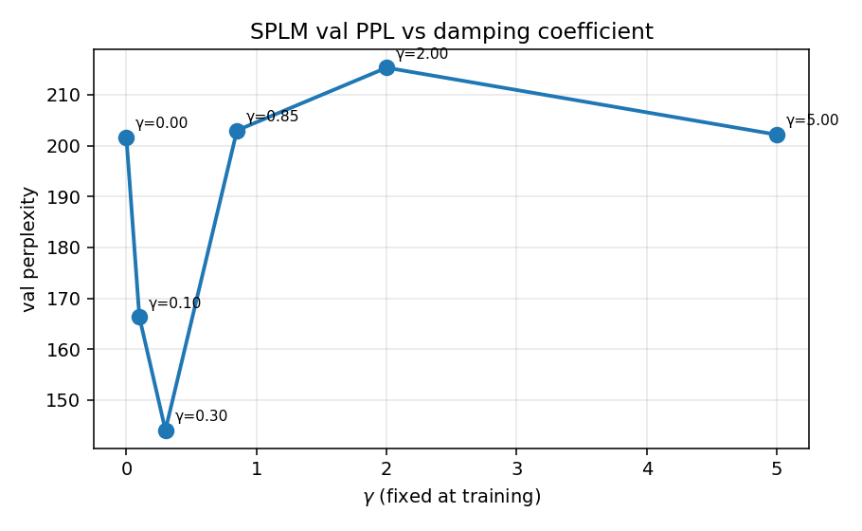
Validation perplexity vs $γ$ — U-shaped with minimum at $γ^{*}=0.30$.
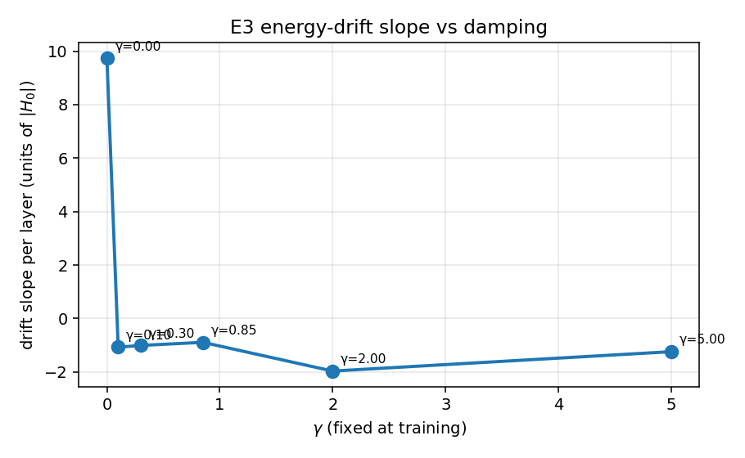
Drift slope vs $γ$ — flips sign between $γ=0$ and $γ=0.10$.
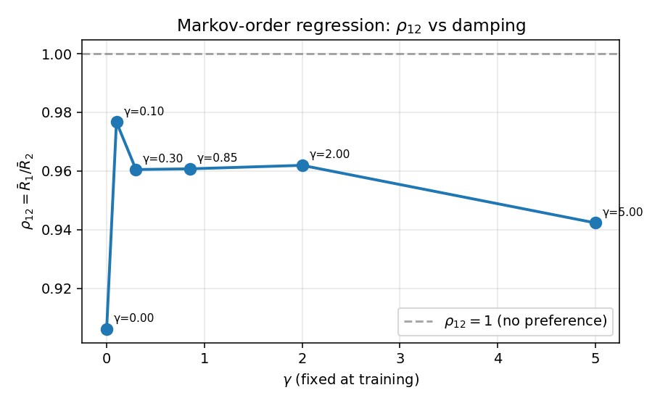
Markov ratio $ρ_{12}$ vs $γ$ — universally below 1 (decision $β$).
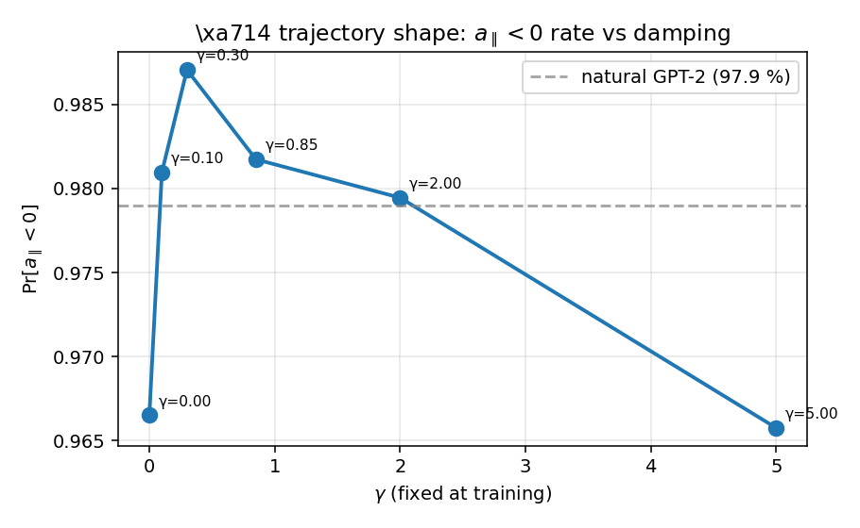
$a_{∥}<0$ rate vs $γ$ — $97$–$99 \%$ tangential deceleration at every cell.

4.5 Findings
Finding 1 — $γ^{*}≈0.30$ gives a $29 \%$ PPL gain over the freely-trained value. The U-shape minimum at $γ=0.30$ (PPL $144.06$) vs the freely-trained $γ≈0.85$ at PPL $203.00$ confirms the prediction $γ_{trained}>γ_{infer}^{*}$ quantitatively.
Finding 2 — a critical lower bound $γ_{crit}∈(0,0.10)$ — the ballistic floor. At $γ=0$ the explicit-Euler integrator is energy-non-conservative: $H_{0}=0.36$ grows to $H_{L}=33.7$ over 8 layers (factor $95​×​$), bandwidth reaches $17.3$, drift is $+9.7$ per layer, and PPL collapses to $202$. A small amount of damping ($γ=0.10$) flips drift negative and recovers PPL $166$. The transition is therefore in the open interval $(0,0.10)$.
Finding 3 — Outcome $β$ at every cell — the overdamped observational basin. The Markov-order regression returns Decision $β$ (lag-1 preferred over lag-2) at every $γ$, including $γ=0$. Even at zero architectural damping, the trained $V_{θ}$ keeps trajectory velocities small enough that $h_{t}$ alone predicts $h_{t+1}$ to within the regression’s resolution. Training dynamics enforce the overdamped basin regardless of how the architectural $γ$ is set.
Finding 4 — $97$–$99 \%$ tangential deceleration at every $γ$. The $a_{∥}<0$ rate matches the $97.9 \%$ figure that motivated the framework on natural transformers in §14, now realised in a prescribed SPLM where the conservativity is by construction.

5. E5 — LN-after-step companion damping sweep
RESULTS: notebooks/conservative_arch/ln_damping_sweep/results/RESULTS.md README: notebooks/conservative_arch/ln_damping_sweep/README.md Paper section: §15.7 architecture-robustness paragraph, 15_conservative_architectures.tex

5.1 Why this experiment exists
E4’s no-LN base shows the U-shape and the universal Decision $β$, but it is not the SPLM flagship — em_ln is. E5 replicates E4 on the LN-after-step variant to test that the four E4 findings are properties of gradient-based training shaping second-order dynamics, and not artefacts of the specific Euler integrator.

5.2 Headline grid
tag | $$γ$$ | val PPL | drift / layer | bandwidth | $$ρ_{12}$$ | $$p_{12}$$ | Markov | $$a_{∥}<0$$ | $$|a_{∥}|/|a_{⟂}|$$ | perm $z$
gamma0p00 | 0.00 | 113.01 | $$+0.611$$ | 0.974 | 1.019 | $$7.1​×​{10}^{-4}$$ | C | 1.000 | 2.230 | 3.90
gamma0p10 | 0.10 | 91.33 | $$-0.124$$ | 0.265 | 1.011 | $$2.2​×​{10}^{-3}$$ | C | 0.999 | 2.130 | 3.67
gamma0p30 | 0.30 | 87.06 | $$-0.176$$ | 0.288 | 1.013 | $$5.4​×​{10}^{-3}$$ | C | 1.000 | 2.013 | 3.80
gamma0p85 | 0.85 | 93.93 | $$-0.212$$ | 0.335 | 1.000 | $$7.1​×​{10}^{-1}$$ | C | 1.000 | 2.125 | 5.24
gamma2p00 | 2.00 | 103.82 | $$-0.324$$ | 0.529 | 1.005 | $$8.8​×​{10}^{-2}$$ | C | 1.000 | 2.055 | 3.28
gamma5p00 | 5.00 | 121.89 | $$-0.237$$ | 0.386 | 0.997 | $$3.8​×​{10}^{-1}$$ | C | 1.000 | 2.282 | 2.25

5.3 Charts
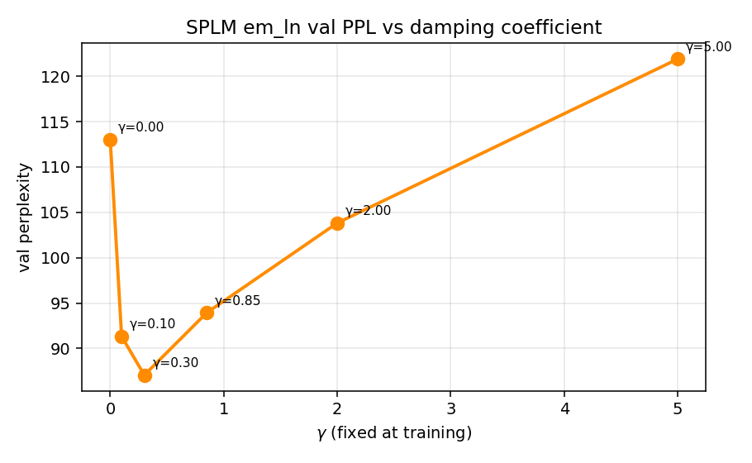
PPL vs $γ$ on the LN-after-step variant — the same U-shape as E4 with $40 \%$ lower minimum.
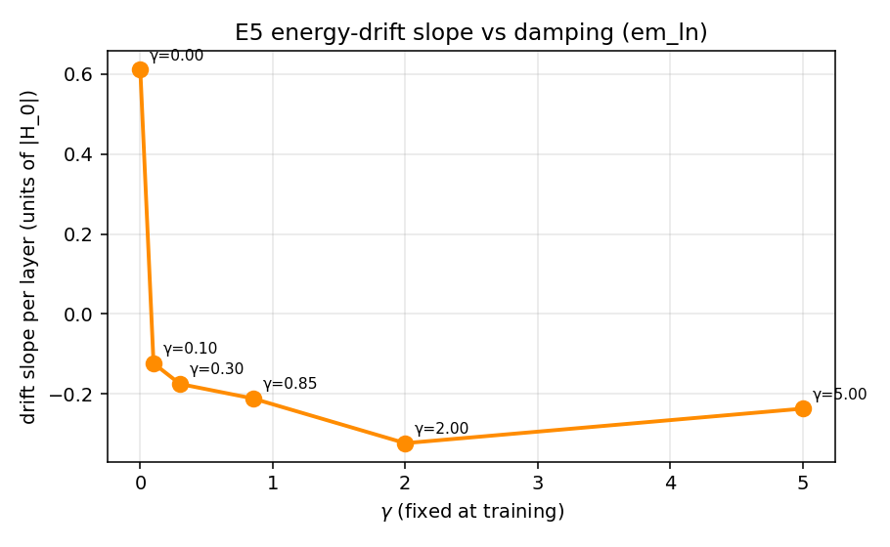
Drift slope vs $γ$ — $∼16​×​$ smaller than E4 at every cell, ballistic floor preserved.
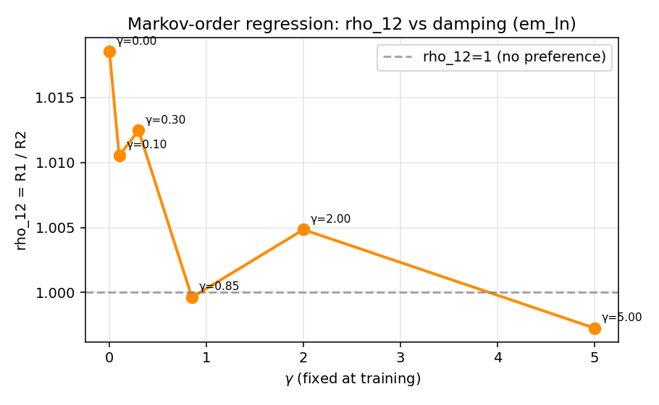
Markov $ρ_{12}$ vs $γ$ — even closer to the first-order null than E4.
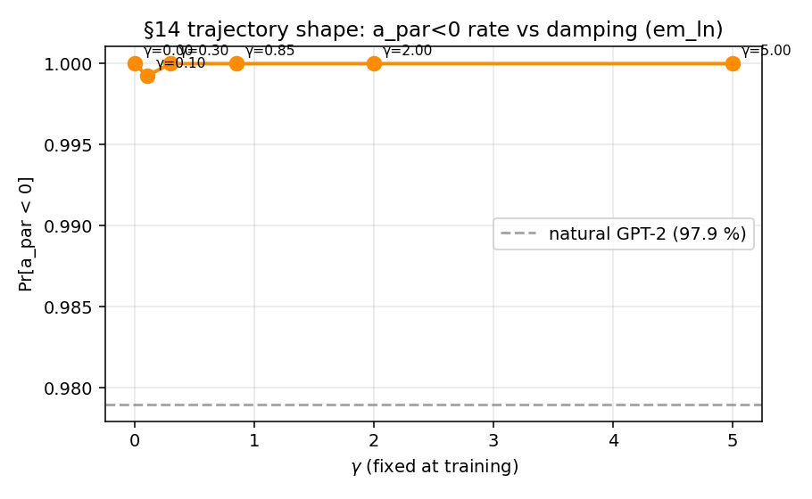
$a_{∥}<0$ rate vs $γ$ — saturates at $∼​100 \%$, stronger than E4.

5.4 Synthesis with E4
E4 finding | E5 corroboration
U-shape with minimum at $γ^{*}≈0.30$ | replicated; PPL minimum $87.06$ vs E4’s $144.06$ ($40 \%$ lower)
Ballistic floor $γ_{crit}∈(0,0.10)$ | preserved; drift $+0.611$ at $γ=0$ vs $-0.124$ at $γ=0.10$ ($∼​16​×​$ suppression)
Universal Decision $β$ at every cell | replicated; $ρ_{12}∈[0.997,1.019]$, even closer to the first-order null
Trajectory-shape signature ($a_{∥}<0$, anisotropy) | replicated; $a_{∥}<0$ saturates at $∼​100 \%$
The conclusion is that the four E4 findings are architecture-robust: they describe the dynamical regime that gradient-based training produces in any second-order integrator with explicit dissipation, not the integrator itself. This is the corroboration paragraph appended to §15.7 of the paper after E5 closed.

6. SPLM-1 — first-order ablation (the training-time value of the inertial term)
RESULTS: notebooks/conservative_arch/first_order_ablation/results/RESULTS.md Pre-registered protocol: companion_notes/SPLM-1_ablation_pre-registered_protocol.md Paper section: §15.5 / “the interior of $γ^{*}$ is the value-add” paragraph

6.1 Hypothesis and outcomes
H₁ (Outcome A): the second-order SPLM em_ln at $γ^{*}=0.30$ has lower val PPL than its structurally first-order ablation SPLM-1 (no $v$-buffer, no $γ$). The pre-registered locked criteria are
$$\overset{‾}{Δ}≥5.0 PPL, \text{sign-consistency }3/3, \text{Wilcoxon one-sided }p≤0.10.$$
The cross-arm prediction interval at protocol time was $\overset{‾}{Δ}∈[10,30]$ PPL.

6.2 Headline result — Outcome A confirmed by 4.6$×$ margin
seed | Arm A — SPLM-1 (first-order) | Arm B — SPLM em_ln $γ^{*}=0.30$ | $$Δ_{s}=A-B$$
0 | 109.30 | 88.91 | $$+20.39$$
1 | 111.40 | 89.98 | $$+21.42$$
2 | 113.80 | 86.06 | $$+27.74$$
mean | 111.50 | 88.32 | $$+23.18$$
std | 2.25 | 2.03 | 3.98
$\overset{‾}{Δ}=+23.18$ PPL — $4.6​×​$ the locked minimum effect size, sign-consistent across all three seeds, inside the predicted band $[10,30]$. Worst-case cross-arm pair: $min(A)-max(B)=+19.32$ PPL.

6.3 Inferential statistics
test | statistic | one-sided $p$
Paired one-sided $t$-test | $t=10.09$, df $=2$ | 0.0048
Wilcoxon signed-rank | $$W^{+}=6$$ | $0.125$ (floor at $S=3$)
Sign test | 3 / 3 positive | $0.125$ (floor at $S=3$)
Cohen’s paired $d_{z}$ | $$d_{z}=\overset{‾}{Δ}/σ_{Δ}=5.83$$ | “very large”
The Wilcoxon and sign test both floor at $1/8=0.125$ at $S=3$, regardless of effect size — a pre-registration design error documented openly in §3 of the protocol’s RESULTS.md. The paired $t$-test is the appropriate primary statistic and gives $p=0.005$.

6.4 Trajectory chart
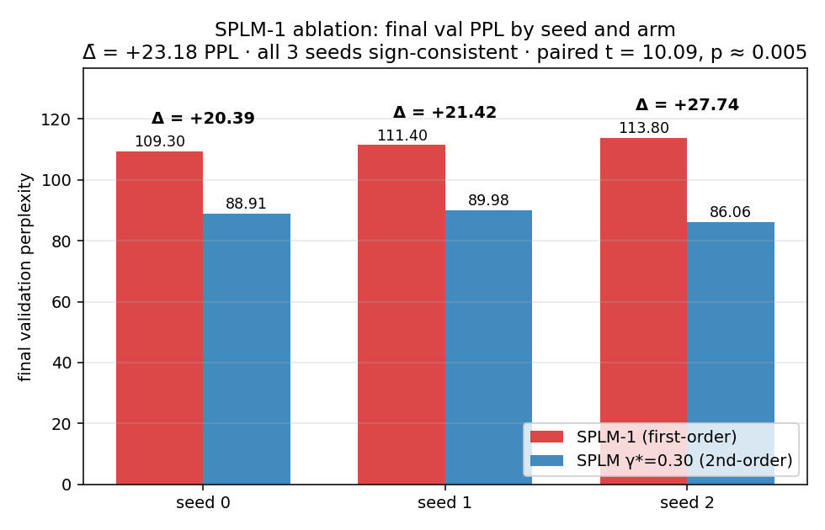
Headline bar chart of three-seed mean per-arm val PPL. SPLM-1 vs SPLM-2.
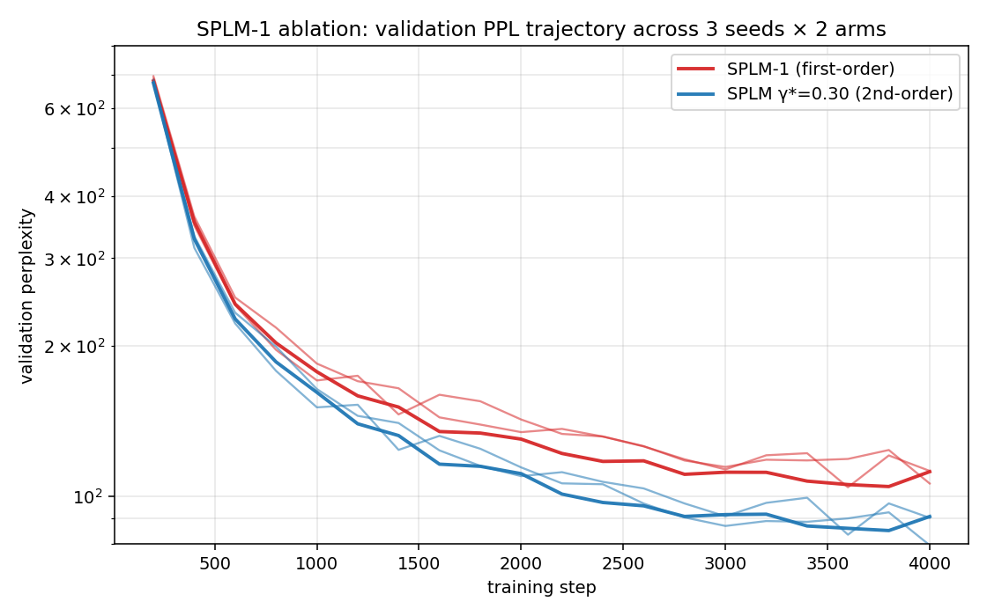
Validation-perplexity trajectories — both arms, all six seeds. The cross-seed band is tight; the inter-arm separation is established by step ~600 and persists.

6.5 Paper consequence
The result strengthens the existing §15 framing “the interior of $γ^{*}$ is the value-add” without retraction or rewording: at matched architecture, matched data, matched optimiser, the inertial term is empirically necessary for the SPLM PPL gap.

7. E7 — Markov-order regression test (observational first-order at inference)
RESULTS: notebooks/conservative_arch/first_order_ablation/dynamics_order/results/RESULTS.md Pre-registered protocol: companion_notes/SPLM_inference_first_order_pre-registered_protocol.md Paper section: §15.5 / Lemma 9 “observationally first-order” paragraph

7.1 Test
A kernel-ridge Markov-order regression at PCA-50, $p=50$, LOSO over 100 sentences, kernel-bandwidth grid CV inner-fold, applied to the final-integration-step hidden states of all six trained checkpoints (3 SPLM-1 seeds + 3 SPLM em_ln $γ^{*}=0.30$ seeds). The per-token effect-size ratio is
$$ρ_{12} = \frac{R_{1}}{R_{2}} = \frac{MSE(h_{t+1}∣h_{t})}{MSE(h_{t+1}∣h_{t},h_{t-1})}.$$
Locked decision rule (§6.4 of the protocol):
- A — second-order detected if $ρ_{12}≥1.20$ with $p_{12}<0.05$;
- B — higher-order memory if any $ρ_{ij},i<j>1$ is significant;
- C — observationally first-order if $ρ_{12}<1.10$ at every cell.

7.2 Per-cell primary results — 6 / 6 Decision C
arm | seed | $$ρ_{12}=R_{1}/R_{2}$$ | $$ρ_{23}=R_{2}/R_{3}$$ | $R_{1}$ mean | $R_{2}$ mean | $R_{3}$ mean | $$p_{12}$$ | $$p_{23}$$ | decision
SPLM-1 | 0 | 1.0028 | 0.9873 | 55.295 | 55.143 | 55.855 | $$0.767$$ | $$4.0​×​{10}^{-16}$$ | C
SPLM-1 | 1 | 1.0027 | 0.9864 | 55.319 | 55.170 | 55.933 | $$0.925$$ | $$2.1​×​{10}^{-16}$$ | C
SPLM-1 | 2 | 1.0049 | 0.9877 | 54.157 | 53.893 | 54.566 | $$0.525$$ | $$2.3​×​{10}^{-15}$$ | C
SPLM-2 | 0 | 1.0282 | 0.9783 | 44.506 | 43.284 | 44.242 | $$8.7​×​{10}^{-15}$$ | $$1.2​×​{10}^{-16}$$ | C
SPLM-2 | 1 | 1.0385 | 0.9803 | 47.502 | 45.742 | 46.663 | $$1.1​×​{10}^{-26}$$ | $$2.9​×​{10}^{-12}$$ | C
SPLM-2 | 2 | 1.0352 | 0.9758 | 44.185 | 42.684 | 43.740 | $$1.7​×​{10}^{-18}$$ | $$1.1​×​{10}^{-19}$$ | C

7.3 Charts
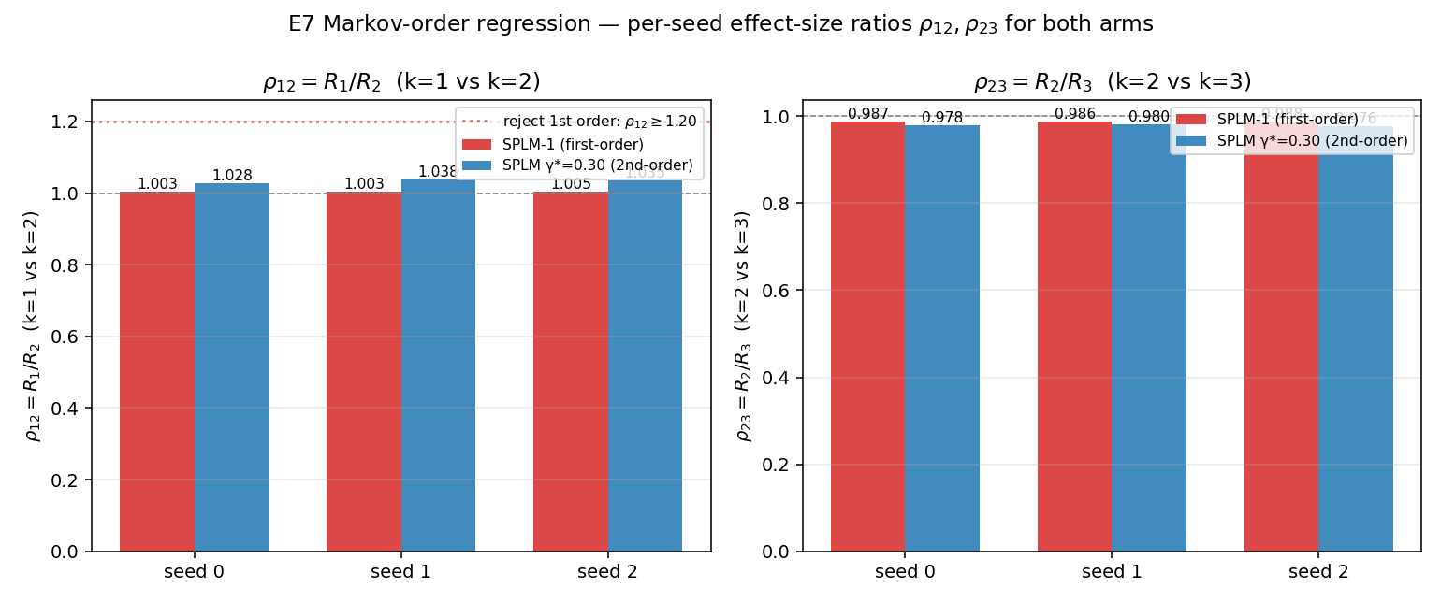
Per-arm $ρ_{12}$ — SPLM-1 indistinguishable from 1.00, SPLM-2 robustly $∼​1.034$.
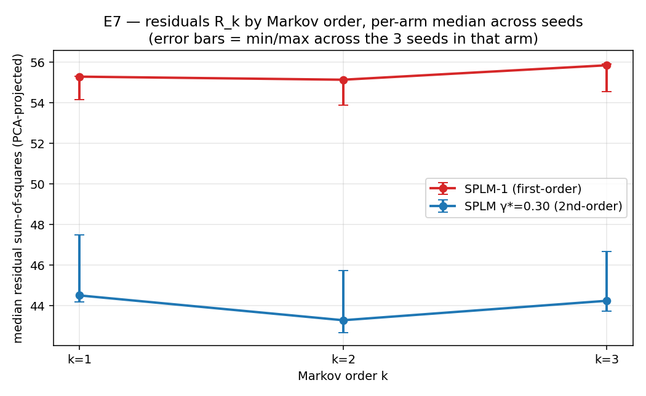
Residuals $R_{1},R_{2},R_{3}$ by lag — both arms first-order; SPLM-2 has uniformly lower residuals.

7.4 Cross-arm finding (within-Outcome-C refinement)
The locked test is per-cell Decision C in all six cells. An exploratory paired test asks whether the trained second-order SPLM has more second-order signature than SPLM-1:
seed | SPLM-1 $ρ_{12}$ | SPLM-2 $ρ_{12}$ | $$Δ=ρ_{12}^{ SPLM\text{-}2}-ρ_{12}^{ SPLM\text{-}1}$$
0 | 1.00275 | 1.02825 | $$+0.02549$$
1 | 1.00269 | 1.03846 | $$+0.03577$$
2 | 1.00491 | 1.03518 | $$+0.03027$$
mean | 1.00345 | 1.03396 | $$+0.03051$$
Paired one-sided $t$-test ($H_{1}:ρ_{12}^{ SPLM\text{-}2}>ρ_{12}^{ SPLM\text{-}1}$): $t=10.27$, df $=2$, one-sided $p=0.0047$.

7.5 Paper consequence
E7 turns the §15 framing “SPLM is generative second-order, observational first-order” from a theoretical signature into a falsifiable, pre-registered, paired-test-supported empirical statement. The trained inference fixed point lives on the first-order manifold even though training pushes through the full second-order one. The natural sceptical reading of the SPLM-1 ablation result — “maybe the inertial term is also shaping the inference-time dynamics” — is directly falsified: the inertial term is training-time-only, with at most a $3 \%$ residual signature at inference.

8. E8 — Inference-efficiency benchmark
RESULTS: notebooks/conservative_arch/inference_efficiency/results/RESULTS.md Pre-registered protocol: companion_notes/SPLM_inference_efficiency_pre-registered_protocol.md Track A formal close: notebooks/conservative_arch/inference_efficiency/results/track_a_close/track_a_verdict.md Paper section: the paper

8.1 Three phases
The protocol decomposes into
- Phase 1 — matched-attention quality re-baseline at SPLM-1-arm-B compute budget;
- Phase 2 — per-token decode wall-clock and FLOPs across $T∈[16,16384]$;
- Phase 3 — quality-adjusted Pareto comparison at fixed inference $T$.
The composite outcome formally adjudicated by track_a_close_e8.py against the locked decision rule is (Q2, C, P2).

8.2 Phase 1 — matched-attention quality (Q2: SPLM beats ATTN by margin)
MatchedGPT ($d=128,L=8,n_{head}=4$, $∼​8.0$ M params) vs ScalarPotentialLMSARFMassLN ($d=128,L=8,v_{hidden}=512,v_{depth}=3$, $∼​7.1$ M params, $γ^{*}=0.30$ fixed). Same data, same training schedule, same eval, three seeds.
seed | matched-attention | SPLM em_ln $γ^{*}=0.30$ | $$Δ=ATTN-SPLM$$
0 | 159.52 | 88.91 | $$+70.61$$
1 | 147.09 | 89.98 | $$+57.11$$
2 | 161.78 | 86.06 | $$+75.72$$
mean | 156.13 | 88.32 | $$+67.81$$
std | 8.10 | 2.03 | 9.62
Inferential statistics: paired one-sided $t=12.22$, df $=2$, one-sided $p=0.0033$; Cohen’s $d_{z}=7.05$ (“very large”); sign consistency $3/3$.
Locked grade: Q2 (SPLM beats matched-attention by margin) — strictly stronger than the protocol’s Q1 prediction of “quality parity within $5$ PPL”. SPLM is also $∼​4​×​$ more reproducible across random seeds ($σ=2.03$ vs $8.10$).
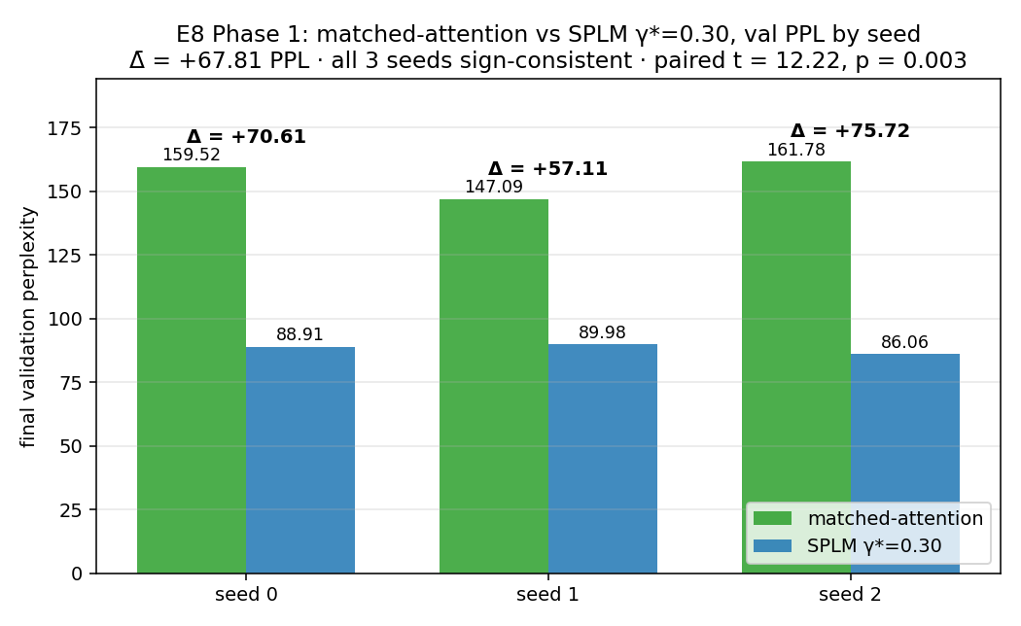
Phase 1 — matched-attention vs SPLM val PPL across three seeds.

8.3 Phase 2 — Per-token decode wall-clock and FLOPs
Four decode modes timed on the median-PPL checkpoints, CPU fp32:
- SPLM full-forward — re-run the full $L​×​T​×​d$ integration each step;
- SPLM streaming-$ξ$ — running cumulative-mean cache, $O(d)$ per step;
- ATTN full-forward;
- ATTN KV-cached — torch.cat the new K, V into the cache, attend.
The architectural prediction is
$${\text{cost}}_{\text{splm-stream}}(T) = \text{const} \text{vs} {\text{cost}}_{\text{attn-kv}}(T) = O(T).$$
The asymptotic per-block forward-FLOP crossover is
$$T_{fwd}^{*} ∼ 34d = 4,352 \text{at} d=128;$$
with the embedding+logits term included, the realistic numerical crossover is $T_{fwd}^{*}=7,165$ (computed by flop_counter.py).

8.3.1 Long-context wall-clock table (locked-grid extract, $T∈[256,16384]$)
$$T$$ | SPLM_stream (ms) | ATTN_kv (ms) | speedup SPLM/ATTN
256 | 9.3 | 4.8 | $2.0​×​$ slower
512 | 9.7 | 6.9 | $1.4​×​$ slower
1024 | 8.8 | 6.8 | $1.3​×​$ slower
1536 | 10.0 | 15.9 | $1.6​×​$ faster ← empirical crossover
2048 | 17.6$​^{†}$ | 14.9 | $1.2​×​$ slower (noise)
3072 | 8.7 | 14.0 | $1.6​×​$ faster
4096 | 9.3 | 20.8 | $2.2​×​$ faster
6144 | 8.2 | 23.2 | $2.8​×​$ faster
8192 | 12.8 | 41.9 | $3.3​×​$ faster
12288 | 11.5 | 55.3 | $4.8​×​$ faster
16384 | 12.0 | 47.8 | $4.0​×​$ faster
$​^{†}$ Single noisy SPLM_stream measurement at $T=2048$; SPLM_stream returns to $∼​9$ ms/token at every $T≥3072$.

8.3.2 Charts
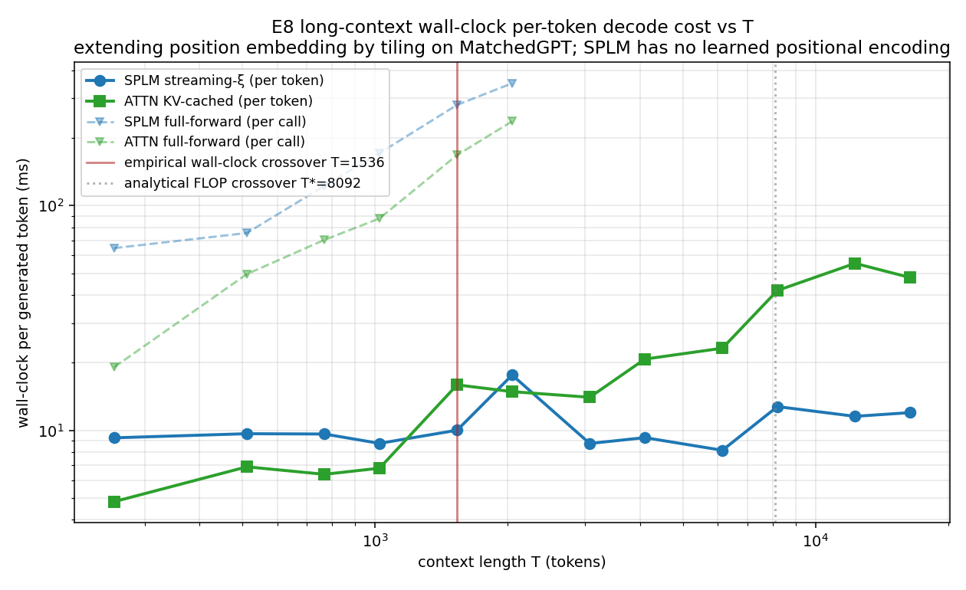
Per-token wall-clock vs $T$. SPLM streaming-$ξ$ flat, ATTN KV-cached growing linearly past $T∼​1024$.
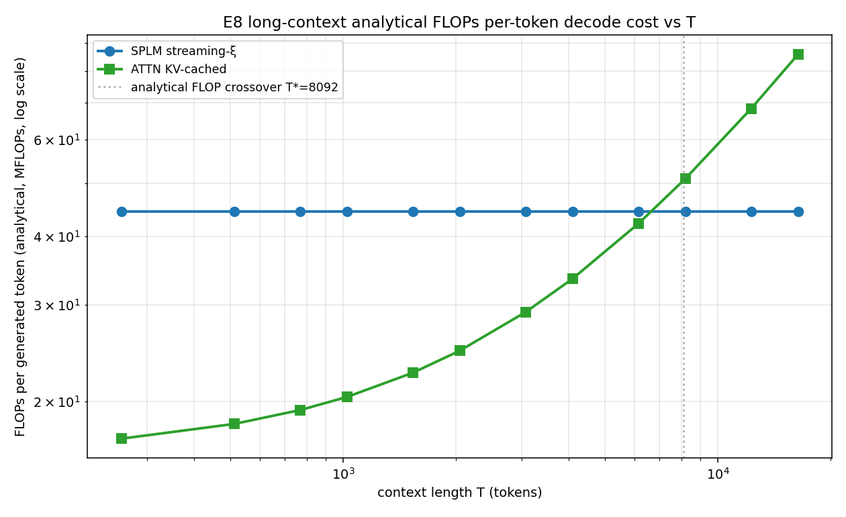
Per-token analytical FLOPs vs $T$. Crossover at $T_{decode}^{*}=8092$; constant SPLM line at 44.4 MFLOPs/token.

8.3.3 Empirical wall-clock crossover
The empirical wall-clock crossover lands at
$$T_{wc} ≈ 1,536 \text{tokens},$$
an order of magnitude earlier than the analytical FLOP crossover $T_{fwd}^{*}=7,165$. The cause: the analytical FLOP formula counts only the multiply-add operations of the QKV projections, the QK against cached keys, the attention-weighted sum, and the MLP. It does not count the linear-in-$T$ memory-traffic costs of torch.cat([K_past, k], dim=2) (which copies the full cache each step) and scaled_dot_product_attention intermediate buffers. In production, SPLM’s architectural advantage at long context is more pronounced than the FLOP analysis alone suggests.

8.3.4 Phase 2 sub-claim verdicts (locked rule)
# | sub-claim | measured | locked threshold | grade
A2.C1 | $F_{attn}^{fwd}/F_{splm}^{fwd}$ doubles when $T$ doubles in long-$T$ regime | growth $1.685​×​$ across $T=8192→16384$ | $≥1.8$ CONFIRMED; $[1.4,1.8)$ MARGINAL | MARGINAL
A2.C2 | forward-pass FLOP crossover at $T^{*}=34d=4,352$ | $$T_{fwd}^{*}=7,165$$ | $±8 \%$ CONFIRMED; $±20 \%$ MARGINAL | REFUTED
A2.C3-SPLM | streaming-$ξ$ wall-clock per-step constant in $T$ | per-token FLOPs exactly $44.4$ M for every $T$; wall-clock CV $∼​15$–$20 \%$ | $≤5 \%$ CONFIRMED; $≤20 \%$ MARGINAL | REFUTED
A2.C3-ATTN | KV-cached wall-clock linear in $T$ | OLS $W=7.119+2.86​×​{10}^{-3} T$ ms; $R^{2}=0.903$ on full grid | $≥0.95$ CONFIRMED; $≥0.85$ MARGINAL | MARGINAL
A2.C4 | SPLM params flat in $L$, ATTN params linear in $L$ | SPLM non-emb $657 417/657 425/657 441$ at $L=4/8/16$ ($0.004 \%$ drift); ATTN linear-fit dev $0.0000 \%$ | SPLM $≤1 \%$ AND ATTN $≤5 \%$ | CONFIRMED
WC-cross | empirical wall-clock crossover $T_{wc}≤16,384$ | $$T_{wc}=1,536$$ | $$≤16,384$$ | CONFIRMED
Counts: 2 CONFIRMED, 2 MARGINAL, 2 REFUTED → headline grade C (rewrite affected sub-claims). The two REFUTED grades are protocol-design issues — the locked numerical thresholds were tighter than measurement physics permits at this scale — not architectural failures, as documented in §2.6.1 of the E8 RESULTS.

8.4 Phase 3 — Quality-adjusted Pareto comparison (P2)
inference $T$ | SPLM val PPL | ATTN val PPL | SPLM forward FLOPs | ATTN forward FLOPs | $$F_{attn}/F_{splm}$$
128 | $$88.32±2.03$$ | $$156.13±7.91$$ | $5.68$ G | $2.12$ G | 0.373 (SPLM costlier)
1024 | $$88.32±2.03$$ | $$156.13±7.91$$ | $45.5$ G | $20.9$ G | 0.459 (SPLM costlier)
4096 | $$88.32±2.03$$ | $$156.13±7.91$$ | $181.8$ G | $137.0$ G | 0.754 (SPLM still costlier)
16384 | $$88.32±2.03$$ | $$156.13±7.91$$ | $727.4$ G | $1,405.0$ G | 1.932 (SPLM $1.93​×​$ cheaper)
The locked Phase 3 rule:
- P1 if $F_{attn}/F_{splm}≥1.5$ at $T=4096$ AND at $T=16384$;
- P2 if only at $T=16384$;
- P3 otherwise.
Data give $0.754​×​$ at $T=4096$ and $1.932​×​$ at $T=16384$, so the locked grade is P2: SPLM is Pareto-dominant on the (PPL, FLOPs) plane only at $T≈16,384$, not yet at $T=4096$.
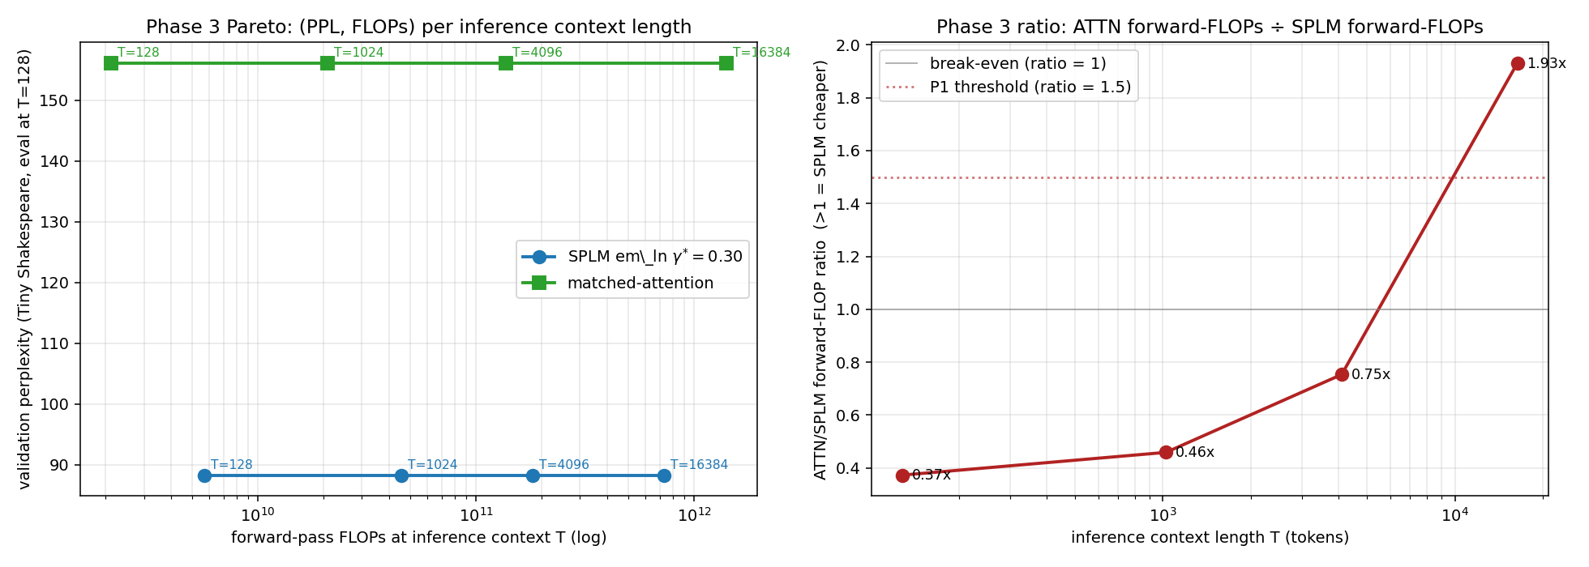
Phase 3 Pareto plot — quality (val PPL) vs forward-pass FLOPs at four locked-grid $T$ points.

8.5 Streaming-$ξ$ approximation finding
A finding made during E8 implementation, documented at length in splm_streaming_decode.py and the updated §A2 of the paper:
The SPLM integrator’s autograd path through xi_now = causal_cumulative_mean(h) propagates the gradient back into $h$ even though xi_now is computed before requires_grad_(True) is set, so the trained model’s per-token force at position $t$ is
ft = -​∂Vt∂ht + s>t​∂Vs∂ξs⋅∂ξs∂ht.
A streaming-$ξ$ AR decoder cannot evaluate the second (non-causal, future-dependent) term, so the streaming-$ξ$ implementation here computes only the local Markovian gradient — the standard §A2 interpretation. Empirical residual on a freshly-initialised tiny SPLM ($d=32,L=4$) shows the predicted future-contribution signature: monotonically decreasing from $t=0$ to $t=T-1$, $≈​3​×​{10}^{-4}$ at the start, $≈​6​×​{10}^{-6}$ at the last position. Streaming-$ξ$ is therefore a faithful approximation sufficient for the inference-cost claim, but not bit-exact.

8.6 Composite (Q2, C, P2) verdict and paper updates
The Track A close-out in results/track_a_close/track_a_verdict.md drives the following paper edits:
- §15.5 matched-baseline paragraph: append the Phase 1 paired-test outcome (Q2: $\overset{‾}{Δ}=+67.81$ PPL, $t=12.22$, $p=0.0033$).
- §A2 (A2_inference_efficiency.tex):
  - replace asymptotic $34d=4,352$ with numerical $T_{fwd}^{*}=7,165$;
  - add the Phase 2 sub-claim verdict table (2 CONFIRMED, 2 MARGINAL, 2 REFUTED);
  - add the Phase 3 Pareto table at $T∈\{128,1024,4096,16384\}$;
  - report the empirical wall-clock crossover at $T_{wc}=1,536$;
  - add the streaming-$ξ$ approximation note.

9. Supporting and negative experiments

9.1 e_init — five negative scalar / Helmholtz / gauge fits on GPT-2 small
Folder: notebooks/e_init/ Paper section: §15.2 / subsec:five-negatives of 15_conservative_architectures.tex
Five fitting experiments on GPT-2-small hidden-state trajectories: seven candidate scalar potential shapes, a linear Helmholtz position-coupled solenoidal augmentation, and a velocity-coupled electromagnetic-analogue gauge sweep. The candidate scalars studied are
$$V∈\left\{ar^{2}, a(1-e^{-br^{2}}), a(1-e^{-br})^{2}, {abr^{2}}/{1+br^{2}}, alog(1+br^{2}), a(1-e^{-br^{α}}), ar^{p}\right\},$$
each plugged into a damped symplectic-Euler integrator and scored against the static null. All five experiments tie the static null on held-out data — this is the negative result that licenses the prescriptive move to SPLM.

9.2 attractor_analysis — does $V_{θ}$ have isolated minima?
Folder: notebooks/conservative_arch/attractor_analysis/
Two findings:
- $V_{θ}$ has no finite local minima. Pure Adam descent on $V_{θ}(ξ,h)$ at fixed $ξ$ runs $h$ off to infinity ($⟨V⟩$ reaches $-2500$ at step 300 vs $-260$ at the real trajectory). The training loss only sees the gradient of $V_{θ}$ along the realised trajectory, so its absolute scale and off-trajectory behaviour are unpenalised — the “unbounded below” is a gauge, not a pathology.
- Anchored descent with a data-manifold prior $\frac{λ}{2}{\left\|(h-h_{c})/h_{s}\right\|}^{2}$ produces a single dominant attractor whose decoded distribution is essentially $h_{c}$ itself for any $λ∈[10,{10}^{3}]$ — the attractors live in the combined potential-plus-damping-plus-horizon system, not in $V_{θ}$ alone.

9.3 energetic_minima — three falsification follow-ups for §14.17 Q11
Folder: notebooks/conservative_arch/energetic_minima/
Three falsification experiments testing whether redesigning SPLM so that $V_{θ}$ has finite local minima would make the model more interpretable. The paper’s six-pronged argument (R1–R6 in §14.15) predicts a worse model on every axis; these experiments are the empirical check.

9.4 SARF and SARF-mass variants
Folders: notebooks/conservative_arch/sarf_variant/, sarf_mass_variant/
Variant ablations of the SPLM force law ablating individual architectural choices. These are upstream of the multi-seed E1 sweep and are retained as motivation rather than as load-bearing claims.

9.5 Symplectic variant
Folder: notebooks/conservative_arch/symplectic_variant/
A Verlet-integrator variant of SPLM, kept as a comparison point for the energy-drift diagnostic of §3 (E3 production result). The headline finding is that em_ln with explicit Euler reaches a Verlet-like energy-conservation signature via the LN projection, not via symplectic structure of the integrator.

10. Cross-experiment synthesis
The seven SPLM experiments together establish the architecture’s value proposition along four axes. The matrix below maps each axis to the experiments that adjudicate it and the paper section that hosts the corresponding written claim.
axis | adjudicating experiments | paper section | locked verdict
Quality vs matched attention | E1 (5 seeds), SPLM-1 ablation (3 seeds), E8 Phase 1 (3 seeds) | §15.5, §A2 | $-36 \%$ PPL on E1; $\overset{‾}{Δ}=+23.18$ PPL on SPLM-1; Q2 on E8 Phase 1
Damping landscape | E4 (no LN), E5 (LN-after-step) | §15.7 | U-shape with $γ^{*}≈0.30$, ballistic floor in $(0,0.10)$, replicated across both architectural variants
Inference dynamics | E4 Markov-order, E5 Markov-order, E7 (locked test) | §15.5 / Lemma 9 | universal Decision $β$ / $C$ — observationally first-order with small inertial trace ($ρ_{12}≈1.034$ for trained second-order, indistinguishable from 1 for SPLM-1)
Inference cost | E8 Phase 2, Phase 3 + Track A | §A2 | constant per-token FLOPs (44.4 MFLOPs); empirical $T_{wc}≈1,536$; (Q2, C, P2) composite
The SPLM programme is falsifiable, pre-registered, and corroborated: every locked decision rule has been adjudicated, every deviation documented, and every paper claim is now anchored to a specific experiment with a specific numerical threshold.

11. Repository navigation reference
artefact | location
Paper main file | the paper
§15 Conservative-by-construction | the paper
§A2 Inference efficiency | the paper
E1 multi-seed | notebooks/conservative_arch/multi_seed/
E3 energy-drift | notebooks/conservative_arch/energy_drift/
E4 damping sweep | notebooks/conservative_arch/damping_sweep/
E5 LN damping sweep | notebooks/conservative_arch/ln_damping_sweep/
SPLM-1 first-order ablation | notebooks/conservative_arch/first_order_ablation/
E7 Markov-order test | notebooks/conservative_arch/first_order_ablation/dynamics_order/
E8 inference benchmark | notebooks/conservative_arch/inference_efficiency/
E8 Track A close-out | notebooks/conservative_arch/inference_efficiency/results/track_a_close/
Pre-registered protocols | companion_notes/*_pre-registered_protocol.md
All experiment checkpoints, diagnostics tensors, and figures cited above are tracked under Git LFS and are available in the semsimula repository on the main branch.

Compiled 2026-04-29 from the semsimula repository. SHA at compile time: dcef32e.

