Jacobi metric and Geodesics in Riemannian Geometry
compiled by D.Gueorguiev, 10/15/2026

Quick Intro

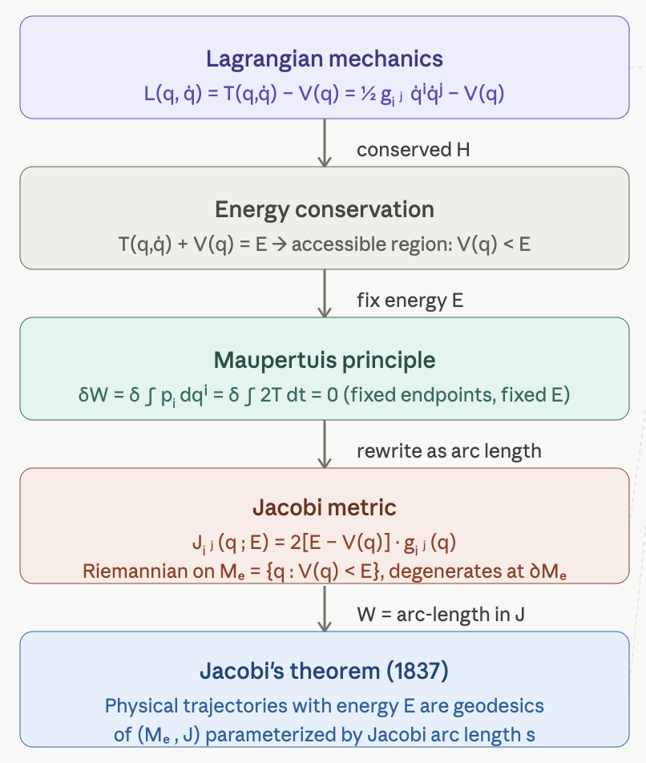
The Jacobi metric is a bridge between classical mechanics and Riemannian geometry — it reframes the dynamics of a conservative system as pure geometry, turning every physical trajectory at fixed energy into a geodesic. Here is a structured development with definitions, derivations, and illustrative figures.

Classical Setup

Let $M$ be a smooth $n$-dimensional manifold (the configuration space) equipped with a Riemannian metric $g=g_{ij}\left(q\right)$.

The coordinates $q=\left(q^{1},…,q^{n}\right)$ are the generalised coordinates of the system and ${\dot{q}}^{i}=dq^{i}/dt$ their velocities. The kinetic energy is a quadratic form in the velocities, and the metric is chosen so that it reads

$$T\left(q,\dot{q}\right)=\frac{1}{2}g_{ij}\left(q\right){\dot{q}}^{i}{\dot{q}}^{j}$$

(the mass is absorbed into the metric: for a particle of mass $m$ in Euclidean space, $g_{ij}=mδ_{ij}$). Repeated indices are summed. With a potential $V\left(q\right)$, the Lagrangian is

$$L\left(q,\dot{q}\right)=T\left(q,\dot{q}\right)-V\left(q\right)=\frac{1}{2}g_{ij}\left(q\right){\dot{q}}^{i}{\dot{q}}^{j}-V\left(q\right)$$

Euler–Lagrange equations

The Euler–Lagrange equation for each coordinate $q^{k}$,

$$\frac{d}{dt}\frac{∂L}{∂{\dot{q}}^{k}}-\frac{∂L}{∂q^{k}}=0,$$

needs two derivatives:

$$\frac{∂L}{∂{\dot{q}}^{k}}=g_{kj}{\dot{q}}^{j}=p_{k}, \frac{∂L}{∂q^{k}}=\frac{1}{2}∂_{k}g_{ij}{\dot{q}}^{i}{\dot{q}}^{j}-∂_{k}V,$$

where $p_{k}$ is the momentum conjugate to $q^{k}$. Differentiating $p_{k}$ along the motion, and writing the term $∂_{i}g_{kj}{\dot{q}}^{i}{\dot{q}}^{j}$ symmetrically in $i$ and $j$, gives

$$g_{kj}{\ddot{q}}^{j}+\frac{1}{2}\left(∂_{i}g_{kj}+∂_{j}g_{ki}-∂_{k}g_{ij}\right){\dot{q}}^{i}{\dot{q}}^{j}=-∂_{k}V.$$

Multiplying by the inverse metric $g^{lk}$ raises the index and introduces the Christoffel symbols of $g$:

$${\ddot{q}}^{l}+Γ_{ij}^{l}{\dot{q}}^{i}{\dot{q}}^{j}=-g^{lk}∂_{k}V, Γ_{ij}^{l}=\frac{1}{2}g^{lk}\left(∂_{i}g_{kj}+∂_{j}g_{ki}-∂_{k}g_{ij}\right).$$

The left side is the covariant acceleration $∇_{\dot{q}}\dot{q}$ of the curve (see the Appendix), and the right side is the force $-∇V$ with its index raised by the metric. Without a potential the equation is $∇_{\dot{q}}\dot{q}=0$: a free particle moves along the geodesics of $g$. The Jacobi metric extends this statement to motion in a potential.

Energy conservation and the accessible region

The energy

$$E=T\left(q,\dot{q}\right)+V\left(q\right)$$

is conserved: along the motion $dE/dt=g_{lk}{\dot{q}}^{k}\left({\ddot{q}}^{l}+Γ_{ij}^{l}{\dot{q}}^{i}{\dot{q}}^{j}\right)+{\dot{q}}^{k}∂_{k}V=-{\dot{q}}^{k}∂_{k}V+{\dot{q}}^{k}∂_{k}V=0$. Because $T≥0$, a motion of energy $E$ is confined to the accessible region

$$M_{E}=\left\{q∈M:V\left(q\right)<E\right\},$$

together with its boundary $∂M_{E}=\left\{V=E\right\}$, where the kinetic energy vanishes and the particle turns back (a turning point). On a motion of energy $E$ the kinetic energy is a known function of position, $T=E-V\left(q\right)$. This is what allows time to be eliminated.

Maupertuis' Principle

Hamilton's principle compares motions between fixed configurations at fixed times. Maupertuis' principle compares motions of fixed energy and lets the travel time vary.

Step 1 (free end time). For the action $S=∫Ldt$, a variation that keeps the end configurations fixed but changes the end time by $δt_{1}$ gives, on the true motion,

$$δS=-Hδt_{1},$$

where $H=p_{k}{\dot{q}}^{k}-L$ is the Hamiltonian. The integrand contributes nothing because the true motion satisfies the Euler–Lagrange equations; only the boundary term remains, and here $H=E$.

Step 2 (fixed energy). If all compared motions have energy $E$, then $δS=-Eδt_{1}=-δ\left(Et_{1}\right)$, so

$$δ∫\left(L+E\right)dt=δ∫p_{k}{\dot{q}}^{k}dt=δ∫2Tdt=0,$$

because $L+E=\left(T-V\right)+\left(T+V\right)=2T=p_{k}{\dot{q}}^{k}$. The quantity

$$W=∫p_{k}dq^{k}=∫2Tdt$$

is the abbreviated action. Among paths of energy $E$ between two points, the true path makes $W$ stationary.

Step 3 (eliminating time). Let $ds_{g}=\sqrt{g_{ij}dq^{i}dq^{j}}$ be the arc length of $g$. Since $2T=g_{ij}{\dot{q}}^{i}{\dot{q}}^{j}={\left(ds_{g}/dt\right)}^{2}$,

$$2Tdt=\sqrt{2T}ds_{g}=\sqrt{2\left(E-V\left(q\right)\right)}ds_{g},$$

and the abbreviated action no longer refers to time:

$$W=∫\sqrt{2\left(E-V\left(q\right)\right)g_{ij}\left(q\right)dq^{i}dq^{j}}.$$

The Jacobi Metric

Definition Jacobi metric
For a fixed energy $E$, the Jacobi metric on the accessible region $M_{E}$ is

$$J_{ij}\left(q;E\right)=2\left(E-V\left(q\right)\right)g_{ij}\left(q\right).$$

It is a conformal rescaling of $g$ by the factor $Ω^{2}=2\left(E-V\right)$: it measures the same angles as $g$, but stretches lengths where the particle is fast and shrinks them where it is slow. It is a Riemannian metric on $M_{E}$ and degenerates on the boundary $∂M_{E}$, where $Ω^{2}=0$. Its arc length,

$$ds=\sqrt{J_{ij}dq^{i}dq^{j}}=\sqrt{2\left(E-V\right)}ds_{g}=2Tdt,$$

is the Jacobi arc length, and by Step 3 the abbreviated action is exactly the $J$-length of the path: $W=∫ds$.

Theorem Jacobi
The trajectories of energy $E$ of the Lagrangian system $\left(M,g,V\right)$ are geodesics of $\left(M_{E},J\right)$, parametrised by the Jacobi arc length $s$.
Proof. By Maupertuis' principle the true path makes $W$ stationary among paths of energy $E$; $W$ is the length of the path in $J$; and paths of stationary length are geodesics. The statement about the parameter is proved in the next section.

- Constant factors do not matter. $cJ$ has the same geodesics as $J$ for any constant $c>0$. Writing the mass explicitly, $g_{ij}=mδ_{ij}$, gives $J=2m\left(E-V\right)δ$, the form used in some texts.
- The principle fixes the path, not the speed along it. Time is recovered from the energy: $dt=ds_{g}/\sqrt{2\left(E-V\right)}$.

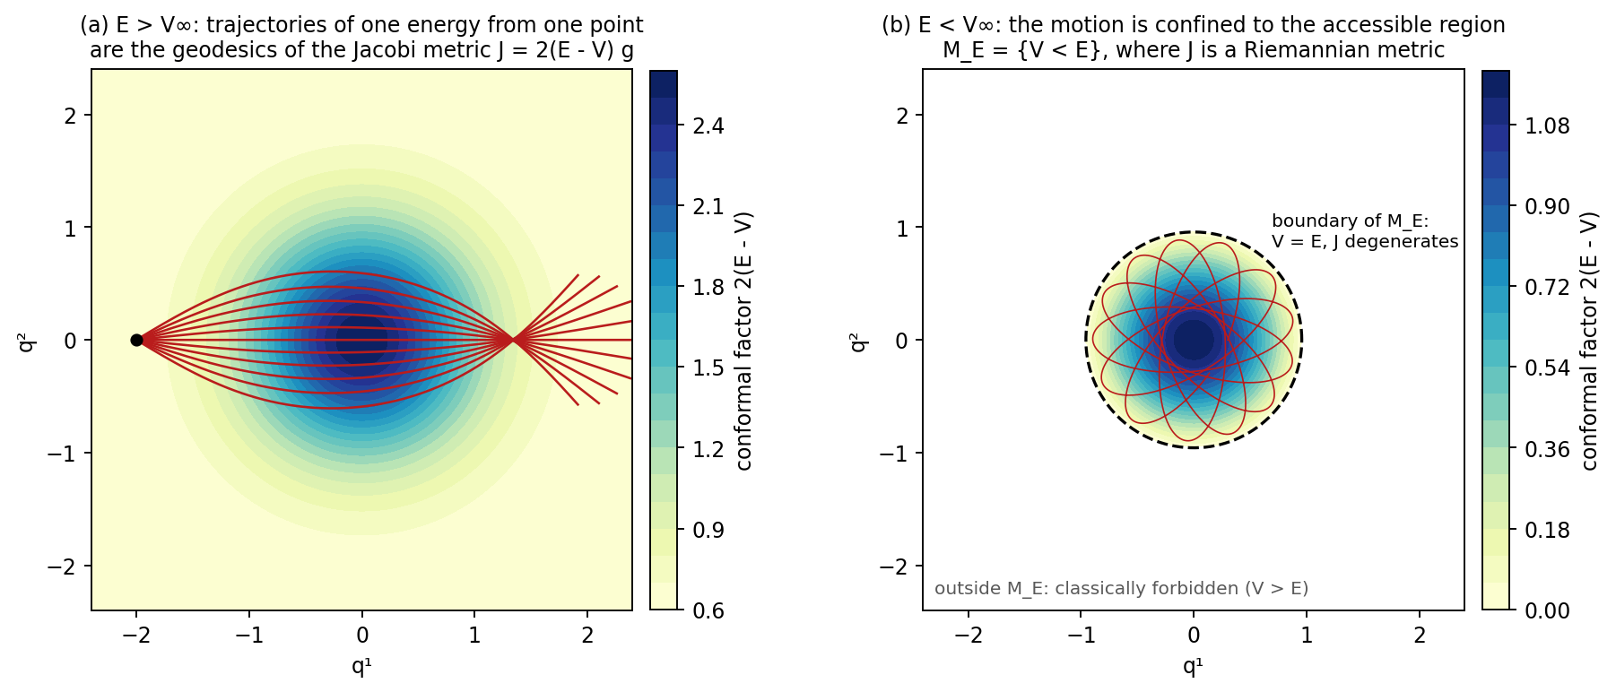
Figure 1. Jacobi's theorem made visible, for a unit mass in the Gaussian well $V\left(q\right)=V_{∞}\left(1-e^{-κ^{2}{\left|q\right|}^{2}}\right)$ in the plane. (a) $E=1.3>V_{∞}$: eleven trajectories of the same energy leave one point in different directions. They are geodesics of $J$, and they refocus at a single point, a conjugate point of the Jacobi metric: $J$ is large where $V$ is low, so the well acts as a converging lens. (b) $E=0.6<V_{∞}$: a bound trajectory fills a rosette inside the accessible region $M_{E}$; on its boundary (dashed) $J$ degenerates and the particle turns back.

Geodesics: a Direct Verification

Jacobi's theorem can also be checked directly from the equation of motion, without the variational argument. This route also shows how the geodesic equation reads in physical time.

The connection of a conformal metric

Write $J=e^{2σ}g$ with $σ=\frac{1}{2}ln2\left(E-V\right)$. The derivatives of the new metric are

$$∂_{k}J_{ij}=e^{2σ}\left(∂_{k}g_{ij}+2∂_{k}σg_{ij}\right).$$

Inserting them into the Christoffel formula, the factors $e^{2σ}$ cancel between the inverse metric and the derivatives, and the Christoffel symbols of $J$ are

$${\tilde{Γ}}_{ij}^{l}=Γ_{ij}^{l}+δ_{i}^{l}∂_{j}σ+δ_{j}^{l}∂_{i}σ-g_{ij}g^{lk}∂_{k}σ.$$

Contracting with ${\dot{q}}^{i}{\dot{q}}^{j}$, the covariant acceleration of any curve in $J$ is

$${\ddot{q}}^{l}+{\tilde{Γ}}_{ij}^{l}{\dot{q}}^{i}{\dot{q}}^{j}=\left({\ddot{q}}^{l}+Γ_{ij}^{l}{\dot{q}}^{i}{\dot{q}}^{j}\right)+2\left({\dot{q}}^{k}∂_{k}σ\right){\dot{q}}^{l}-2Tg^{lk}∂_{k}σ,$$

where $2T=g_{ij}{\dot{q}}^{i}{\dot{q}}^{j}$.

Inserting the motion

On a motion of energy $E$, $∂_{k}σ=-∂_{k}V/\left(2\left(E-V\right)\right)=-∂_{k}V/\left(2T\right)$, and the first bracket equals $-g^{lk}∂_{k}V$. The two terms in $∂V$ that act across the motion cancel exactly, leaving

$${\ddot{q}}^{l}+{\tilde{Γ}}_{ij}^{l}{\dot{q}}^{i}{\dot{q}}^{j}=-\frac{{\dot{q}}^{k}∂_{k}V}{T}{\dot{q}}^{l}=\left(\frac{d}{dt}ln2T\right){\dot{q}}^{l},$$

where the last step uses $dT/dt=-{\dot{q}}^{k}∂_{k}V$ (energy conservation). The right side points along the motion. Its component across the motion is zero, so the path bends exactly as a geodesic of $J$ does: this is Jacobi's theorem again, reached without any variational argument.

Physical time and Jacobi arc length

If a curve is written as $q\left(t\right)=c\left(s\left(t\right)\right)$, the chain rule gives $\dot{q}=\dot{s}c^{'}$ and $\ddot{q}={\dot{s}}^{2}c^{″}+\ddot{s}c^{'}$, so

$$\ddot{q}+\tilde{Γ}\left(\dot{q},\dot{q}\right)={\dot{s}}^{2}\left(c^{″}+\tilde{Γ}\left(c^{'},c^{'}\right)\right)+\frac{\ddot{s}}{\dot{s}}\dot{q}.$$

For the Jacobi arc length $\dot{s}=ds/dt=2T$, so $\ddot{s}/\dot{s}=\frac{d}{dt}ln2T$, and comparison with the previous result gives

$$c^{″}+\tilde{Γ}\left(c^{'},c^{'}\right)=0:$$

the trajectory is an affinely parametrised geodesic of $J$ in the Jacobi arc length, which completes the proof of Jacobi's theorem. In physical time the same curve obeys $\ddot{q}+\tilde{Γ}\left(\dot{q},\dot{q}\right)=\left(\frac{d}{dt}ln2T\right)\dot{q}$: a geodesic traversed at a non-uniform rate. The two forms must not be mixed. Setting the right side to zero in physical time is correct only for the component across the motion.

Dissipation: Damped Jacobi Geodesics

Friction proportional to velocity enters through the Rayleigh dissipation function $R=\frac{1}{2}γg_{ij}{\dot{q}}^{i}{\dot{q}}^{j}$, which adds $∂R/∂{\dot{q}}^{k}=γg_{kj}{\dot{q}}^{j}$ to the Euler–Lagrange equation:

$${\ddot{q}}^{l}+Γ_{ij}^{l}{\dot{q}}^{i}{\dot{q}}^{j}=-g^{lk}∂_{k}V-γ{\dot{q}}^{l}.$$

The energy now decreases, $dE/dt=-2γT$, so there is no single Jacobi metric. At each instant there is the Jacobi metric of the current energy, $J_{t}=2\left(E\left(t\right)-V\right)g$, whose conformal factor at the particle equals $2T\left(t\right)$. Repeating the computation of the previous section with the extra term, and with $dT/dt=-{\dot{q}}^{k}∂_{k}V-2γT$,

$$\ddot{q}+\tilde{Γ}\left(\dot{q},\dot{q}\right)=\left(\frac{d}{dt}ln2T+γ\right)\dot{q},$$

and in the Jacobi arc length of the current metric, $ds=2Tdt$,

$$c^{″}+\tilde{Γ}\left(c^{'},c^{'}\right)=\frac{γ}{2T}c^{'}.$$

Both right sides point along the motion. Friction exerts no force across the path: at every instant the path bends as a geodesic of the current Jacobi metric. It changes the path only through the falling energy, which makes the metric itself drift. The friction term changes sign under time reversal, so a damped geodesic from $A$ to $B$ is not the reverse of one from $B$ to $A$.

Worked Example: a Particle in a Gaussian Well

Figure 2 integrates a particle of mass $m=1.3$ in the well $V\left(q\right)=mυ^{2}\left(1-e^{-κ^{2}{\left|q\right|}^{2}}\right)$ with $υ=1$ and $κ=0.8$, by a fourth-order Runge–Kutta scheme at step ${10}^{-4}$, without friction and with $γ=0.15$. Along the trajectory, $\ddot{q}+\tilde{Γ}\left(\dot{q},\dot{q}\right)$ is computed from the Jacobi metric of the current energy and split into its components along and across the motion.

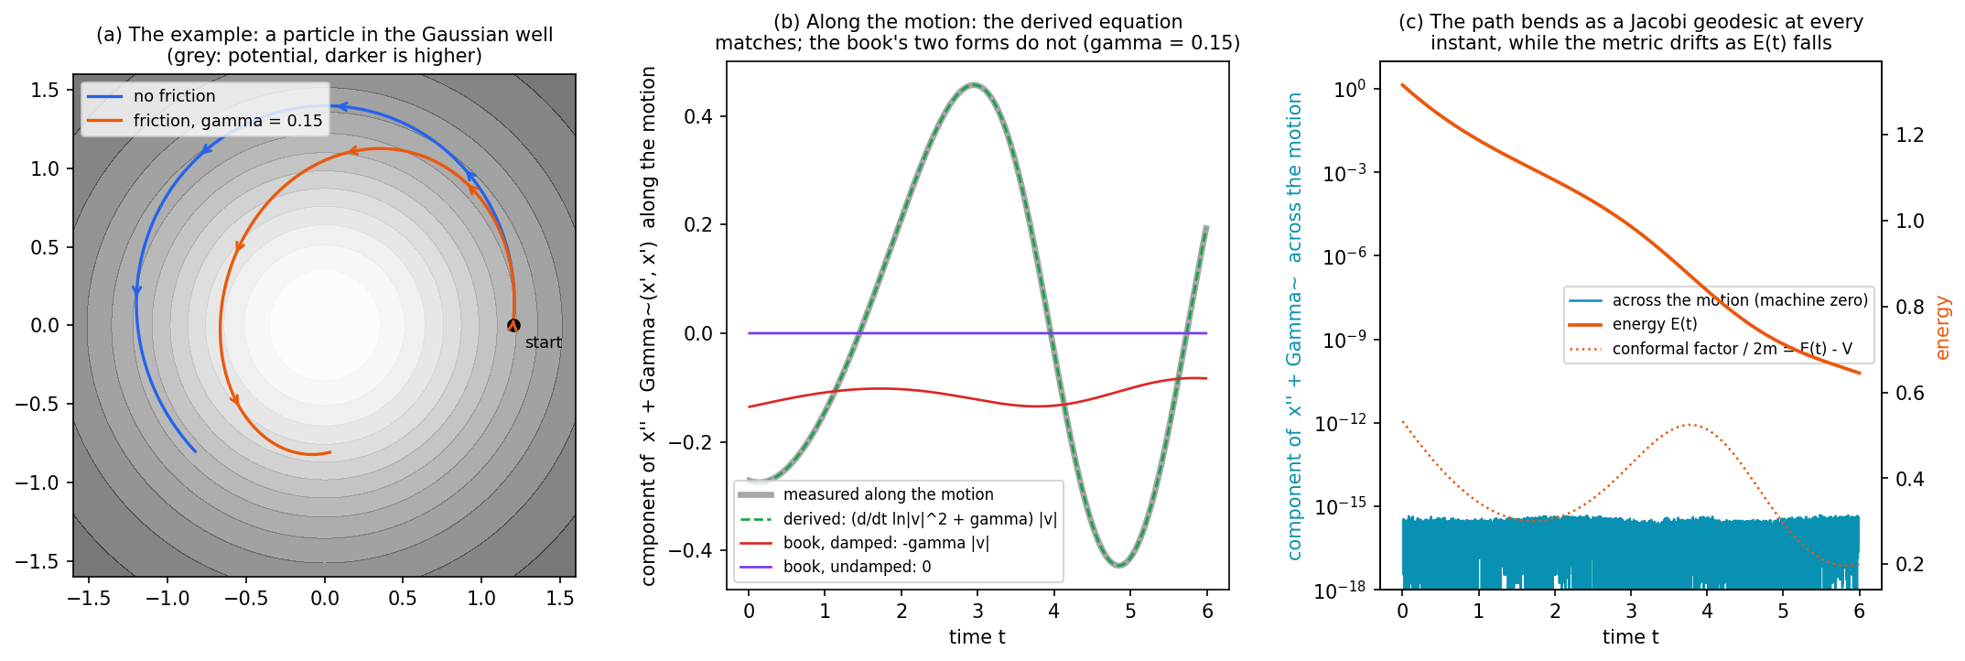
Figure 2. (a) The motion, from the same start, without friction (blue) and with $γ=0.15$ (orange), over the potential (darker is higher). (b) Along the damped trajectory, the component of $\ddot{q}+\tilde{Γ}\left(\dot{q},\dot{q}\right)$ along the motion: measured (thick grey), the derived $\left(\frac{d}{dt}ln2T+γ\right)\left|\dot{q}\right|$ (green dashed, on top of it), and the two forms that omit the reparametrisation term, $0$ and $-γ\left|\dot{q}\right|$ (purple and red). (c) The component across the motion (logarithmic scale), at machine precision throughout, together with the falling energy and the conformal factor at the particle.

- Across the motion the component is at machine precision, about ${10}^{-16}$: the path is a geodesic of the current Jacobi metric at every instant.
- Along the motion the derived right side $\left(\frac{d}{dt}ln2T+γ\right)\dot{q}$ matches to about $3×{10}^{-9}$, the precision of the finite-difference time derivative.
- The forms $\ddot{q}+\tilde{Γ}\left(\dot{q},\dot{q}\right)=0$ and $=-γ\dot{q}$ in physical time are wrong by 100% and 126% along the motion.

Application: Semantic Simulation

In the Semantic Simulation framework the hidden state of a token plays the role of $q$, the layer index plays the role of time, and the learned scalar potential plays the role of $V$, with $g_{ij}=mδ_{ij}$ for the semantic mass $m$. The models integrate the damped equation of motion, so their trajectories are damped Jacobi geodesics of the metric of the current energy, whose conformal factor at the state is proportional to the kinetic energy of the state at each layer. The Riemannian Diagnostic Battery finds this factor positive at every sampled position. The geodesic equation in layer time is the damped form above, including the reparametrisation term; the book corrects its earlier statement of it, which omitted that term, in the Riemannian-geometry chapter (Remark 105).

Summary

- Jacobi metric: $J=2\left(E-V\right)g$ on the accessible region $M_{E}=\left\{V<E\right\}$, degenerate on its boundary.
- Jacobi's theorem: motions of energy $E$ are geodesics of $J$, affinely parametrised by the Jacobi arc length $ds=2Tdt$, which is also the abbreviated action.
- In physical time: $\ddot{q}+\tilde{Γ}\left(\dot{q},\dot{q}\right)=\left(\frac{d}{dt}ln2T\right)\dot{q}$.
- With friction $γ$, in the metric of the current energy: $\ddot{q}+\tilde{Γ}\left(\dot{q},\dot{q}\right)=\left(\frac{d}{dt}ln2T+γ\right)\dot{q}$. Friction exerts no force across the path; the metric drifts as the energy falls.

References.
[1] V. I. Arnold, Mathematical Methods of Classical Mechanics, 2nd ed., Springer (1989), §45.
[2] L. D. Landau, E. M. Lifshitz, Mechanics, 3rd ed., Pergamon (1976), §44.
[3] H. Goldstein, C. Poole, J. Safko, Classical Mechanics, 3rd ed., Addison-Wesley (2002), §8.6.
[4] J. M. Lee, Introduction to Riemannian Manifolds, 2nd ed., Springer (2018).
[5] C. G. J. Jacobi, Vorlesungen über Dynamik, ed. A. Clebsch, Reimer (1866).

Appendix

Riemannian Metric in Riemannian Geometry

Definition Riemannian space (manifold)
Informally, Riemannian space is a smooth space equipped with a Riemannian metric, which acts as a locally varying tape measure for calculating lengths, angles, and volumes directly on a curved surface without embedding it in high-dimensional space.
Formally, a Riemannian manifold ($M,g$) consists of two components:
1 ) The Manifold $M$ : a topological space that locally resembles flat Euclidean space $R^{n}$
2 ) The Metric Tensor $g$ : a choice of an inner product $g_{p}$ on the tangent space $T_{p}M$ at each point $p∈M$ that varies smoothly from point to point.
For any two tangent vectors $u, v∈T_{p}M$, the metric $g_{p}\left(u,v\right)$ returns a real number satisfying three properties:

- bilinear in both arguments i.e. $g_{p}\left(u_{1}+u_{2},v\right)=g_{p}\left(u_{1},v\right)+g_{p}\left(u_{2},v\right)$ $∧g_{p}\left(u,v_{1}+v_{2}\right)=g_{p}\left(u,v_{1}\right)+g_{p}\left(u,v_{2}\right)$
- symmetric : $g_{p}\left(u,v\right)=g_{p}\left(v,u\right)$
- positive-definite: $g_{p}\left(u,u\right)>0$ for any non-zero vector $u$

In a local coordinate chart $\left(x^{1},x^{2},…,x^{n}\right)$, the metric tensor is expressed as a symmetric matrix $g_{ij}$:

$g_{ij}\left(x\right)=g\left(\frac{∂}{∂x^{i}},\frac{∂}{∂x^{j}}\right)$

The infinitesimal line element ${ds}^{2}$ tracks how distance changes along any coordinate direction:

${ds}^{2}=\sum_{i,j}{g_{ij}{dx}^{i}{dx}^{j}}$

What the Metric Induces?

Vector Norms and Angles
The length of a vector $u$ Is given by $\left\|u\right\|=\sqrt{g_{p}\left(u,u\right)}$ and the angle $θ$ between two vectors $u$ and $v$ is found via $\cos{θ}=\frac{g_{p}\left(u,v\right)}{\left\|u\right\|∙\left\|v\right\|}$.

Arc Length of Curves
The length $L$ of a smooth curve $γ\left(t\right)$ for $t∈\left[a,b\right]$ is computed by integrating its speed:

$$L\left(γ\right)=\int_{a}^{b}{\sqrt{g_{ij}\left(γ\left(t\right)\right){\dot{γ}}^{i}\left(t\right){\dot{γ}}^{j}\left(t\right)}}dt$$

Geodesics
Curves that make the length stationary between two points are the geodesics. In coordinates they satisfy

$${\ddot{γ}}^{l}+Γ_{ij}^{l}{\dot{γ}}^{i}{\dot{γ}}^{j}=0, Γ_{ij}^{l}=\frac{1}{2}g^{lk}\left(∂_{i}g_{kj}+∂_{j}g_{ki}-∂_{k}g_{ij}\right).$$

The left side is the covariant acceleration $∇_{\dot{γ}}\dot{γ}$: a geodesic is a curve with zero covariant acceleration. The equation holds in the form shown when the curve is parametrised by arc length, or by any parameter proportional to it; with any other parameter the right side becomes a multiple of $\dot{γ}$.

More on Topological Spaces

Definition second-countable
There exists a countable collection of open sets $B=\left\{U_{1},U_{2},U_{3},…\right\}$ such that every open set in the space can be written as a union of elements from $B$.

Definition Hausdorff ($T_{2}$)
For any two distinct points $x$ and $y$, there exist open sets $U$ and $V$ such that $x∈U,y∈V$, and $U∩V=∅$.

Definition second-countable Hausdorff space
A topological space that has a countable base for its topology (second-countable) and in which distinct points can be separated by disjoint open sets (Hausdorff).

Properties of second-countable Hausdorff spaces

Separability: Every second-countable space contains a countable dense subset

Lindelöf: Every open cover of the space has countable subcover

