Deep Dive in the SPLM model and code
Compiled by D. Gueorguiev, 5/23/2026

Table of Contents
Reference Vanilla Architecture for the Scalar Potential Language Model 2
Notation and Introductory Notes 2
Architecture Hyperparameters 2
State Variables 2
Learnable Parameters 3
Derived / Intermediate Quantities 4
Loss and Training Quantities 4
Oracle-Fit Quantities 4
Architectural Principles 5
A Note on the oracle fit 7
Training the SPLM : Learning the Reference Scalar Potential 8
The Strictest Test: One Scalar Potential for Every Layer (shared_potential_fit.py) 9
Symmetry as a Fingerprint of Conservative Flow (jacobian_symmetry.py) 10
A Note on the Causal Probe (causal_probe.py) 11
References 12
Appendix 12
Module splm_oracle_fit.py 12
Function fit_scalars 12
Function extract_oracle_tuples 13
Module model.py 15
The SPLM Config : class SPLMConfig 15
Class ScalarPotential 16
Class ScalarPotentialLM 16
Putting it together: the reference forward pass 18
Module model_sarf_mass.py 19
The SARF Config - class SPLMSARFMassConfig 19
Function causal_cumulative_mean 20
Class ScalarPotentialLMSARFMass 20
Module model_ln.py 25
The Config Class: SPLMSARFMassLNConfig 25
Class ScalarPotentialLMSARFMassLN 25
Module train_splm.py 27
Per-mode configuration: build_config 27
Learning-rate schedule: lr_schedule 27
The training step 28
Module trajectory_extraction.py 29
Auto-detecting the checkpoint variant: _build_model_from_checkpoint 29
Extracting one trajectory: extract_one 29
Module shared_potential_fit.py 30
The shared scalar network: SharedPotential 30
Pooling samples across layers: build_samples 31
The joint fit: fit_shared_V 31
Module jacobian_symmetry.py 32
Unconstrained vs symmetric fit: fit_linear_and_symmetric 32
Why velocity matters: fit_second_order 32
Module token_direction_fit.py 33
Building token triples: build_token_triples 33
Module causal_probe.py 34
The probe: causal_violation_probe 34
Regression discipline: class_smoke 34
Probing natural transformers 35

Reference Vanilla Architecture for the Scalar Potential Language Model

Notation and Introductory Notes

Architecture Hyperparameters
The architecture hyperparameters are set at constructions and not learned. Here is a complete list of these hyperparameters

$V$ – vocabulary size ; in code: cfg.vocab_size. vocabulary produced for example by the GPT-2 BPE Tokenizer).
$d$ – embedding/hidden state dimension ; in code – cfg.d. Every tensor in SPLM lives in $R^{d}$ or products of it thereof.
$T$ – maximum sequence length (context window); in code cfg.max_len, example values: $128$, $256$, $512$. Positional embeddings are indexed for the positions $0,…,T-1$.
$L$ – number of integration steps (shared-weight depth). Each step applies the same $V_{θ}, m, γ$; in code cfg.L.
$∆t$ – integration time step for the damped Velocity-Verlet integrator; in code cfg.dt; $∆t$ is fixed to 1.0.
$d_{V}$ – hidden width of the $V_{θ}$ MLP; in code cfg.v_hidden; $d_{V}=128$ in smoke test code, 512 with TinyShakespeare dataset, 768 with TinyStories dataset.
$n_{V}$ – number of hidden layers in the $V_{θ}$ MLP (before the final scalar head); in code cfg.v_dept. $n_{V}=2$ in the smoke test code and is $3$ otherwise.
$K_{ξ}$ – number of multi-$ξ$ context channels. When the context permits, we will use $K$ instead of $K_{ξ}$ to denote number of context channels.
$K_{w},K_{mix}$ – number of energy wells per bank; $K_{mix}$ represents the older notation adopted when the scalar potential was constructed using mixture models (e.g. SQ3)
$n_{ctx}$ – number well banks; usually $n_{ctx}=K_{ξ}$

State Variables
State variables are computed during the forward pass
$x$ – input token-id tensor; in code – x. Shape: $\left(B,T\right)$; $x_{b,t}∈0,…,V-1$
$h_{t}^{\left(0\right)}$ – decontextualized initial embedding; we have $h_{t}^{\left(0\right)}=TE\left(x_{t}\right)+PE\left(t\right)$; in code – emb. Shape: $\left(B,T,d\right)$
$h_{t}^{\left(l\right)}$ - hidden state at integration step $l∈0,…,L$. Sometimes we drop the subscript $t$ - $h_{l}$. Each $h_{l}$ is a position in semantic space ($R^{d}$). In code – h. Shape: $\left(B,T,d\right)$
$v_{l}$ - velocity at integration step $l∈0,…,L$. $v_{l}≔h_{l}-h_{l-1}$; in code – v. Shape: $\left(B,T,d\right)$

Disambiguation on the term Hidden State
In SPLM context and in the context the term hidden state denotes the $d$-dimensional residual stream vector $h_{t}^{\left(l\right)}∈R^{d}$ associated with token position $t$ at layer depth $l$ - i.e. row $t$ of the per-layer activation tensor $H^{\left(l\right)}∈R^{T×d}$ that each sub-layer additively updates via $H^{\left(l\right)}=H^{\left(l-1\right)}+SubLayer\left(H^{\left(l-1\right)}\right)$ in the residual-stream sense of Elhage et al 2021 ([8]). Because both the present SPLM framework and the Semantic Tube Prediction (STP) objective of Huang, LeCun & Balestriero ([7]) speak of a “hidden-state trajectory”, it is essential to fix which axis of the tensor $H$ the trajectory traverses. STP operates along the token axis: its hidden states are the final-layer representations $h_{t}^{\left(L\right)}=f\left(x_{≤t}\right)$, and the object it regularizes is the sequence-indexed path ${\left\{h_{t}^{\left(L\right)}\right\}}_{t=1}^{T}$, which the Geodesic Hypothesis posits to be locally linear and which the STP loss confines to a tubular neighborhood of a geodesic on the semantic manifold. The SPLM design , by contrast, operates along the depth axis: it studies the layer-indexed path ${\left\{h_{t}^{\left(l\right)}\right\}}_{l=1}^{L}$ of a fixed token position, treating depth $l$ as the time-like evolution parameter of a dynamical system whose equation of motion is the discretized Euler-Lagrange equation with a restoring force $-∇_{h}V_{θ}$ from a learned scalar potential and layer-space dissipation $-γv$. The two notions are therefore orthogonal projections of the same residual-stream tensor – STP constrains the inter-token geometry at the boundary layer $l=L$, whereas SPLM specifies the intra-token, depth-resolved dynamics for every $l$ - and the term “hidden state” should be read as referring to the common vector $h_{t}^{\left(l\right)}$, disambiguated only by the trajectory index ($t$ for STP, $l$ for SPLM) under discussion.

$ξ_{t}$ – per position causal context vector. In the vanilla SPLM: $ξ_{t}=\frac{1}{t}\sum_{s=1}^{t}{h_{s}}$ – causal cumulative mean, computed once at layer $l=0$. In the SARF variant $ξ_{t}^{\left(l\right)}=\frac{1}{t}\sum_{s=1}^{t}{h_{s}^{\left(l\right)}}$ ( re-pooled from h.detach() at each step $l$ ). In code: xi / xi_now. Shape: $\left(B,T,d\right)$

$f_{l}$ - conservative force at integration step $l$. $f_{l}=-∇_{h}V_{θ}\left(ξ,h_{l}\right)$. In code: f. Shape: $\left(B,T,d\right)$

$∇_{h}V_{θ}$ – gradient of the scalar potential w.r.t. the hidden state, computed via torch.autograd.grad(V, h_in). The negation of this gradient is the conservative force f. In code: grad_V. Shape: $\left(B,T,d\right)$

Learnable Parameters

$E$ – token embedding matrix; weights are tied: output logits are $h_{L}∙E^{T}$. in code: self.E. Initialized with $N\left(0,{0.02}^{2}\right)$. Shape: nn.Embedding(V, d)

$e_{w}=E_{w,:}$ - row of the embedding matrix for a row $w$ (the embedding of a token $w$). Shape: (d,)

$P$ – positional encoding/embedding matrix; Added to token embeddings as : $h_{0}=E\left[x_{t}\right]+P_{t}$. In code: self.P. Initialized with $N\left(0,{0.02}^{2}\right)$. Shape: nn.Parameter(T, d)

$θ$ – all weights and biases of the scalar-potential MLP. These parametrize the energy landscape $V_{θ}\left(ξ,h\right)$. In code: self.V_theta.net.parameters()
$V_{θ}\left(ξ,h\right)$ - the scalar potential (energy) function. An MLP: Linear($2d$ $→$ $d_{V}$) $→$ GELU $→$ [Linear$\left(d_{V}→ d_{V}\right)→$ GELU] $×$ $\left(n_{V}-1\right)→$ Linear$\left(d_{V}→ 1\right)$; takes a concatenation $\left[ξ;h\right]$ and outputs a scalar energy. In code: self.V_theta. Shape: $R^{2d}→R$
Note: the final layer of the $V_{θ}$ MLP is initialized with very small weights ($σ=0.002$) so the initial force is tiny, and the integrator starts stably.

$m$ – semantic mass. Stored as a raw parameter; the physical mass is $m=softplus\left(m_{raw}\right)+ε$ to ensure positivity.
Three modes in the SARF-mass variant: (a) global – single scalar shared by all tokens (b) embed_head - $m_{t}=softplus\left(〈w_{m},E\left[x_{t}\right]〉+b_{m}\right)+ε$ (c) logfreq - $m_{t}=softplus\left(m_{raw}+s_{t}\right)+ε$ where $s_{t}=-\log{\hat{p}\left(x_{t}\right)}$ is unigram surprisal. In code: self.m / self.raw_m. Shape: scalar or (B, T, 1)

$γ$ – damping coefficient, controls the rate at which velocity decays. Given with $γ=softplus\left(γ_{raw}\right)$. Can be learned or fixed. In code : self.gamma / self.raw_gamma / cfg.fixed_gamma.

$α$ – logfreq scale factor for the surprisal-based mass mode, only present when mass_mode = “logfreq”. $α=softplus\left(α_{raw}^{logfreq}\right)$. In code: self.raw_logfreq_alpha. Shape: scalar

Derived / Intermediate Quantities

$V_{θ}\left(ξ_{t},h_{t}^{\left(l\right)}\right)$ - scalar potential energy evaluated at position $h_{t}^{\left(l\right)}$ with context $ξ_{t}$. In code: self.V_theta(xi_now, h_in).sum(). The .sum() aggregates over batch and position for a single backward pass; per-token gradients emerge because each $h_{t}$ contributes independently to its own $V_{θ}$ slice.

$v_{l+1} = \frac{v_{l}+∆t∙f_{l}/m}{1+∆t∙γ}$ - velocity update via damped semi-implicit Euler (one half of the Velocity-Verlet scheme). In code: v = (v + dt * f / m) / (1 + dt * gamma).

$h_{l+1} =h_{l}+∆t∙v_{l+1}$ - position update (second half of Verlet). In code: h = h_in + dt * v.

$\frac{1}{1+∆t∙γ}$ - velocity retention – fraction of velocity surviving each step. At $γ=1.0, ∆t=1.0$ the velocity retention is $0.5$; at $γ=2.4$ (Experiment A learned value) the velocity retention becomes $0.294$.

$LayerNorm$ projection - $h←\frac{h-μ}{σ+ε}$ after each step, projecting $h$ to the unit-norm shell $S^{d-1}$ (up to mean shift). Ensures compactness of the domain and a finite minimum of any continuous $V_{θ}$. In code: self._project(h).

${logits}_{t}=h_{L}^{\left(t\right)}∙E^{T}∈R^{V}$ – Logits as defined in classical network architectures

Loss and Training Quantities

$L_{NTP}$ - next token cross entropy loss. The only training objective in the vanilla SPLM – no auxiliary regularizers on $V_{θ}$, $m$, or $γ$. In code: F.cross_entropy(logits, targets).

$\exp{L_{NTP}}$ – The Perplexity (PPL) : it is our primary evaluation metric

Weight decay – AdamW parameter; it is L2 penalty on all parameters, In code: weight_decay. Typical values: $0.01$ for Shakespeare, $0.0$ for smoke.

Gradient clip – maximum gradient norm, in code: grad_clip, nn.utils.clip_grad_norm_, prevents integrator instability during early training, typical value: $1.0$

LR Schedule – cosine annealing with linear warmup. In code: lr_schedule(step, ...). Warmup: $20$ (smoke) / $200$ (Shakespeare) steps

Oracle-Fit Quantities

$α_{l}$ - per-layer scalar coefficient on $V_{θ}$ in the oracle regression: $∆h_{l} \sim α_{l}v_{l}+β_{l}\left(-∇_{h}V_{θ}\left(ξ,h_{l}\right)\right)$ ; $v_{l} :=h_{l}-h_{l-1}$ . Fitten by closed form least squares. In code: alpha[ell].

$β_{l}$ - per-layer scalar coefficient on the conservative force $-∇_{h}V_{θ}\left(ξ,h_{l}\right)$ in the oracle regression. Together $\left(α_{l},β_{l}\right)$ measure how much of the per-layer state change $∆h_{l}$ is explained by the model’s own learned potential. In code: beta[ell].

$R^{2}$ – Shared-potential $R^{2}$ separator: fraction of variance in $∆h_{l}$ explained by the two-scalar model. Values near 1.0 indicate the dynamics is well-described by $V_{θ}$; values near 0 indicate the model’s potential does not explain the layer-to-layer transitions.

$H$ – raw hidden-state trajectory extracted from a single sentence, tensor with shape $(L+1, T, d)$. In code: H.

$GV$ – gradient of $V_{θ}$ at each integration step i.e. $∇_{h}V_{θ}\left(ξ_{l},h_{l}\right)$. tensor with shape $(L, T, d)$. In code: GV.

$Ξ={\left[ξ_{1},…,ξ_{T}\right]}^{T}∈R^{T×d}$ - context vectors used during extraction. Tensor with shape $(T, d)$. In. code: XI.

Disambiguation of the context-vector subscript
Throughout the paper $ξ$ carries a subscript whose meaning depends on which axis is being iterated:

- $ξ_{t}$ – context indexed by token position $t∈\left\{1,…,T\right\}$. This is the natural index when the model processes a fixed layer step by step through the sequence; $ξ_{t}∈R^{K×d}$ is the $K$-channel context summary accumulated up to position $t$.
- $ξ_{l}$ – context indexed by layer depth $l∈\left\{1,…,L\right\}$. This is the natural index in the non-autonomous decomposition, where each layer has its own parameter block $θ_{l}$ and its own context slice $ξ_{l}$ drawn from the prefix; together they generate depth-indexed and context-indexed non-autonomy in attention-based transformers.
In both cases $ξ$ denotes the same conceptual object – “whatever additional information $V_{θ}$ receives beyond the hidden state $h$” – and $Ξ$ denotes the space from which it is drawn. The subscript signals only which axis is being varied; no new symbol is introduced.

Architectural Principles

Weight sharing across steps. $V_{θ}, m, γ$ are the same at every integration step $l∈\left\{1,…,L\right\}$. This is what makes the architecture “conservative by construction” – the force law is a single shared scalar potential, not $L$ different networks.

Asymmetric role of $ξ$ vs $h$. In $V_{θ}\left(ξ,h\right)$, $ξ$ is a frozen conditional variable (detached from the graph in the SARF variant) while $h$ is the differentiation variable. The force $f=-∇_{h}V_{θ}$ is taken only w.r.t. $h$. This makes each $V_{θ}\left(ξ_{t}, ∙ \right)$ a genuine scalar potential in $h$-space for fixed $ξ_{t}$.

Causal force fix (causal_force = True). In the SARF variant, $ξ$ is computed from h.detach() to sever the autograd path from $ξ$ back to $h$, eliminating an anti-causal gradient leak where $\frac{∂V(t^{'})}{∂h\left(t\right)}≠0$ for $t^{'}>t$.

$ξ$ as a frozen conditioning variable. The conservative force $f_{t}=-\frac{∂V_{θ}\left(ξ_{t},h_{t}\right)}{∂h_{t}}$ is the partial derivative with respect to $h$ at fixed $ξ$. This is what makes the force curl-free: $V_{θ}\left(ξ,∙\right)$ is a genuine scalar potential landscape in $h$-space for each fixed $ξ$ – different tokens see different slices $V_{θ}\left(ξ_{t},∙\right)$. In the base model, this is automatic: $ξ$ is computed once from the initial embedding before the integration loop stars. In the SARF variant, $ξ$ is re-pooled at every step from h.detach(), enforcing the same invariant dynamically. The causal_force=True config flag is the implementation switch that guarantees this.

Tied embeddings. The same matrix $E$ is used for both input embedding and the output projection $h_{L}∙E^{T}$, reducing parameter count and coupling the input/output representations.

The reference (vanilla) architecture uses fixed-$ξ$ context, a single scalar mass, no LayerNorm.

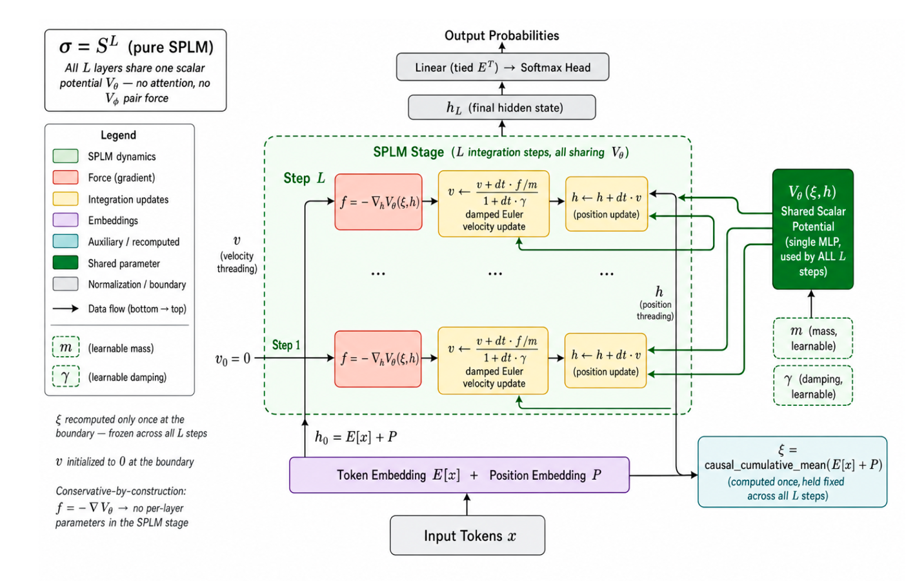

model.py – the base ScalarPotentialLM class

model.py – the ScalarPotential class
The class ScalarPotential obviously models $V_{θ}\left(ξ,h\right)$. Recall, the conservative (curl-free) force is given with $f =-∇_{h}V_{θ}\left(ξ,h\right)$.

Linear($2d$ $→$ $d_{V}$) $→$ GELU $→$ [Linear$\left(d_{V}→ d_{V}\right)→$ GELU] $×$ $\left(n_{V}-1\right)→$ Linear$\left(d_{V}→ 1\right)$

So in the Shakespeare config, 2·128 → 512 → 512 → 512 → 1 with GELU nonlinearities, ending in a scalar head.
The final 1-unit output makes $V_{θ}$ a scalar field $R^{2d}→R$, so that ${-∇}_{h}V_{θ}\left(ξ,h\right)$ is a conservative (curl-free) force rather than an arbitrary vector field. Here the parameter $θ$ refers to the MLP weights.
Thus, the signature of the scalar potential $V$ is : parameters (the MLP weights) $θ$, inputs $\left(ξ,h\right)$.
$ξ$ plays very specific asymmetric role among the two inputs which is central to the question why the architecture is conservative.
The force is given with $f =-∇_{h}V_{θ}\left(ξ,h\right)$ and the gradient is taken only with respect to $h$, never $ξ$.
In the code: torch.autograd.grad(V, h_in, ...) differentiates w.r.t. h_in alone, and $ξ$ is fed in detached ( h.detach() before causal_cumulative_mean ). So during the integration step, $ξ$ is frozen – a conditioning variable, held constant while the differentiation on $h$ is performed.
Thus, for a fixed $ξ$, the map $h↦V_{θ}\left(ξ,h\right)$ is an “honest” scalar potential and the step is pointwise conservative. $ξ$ acts as a context-dependent reshaping of which scalar potential the token currently feels – different tokens (and, in the re-pooled variants, different layers) see different slices $V_{θ}\left(ξ,∙\right)$ of the same underlying two-argument function, but each slice is still a scalar field in $h$.
The scalar potential $V_{θ}$ is an MLP whose learned weights are $θ$; it takes two inputs $\left(ξ,h\right)$; $ξ$ is a frozen conditioning input that selects a potential slice while $h$ is the differentiation variable which negative gradient is the conservative force. $V_{ψ}\left(h\right)$ with no argument $ξ$ cannot represent the $ξ$-conditioning. The missing conditioning is one of the two factors which are the source of the gap between the oracle’s 0.931 and the perfect 1.0 on the LN variant.

Where is $V_{θ}$ defined?
In model_sarf_mass.py (inherited unchanged by the LN model) , V_theta is an attribute of the model, constructed once:

class ScalarPotentialLMSARFMass(nn.Module):
def __init__(self, cfg):
...
self.V_theta = ScalarPotential(cfg.d, cfg.v_hidden, cfg.v_depth)

and the ScalarPotential is the MLP

class ScalarPotential(nn.Module):
def __init__(self, d, hidden, depth):
layers = [nn.Linear(2 * d, hidden), nn.GELU()]
for _ in range(depth - 1):
layers += [nn.Linear(hidden, hidden), nn.GELU()]
layers += [nn.Linear(hidden, 1)]
self.net = nn.Sequential(*layers)
...
def forward(self, xi, h):
return self.net(torch.cat([xi, h], dim=-1))
The learnable weights here - self.V_theta.net.parameters() are $θ$.

A Note on the oracle fit
The oracle (splm_oracle_fit.py) is the ordinary shared-potential regression with one substitution – instead of training a fresh generic $V_{ψ}\left(h\right)$, it plugs in the model’s own learned $V_{θ}\left(ξ,h\right)$ and fits only the two per-layer scalars by closed-form least squares ( function fit_scalars – see Appendix)

$∆h_{l}≈^{?}α_{l} v_{l}-β_{l}{ ∇}_{l}V_{θ}\left(ξ_{l},h_{l}\right)$, $v_{l}≔h_{l}-h_{l-1}$

Two observations from extract_oracle_tuples (shown in the Appendix):
The gradient regressor $G_{l}$ (GV[l] in the code) is not a freshly trained generic potential: it is grad_h V_theta(xi, h_l), the gradient of the model's own learned scalar potential, evaluated at the exact hidden states h_l the model visits when it replays the sentence. The oracle does not re-learn an energy landscape — it reuses the one the network already learned and only asks how well a single per-layer rescaling of that landscape's force reproduces the observed motion.

The velocity regressor is reconstructed by finite differences. In build_pools the per-step velocity proxy is v_l = H[l] - H[l-1] and the regression target is the next displacement Delta h_l = H[l+1] - H[l]. These are exactly the two ingredients of the damped semi-implicit Euler update, so the two-scalar ansatz Delta h_l ~ alpha_l * v_l - beta_l * grad_h V_theta(xi, h_l) is not an approximation of the dynamics — it is the dynamics, written with the integrator constants left free.
To see why, expand the update used during extraction. With v_{l+1} = (v_l + dt*f_l/m)/(1 + dt*gamma) and f_l = -grad_h V_theta, the displacement is
Delta h_l = dt * v_{l+1}
= (1/(1+dt*gamma)) * v_l_proxy - (dt^2 / (m*(1+dt*gamma))) * grad_h V_theta,
where v_l_proxy = dt * v_l. This is precisely alpha_l * v_l + beta_l * (-grad_V) with the closed-form values alpha_l = 1/(1+dt*gamma) and beta_l = dt^2 / (m*(1+dt*gamma)). The least-squares step in fit_scalars simply recovers these two constants per layer.
Consequently the oracle is an upper bound, not a model. For the reference (vanilla) architecture, where xi is held fixed and no projection is applied, the displacement is an exact linear combination of the two regressors and the fit is numerically perfect: splm_oracle_fit.py returns R^2 = 1.0000 at every layer. That figure is the right consistency check — it confirms that the extracted (H, GV, XI) tuples and the integrator algebra agree to machine precision.
The LayerNorm-after-step variant (model_ln.py) lands lower, at R^2 ~ 0.931. The shortfall has a single structural cause: after every step the state is projected back onto the unit-LayerNorm shell, h_{l+1} <- (h_{l+1} - mu)/(sigma + eps), a non-affine map. The observed displacement is then Delta h_l = project(h_l + dt*v_{l+1}) - h_l, which is no longer an exact linear combination of v_l and -grad_V; the per-layer two-scalar model captures the projected motion only up to the curvature of the shell, and that residual is what separates 0.931 from 1.0. The gap is the price the LN variant pays for a guaranteed finite energy minimum (see Module model_ln.py), not evidence that its force is any less conservative.
Read together, the two numbers bracket the question the shared-potential separator asks. The oracle (true V_theta(xi, h): R^2 = 1.0000 base / 0.931 LN) is the upper bound reachable when the regressor is the model's own context-conditioned potential. The step-2 fit of a generic, context-free V_psi(h) shared across layers sits below it: dropping the xi argument removes the per-token slice selection that V_theta exploits, so a single V_psi(h) cannot represent the context-dependent reshaping of the landscape. The distance between the generic-V_psi fit and the oracle measures exactly how much of SPLM's per-layer motion is context-driven rather than position-in-state-space-driven.

Training the SPLM : Learning the Reference Scalar Potential

The reference scalar potential is learned end-to-end with a single objective and no trajectory-level supervision. The base model ScalarPotentialLM is trained by train_splm.py; the SARF-mass and LayerNorm variants by train_splm_em_ln.py ([4]). In every case the only loss is next-token cross-entropy on the tied-embedding logits logits = h_L @ E^T. There is no auxiliary penalty on the velocity, the potential, the per-step displacement, or the trajectory shape: the energy landscape V_theta, the mass m, and the damping gamma are shaped solely by the requirement that the depth-L damped flow carry the initial embedding h_0 to an endpoint h_L whose logits predict the next token.
What makes this non-trivial is that the loss gradient must pass through the force computation at every step. Inside integrate, the force is itself a gradient: grad_V, = torch.autograd.grad(V, h_in, create_graph=self.training, retain_graph=True). The flag create_graph=self.training keeps that inner gradient inside the autograd graph during training, so backpropagating the cross-entropy loss differentiates through the gradient of V_theta — a second-order (double-backward) computation. The optimizer therefore receives dL/dtheta terms that already account for how a change in the potential reshapes the force field at each of the L shared steps. This is the mechanism by which a single shared V_theta learns a genuine force law, rather than L independent layers learning arbitrary maps.
The optimization recipe is deliberately plain. The optimizer is AdamW (betas (0.9, 0.95) in the em_ln trainer) with weight decay 0.01 for the Shakespeare runs and 0.0 for smoke. The learning rate follows a cosine schedule with linear warmup (lr_schedule): 20 warmup steps (smoke) or 200 (Shakespeare), then cosine decay to zero. Gradients are clipped to a global norm of grad_clip = 1.0 (nn.utils.clip_grad_norm_) before every step — this clip matters early in training, when the integrator can briefly amplify gradients before V_theta has settled into a stable basin. Training runs for 300 steps (smoke) or 4000 steps (Shakespeare). The core loop is:

for step in range(train_cfg["steps"]):
lr_now = lr_schedule(step, lr, warmup_steps, steps)
for g in optim.param_groups:
g["lr"] = lr_now
x, y = get_batch(train_ids, batch_size, block_size, rng)
_, loss = model(x, y) # forward = L damped EL steps + CE loss
optim.zero_grad(set_to_none=True)
loss.backward() # double-backward through the force
grad_norm = nn.utils.clip_grad_norm_(model.parameters(), grad_clip)
optim.step()

The mass and damping are optimized jointly with the potential, parametrized through softplus so they remain positive: m = softplus(raw_m) + 1e-3 and gamma = softplus(raw_gamma). For the damping sweep the damping is instead pinned to a constant via cfg.fixed_gamma, in which case raw_gamma is frozen and the gamma property returns that fixed value. Experiment A's learned damping settles near gamma ~ 0.30, giving a per-step velocity retention 1/(1+dt*gamma) ~ 0.77 at dt = 1.0 — the flow keeps most of its momentum between layers rather than collapsing immediately onto the nearest minimum.
At the end of training the checkpoint stores the full config (model_cfg), the state dict, the final validation loss / perplexity, the final gamma, and a variant tag ("sarf_mass_ln" for the LN model). The tag is what later lets the extractors and the oracle (splm_oracle_fit.py, extract_oracle_tuples) reconstruct the correct subclass and replay the exact dynamics that produced the trained potential.

One Scalar Potential for Every Layer (shared_potential_fit.py)
Everything up to this point has described how to build a conservative-by-construction language model and how to train it. The natural next question is diagnostic rather than constructive: given a trajectory of hidden states — from our model or from a black-box transformer — how do we test whether its dynamics is genuinely the gradient flow of a single energy? shared_potential_fit.py answers the strictest possible version of that question.

The test is deceptively simple to state. Pool, across every interior layer, every token and every sentence, the triple of centered position x_l, velocity proxy v_l = x_l - x_{l-1} and one-step displacement Delta x_l = x_{l+1} - x_l. Then fit a single neural scalar V_psi(x), shared across all layers, together with per-layer scalars alpha_l, beta_l, to the ansatz Delta x_l ~= alpha_l v_l - beta_l grad V_psi(x_l). The interesting word is *single*. A per-layer symmetric operator (the subject of the next section) is a weak constraint; demanding that one smooth scalar explain twelve layers of behaviour at once is a far stronger one, and it is exactly the property that distinguishes a true physical potential from a layer-wise curve-fit.

Two design choices make the result trustworthy rather than merely suggestive. First, the per-layer scalars are initialised to zero, so the fit begins as the static null Delta x = 0 and has to earn every fraction of explained variance:

alpha = nn.Parameter(torch.zeros(L)) # start as the static null ...
beta = nn.Parameter(torch.zeros(L)) # ... and earn every bit of variance
# ...
y_pred = alpha[lb].unsqueeze(-1) * vb - beta[lb].unsqueeze(-1) * gV
loss = F.mse_loss(y_pred, yb) + 1e-5 * torch.mean(gV ** 2)

Second, the script reports three *nested* baselines — static null, velocity-only alpha_l v_l, and the full velocity-plus-shared-V fit — each a strict subset of the next. Because they are nested, any gain the shared potential shows over the velocity-only baseline cannot be an artifact of momentum; it is attributable to the conservative force and nothing else. The small 1e-5 * mean(gV**2) penalty keeps the learned potential from inflating its own gradient to cheat the residual.

The deepest insight is in the asymmetry of what we expect. Our SPLM passes this test *by construction* — its dynamics literally is the gradient of one scalar V_theta — so a high held-out R^2 there is a positive control confirming the diagnostic itself is sound. The scientific payload is what happens to a *pretrained transformer*: does the composition of attention, MLP and LayerNorm across all layers admit any single smooth potential, or does it not? Reporting R^2 on held-out sentences, rather than the training pool, turns this from a curiosity into a falsifiable claim about whether attention dynamics is conservative at all.

Symmetry as a Fingerprint of Conservative Flow (jacobian_symmetry.py)
If the shared-potential fit is the strict global test, jacobian_symmetry.py is the sharp local one. It rests on a single fact from mechanics: the linearisation of a gradient flow is the Hessian of a scalar, and Hessians are symmetric. So if we fit a per-step linear operator M_l to the transition x_{l+1} - x_l ~= M_l x_l on a principal-component subspace, then constraining M_l = M_l^T should cost essentially nothing whenever the underlying flow is conservative. Symmetry is a *fingerprint*: a necessary signature that a hidden scalar energy is in charge.

The most interesting idea in the module is a methodological warning about how this test can be done *wrong*. A naive position-only fit Delta x ~= M x is confounded for second-order damped dynamics, because a single step mixes the position x_l with the hidden velocity v_l ~= x_l - x_{l-1}. That mixing can manufacture apparent asymmetry even in a flow that is genuinely conservative — meaning a careless 'GPT-2 looks asymmetric' conclusion drawn from a position-only fit could be an artifact of the diagnostic, not a property of the model. The fix is to make the fit velocity-aware, regressing on the concatenated design [X | V] so that an unconstrained A absorbs the velocity term while M — now the clean per-step spring matrix — is the only operator whose symmetry is judged:

# position-only (confounded for 2nd-order dynamics): y = M x
# velocity-aware (the clean test):
Phi = np.concatenate([Xc, Vc], axis=1) # [X | V]
B = np.linalg.solve(Phi.T @ Phi + reg, Phi.T @ Yc).T
M_full, A_full = B[:, :k], B[:, k:] # M is the spring matrix; A absorbs v

There is also a small piece of implementation elegance worth pointing out. Rather than running a constrained optimiser to enforce M = M^T, the module parameterises M by the free entries of its upper triangle and builds a design matrix in which each off-diagonal parameter (i, j) feeds both output channel i (through predictor j) and channel j (through predictor i). The symmetry constraint then falls out of an ordinary least-squares solve — no projection, no iteration.

What makes the diagnostic decisive is the size of the contrast it produces. For the attention transformers in the companion failure study, the unconstrained fit reaches R^2 in [0.5, 0.8] while the symmetric fit goes negative — worse than predicting the mean displacement. That is not a model that is slightly asymmetric; it is a flow dominated by a non-Hessian, rotational component that no scalar potential can ever reproduce. Our SPLM, run through the identical code, is expected to show the symmetric fit tracking the unconstrained one layer by layer — the fingerprint of the conservativity it was built to have.

A Note on the Causal Probe (causal_probe.py)
The final diagnostic guards against the subtlest failure mode of the entire construction, and its story is the most cautionary. Recall that the conservative force is the gradient of a sum of potentials over positions, f(t) = -d(sum_t' V[t']) / dh[t]. The moment the context vector xi is built as a causal running average that itself includes h[t], differentiating that summed energy picks up off-diagonal terms dV[t']/dh[t] for t' > t. In other words, the very elegance that makes the architecture physical — force as the gradient of a global energy — quietly opens an *anti-causal channel*, and a trained V_theta will happily learn to route information backwards through it, leaking future tokens into past predictions and producing a 'too good to be true' validation loss that is, in fact, cheating.

The insight worth dwelling on is that this bug is not a coding slip; it is a structural hazard specific to energy-based, differentiate-the-objective architectures. A standard decoder never differentiates a summed loss to produce its forward activations, so it cannot leak this way. The fix is a single token — compute xi from h.detach(), severing the autograd path from the context back to the state — and it is exposed everywhere as a causal_force: bool = True config field:

# leak: xi = causal_mean(h) -> d(sum_t' V[t'])/dh[t] picks up t' > t
# fix: xi = causal_mean(h.detach()) # sever the anti-causal autograd path

causal_probe.py converts that fix into a falsifiable, exact test. It perturbs a single token at position t_pert, runs two forward passes, and measures the largest change in any logit strictly before the perturbation. For a correct autoregressive model this number must be zero — not small, but zero to machine precision. Seeding the buggy and fixed models identically so they share weights isolates the entire difference to the detach:

pre_f, _, _ = causal_violation_probe(model_fixed, vocab_size=257)
ok_fixed = pre_f < 1e-6 # the fixed model MUST be causal to machine precision

Two things elevate this from a unit test to a trust anchor. First, the same probe is run unchanged on natural transformers — a local MatchedGPT checkpoint, or gpt2 and EleutherAI/pythia-160m from the Hub — where the causal-side delta is zero by construction of the attention mask. Holding our physics-style model to the identical standard as a vanilla decoder is what licenses comparing their perplexities at all. Second, with --strict the probe exits non-zero on any violation, so it can sit in a continuous-integration gate. The result is a clean separation between belief and proof: the headline efficiency and perplexity numbers elsewhere in this document are quotable precisely because this probe certifies that the conservative dynamics never once looked at the future.

References
[1] Gueorguiev, D. (2026). Locally Conservative, Globally Not: Diagnosing the Lagrangian Structure of Pretrained Transformers. Preprint: Zenodo & SSRN. GitHub: https://github.com/dimitarpg13/paper_tmlr_1

[2] Gueorguiev, D. (2026). Semantic Simulation: A Prescriptive Lagrangian Framework for Efficient Semantic Inference. Preprint: Zenodo & SSRN. GitHub: github.com/dimitarpg13/semsimula-paper

[3] https://github.com/dimitarpg13/paper_tmlr_1/blob/main/notebooks/conservative_arch/model_sarf_mass.py

[4] https://github.com/dimitarpg13/paper_tmlr_1/blob/main/notebooks/conservative_arch/ln_damping_sweep/train_splm_em_ln.py

[5] https://github.com/dimitarpg13/paper_tmlr_1/blob/main/notebooks/conservative_arch/splm_oracle_fit.py

[6] https://github.com/dimitarpg13/paper_tmlr_1/blob/main/notebooks/conservative_arch/train_splm.py

[7] https://github.com/dimitarpg13/paper_tmlr_1/blob/main/notebooks/conservative_arch/trajectory_extraction.py

[8] https://github.com/dimitarpg13/paper_tmlr_1/blob/main/notebooks/conservative_arch/shared_potential_fit.py

[9] https://github.com/dimitarpg13/paper_tmlr_1/blob/main/notebooks/conservative_arch/jacobian_symmetry.py

[10] https://github.com/dimitarpg13/paper_tmlr_1/blob/main/notebooks/conservative_arch/token_direction_fit.py

[11] https://github.com/dimitarpg13/paper_tmlr_1/blob/main/notebooks/conservative_arch/causal_probe.py

[12] Byte-Pair Encoding Tokenization, LLM Course, Hugging Face

[13] Semantic Tube Prediction : Beating LLM Efficiency with JEPA, Hai Huang, Yann LeCunn, Randall Balestriero, 2026

[14] Mathematical Framework of Transformer Circuits, Nelson Elhage et al, Anthropic, 2021

[15] Analytic Multi-Channel Integration in a Single Structured $V_{θ}$ Well, companion note to [2], 2026

[16] Gaussian Mixture Model Clearly Explained, R. Ravihara, Towards Data Science, 2023

[17] The Elements of Statistical Learning, Section 8.5: The EM Algorithm and Section 12.7: Mixture Discriminant Analysis, T. Hastie, R. Tibshirani, J. Friedman, print 12, 2017

Appendix

Note on multi-$ξ$ context channels and K-EMA

Role of $ξ$ in the Euler-Lagrange step

At each integration layer the hidden state $h_{t}∈R^{d}$ of token t is driven by a conservative force from a scalar potential that is allowed to depend on a causal context summary $ξ_{t}$:

$m_{t}{\ddot{h}}_{t}+γ{\dot{h}}_{t}=-∇_{h_{t}}V_{θ}\left(ξ_{t},h_{t}\right)$ (a1.ode)

(In the related models PARFLM, Fock-PARFLM there are additional pair and Fock terms which do not replace $ξ$.)

Without $ξ$, $V_{θ}\left( ∙ ,h_{t}\right)$ would be a memoryless well: token $t$ would feel only its own current state. $ξ$ is the mechanism by which past hidden states enter the single-particle potential while remaining a fixed external field for the $h_{t}$-gradient (so the force stays causal and conservative in $h_{t}$).

In the SARF-faithful stack, $ξ$ is recomputed at every layer from the current $h$-stream, not frozen from layer-0 embeddings. Implementation: causal_force=True feeds h.detach() into the $ξ$ block so autograd cannot route future $V_{θ}$ values back into past tokens (that is the anti-causal leak that collapsed pre-fix multi- $ξ$ PPL).

Single channel : rank-1 causal mean

The original SPLM / SARF construction uses one context vector, the causal cumulative mean

$ξ_{t}=\frac{1}{t}\sum_{s≤t}{h_{s}}$ (ccm.1)

(causal_cumulative_mean in sarf_variant/model_sarf.py)

Then,

$V_{θ} : R^{2d}→R$ , $input = cat\left(ξ_{t},h_{t}\right)$

This is a rank-1 summary of the prefix : any two prefixes with the same arithmetic mean of hidden states are indistinguishable to $V_{θ}$. Attention, by contrast, mixes the prefix in a content-conditioned way. The single- $ξ$ bottleneck (demonstrated by experiment E11/R6 ladder available in the companion repo) is the structural reason the multi-channel extension exists.

K-EMA : $K$ causal weighted averages at several horizons

Multi- $ξ$ replaces the one mean with $K$ parallel exponential kernels (MultiChannelXi in multixi/model_multixi.py).
Channel $k$ has a decay $α_{k}∈\left(0,1\right)$:

$W_{k}\left[t,s\right]=\frac{α_{k}^{t-s}}{\sum_{r≤t}{α_{k}^{t-r}}}$ $\left(s≤t\right)$ , $W_{k}\left[t,s\right]=0$ $\left(s>t\right)$ , $ξ_{t}^{\left(k\right)}=\sum_{s≤t}{W_{k}\left[t,s\right]h_{s}}$ (chk.1)

Weights in (chk.1) are built with in log-space and are row-normalized with logsumexp , so each row sums to $1$ even for $α$ near $0$ or $1$.

Endpoint interpolation (this is the implemented kernel, not the classical IIR EMA):

- $α_{k}→0 : W_{k}=I$, so $ξ_{t}^{\left(k\right)}=h_{t}$ (no past);
- $α_{k}→1 : W_{k}$ is the causal uniform mean , so $ξ_{t}^{\left(k\right)}$ recovers the single- $ξ$ baseline;
- $α_{k}∈\left(0+ε,1-ε\right)$ where $ε>0$ is small enough but fixed : a causal weighted mean with effective horizon $τ_{k} \sim 1/\left(1-α_{k}\right)$.

The architecture therefore is strict superset : driving $α_{k}→1$ recovers the old context; other channels can keep shorter or longer memory.
Note that this interpolation (chk.1) is not the same as the textbook recurrence

$ξ_{t}=αξ_{t-1}+\left(1-α\right)h_{t}$ (iir.1)

That IIR form is unnormalized and its limit $α→1$ limit freezes early tokens rather than recovering the cumulative mean. In [2], (iir.1) is denoted as R6.h.0. With (iir.1) when $α_{k}→0$ $ξ_{t}^{\left(k\right)}=h_{t}$ like with (chk.1), however when $α_{k}→1$ $ξ_{t}^{\left(k\right)}≈ξ_{t-1}^{\left(k\right)}$ (memory freezes).

The code in the companion repo uses the row-normalized kernel (chk.1) above with $α_{k}=sigmoid\left({raw}_{k}\right)$ which guarantees $α_{k}∈\left(0,1\right)$. The decays $α_{k}$ can be frozen or learnable (xi_learnable). All current models in the SPLM family use learnable decays.

Default Configuration : $K = 4$ (config field xi_channels)
Init mode | Typical $α$ | Horizons (tokens, $τ \sim 1/\left(1-α\right)$)
Explicit (R6.h.0) | $0, 0.5, 0.9, 0.99$ | $≈1, 2, 10, 100$
Log-spaced (R6.h.1)) | $$α_{k}=1-τ_{max}^{-\frac{k}{\left(K-1\right)}},τ_{max}=100$$ | $≈1, 4.6, 21.5, 100⇒ α≈0., 0.785, 0.954, 0.99$

Log-spacing is the prior that relevant linguistic timescales are scale-free up to a paragraph length: horizons sit on a geometric grid rather than on an ad-hoc list.

Forward shape: $h∈R^{B×T×d}⟼ξ∈R^{B×T×d×k}$.

Note on the hidden width of the MLP $V_{θ}$

This note is on the difference between the hidden width of MLP $V_{θ}$ denoted with $d_{V}$ and the number of hidden dimensions of the embeddings (or state) $d$. $d_{V}$ and $d$ represent different widths for two different objects.
The hidden state dimensions width $d$ represents the fact that each semantic particle (vector embedding of a token) lives in $R^{d}$ (the current TinyStories scale-up model code uses $d=256$; some of the previous experiments used $d=192$ and $d_{V}=768$). $d_{V}$ is the MLP width of the scalar potential $V_{θ}\left(ξ,h\right)$. That network is not a residual stream and it maps a concatenated input to one energy:

layers: List[nn.Module] = [nn.Linear(2 * d, hidden), nn.GELU()]
...
layers += [nn.Linear(hidden, 1)]
def forward(self, xi: torch.Tensor, h: torch.Tensor) -> torch.Tensor:
return self.net(torch.cat([xi, h], dim=-1))

So, the first layer already sees
//TODO:

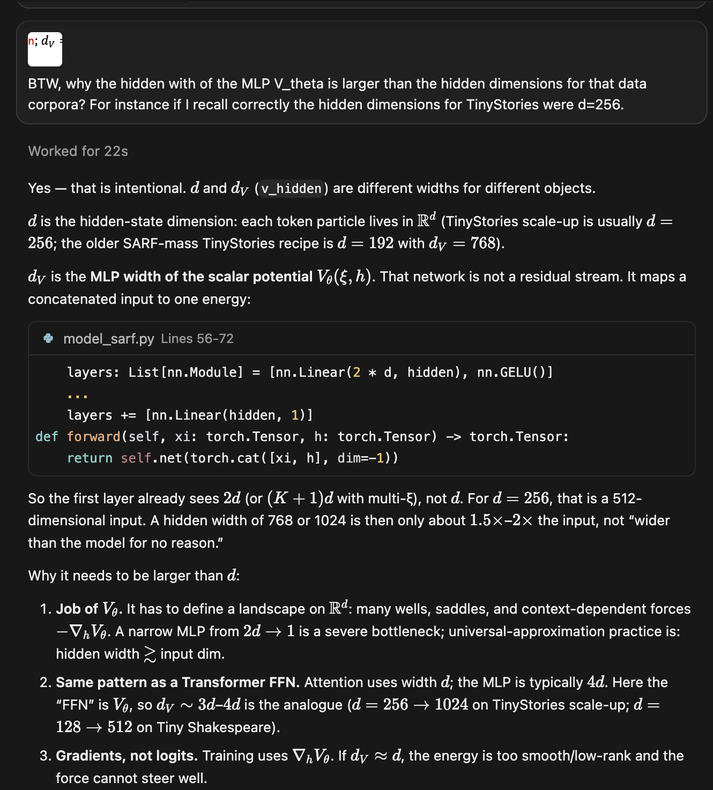

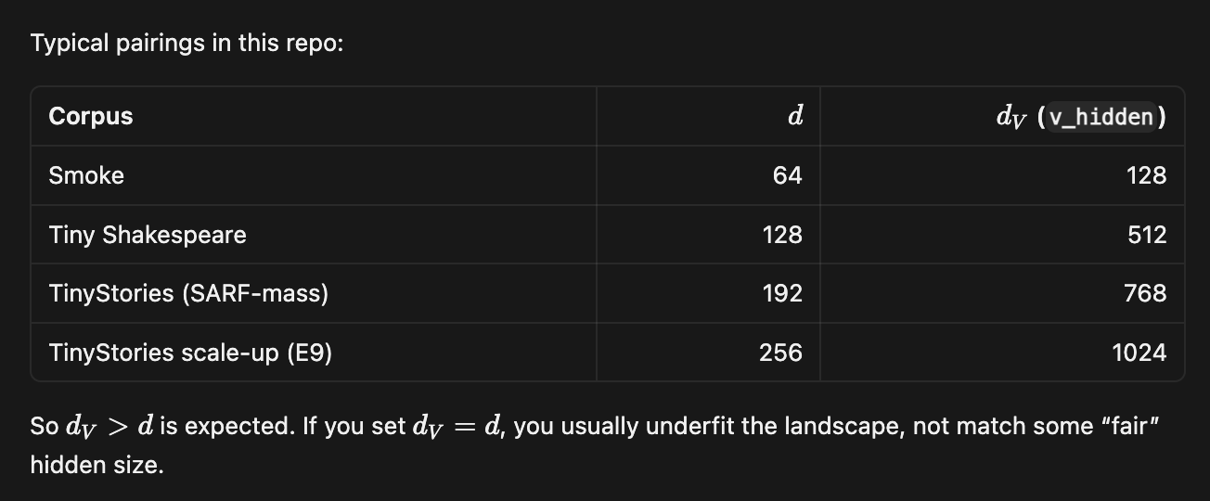

How MLP $V_{θ}$ consumes the bank of context channels $ξ_{t}^{\left(k\right)}$

The original energy is defined as MLP (GELU stack) on the concatenated pair $\left(ξ,h\right).$Multi-$ξ$ only widens the first linear map:

$V_{θ} : R^{\left(K+1\right)d}→R$ , $input = cat\left(ξ_{t}^{\left(1\right)},…,ξ_{t}^{\left(K\right)},\right)$
Thus, ScalarPotential is $2d→v_{hidden}→⋯→1$, while ScalarPotentialMultiXi is $\left(K+1\right)d→v_{hidden}→⋯→1$. $v_{hidden}$ (in code v_hidden) typically $3d-4d$ e.g. With TinyStories we set $d = 256$, $v_{hidden}=1024$. The $α_{k}$’s are $K$ scalars.

Because the MLP hidden layers mix all $\left(K+1\right)d$ coordinates, they can in principle use cross-horizon correlations (short-timescale $ξ$ vs long-timescale $ξ$ vs current $h$). That is why the MLP reference on TinyStories benefits from $K_{ξ}=4$ relative to single- $ξ$ whereas a diagonal-structured well bank often does not (in [2] : doubling $K_{ξ}$ from 4 to 8 did not help SQ3; the MLP baseline at $K_{ξ}=4$ reached lower PPL compared to its structured counterpart at $K_{ξ}=8$).

Structured and Gaussian $V_{θ}$ : flatten, then project

Structured potentials (quadratic (SQ3), isotropic and anisotropic Gaussians) were originally designed for single context vector of dimension $ξ_{d}$. The multi-$ξ$ adapters do not use new geometry to incorporate the multiple channels in the well – they simply flatten the bank:

$ξ_{flat}=reshape\left(ξ\right)∈R^{K_{ξ}d}$ , $V=V_{inner}\left(ξ_{flat},h\right)$

- StructuredVThetaMultiXiAdapter – quadratic / LSE mixtures ; inner xi_d = K_xi*d in code.

- GaussianVThetaMultiXiAdapter – same flatten into mu_proj, a_proj, and w_proj.

Well centers (mu_proj), precisions (a_proj), and mixture weights (w_proj) then become linear functions of the concatenated multi-resolution summary. A later variant, MultiContextGaussianVTheta, gives each $ξ^{\left(k\right)}$ its own well bank and sums $V =\sum_{k}{V_{k}\left(ξ^{\left(k\right)},h\right)}$ , so attractors are not forced to read a blurred $K_{ξ}d$ vector. That is an expressivity choice on top of K-EMA, not a change to the EMA itself. Specifically, the $k$-th well bank $V_{k}\left(ξ^{\left(k\right)},h\right)$ in MultiContextGaussianVTheta is given as

$V_{k}\left(ξ^{\left(k\right)},h\right)=-\sum_{j=1}^{K_{w}}{W_{j}^{\left(k\right)}\left(ξ^{\left(k\right)},h\right)}$ (mcgvt.1)

The $j$-th term $W_{j}^{\left(k\right)}\left(ξ^{\left(k\right)},h\right)$ in the RHS of (mcgvt.1) represents a single Gaussian well:

$W_{j}^{\left(k\right)}\left(ξ^{\left(k\right)},h\right)=w_{j}^{\left(k\right)}\left(ξ^{\left(k\right)}\right)\exp\left(-\frac{1}{2}{\left(h-μ_{j}^{\left(k\right)}\right)}^{T}P_{j}^{\left(k\right)}\left(h-μ_{j}^{\left(k\right)}\right)\right)$ (mcgvt.2)

Finally, the total structured potential $V_{θ}$ , abbreviated with $V$, is the sum of all banks:

$V=\sum_{k=1}^{K_{ξ}}{V_{k}\left(ξ^{\left(k\right)},h\right)}$ (mcgvt.3)

Note on structured $V_{θ}$ : Well Banks, Well Centres, Well Precisions, Well Mixture weights and their projections

Definition Bank
Bank is one copy of structured well module: a mixture model (e.g. GMM) with its own projections, producing one scalar potential from one context vector $ξ$ and hidden state $h$.

The number of wells in the bank is denoted with $K_{w}$ in general. In older companion notes and in [2] in the context of using mixture models to construct $V_{θ}$ we use $K_{mix}$ to denote the number of wells in the mixture model.
For example, in MixtureQuadraticVTheta which represents the SQ3 variant of quadratic $V_{θ}$ we use the following component mixture representation of the scalar potential $V_{θ}=-τ\log{\sum_{k=1}^{K_{mix}}{π_{k}e^{-E_{k}/τ}}}$. In this formula we have $K_{mix}$ components with weights $π_{k}$ with energies $E_{k}$ , combined by log-sum-exp.

How are banks assembled?

- one bank (concat / joint): V_theta.banks has length 1. That bank’s $d_{in}$ is $d$ or $K_{ξ}d$. The context channels are no longer per bank, all channels feed this one mixture.
- additive multi-context: n_ctx banks, banks[m] reads only $ξ^{\left(m\right)}$ with $d_{m}=d$. Then $V_{θ}=\sum_{m}{V_{bank}^{\left(m\right)}}$. For example, in many of our recent models we use 5 banks with 8 wells each abbrev. 5 heads $×$ 8 wells.

One Bank (Concat / Joint)
Implemented via Concat Adapters in quadratic $V_{θ}$ (SQ3) and early Gaussian implementations.
Flatten $ξ↦R^{K_{ξ}d}$, one mixture, ${d_{in}=K}_{ξ}d$. No V_theta.banks or not used in the usual way.
Concat adapters are :
- StructuredVThetaMultiXiAdapter – used in the quadratic $V_{θ}$ implementation SQ3 MixtureQuadraticVTheta. Used on Multi- $ξ$ SPLM / PARFLM / Fock-PARFLM v2.1 (A1–A5, Phase 4 OWT SQ3)
- GaussianVThetaMultiXiAdapter - used in isotropic MixtureGaussianVTheta and in SARFGaussianVTheta. Used on hybrid Gaussian–quadratic notebook and in Phase 5 SARF/Gaussian concat arms.
There is also a newer implementation which uses one Joint Bank (see [15])
- JointContextAnisotropicGaussianVTheta – used in AnisotropicDepthConditionedGaussianVTheta , code : model_aniso_gaussian_vtheta.py.

The well centres are denoted with $μ_{k}∈R^{d}$. The diagonal precisions are denoted with $a_{k}∈R_{>0}^{d}$ and represent the inverse variances per coordinate. The mixture weights are denoted with $w_{k}∈R$.

More recently we have studied GMMs such as MixtureGaussianVTheta and AnisotropicMixtureGaussianVTheta.
So, the inputs, parameters and outputs of those mixture models are:

- inputs : $ξ∈R^{d_{in}}$ , $h∈R^{d}$
- parameters : the bank’s mu_proj, a_proj, w_proj, (and B_proj if anisotropic)
- output: $K_{w}$ wells ${\left\{\left(μ_{k},P_{k},w_{k}\right)\right\}}_{k=1}^{K_{w}}$ and $V_{bank}\left(ξ,h\right)=-\sum_{k=1}^{K_{w}}{w_{k}\exp\left(-\frac{1}{2}{\left(h-μ_{k}\right)}^{T}P_{k}\left(h-μ_{k}\right)\right)}$

There are three maps, also denoted as projections, which are ordinary nn.Linear layers and their goal is to turn context only into Gaussian-mixture parameters:

Layer | Shape | Meaning after reshape / nonlinearity
mu_proj | $d_{in}→K_{w}d$ | Well centres $μ_{k}∈R^{d}$
a_proj | $d_{in}→K_{w}d$ | Diagonal precisions $a_{k}∈R_{>0}^{d}$ (inverse variances per coordinate)
w_proj | $d_{in}→K_{w}$ | Mixture logits $→$ softmax weights $w_{k}$

In the method MixtureGaussianVTheta::_components the following happens

$μ=reshape\left(mu_proj\left(ξ\right)\right)∈R^{K_{w}×d}$
$a = softplus\left(a_proj\left(ξ\right)\right)+{10}^{-4}$ $∈R^{K_{w}×d}$ (then optional clamp)
$w = w_{scale}∙softmax\left(w_proj\left(ξ\right)\right)∈R^{K_{w}}$

The potential for a single bank for isotropic Gaussian family is then:

$V\left(ξ,h\right)=-\sum_{k=1}^{K_{w}}{w_{k}\left(ξ\right)}\exp\left(-\frac{1}{2}\sum_{i=1}^{d}{a_{k,i}\left(ξ\right)}{\left(h_{i}-μ_{k,i}\left(ξ\right)\right)}^{2}\right)$ (igp.1)

So,

mu_proj tells us where is the well $k$. It is affine in $ξ$ because mu_proj is implemented as nn.Linear, that is: $μ\left(ξ\right)=W_{μ}ξ+b_{μ}$.
a_proj tells us how sharp well $k$ is along each axis. softplus keeps a > 0. With init_log_precision $=\log{d}, a≈\frac{1}{d}$ so $σ_{eff}≈\sqrt{d}$, matching LayerNorm scale. a_proj, being nn.Linear, renders $a\left(ξ\right)=softplus\left(W_{a}ξ+b_{a}\right)+{10}^{-4}$ which clearly is not affine transformation.
w_proj tells us which wells of the bank are on for this context ; softmax scales $\sum_{k}{w_{k}}=w_{scale}$ which is usually $1$.

Anisotropic banks add an extra map : B_proj: $d_{in}→K_{w}∙d∙r$, reshaped to $B_{k}∈R^{d×r}$ so the precision is $diag\left(a_{k}\right)+B_{k}B_{k}^{T}$. Here $r$ is the rank of the off-diagonal precision factor for each well – it is given with constructor argument rank , typically is $4$ on OWT anisotropic Gaussian Fock models. Recall, that each anisotropic Gaussian well $k$ has a factor $B_{k}∈R^{d×r}$ obtained from B_proj. The precision (inverse covariance) $P_{k}$ is the diagonal plus a rank-r PSD update:

$P_{k}=diag\left(a_{k}\right)+B_{k}B_{k}^{T}∈R^{d×d}$

$B_{k}B_{k}^{T}$ has rank of at most $r$, so the well is an ellipsoid that can tilt off the coordinate axes (correlations between hidden dimensions). rank = 0 drops B_proj and $P_{k}=diag\left(a_{k}\right)$ and we recover the isotropic bank.

Contrast with MLP $V_{θ}$
The MLP first layer sees cat$\left(ξ,h\right)$. Gaussian projections see $ξ$ only. $h$ appears only in ${\left(h-μ\right)}^{T}P\left(h-μ\right)$. That is why centres can be read off as $μ\left(ξ\right)$.

Where Does Flattening Happens?

The inner bank always assumes one context vector of length $d_{in}$. The multi-$ξ$ context state is a tensor

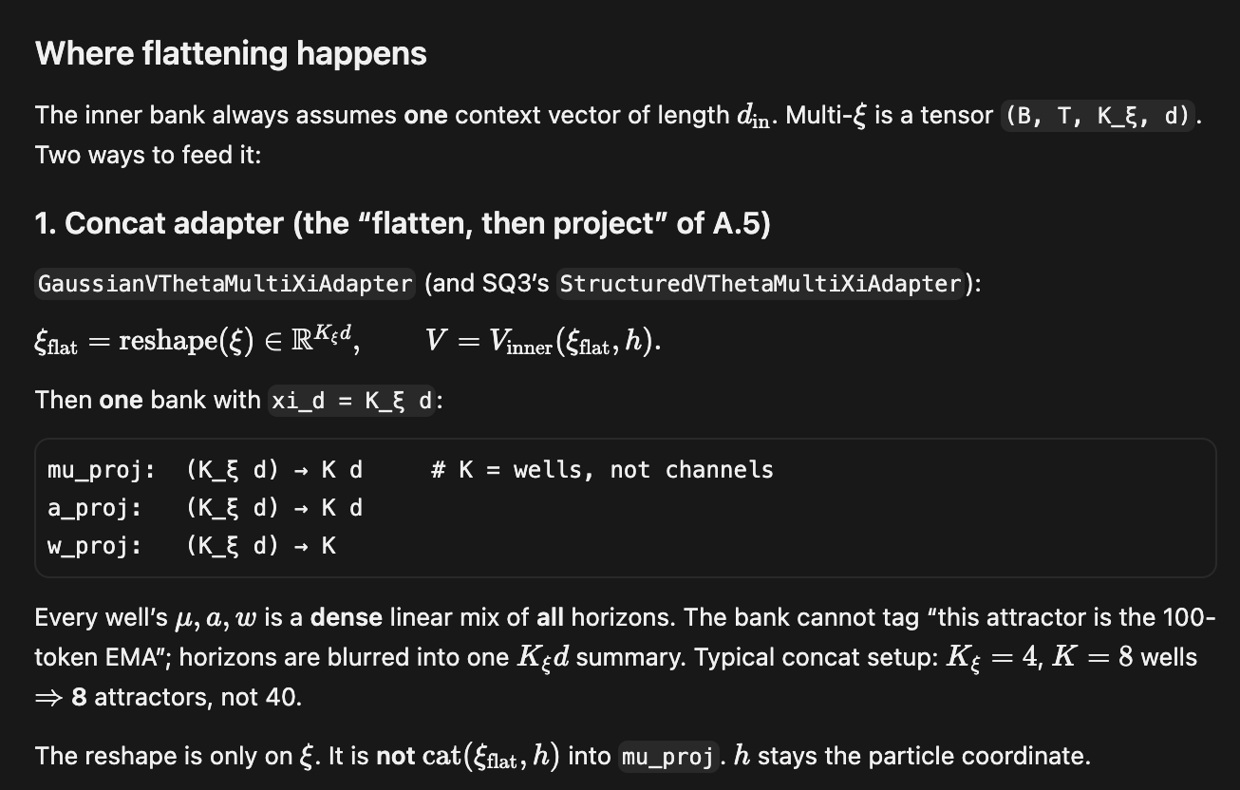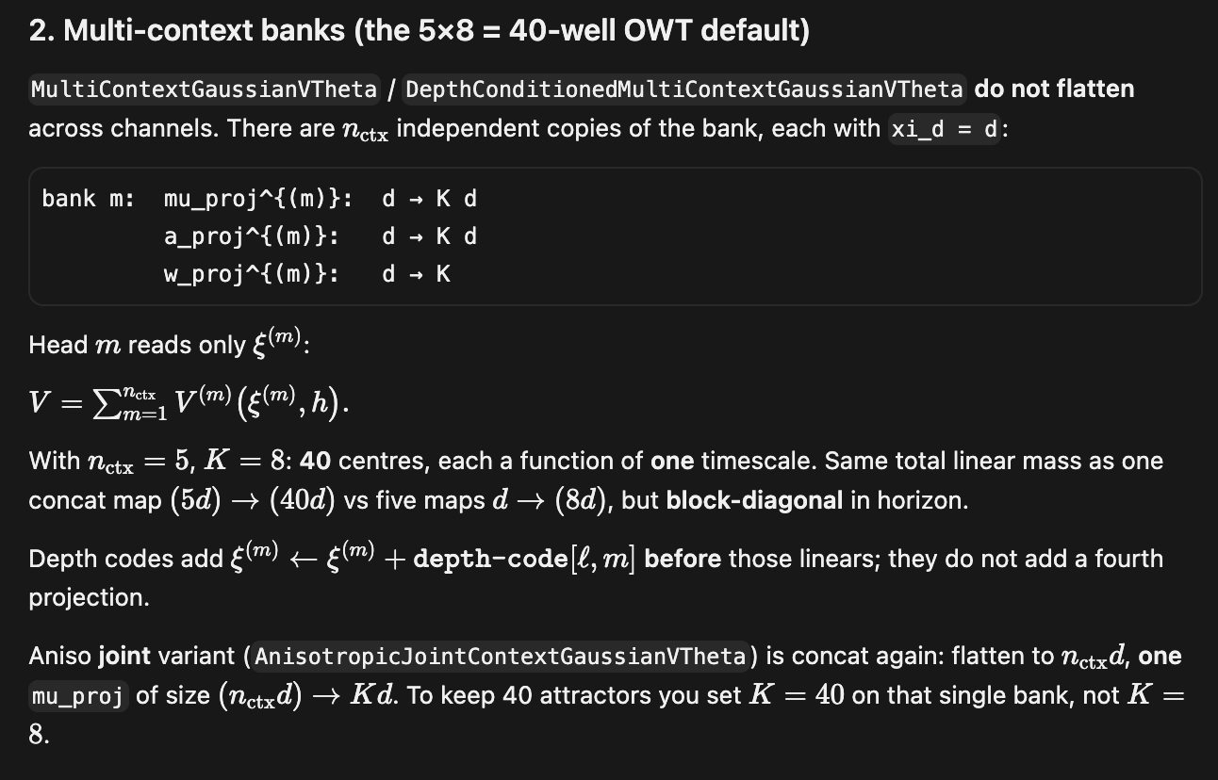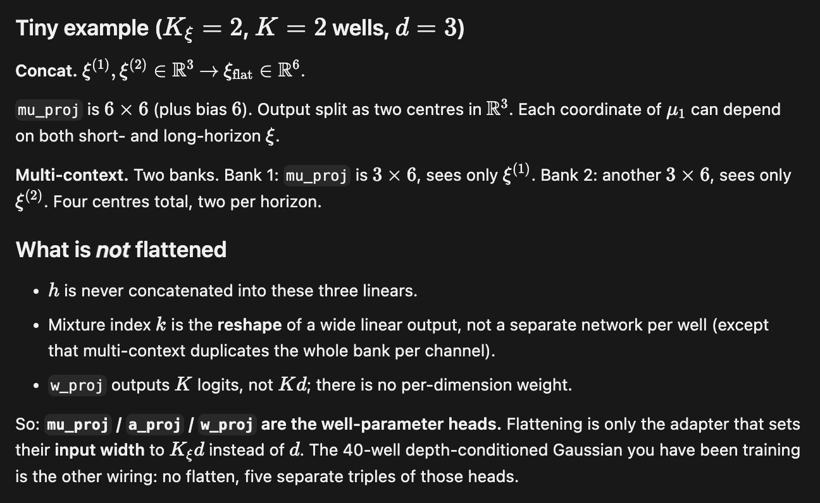

Does the anisotropic Gaussian benefit beyond 4 Channels?

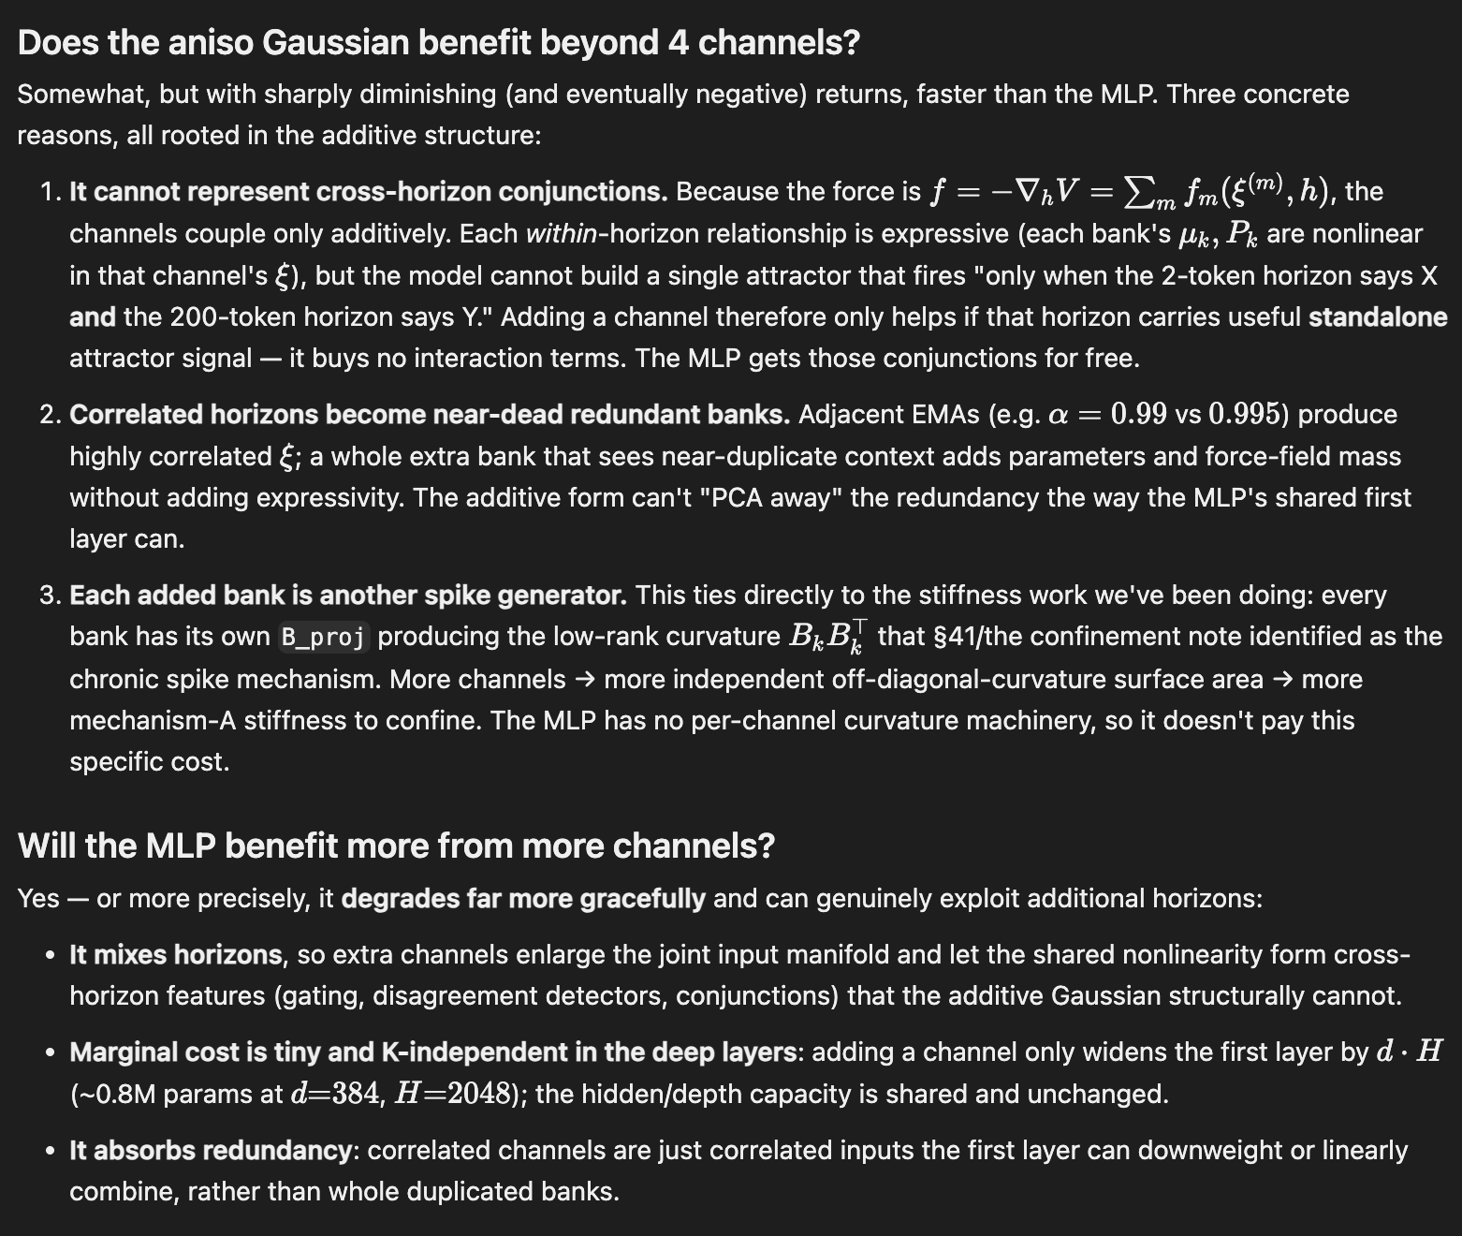
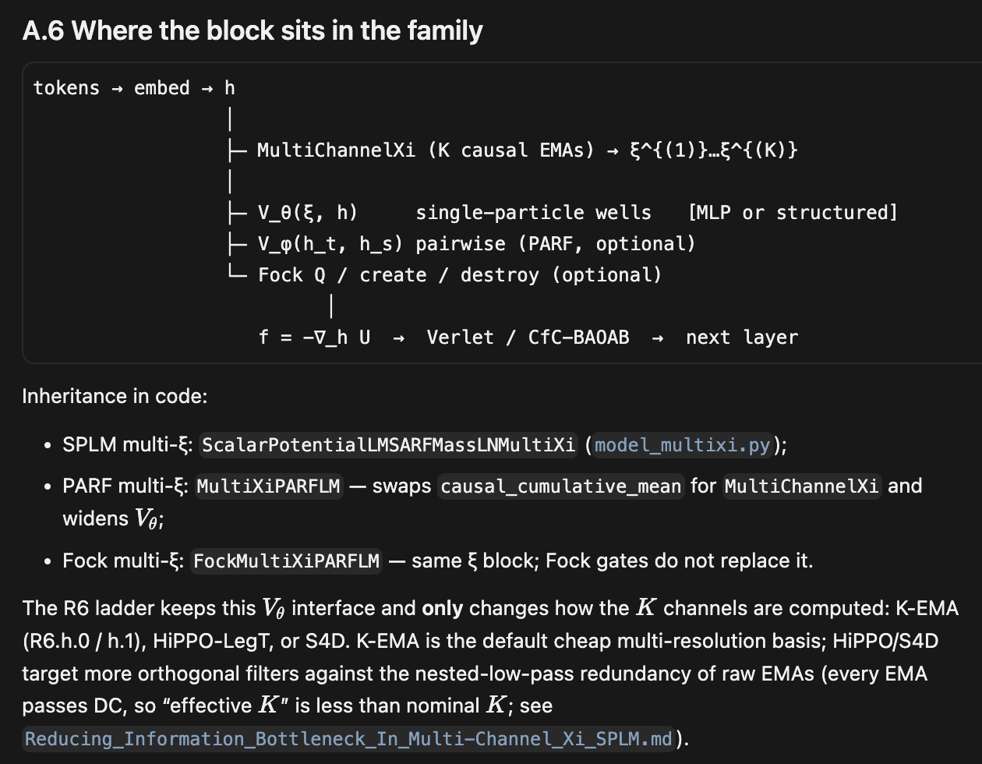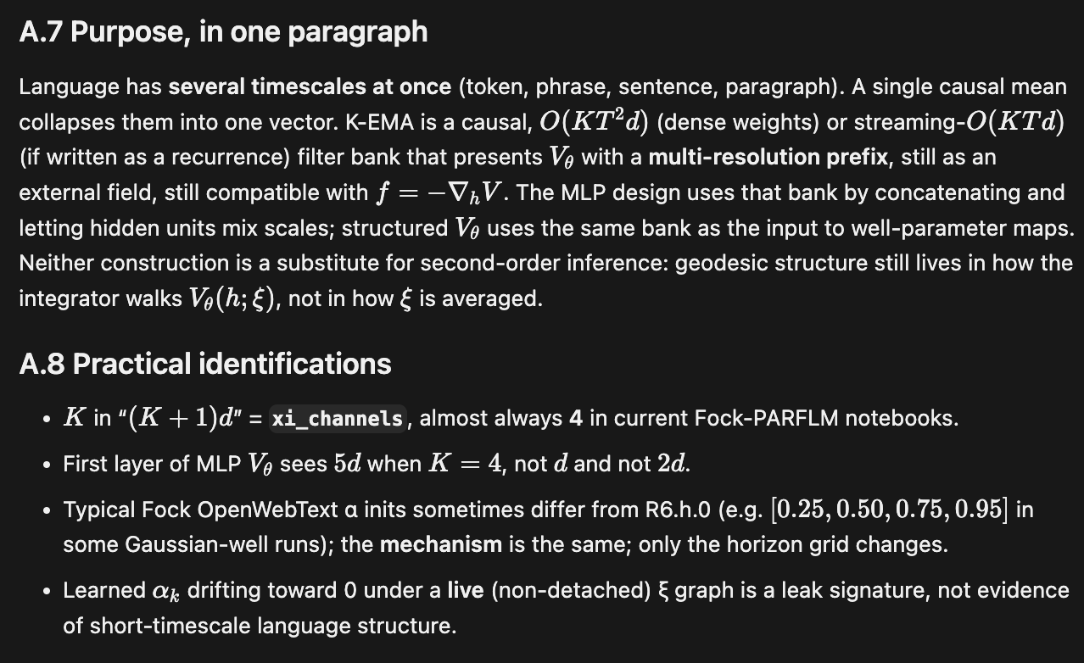

Can we do something better than flattening?
//TODO: check [15]

Depth conditioning and context banks in structured V theta

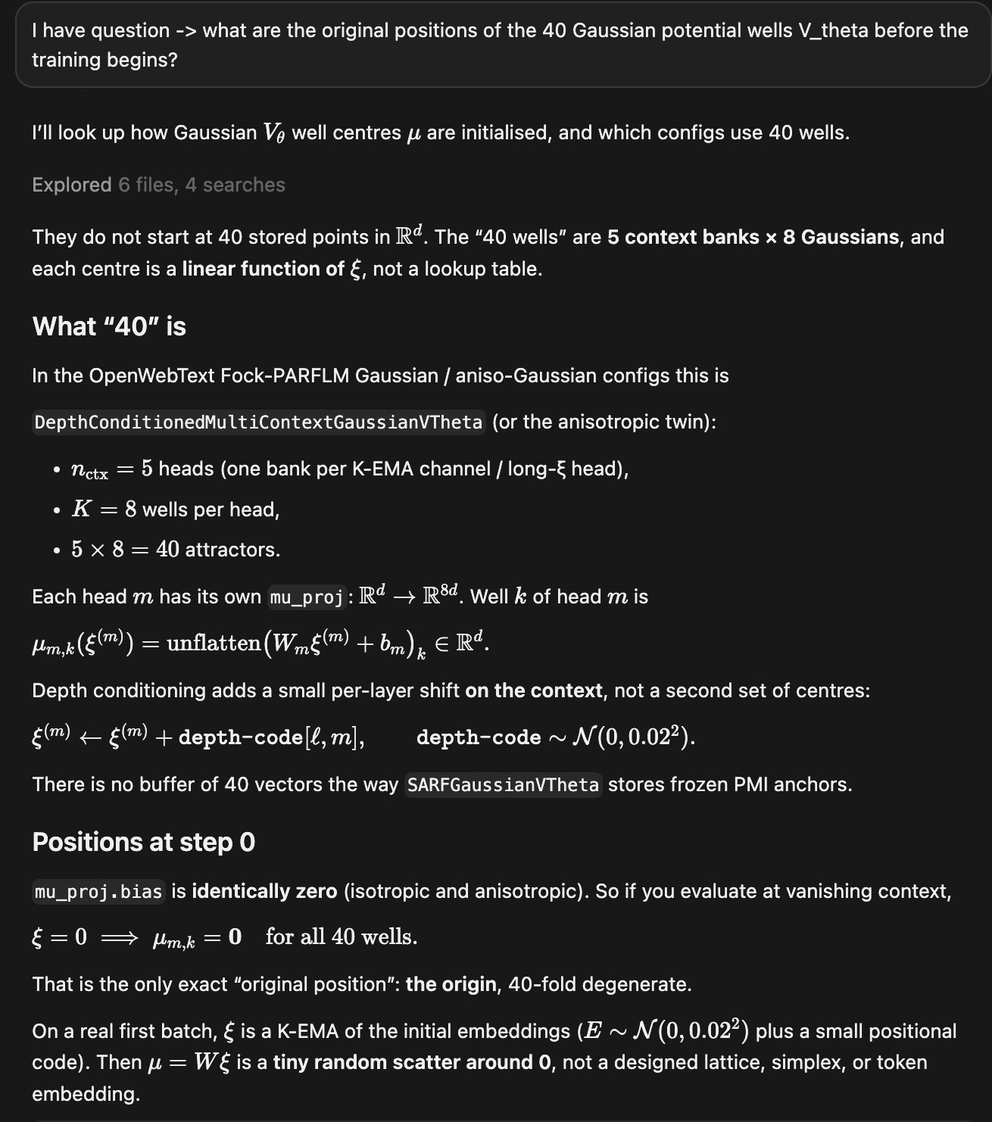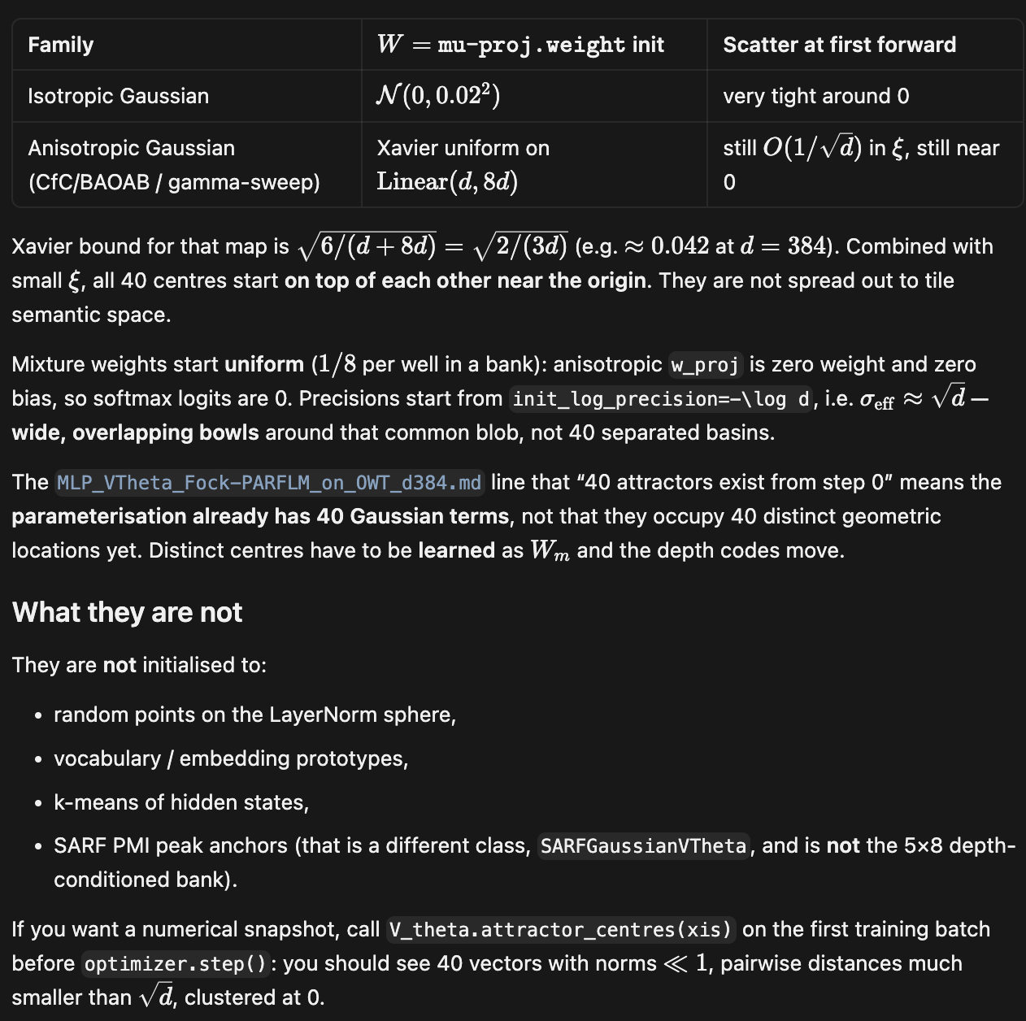

Module splm_oracle_fit.py

Function fit_scalars

It finds $\arg{\min{{\left\|Y-αV-β\left(-G\right)\right\|}^{2}}}$ that it fits $Y≈αV+β\left(-G\right)$ per layer.
Here:
$Y$ – the regression target : per-step displacement $∆h_{l}=h_{l+1}-h_{l}$. Shape: $(L,T,d)$, i.e.

def fit_scalars(V: np.ndarray, G: np.ndarray, Y: np.ndarray, LAY: np.ndarray):
"""Per-layer least-squares: [alpha_l, beta_l] = argmin || Y - alpha V - beta*(-G) ||^2.
V: np.ndarray – the velocity proxy
G: np.ndarray – the potential gradient
Y: np.ndarray – the regression target
LAY: np.ndarray – layer indices
"""
alpha = {}; beta = {}
Y_pred = np.zeros_like(Y)
for ell in np.unique(LAY):
m = LAY == ell
v = V[m].reshape(-1); g = (-G[m]).reshape(-1); y = Y[m].reshape(-1)
A = np.stack([v, g], axis=1) # (N*d, 2)
coef, *_ = np.linalg.lstsq(A, y, rcond=None)
a, b = coef
alpha[int(ell)] = float(a); beta[int(ell)] = float(b)
Y_pred[m] = a * V[m] + b * (-G[m])
return Y_pred, alpha, beta

Function extract_oracle_tuples

What does extract_oracle_tuples do
It takes a model, a raw string, and a device; returns (H, GV, XI). The shapes of these are:
H: (L+1, T, d), GV: (L, T, d), XI: (T, d).
extract_oracle_tuples replays the system dynamics via the damped semi-implicit Euler form:
$h_{l+1}=h_{l}+∆t∙v_{l+1}$ ; $v_{l+1}=\left(v_{l}+∆t∙{f_{l}}/m\right)/\left(1+∆t∙γ\right)$ ; $f_{l}=-∇_{h}V_{θ}\left(ξ,h_{l}\right)$

The lines

max_len = model.cfg.max_len
ids = tokenize(sentence, max_len)
x = torch.from_numpy(ids).unsqueeze(0).to(device)

tokenize the sentence to ids, then unsqueeze(0) adds a batch dimension of $1$ so x has shape (1,T).
This is the B = 1 that later gets dropped by the [0] indexing, which is why the outputs are (L+1,T,d) instead of (B,T,d) which was the shape of the raw h tensor in the forward pass.

The lines below define two capability flags that drive all the branching: whether to re-pool $ξ$
per step, and whether to apply the LayerNorm-after-step projection:

is_sarf = isinstance(model, ScalarPotentialLMSARFMass)
has_ln = hasattr(model, '_project') and getattr(cfg, 'ln_after_step', False)

Next gradient track is enabled via the line

with torch.enable_grad():

On the code shown below we have two branches: a) the SARF branch - it embeds , computes a possibly per-token mass m_b, and optionally LN-projects the initial state. b) Base branch: _embed_and_pool returns both the embedding and the frozen $ξ$ computed once (the fixed-$ξ$ semantics), and mass is the single global scalar model.m. In both, h is now $h^{\left(0\right)}$- the decontextualized initial embedding (or its LN projection)

if is_sarf:
emb = model._embed(x)
m_b = model.compute_mass(x, emb)
gamma = model.gamma
h = model._project(emb) if has_ln else emb
else:
emb, xi_fixed = model._embed_and_pool(x)
m_b = model.m
gamma = model.gamma
h = emb

And here is the full code:
def extract_oracle_tuples(model, sentence: str, device: str) \
-> Tuple[np.ndarray, np.ndarray, np.ndarray]:
"""For a single sentence, re-run SPLM and return
H : (L+1, T, d) raw hidden states h_l
GV : (L, T, d) grad_h V_theta(xi, h_l) for l = 0..L-1
XI : (T, d) the constant context vector

The dynamics equation is

h_{l+1} = h_l + dt * v_{l+1}
v_{l+1} = (v_l + dt*f_l/m) / (1 + dt*gamma), f_l = -grad_h V_theta(xi, h_l)

so Delta h_l := h_{l+1} - h_l depends on (v_l, grad_V at h_l).

Handles both the base ScalarPotentialLM (fixed xi from _embed_and_pool)
and ScalarPotentialLMSARFMass[LN] variants (per-step xi via
causal_cumulative_mean, per-token mass, optional LN projection).
"""
from model_sarf_mass import ScalarPotentialLMSARFMass, causal_cumulative_mean

max_len = model.cfg.max_len
ids = tokenize(sentence, max_len)
x = torch.from_numpy(ids).unsqueeze(0).to(device)
cfg = model.cfg
is_sarf = isinstance(model, ScalarPotentialLMSARFMass)
has_ln = hasattr(model, '_project') and getattr(cfg, 'ln_after_step', False)

with torch.enable_grad():
if is_sarf:
emb = model._embed(x)
m_b = model.compute_mass(x, emb)
gamma = model.gamma
h = model._project(emb) if has_ln else emb
else:
emb, xi_fixed = model._embed_and_pool(x)
m_b = model.m
gamma = model.gamma
h = emb

v = torch.zeros_like(h)
dt = cfg.dt

H = [h.detach().cpu().numpy()[0]]
GV = []
xi_out = None
for _ in range(cfg.L):
if is_sarf:
xi_input = h.detach() if getattr(cfg, 'causal_force', True) else h
xi_now = causal_cumulative_mean(xi_input)
else:
xi_now = xi_fixed

h_in = h.detach().requires_grad_(True)
V_out = model.V_theta(xi_now, h_in).sum()
grad_V, = torch.autograd.grad(V_out, h_in)
GV.append(grad_V.detach().cpu().numpy()[0])
f = -grad_V
v = (v + dt * f / m_b) / (1.0 + dt * gamma)
h_new = h_in + dt * v
if has_ln:
h_new = model._project(h_new)
h = h_new
H.append(h.detach().cpu().numpy()[0])
if xi_out is None:
xi_out = xi_now

xi_np = xi_out.detach().cpu().numpy()[0].astype(np.float32)
return (np.stack(H, axis=0).astype(np.float32),
np.stack(GV, axis=0).astype(np.float32),
xi_np)

Module model.py

The SPLM Config : class SPLMConfig

@dataclass
class SPLMConfig:
vocab_size: int = 50257
d: int = 128
max_len: int = 512
v_hidden: int = 512
v_depth: int = 3 # number of hidden layers in V_theta MLP
L: int = 8 # integration steps (shared-weight "depth")
dt: float = 1.0
init_m: float = 1.0
init_gamma: float = 1.0
learn_mgamma: bool = True

Class ScalarPotential
Note: the class ScalarPotential in module model.py is identical to the same class in the modules model_ln.py and model_sarf_mass.py.

class ScalarPotential(nn.Module):
"""MLP (xi, h) in R^(2d) -> scalar energy."""

def __init__(self, d: int, hidden: int, depth: int):
super().__init__()
layers: List[nn.Module] = [nn.Linear(2 * d, hidden), nn.GELU()]
for _ in range(depth - 1):
layers += [nn.Linear(hidden, hidden), nn.GELU()]
layers += [nn.Linear(hidden, 1)]
self.net = nn.Sequential(*layers)
# Gentle init so gradients are small at start -- integrator stays stable.
for m in self.net.modules():
if isinstance(m, nn.Linear):
nn.init.normal_(m.weight, std=0.02)
if m.bias is not None:
nn.init.zeros_(m.bias)
# Final layer even smaller -- the initial force should be tiny.
last = [m for m in self.net.modules() if isinstance(m, nn.Linear)][-1]
nn.init.normal_(last.weight, std=0.002)
nn.init.zeros_(last.bias)

def forward(self, xi: torch.Tensor, h: torch.Tensor) -> torch.Tensor:
"""xi: (..., d), h: (..., d) -> V: (..., 1)"""
return self.net(torch.cat([xi, h], dim=-1))

Class ScalarPotentialLM

class ScalarPotentialLM(nn.Module):
def __init__(self, cfg: SPLMConfig):
super().__init__()
self.cfg = cfg
self.E = nn.Embedding(cfg.vocab_size, cfg.d)
self.P = nn.Parameter(torch.zeros(cfg.max_len, cfg.d))
nn.init.normal_(self.E.weight, std=0.02)
nn.init.normal_(self.P, std=0.01)

self.V_theta = ScalarPotential(cfg.d, cfg.v_hidden, cfg.v_depth)

# Positive-definite mass / damping via softplus.
# raw values chosen so F.softplus(raw) ~ init_m / init_gamma.
def _raw_from_positive(y: float) -> float:
import math
return math.log(math.expm1(max(y, 1e-3)))
self.raw_m = nn.Parameter(torch.tensor(_raw_from_positive(cfg.init_m)),
requires_grad=cfg.learn_mgamma)
self.raw_gamma = nn.Parameter(torch.tensor(_raw_from_positive(cfg.init_gamma)),
requires_grad=cfg.learn_mgamma)

@property
def m(self) -> torch.Tensor:
return F.softplus(self.raw_m) + 1e-3

@property
def gamma(self) -> torch.Tensor:
return F.softplus(self.raw_gamma)

# ------------------------------------------------------------------
def _embed_and_pool(self, x: torch.Tensor) -> Tuple[torch.Tensor, torch.Tensor]:
"""x: (B, T) token ids -> (emb, xi)"""
B, T = x.shape
pos = self.P[:T].unsqueeze(0) # (1, T, d)
emb = self.E(x) + pos # (B, T, d)
cumsum = emb.cumsum(dim=1) # (B, T, d)
denom = torch.arange(1, T + 1, device=x.device,
dtype=emb.dtype).view(1, T, 1)
xi = cumsum / denom # causal cumulative mean
return emb, xi

# ------------------------------------------------------------------
def integrate(
self,
emb: torch.Tensor, # (B, T, d) initial h_0
xi: torch.Tensor, # (B, T, d) context (held fixed along integration)
return_trajectory: bool = False,
) -> Tuple[torch.Tensor, Optional[List[torch.Tensor]]]:
"""Damped Lagrangian flow starting from h_0 = emb, v_0 = 0.

Returns h_L (and optionally the full per-step trajectory
[h_0, h_1, ..., h_L] as a list of detached tensors for analysis).
"""
cfg = self.cfg
h = emb
v = torch.zeros_like(h)
m, gamma, dt = self.m, self.gamma, cfg.dt

traj: Optional[List[torch.Tensor]] = None
if return_trajectory:
traj = [h.detach().cpu()]

for _ in range(cfg.L):
# Force f = -grad_h V_theta(xi, h), differentiable through V_theta.
h_in = h
if not h_in.requires_grad:
h_in = h_in.requires_grad_(True)
V = self.V_theta(xi, h_in).sum()
grad_V, = torch.autograd.grad(
V, h_in, create_graph=self.training, retain_graph=True,
)
f = -grad_V
v = (v + dt * f / m) / (1.0 + dt * gamma)
h = h_in + dt * v
if return_trajectory:
assert traj is not None
traj.append(h.detach().cpu())

return h, traj

# ------------------------------------------------------------------
def forward(
self,
x: torch.Tensor,
targets: Optional[torch.Tensor] = None,
return_trajectory: bool = False,
):
"""x: (B, T) token ids, targets: (B, T) next-token ids (or None).

Returns (logits, loss, traj?). traj is a list of (B, T, d)
tensors on CPU only when return_trajectory=True.
"""
emb, xi = self._embed_and_pool(x)
h_L, traj = self.integrate(emb, xi, return_trajectory=return_trajectory)

logits = h_L @ self.E.weight.T # (B, T, V)

loss = None
if targets is not None:
loss = F.cross_entropy(
logits.reshape(-1, self.cfg.vocab_size),
targets.reshape(-1),
)
if return_trajectory:
return logits, loss, traj
return logits, loss

# ------------------------------------------------------------------
@torch.no_grad()
def generate(self, x: torch.Tensor, max_new_tokens: int,
temperature: float = 1.0, top_k: Optional[int] = None) -> torch.Tensor:
"""Autoregressive greedy / sampled generation. x: (1, T0)."""
self.eval()
for _ in range(max_new_tokens):
x_cond = x[:, -self.cfg.max_len:]
logits, _ = self.forward(x_cond)
logits = logits[:, -1, :] / max(temperature, 1e-6)
if top_k is not None:
v, _ = torch.topk(logits, top_k)
logits[logits < v[:, [-1]]] = -float("inf")
probs = F.softmax(logits, dim=-1)
nxt = torch.multinomial(probs, num_samples=1)
x = torch.cat([x, nxt], dim=1)
return x

# ------------------------------------------------------------------
def num_params(self) -> int:
return sum(p.numel() for p in self.parameters() if p.requires_grad)

Putting it together: the reference forward pass
The three pieces above compose into a single forward pass. _embed_and_pool builds the initial state h_0 = E[x] + P and, in the same call, the context xi as the causal cumulative mean of those embeddings — computed once and then held fixed for the entire integration. integrate runs the L shared damped Euler-Lagrange steps from h_0 with v_0 = 0, at each step taking the force f = -grad_h V_theta(xi, h) and updating v then h. forward reads out tied-embedding logits h_L @ E^T and, when targets are supplied, the next-token cross-entropy. generate and num_params are utilities — autoregressive sampling and a trainable-parameter count — and introduce no new dynamics.
Two design choices distinguish this reference model from its descendants and are worth stating explicitly. First, the context is fixed-xi: xi is derived once from the initial embeddings and never recomputed, so every layer differentiates the same two-argument potential against the same conditioning slice. This is the simplest way to honour the asymmetric role of xi (frozen conditioner) versus h (differentiation variable), and it makes the per-token force trivially curl-free. Second, the mass is a single global scalar self.m (softplus of one learned parameter) shared by every token and position; there is no LayerNorm, and the domain of h is unconstrained.
These choices place model.py at the root of the model family. model_sarf_mass.py relaxes the first by re-pooling xi at every step from h.detach() (the SARF, causal-force-correct dynamics) and the second by making the mass per-token (global, embed_head, or logfreq). model_ln.py then adds a LayerNorm-after-step projection on top of the SARF model, compactifying the domain. The integration kernel — damped semi-implicit Euler with a force read from a single shared scalar potential — is identical across all three; only the conditioning, the mass, and the domain change.

Module model_sarf_mass.py

The SARF Config - class SPLMSARFMassConfig

@dataclass
class SPLMSARFMassConfig:
vocab_size: int = 50257
d: int = 128
max_len: int = 512
v_hidden: int = 512
v_depth: int = 3
L: int = 8
dt: float = 1.0
init_m: float = 1.0
init_gamma: float = 1.0
learn_mgamma: bool = True

mass_mode: str = "global"
logfreq_init_alpha: float = 0.0
logfreq_path: Optional[str] = None

fixed_gamma: Optional[float] = None

# When True (default), compute ξ from h.detach() inside the integration
# loop. This severs the autograd path from ξ back to h, eliminating an
# anti-causal leak in the conservative force where ∂V[t']/∂h[t] ≠ 0 for
# t' > t (because ξ[t'] is a causal weighted average that includes h[t]).
# The fix restores the physics-correct Euler-Lagrange equation
# m · ḧ_t = -∂V(ξ_t, h_t)/∂h_t
# as the per-token dynamics. See docs/Causal_Leak_in_SPLM_Integrate_Bug_and_Fix.md
# for the full bug-and-fix writeup. Set causal_force=False ONLY to
# bit-exactly reproduce pre-fix experiments (e.g. E9 forensics).
causal_force: bool = True

Function causal_cumulative_mean

This function computes a running (prefix) mean over the sequence dimension, in a causal way — each position gets the average of itself and everything before it, with no leakage from future positions.

def causal_cumulative_mean(h: torch.Tensor) -> torch.Tensor:
T = h.shape[1]
cumsum = h.cumsum(dim=1)
denom = torch.arange(1, T + 1, device=h.device, dtype=h.dtype).view(1, T, 1)
return cumsum / denom

Class ScalarPotentialLMSARFMass

Note on method compute_mass:

compute_mass produces the semantic field $m$ for each token, shaped so it broadcasts over (B, T, d), and dispatches on cfg.mass_mode between three strategies of increasing structure.

“global” is the trivial case : it returns self.m_global directly, a single learned mass shared by every token and position. No dependence on identity or context – just one scalar / 1-element tensor the optimizer tunes. This is our baseline mass.

“embed_head” makes mass a learned function of token identity. It re-embeds the ids with self.E(x) to get (B, T, d) embeddings, runs them through self.mass_head (a small projection down to a scalar-per-token), then maps that raw output to a strictly positive mass via F.softplus(raw + self.raw_m_bias) + 1e-3. The raw_m_bias shifts the operating point of the softplus, so the head doesn’t have to learn the baseline magnitude itself, and the + 1e-3 floor guarantees m never collapses toward zero. So here different tokens can carry systematically different mass, learned end-to-end.

“logfreq” ties mass to token rarity instead of letting it be free. self.logfreq_surprisal[x] looks up precomputed surprisal (essentially -log p(token)) per id, so rare tokens score high and frequent tokens low.
alpha = F.softplus(self.raw_logfreq_alpha) is a learned, strictly-positive gain on that surprisal.

def compute_mass(self, x: torch.Tensor, emb: torch.Tensor) -> torch.Tensor:
"""Return m as a tensor broadcastable over (B, T, d).

x: (B, T) token ids
emb: (B, T, d) first-layer hidden state E[x] + P
"""
cfg = self.cfg
if cfg.mass_mode == "global":
return self.m_global

if cfg.mass_mode == "embed_head":
raw = self.mass_head(self.E(x))
return (F.softplus(raw + self.raw_m_bias) + 1e-3)

if cfg.mass_mode == "logfreq":
surprisal = self.logfreq_surprisal[x]
alpha = F.softplus(self.raw_logfreq_alpha)
scaled = alpha * surprisal.unsqueeze(-1)
return F.softplus(self.raw_m_bias + scaled) + 1e-3

raise RuntimeError("unreachable")

Full code of this class below:
class ScalarPotentialLMSARFMass(nn.Module):
"""SARF-faithful SPLM with pluggable per-token mass."""

def __init__(self, cfg: SPLMSARFMassConfig):
super().__init__()
self.cfg = cfg
self.E = nn.Embedding(cfg.vocab_size, cfg.d)
self.P = nn.Parameter(torch.zeros(cfg.max_len, cfg.d))
nn.init.normal_(self.E.weight, std=0.02)
nn.init.normal_(self.P, std=0.01)

self.V_theta = ScalarPotential(cfg.d, cfg.v_hidden, cfg.v_depth)

self.raw_m_bias = nn.Parameter(
torch.tensor(_raw_from_positive(cfg.init_m)),
requires_grad=cfg.learn_mgamma,
)
if cfg.fixed_gamma is not None:
self.raw_gamma = nn.Parameter(
torch.tensor(0.0),
requires_grad=False,
)
self._gamma_value: Optional[float] = float(cfg.fixed_gamma)
else:
self.raw_gamma = nn.Parameter(
torch.tensor(_raw_from_positive(cfg.init_gamma)),
requires_grad=cfg.learn_mgamma,
)
self._gamma_value = None

if cfg.mass_mode == "global":
pass
elif cfg.mass_mode == "embed_head":
self.mass_head = nn.Linear(cfg.d, 1, bias=True)
nn.init.zeros_(self.mass_head.weight)
nn.init.zeros_(self.mass_head.bias)
elif cfg.mass_mode == "logfreq":
if cfg.logfreq_path is None:
raise ValueError(
"mass_mode='logfreq' requires cfg.logfreq_path (a .npy file "
"with one surprisal value per vocabulary id)."
)
surprisal = torch.from_numpy(
_load_npy(cfg.logfreq_path)
).float()
if surprisal.numel() != cfg.vocab_size:
raise ValueError(
f"logfreq vector length {surprisal.numel()} != "
f"vocab_size {cfg.vocab_size}"
)
self.register_buffer("logfreq_surprisal", surprisal)
self.raw_logfreq_alpha = nn.Parameter(
torch.tensor(_raw_from_positive(max(cfg.logfreq_init_alpha, 1e-3))),
requires_grad=True,
)
else:
raise ValueError(f"unknown mass_mode: {cfg.mass_mode!r}")

@property
def gamma(self) -> torch.Tensor:
if self._gamma_value is not None:
return torch.full(
(), self._gamma_value,
device=self.raw_gamma.device, dtype=self.raw_gamma.dtype,
)
return F.softplus(self.raw_gamma)

@property
def m_global(self) -> torch.Tensor:
return F.softplus(self.raw_m_bias) + 1e-3

def compute_mass(self, x: torch.Tensor, emb: torch.Tensor) -> torch.Tensor:
"""Return m as a tensor broadcastable over (B, T, d).

x: (B, T) token ids
emb: (B, T, d) first-layer hidden state E[x] + P
"""
cfg = self.cfg
if cfg.mass_mode == "global":
return self.m_global

if cfg.mass_mode == "embed_head":
raw = self.mass_head(self.E(x))
return (F.softplus(raw + self.raw_m_bias) + 1e-3)

if cfg.mass_mode == "logfreq":
surprisal = self.logfreq_surprisal[x]
alpha = F.softplus(self.raw_logfreq_alpha)
scaled = alpha * surprisal.unsqueeze(-1)
return F.softplus(self.raw_m_bias + scaled) + 1e-3

raise RuntimeError("unreachable")

def _embed(self, x: torch.Tensor) -> torch.Tensor:
B, T = x.shape
pos = self.P[:T].unsqueeze(0)
return self.E(x) + pos

def integrate(
self,
x: torch.Tensor,
emb: torch.Tensor,
return_trajectory: bool = False,
return_xi_trajectory: bool = False,
) -> Tuple[torch.Tensor, Optional[List[torch.Tensor]], Optional[List[torch.Tensor]]]:
"""SARF-faithful damped EL with per-token mass.

x: (B, T)
emb: (B, T, d) first-layer hidden state (with position embed)
"""
cfg = self.cfg
h = emb
v = torch.zeros_like(h)
gamma, dt = self.gamma, cfg.dt

m = self.compute_mass(x, emb)
if m.dim() == 0:
m_b = m
else:
m_b = m

traj_h: Optional[List[torch.Tensor]] = None
traj_xi: Optional[List[torch.Tensor]] = None
if return_trajectory:
traj_h = [h.detach().cpu()]
if return_xi_trajectory:
traj_xi = []

for _ in range(cfg.L):
xi_input = h.detach() if cfg.causal_force else h
xi_now = causal_cumulative_mean(xi_input)
if return_xi_trajectory:
assert traj_xi is not None
traj_xi.append(xi_now.detach().cpu())

h_in = h
if not h_in.requires_grad:
h_in = h_in.requires_grad_(True)
V = self.V_theta(xi_now, h_in).sum()
grad_V, = torch.autograd.grad(
V, h_in, create_graph=self.training, retain_graph=True,
)
f = -grad_V
v = (v + dt * f / m_b) / (1.0 + dt * gamma)
h = h_in + dt * v
if return_trajectory:
assert traj_h is not None
traj_h.append(h.detach().cpu())

return h, traj_h, traj_xi

def forward(
self,
x: torch.Tensor,
targets: Optional[torch.Tensor] = None,
return_trajectory: bool = False,
return_xi_trajectory: bool = False,
):
emb = self._embed(x)
h_L, traj_h, traj_xi = self.integrate(
x, emb,
return_trajectory=return_trajectory,
return_xi_trajectory=return_xi_trajectory,
)
logits = h_L @ self.E.weight.T

loss = None
if targets is not None:
loss = F.cross_entropy(
logits.reshape(-1, self.cfg.vocab_size),
targets.reshape(-1),
)
out = [logits, loss]
if return_trajectory:
out.append(traj_h)
if return_xi_trajectory:
out.append(traj_xi)
return tuple(out) if len(out) > 2 else (out[0], out[1])

@torch.no_grad()
def generate(self, x: torch.Tensor, max_new_tokens: int,
temperature: float = 1.0, top_k: Optional[int] = None) -> torch.Tensor:
self.eval()
for _ in range(max_new_tokens):
x_cond = x[:, -self.cfg.max_len:]
logits, _ = self.forward(x_cond)
logits = logits[:, -1, :] / max(temperature, 1e-6)
if top_k is not None:
v, _ = torch.topk(logits, top_k)
logits[logits < v[:, [-1]]] = -float("inf")
probs = F.softmax(logits, dim=-1)
nxt = torch.multinomial(probs, num_samples=1)
x = torch.cat([x, nxt], dim=1)
return x

def num_params(self) -> int:
return sum(p.numel() for p in self.parameters() if p.requires_grad)

@torch.no_grad()
def mass_stats(self, x: torch.Tensor) -> dict:
"""Diagnostic summary of the per-token mass on a batch of tokens."""
emb = self._embed(x)
m = self.compute_mass(x, emb)
if m.dim() == 0:
return {"mean": float(m.item()), "std": 0.0,
"min": float(m.item()), "max": float(m.item())}
m_flat = m.reshape(-1)
return {
"mean": float(m_flat.mean().item()),
"std": float(m_flat.std().item()),
"min": float(m_flat.min().item()),
"max": float(m_flat.max().item()),
}

Module model_ln.py

The Config Class: SPLMSARFMassLNConfig

@dataclass
class SPLMSARFMassLNConfig(SPLMSARFMassConfig):
"""Extends SPLMSARFMassConfig with LayerNorm-after-step switches."""
ln_eps: float = 1e-5
ln_after_step: bool = True
ln_affine: bool = False

Class ScalarPotentialLMSARFMassLN
model_ln.py makes exactly one change to the SARF-faithful SPLM: after every damped integration step it projects the hidden state back onto the unit-LayerNorm shell. V_theta, the mass machinery, the causal xi re-pooling, and the integrator are all inherited unchanged from ScalarPotentialLMSARFMass. The config SPLMSARFMassLNConfig (above) simply adds three switches — ln_eps, ln_after_step, and ln_affine — to the SARF config it subclasses.
The class subclasses the SARF model and overrides only __init__ (to optionally allocate an affine nn.LayerNorm), adds the projection method _project, and overrides integrate to apply that projection. When ln_affine is False (the default) the projection is parameter-free — F.layer_norm(h, (d,), eps) removes each token's mean and scales it to unit standard deviation with no learned gain or bias. When ln_affine is True a standard nn.LayerNorm(d) with learnable affine parameters is used instead.
class ScalarPotentialLMSARFMassLN(ScalarPotentialLMSARFMass):
"""SARF-faithful SPLM with mandatory LayerNorm after every damped step."""

def __init__(self, cfg: SPLMSARFMassLNConfig):
super().__init__(cfg)
self.cfg: SPLMSARFMassLNConfig = cfg
if cfg.ln_affine:
self.post_ln = nn.LayerNorm(cfg.d, eps=cfg.ln_eps)
else:
self.post_ln = None

def _project(self, h: torch.Tensor) -> torch.Tensor:
if self.post_ln is not None:
return self.post_ln(h)
return F.layer_norm(h, (self.cfg.d,), eps=self.cfg.ln_eps)

def integrate(self, x, emb, return_trajectory=False,
return_xi_trajectory=False):
cfg = self.cfg
h = self._project(emb) if cfg.ln_after_step else emb
v = torch.zeros_like(h)
gamma, dt = self.gamma, cfg.dt
m_b = self.compute_mass(x, emb)

traj_h = [h.detach().cpu()] if return_trajectory else None
traj_xi = [] if return_xi_trajectory else None

for _ in range(cfg.L):
xi_input = h.detach() if cfg.causal_force else h
xi_now = causal_cumulative_mean(xi_input)
if return_xi_trajectory:
traj_xi.append(xi_now.detach().cpu())

h_in = h if h.requires_grad else h.requires_grad_(True)
V = self.V_theta(xi_now, h_in).sum()
grad_V, = torch.autograd.grad(
V, h_in, create_graph=self.training, retain_graph=True)
f = -grad_V
v = (v + dt * f / m_b) / (1.0 + dt * gamma)
h_new = h_in + dt * v
if cfg.ln_after_step:
h_new = self._project(h_new) # <-- the only new line
h = h_new
if return_trajectory:
traj_h.append(h.detach().cpu())

return h, traj_h, traj_xi
Note that the projection is applied both at initialization — h = self._project(emb) before the loop — and after each step, so the trajectory lives on the shell from h_0 onward. The xi fed to the force is still the causal cumulative mean of h.detach() (the leak-free SARF context), and the force is still the negative gradient of the same shared V_theta: LayerNorm changes where the state is allowed to live, not how the force is computed.
The rationale is geometric. A free scalar potential V_theta on all of R^d need not attain a minimum — its basins can run off to infinity, and the damped flow then has no well-defined attractor to settle into. Restricting h to the unit-LayerNorm shell makes the domain compact (it is S^{d-1} up to the mean-shift), and by the extreme-value theorem any continuous V_theta attains a finite minimum on it. LayerNorm-after-step is thus the cheapest way to guarantee a finite energy minimum — a genuine attractor basin — without altering the functional form of V_theta or adding any loss-side gauge term. It is also exactly the normalization every attention transformer already applies, which keeps the comparison to standard architectures clean.
This compactness carries a measurable cost on the oracle fit. Because _project is a non-affine map, the per-step displacement Delta h_l = project(h_l + dt*v_{l+1}) - h_l is no longer an exact linear combination of v_l and -grad_h V_theta. The two-scalar oracle therefore cannot reach a perfect score on this variant: splm_oracle_fit.py reports R^2 ~ 0.931 for the LN model versus R^2 = 1.0000 for the projection-free base model (see A Note on the oracle fit). The 0.931 is not a failure of conservativity — the force is still the exact negative gradient of a single shared potential — but the signature of the shell's curvature folded into each step.
Checkpoints written by the LN trainer tag themselves variant="sarf_mass_ln", which is how extract_oracle_tuples and the trajectory extractors detect the projection (has_ln = hasattr(model, '_project') and cfg.ln_after_step) and faithfully replay the projected dynamics during analysis.

Module train_splm.py
The four modules documented so far define the conservative architecture; the remaining modules in this appendix form the pipeline that trains it and then interrogates the geometry of the states it produces. The order below follows that pipeline: train_splm.py produces a checkpoint, trajectory_extraction.py turns the checkpoint into per-sentence hidden-state trajectories, and shared_potential_fit.py, jacobian_symmetry.py and token_direction_fit.py are the geometric diagnostics that consume those trajectories. causal_probe.py closes the loop with the regression test that guarantees the dynamics never leaks future tokens into the past.

train_splm.py is the reference training loop for the base ScalarPotentialLM. It is deliberately minimal — a single cross-entropy objective, AdamW, and a cosine schedule — because the architecture, not the optimiser, is the object of study. Three modes share one code path and differ only in model size and step budget: smoke (a 300-step pipeline check), shakespeare (the paper-grade Tiny-Shakespeare run), and tinystories (a larger corpus). Each run writes a checkpoint, a JSONL metric log, a loss curve and a Markdown summary under results/.

Per-mode configuration: build_config
build_config returns a (model_cfg, train_cfg) pair. The paper-grade shakespeare mode fixes the same eight-step, d = 128 potential model used throughout the experiments:

elif mode == "shakespeare":
model_cfg = SPLMConfig(
vocab_size=50257, d=128, max_len=256,
v_hidden=512, v_depth=3, L=8,
init_m=1.0, init_gamma=1.0,
)
train_cfg = dict(
batch_size=16, block_size=128,
steps=4000, lr=5e-4, weight_decay=0.01,
warmup_steps=200, grad_clip=1.0,
eval_interval=200, eval_iters=40,
log_interval=50,
)

Note the small step budget (4000) and global gradient clip (grad_clip = 1.0). Both are conservative choices forced by the second-order nature of the model: every forward pass already builds a graph through torch.autograd.grad(..., create_graph=True) to compute the conservative force, so the backward pass differentiates through that inner gradient, and the loss landscape is correspondingly stiffer than for a plain decoder.

Learning-rate schedule: lr_schedule
A textbook linear warmup followed by cosine decay to zero — kept explicit rather than delegated to a scheduler object so the exact shape is auditable:

def lr_schedule(step: int, lr: float, warmup: int, total: int) -> float:
if step < warmup:
return lr * (step + 1) / warmup
progress = (step - warmup) / max(total - warmup, 1)
return lr * 0.5 * (1.0 + math.cos(math.pi * min(progress, 1.0)))

The training step
The inner loop is ordinary except for one consequence of the architecture: model(x, y) returns (logits, loss), and the forward pass that produced loss has already invoked autograd internally to integrate the dynamics. Calling loss.backward() therefore performs second-order backpropagation. Per-step gradients are clipped before the optimiser step, and the resulting grad_norm, together with the learned scalars m and gamma, is logged:

for step in range(train_cfg["steps"]):
lr_now = lr_schedule(step, train_cfg["lr"],
train_cfg["warmup_steps"], train_cfg["steps"])
for g in optim.param_groups:
g["lr"] = lr_now

xb, yb = get_batch(train_ids, train_cfg["batch_size"],
train_cfg["block_size"], rng)
x = torch.from_numpy(xb).to(device)
y = torch.from_numpy(yb).to(device)

_, loss = model(x, y)
optim.zero_grad(set_to_none=True)
loss.backward()
grad_norm = nn.utils.clip_grad_norm_(model.parameters(),
train_cfg["grad_clip"])
optim.step()

Two details are easy to miss but matter for reproducibility. First, evaluation cannot run under a blanket torch.no_grad(): the conservative force needs autograd even at inference, so evaluate is decorated @torch.no_grad() for memory but re-opens an inner with torch.enable_grad(): around the forward call:

@torch.no_grad()
def evaluate(model, ids, iters, batch_size, block_size, rng, device):
model.eval()
losses = []
for _ in range(iters):
xb, yb = get_batch(ids, batch_size, block_size, rng)
x = torch.from_numpy(xb).to(device)
y = torch.from_numpy(yb).to(device)
with torch.enable_grad(): # the SPLM force needs autograd at eval too
_, loss = model(x, y)
losses.append(loss.item())
model.train()
return float(np.mean(losses))

Second, on CUDA the trainer disables TF32 by default. The second-order create_graph=True path is sensitive to TF32's 10-bit mantissa, so unless --allow-tf32 is passed the matmuls are forced to true fp32:

torch.backends.cuda.matmul.allow_tf32 = False
torch.backends.cudnn.allow_tf32 = False

Module trajectory_extraction.py
trajectory_extraction.py is the bridge between a trained checkpoint and the geometric diagnostics. For each sentence in a small fixed corpus it re-runs the model with return_trajectory=True, capturing the full per-layer hidden-state path h_0, h_1, ..., h_L, the per-token next-token cross-entropy, and a flat per-token mass. The output is a list of Trajectory objects pickled to disk — deliberately the same dataclass the earlier E-init pipeline consumed, so every downstream fit reads one format.

Auto-detecting the checkpoint variant: _build_model_from_checkpoint
A single extractor must handle all three SPLM families (base, SARF-mass, and LayerNorm). It dispatches purely on the shape of the stored config dict — the presence of ln_after_step or mass_mode keys — then filters the dict down to the fields the chosen config dataclass actually accepts, so a checkpoint carrying extra bookkeeping keys still loads:

raw_cfg = dict(ck["model_cfg"])
is_ln = "ln_after_step" in raw_cfg
is_sarf = "mass_mode" in raw_cfg

if is_ln:
from model_ln import SPLMSARFMassLNConfig, ScalarPotentialLMSARFMassLN
CfgCls = SPLMSARFMassLNConfig
ModelCls = ScalarPotentialLMSARFMassLN
elif is_sarf:
from model_sarf_mass import SPLMSARFMassConfig, ScalarPotentialLMSARFMass
CfgCls = SPLMSARFMassConfig
ModelCls = ScalarPotentialLMSARFMass
else:
CfgCls = SPLMConfig
ModelCls = ScalarPotentialLM

accepted = {f.name for f in dataclasses.fields(CfgCls)}
filtered = {k: v for k, v in raw_cfg.items() if k in accepted}
cfg = CfgCls(**filtered)
model = ModelCls(cfg).to(device)
model.load_state_dict(ck["model_state_dict"])
model.eval()

A small robustness trick handles the logfreq mass mode: if the surprisal table referenced by the config is not on disk, the extractor writes a zero-filled dummy of the right length so the buffer shape matches, knowing that load_state_dict will immediately overwrite it with the trained values. Extraction never needs the original corpus file.

Extracting one trajectory: extract_one
The same @torch.no_grad() / inner enable_grad() pattern from the trainer reappears here, for the same reason. The trajectory tensors are stacked into a single (L+1, T, d) array and the per-token loss is the shifted-target cross-entropy:

@torch.no_grad()
def extract_one(model, tokenizer, sentence, domain, split, device, max_len):
ids = tokenizer.encode(sentence)[:max_len]
x = torch.tensor(ids, dtype=torch.long, device=device).unsqueeze(0) # (1, T)

with torch.enable_grad():
logits, _, traj_list = model(x, return_trajectory=True)
# traj_list: [h_0, h_1, ..., h_L], each (1, T, d)
hs = torch.stack([t.squeeze(0) for t in traj_list], dim=0).numpy() # (L+1, T, d)

if len(ids) >= 2:
tgt = torch.tensor(ids[1:], device=device)
ptl = torch.nn.functional.cross_entropy(
logits[0, :-1, :], tgt, reduction="none"
).cpu().numpy()
else:
ptl = np.zeros((0,), dtype=np.float32)
...

After extraction, every trajectory is centered per sentence. The centered state x_ps = hs - mean_t(hs) is the quantity all three fits operate on; subtracting the per-sentence mean removes the trivial common-mode component and matches the convention of the original depth-direction pipeline:

for tr in trajs:
tr.mu_ps = tr.hs.mean(axis=1, keepdims=True)
tr.x_ps = tr.hs - tr.mu_ps

Module shared_potential_fit.py
This is the strict conservative-dynamics test. The Jacobian-symmetry diagnostic below asks only that each layer's local operator be symmetric; the shared-potential fit asks the much stronger question of whether a single smooth scalar V_psi, shared across every layer, can explain all layers' forces at once. The ansatz, fit jointly over all layers, all tokens and all sentences, is

Delta x_l ~= alpha_l * v_l - beta_l * grad_h V_psi(x_l)

with v_l = x_l - x_{l-1} the velocity proxy, Delta x_l = x_{l+1} - x_l the displacement target, and alpha_l, beta_l per-layer scalars absorbing scale. By construction an SPLM trajectory fits well — its true dynamics is the gradient of one scalar. The open question is whether GPT-2 trajectories admit any such shared description. The script reports three nested baselines: a static null (Delta x = 0), velocity-only (Delta x = alpha_l v_l), and the full velocity-plus-shared-V fit.

The shared scalar network: SharedPotential
A small GELU MLP $R^{d}→R$ whose gradient supplies the conservative force. grad_V returns dV/dh, building a differentiable graph only while training so the per-layer scalars can be co-optimised:

class SharedPotential(nn.Module):
def __init__(self, d: int, hidden: int = 256, depth: int = 2):
super().__init__()
layers: List[nn.Module] = [nn.Linear(d, hidden), nn.GELU()]
for _ in range(depth - 1):
layers += [nn.Linear(hidden, hidden), nn.GELU()]
layers += [nn.Linear(hidden, 1)]
self.net = nn.Sequential(*layers)

def forward(self, h: torch.Tensor) -> torch.Tensor:
return self.net(h)

def grad_V(self, h: torch.Tensor) -> torch.Tensor:
"""Return dV/dh of shape (N, d)."""
h = h.requires_grad_(True) if not h.requires_grad else h
V = self.forward(h).sum()
g, = torch.autograd.grad(V, h, create_graph=self.training)
return g

Pooling samples across layers: build_samples
Every interior layer of every trajectory contributes one (x, v, dx, layer) tuple per token. The loop runs l in [1, L-1] because the velocity proxy needs l-1 and the displacement target needs l+1:

for tr in trajs:
for ell in range(1, L): # need l-1 for v, l+1 for dx
x_prev = tr.x_ps[ell - 1] # (T, d)
x = tr.x_ps[ell]
x_next = tr.x_ps[ell + 1]
Xs.append(x)
Vs.append(x - x_prev)
Ys.append(x_next - x)
Ls.append(np.full((x.shape[0],), ell, dtype=np.int64))

The joint fit: fit_shared_V
The per-layer scalars start at zero, so the model begins as the static null and must earn every increment of explained variance. Each step differentiates the shared potential at the batch positions, forms the prediction alpha[l]*v - beta[l]*grad V, and minimises the MSE residual plus a mild penalty on the gradient magnitude to prevent blow-up:

alpha = nn.Parameter(torch.zeros(L, device=device)) # start at 0 -> velocity-only disabled
beta = nn.Parameter(torch.zeros(L, device=device))
optim = torch.optim.AdamW(
list(model.parameters()) + [alpha, beta],
lr=lr, weight_decay=weight_decay, betas=(0.9, 0.95),
)

for step in range(steps):
idx = rng.integers(0, N, size=batch_size)
xb, vb, yb, lb = X_t[idx], V_t[idx], Y_t[idx], L_t[idx]

xb_r = xb.clone().requires_grad_(True)
Vout = model(xb_r).sum()
gV, = torch.autograd.grad(Vout, xb_r, create_graph=True)

y_pred = alpha[lb].unsqueeze(-1) * vb - beta[lb].unsqueeze(-1) * gV
loss = F.mse_loss(y_pred, yb)
reg = 1e-5 * torch.mean(gV ** 2)
(loss + reg).backward()
torch.nn.utils.clip_grad_norm_(list(model.parameters()) + [alpha, beta], 5.0)
optim.step()
optim.zero_grad(set_to_none=True)

All R^2 numbers are reported on held-out sentences, both per layer and pooled, and saved alongside a figure and a Markdown table. The headline quantity is the per-layer gain of the shared-V fit over velocity-only: a positive gain on test sentences is the signature of genuine shared conservative structure rather than mere momentum.

Module jacobian_symmetry.py
The Jacobian-symmetry test is the structural positive control. For a conservative flow x_{l+1} - x_l ~= -dt * grad_h V(x_l) / m, the local linearisation is the Hessian of a scalar and is therefore symmetric. So if we fit a per-step linear operator y ~= M_l x_l + b_l on a PCA subspace, constraining M_l = M_l^T should cost almost nothing when the dynamics is conservative. For the attention transformers in the companion failure study the unconstrained fit sits at R2 in [0.5, 0.8] while the symmetric fit is *negative* — a decisive failure of conservativity. This script runs the identical diagnostic on SPLM trajectories.

Unconstrained vs symmetric fit: fit_linear_and_symmetric
The unconstrained branch is a ridge-regularised least squares. The symmetric branch is the interesting one: it parameterises M by its upper-triangular free entries and builds a design matrix Phi so that solving the normal equations directly returns a symmetric operator. Each off-diagonal free entry (i, j) feeds *both* output column i (via predictor j) and column j (via predictor i), which is exactly the constraint M[i,j] = M[j,i]:

# ---- Unconstrained ridge fit.
G = Xc.T @ Xc # (k, k)
reg = ridge * (np.trace(G) / max(N, 1)) * np.eye(k)
M_full = np.linalg.solve(G + reg, Xc.T @ Yc).T
r2_full = 1.0 - float(np.sum((Yc - Xc @ M_full.T) ** 2)) / (ss_tot + 1e-12)

# ---- Symmetric-constrained fit: parameterise M by its free upper triangle.
idx_ij = [(i, j) for i in range(k) for j in range(i, k)]
p = len(idx_ij)
Phi = np.zeros((N * k, p))
for col, (i, j) in enumerate(idx_ij):
if i == j:
Phi[i * N:(i + 1) * N, col] = Xc[:, i]
else:
Phi[j * N:(j + 1) * N, col] = Xc[:, i] # column j gets predictor i
Phi[i * N:(i + 1) * N, col] = Xc[:, j] # column i gets predictor j
vecY = np.concatenate([Yc[:, c] for c in range(k)], axis=0)
h_sym = np.linalg.solve(Phi.T @ Phi + reg2, Phi.T @ vecY)

Why velocity matters: fit_second_order
A position-only fit is confounded for damped second-order dynamics: the single-step transition mixes position x_l with the hidden velocity v_l = x_l - x_{l-1}, and that mixing can manufacture apparent asymmetry even in a genuinely conservative flow. The velocity-aware fit removes the confound by regressing on the concatenated design [X | V], letting an unconstrained A absorb the velocity term while M — now the clean per-step spring matrix — is the operator whose symmetry is tested:

# ---- Unconstrained (concatenated design [X | V] of shape (N, 2k)).
Phi = np.concatenate([Xc, Vc], axis=1) # (N, 2k)
G = Phi.T @ Phi
reg = ridge * (np.trace(G) / max(N, 1)) * np.eye(2 * k)
B = np.linalg.solve(G + reg, Phi.T @ Yc).T # (k, 2k)
M_full = B[:, :k].copy() # the spring matrix
A_full = B[:, k:].copy() # the velocity coupling

The symmetric variant reuses the upper-triangle construction for M while keeping A unconstrained. The reported verdict is the maximum test-set gap between the unconstrained and symmetric fits in the velocity-aware variant: a gap below 0.10 means the per-step spring matrix is consistent with a symmetric Hessian, i.e. the depth dynamics is conservative in h.

Module token_direction_fit.py
The depth-direction diagnostics trace a hidden state across layers at a fixed token. But autoregressive inference advances a second axis — token position — and that is the natural time axis of the Geodesic Hypothesis. token_direction_fit.py runs the very same two diagnostics with the token axis playing the role of time at a fixed layer. Its key design feature is reuse: it imports the scalar network and the fitting routines verbatim from the depth-direction modules, guaranteeing an apples-to-apples comparison:

from shared_potential_fit import SharedPotential
from jacobian_symmetry import (
fit_linear_and_symmetric,
fit_second_order,
_pca_basis,
)

Building token triples: build_token_triples
At each layer ell (now including the embedding ell=0 and the final ell=L) and each interior token t, the script collects the triple (h_t, v_t = h_t - h_{t-1}, dh_t = h_{t+1} - h_t). A t_skip margin drops the first and last few tokens of every sentence to avoid BOS/EOS initialisation transients:

for tr in trajs:
T = tr.x_ps.shape[1]
if T < 3 + 2 * t_skip:
continue
tlo = 1 + t_skip
thi = T - 1 - t_skip
for ell in range(L + 1):
hs = tr.x_ps[ell] # (T, d)
h_prev = hs[tlo - 1:thi - 1]
h = hs[tlo:thi]
h_next = hs[tlo + 1:thi + 1]
Xs.append(h)
Vs.append(h - h_prev)
Ys.append(h_next - h)
Ls.append(np.full((h.shape[0],), ell, dtype=np.int64))

The three-way reading is the payoff. Given the depth-direction result (SPLM uniform, matched-GPT decaying, pretrained GPT-2 collapsing in the middle layers), the token-direction test asks whether the same separator reproduces in sequence-time. If GPT-2 mid layers pass in token-time but fail in depth, the depth failure is a composition-of-operators artefact and the Geodesic Hypothesis survives in its natural coordinate; if they fail in both, no natural coordinate rescues the shared-scalar description for attention transformers. The module also emits a paper-headline JSON with full provenance for both sub-tests.

Module causal_probe.py
causal_probe.py is the regression test that protects the entire construction. A correct autoregressive model must satisfy a hard invariant: perturbing the token at position t_pert may change logits at positions t >= t_pert, but it must leave every logit at t < t_pert exactly unchanged. The probe perturbs one token, runs two forward passes, and measures the maximum logit change on the causal side.

This test exists because the SPLM integrate() method is vulnerable to a subtle leak. The conservative force is the gradient of a sum of potentials, f(t) = -d(sum_t' V[t']) / dh[t]. When the context vector xi is a causal running average that itself includes h[t], differentiating the summed potential picks up off-diagonal terms dV[t']/dh[t] for t' > t, and a trained V_theta can route information backwards through that channel — inflating validation perplexity by orders of magnitude. The fix is one line: compute xi from h.detach() so the autograd path from xi back to h is severed. Every model config exposes a causal_force: bool = True field that controls it.

The probe: causal_violation_probe
Two inputs differ in a single token; the probe returns the maximum logit delta strictly before the perturbation (pre) and strictly after (post). For a causal model pre must be zero:

def causal_violation_probe(model, vocab_size, T=32, t_pert=20, seed=0):
"""Return (max delta on causal side, max delta on after-side, full delta vector)."""
rng = np.random.default_rng(seed)
xb = rng.integers(0, vocab_size, size=(1, T)).astype(np.int64)
x_a = torch.from_numpy(xb)
x_b = x_a.clone()
orig = int(x_b[0, t_pert].item())
x_b[0, t_pert] = (orig + 17) % vocab_size

model.eval()
out_a = model(x_a)
out_b = model(x_b)
logits_a = out_a[0].detach()
logits_b = out_b[0].detach()
diffs = (logits_a - logits_b).abs().max(dim=-1).values[0]
pre = float(diffs[:t_pert].max().item())
post = float(diffs[t_pert + 1:].max().item())
return pre, post, diffs

Regression discipline: class_smoke
With no checkpoint argument the script random-initialises every registered model class in both causal_force=True and causal_force=False modes and asserts that the fixed variant produces delta identically zero. Seeding before each construction makes the buggy/fixed pair share weights, so any difference is attributable solely to the xi detach:

for entry in _registry():
torch.manual_seed(0)
model_buggy = entry.cls_factory(entry.cfg_factory(False))
torch.manual_seed(0)
model_fixed = entry.cls_factory(entry.cfg_factory(True))
pre_b, _, _ = causal_violation_probe(model_buggy, vocab_size=257)
pre_f, _, _ = causal_violation_probe(model_fixed, vocab_size=257)
ok_fixed = pre_f < 1e-6 # the fixed variant MUST give exactly 0
verdict = "OK" if ok_fixed else "FAIL"

The registry itself is defensive. The core SPLM classes (model_ln, model_sarf_mass) are imported unconditionally, while every optional research variant is wrapped in try/except so the probe still runs against the shipped models even when an extension module is absent from this repository:

try:
from model_multixi import ( # optional extension — not shipped here
SPLMSARFMassLNMultiXiConfig, ScalarPotentialLMSARFMassLNMultiXi,
)

def _cfg_multixi(causal):
return SPLMSARFMassLNMultiXiConfig(
vocab_size=257, d=16, max_len=64, v_hidden=32, v_depth=2, L=4,
mass_mode="global", ln_after_step=True,
xi_channels=4, xi_alpha_inits=[0.0, 0.5, 0.9, 0.99],
xi_learnable=True,
causal_force=True if causal is None else causal,
)
out.append(ModelEntry(
"multixi (K=4 EMAs)", _cfg_multixi, ScalarPotentialLMSARFMassLNMultiXi,
))
except Exception:
pass

Probing natural transformers
The same probe applies to real transformers. A thin _LogitsAdapter wraps an arbitrary causal-LM — a local MatchedGPT checkpoint or a HuggingFace Hub model such as gpt2 or EleutherAI/pythia-160m — so its forward returns the (logits, None) tuple the probe expects:

class _LogitsAdapter(torch.nn.Module):
"""Wrap an arbitrary causal-LM so forward returns (logits, None)."""
def __init__(self, model, extract):
super().__init__()
self.model = model
self._extract = extract

def forward(self, x):
return self._extract(self.model(x)), None

For these models the causal-side delta is zero by construction of the attention mask, so the natural-transformer probe is a sanity check on the harness rather than a test of the models — but running it through the same code path is what makes the SPLM result trustworthy: the conservative architecture is held to exactly the same causal standard as a standard decoder, and --strict turns any violation into a non-zero exit suitable for a CI gate.

In the classic (GPT-2-style) transformer architectures we have two separate embedding/encoding tables – a) token embeddings ($TE$) with shape $\left(V,d\right)$, indexed by token ID ($tok_{i}$) which encode what the symbol is, b) positional encodings ($PE$) with shape $\left(T,d\right)$, indexed by position $0...T-1$ which encode where in the sequence a slot sits. At the input layer a) and b) are combined additively: $x_{i}=TE\left[{tok}_{i}\right]+PE\left[i\right], i=0,…,n-1, n≤T$
See the Note on the MLP $V_{θ}$ hidden width in the Appendix
See the Note on multi-$ξ$ context channels in the Appendix
as with the previous footnote $TE$ denotes token embedding and $PE$ denotes positional encoding
GMM – Gaussian Mixture Model, see [16] and [17] for additional info
The shape of the live forward-pass tensor $h$ is $\left(B,T,d\right)$ but fit_scalars never sees the live tensor. Instead, fit_scalars operates on the numpy arrays produced by extract_oracle_tuples which changes the shape of $h$. For details see the Appendix subsection on extract_oracle_tuples.
In torch.nn.functonal.softplus $Softplus\left(x\right)=\frac{1}{β}∙\log\left(1+\exp\left(β∙x\right)\right)$; for numerical stability $Softplus\left(x\right)$ reverts to linear function when $β∙x>threshold$

