The Connection between Bayesian Additive Regression Trees and Gaussian Processes
By Richard Hahn, 1/19/2026

Did you know that BART is intimately related to Gaussian processes?

It is well-known that linear regression can be employed in the service of nonlinear regression by first making a set of known nonlinear transformations of the observed covariates, a so-called “basis expansion”.

There are assorted variations on this theme, each emphasizing a different aspect of the problem or focusing on a different set of transformations.

When I started graduate school in 2007 one of the hottest areas was “kernel regression”, which was built around the elegant mathematical theory of “Reproducing Kernel Hilbert Spaces”. Practically, the idea was that with n observations, one could derive a basis of n features based on the collection of pairwise similarities (defined by a kernel function) between your data points. The choice of kernel function *implicitly* determines the transformations used to create the basis expansion.

But the RKHS theory, and the appeal of “similarities”, just kicked the can down the road, in the end. Whether you focus on selecting a kernel or selecting a set of transformations, making linear regression work for nonlinear function really depends on making a choice.

Researchers quickly caught on to this, and I was very inspired by the 2004 paper by Lanckriet, et al “Learning the Kernel Matrix with Semidefinite Programming”. It acknowledged head-on that to be truly data driven about our predictions we probably need to learn the kernel matrix rather than pre-specify it.

To my knowledge, the SDP approach never really took off. Years later, I would pivot my own focus to tree ensemble methods, mainly because they just seem to work so much better than alternatives (especially in the mid-size data regimes we have in the health and behavioral sciences). Specifically, I became a “BART guy”.

Which brings me to the point of this post: BART turns out to be a very effective approach to “learning the kernel matrix”.

Specifically, there is an intimate relationship between BART and Gaussian processes — and Gaussian processes are themselves a kernel regression method, the choice of kernel corresponding to the choice of covariance function.

The relationship is simply this: given a tree ensemble, one may derive an expression for the implied mean function as a linear regression in terms of a basis expansion where the h-th column is a binary string indicating which of the n observations appear in the h-th node of the ensemble.

In BART, the constant prediction at each leaf node is given an independent Gaussian prior. Which means that — conditional on the tree ensemble, but integrating over the prior for the level — we know the covariance function in terms of the basis matrix B.

Furthermore, this implied kernel has a straightforward interpretation: The (j,k) entry reflects how often across the trees in the forest, observations j and k appear in the same leaf.

That is: learning the forest is learning the kernel.
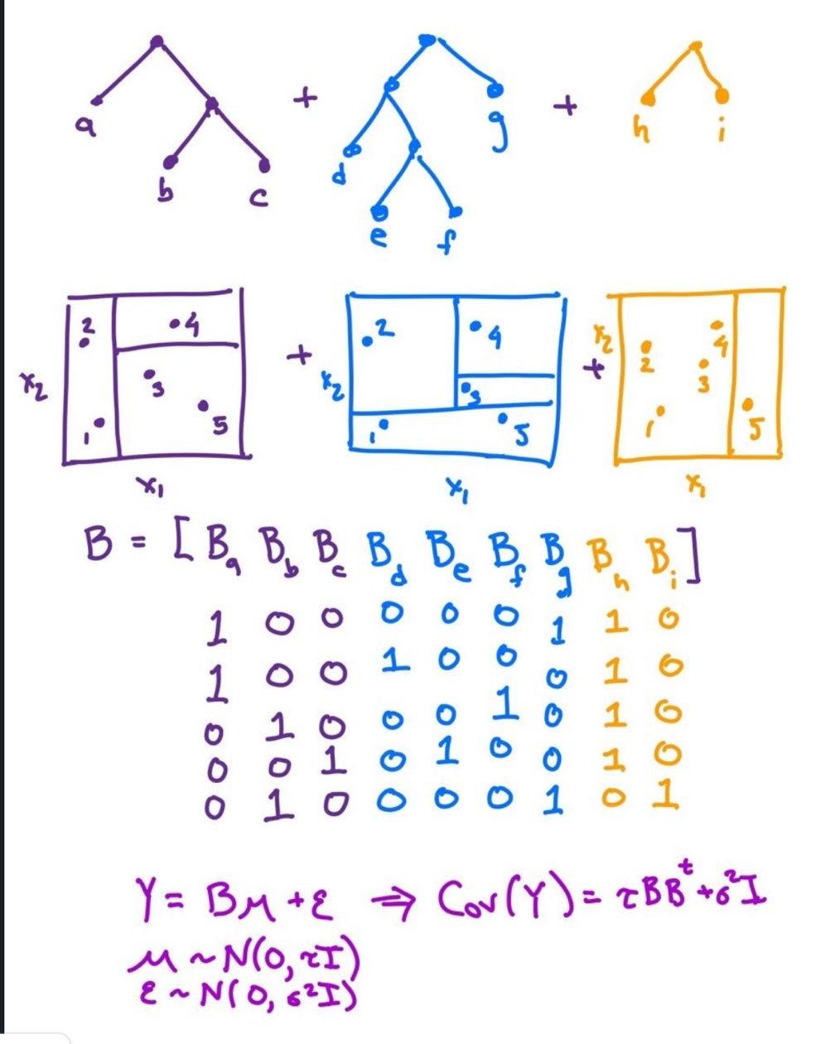

References
[1] BART - Bayesian Additive Regression Trees, Hugh Chipman et al, 2010
[2] Machine Learning: A Probabilistic Perspective, Kevin P. Murphy, Chapter 4 and Chapter 15, 2012
[3] Richard Hahn’s Linkedin post , 1/19/2026

Appendix

The Notion of Bayesian Additive Regression Tree

