Diving into Attention Implementations via Well Constructed Toy Examples
Compiled by D.Gueorguiev with Claude Opus 4.6

Introduction

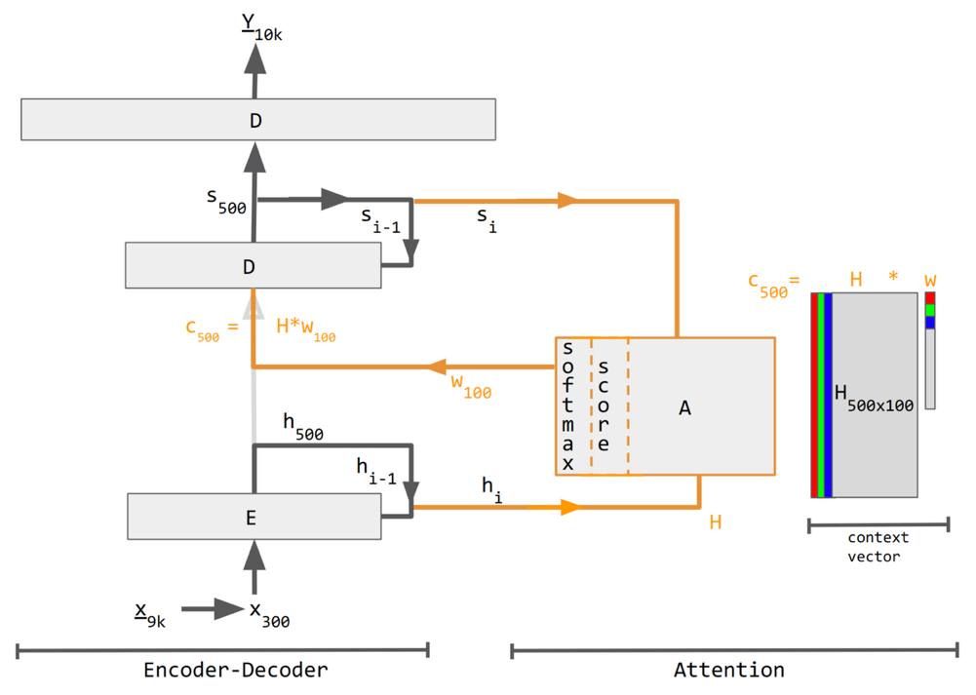

References
[1]
[2]
[3]
[4]

