Bi-Directional Encoders and Cross-Encoders: Architecture, Design and Implementation
compiled by D.Gueorguiev using Claude Opus 4.1, 12/28/2025

The Bi-Directional Encoder

The key in the Bi-Directional Encoder architecture is the independent embedding. The independent encoding / embedding allows pre-computation of the document embeddings. Fast similarity search is possible using vector operations e.g. dot product, cosine similarity. This architecture is scalable to millions of documents via approximate neighbors search. Note that different encoders can be used for queries and documents as shown on the Figure below.
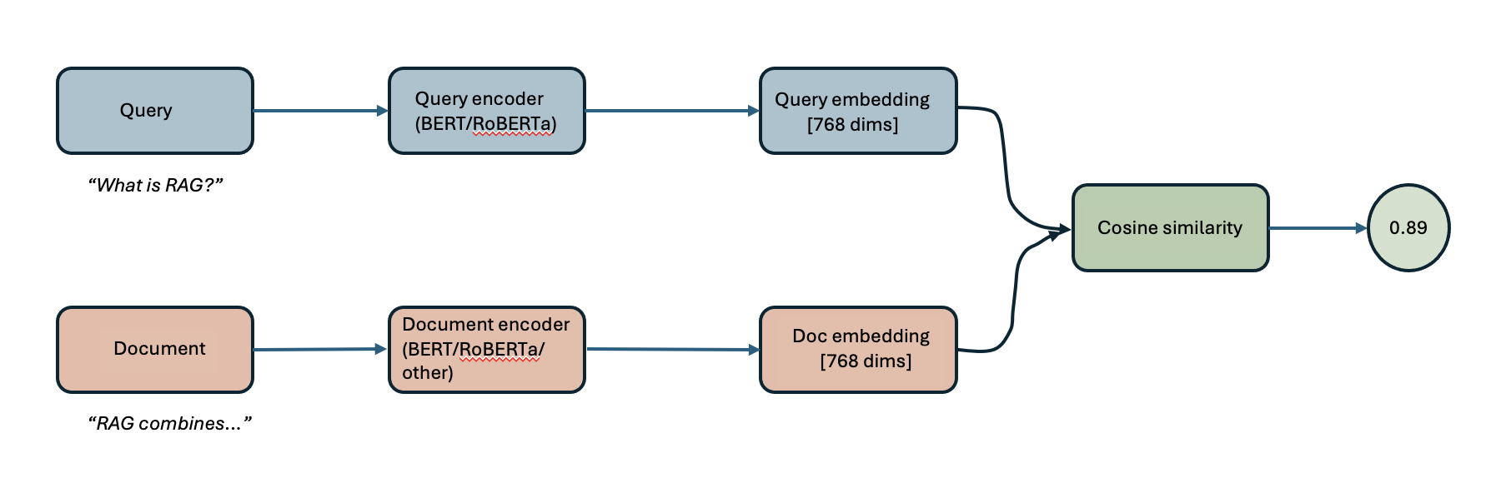

Bi-encoders process queries and documents independently through separate or shared encoder networks. The independence of the query processing and the document processing paths is the main feature of this architecture. There are 4 phases in the workflow associated with this architecture:
Encoding Phase : Each text (query or document) is transformed into a fixed size dense-vector representation

References
[1] Example notebook https://github.com/dimitarpg13/transformer_examples/blob/main/notebooks/sentence_transformers/bi_encoder_vs_cross_encoder_comparison.ipynb

[2] Markdown for the notebook https://github.com/dimitarpg13/transformer_examples/blob/main/notebooks/sentence_transformers/bi_encoder_cross_encoder_comparison.md

