Postlab 9:

Thomas Nattestad

I designed a circuit to deal with the difference in Ib that comes from using pMOS and nMOS bias transistors. It involves constructing a nMOS current mirror before the nMOS bias transistor and a pMOS current mirror the pMOS bias transistor. We then had to construct nMOS current mirror attached to the inverting output of the pMOS version and a pMOS current mirror attached to the non-inverting output of the nMOS version. This is all shown in the schematic below:

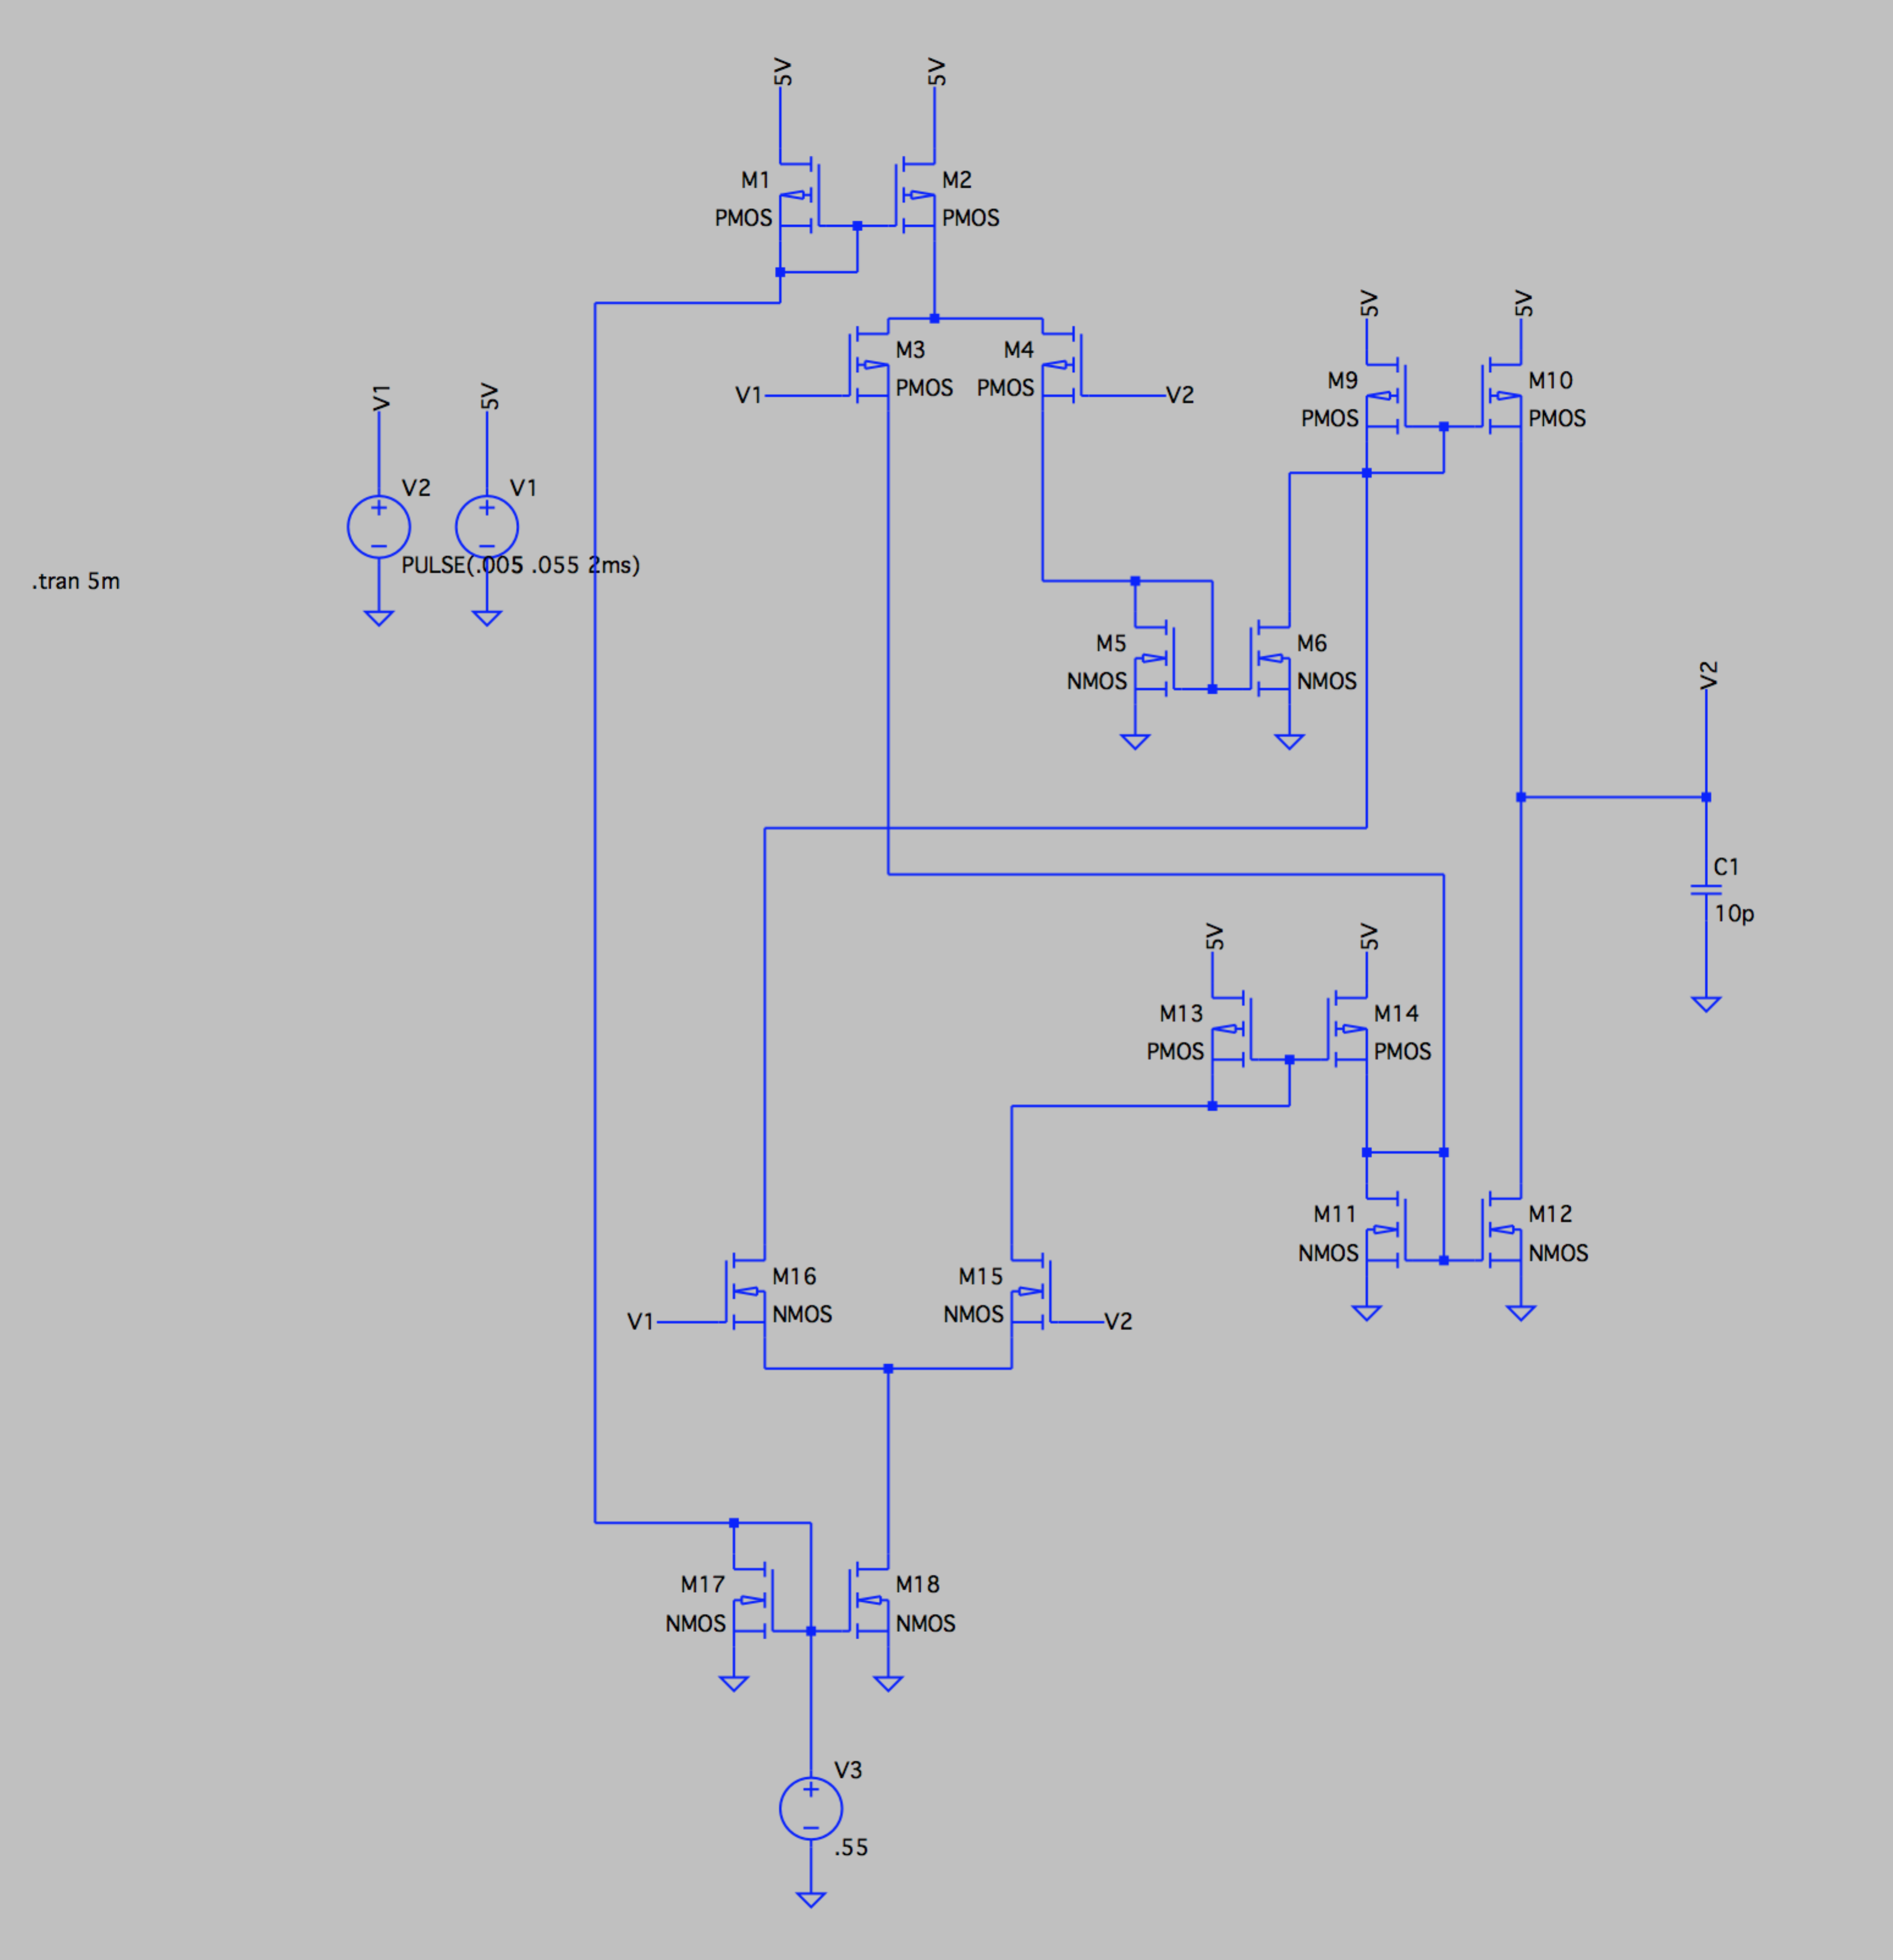

I then implemented a step response in V1 as shown in the graph below:

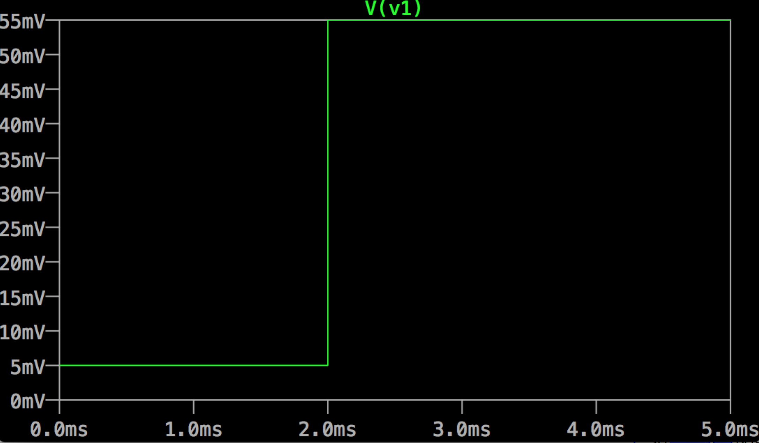

Sadly after a long time of banging my head against a wall, I was unable to get an accurate response from the circuit in terms of Vout (V2). This could be due to an improperly designed circuits or imperfect translation into LTSpice. Sorry.