Gabrielle Rianna Q. Borbon BS IT 404-A

Software Engineering

Create account www.github.com

Sign Up

Choose the Plan (Free)

Type <https://github.com/dimitrio25/softEngSSC/watchers> and from the left hand corner of the screen besides the “Watch” button, click 1. And then click “Follow”.

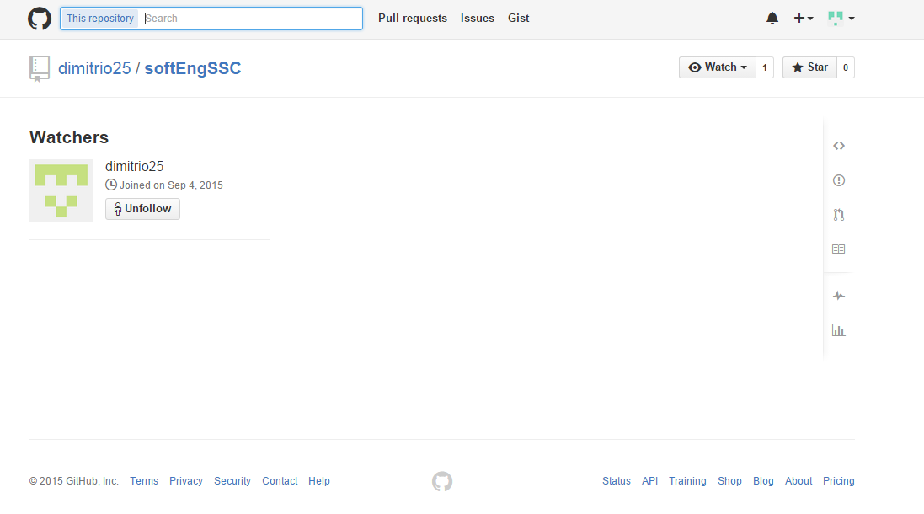

By clicking follow you will be a member or follower of that person.

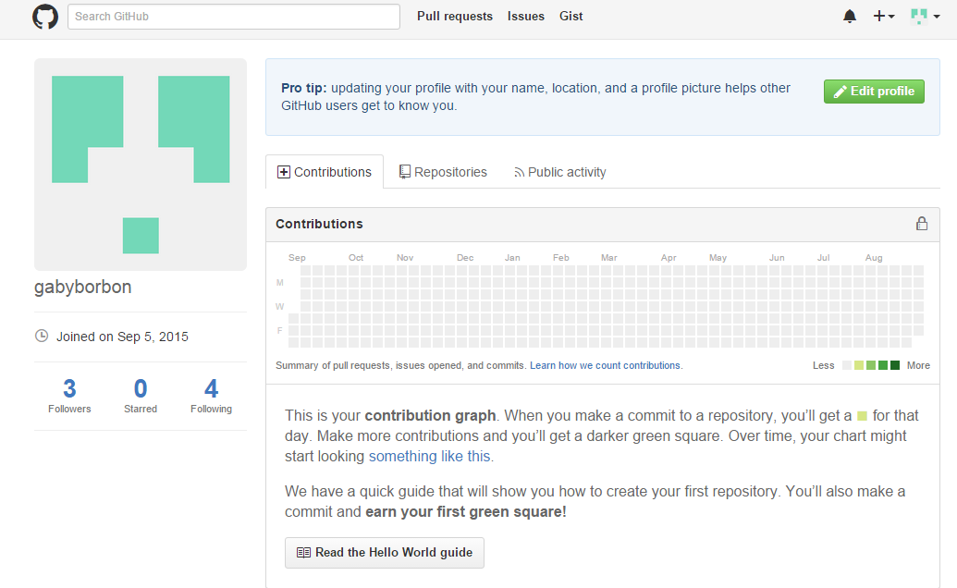

To be a “Watcher” you have to click the watch into “Watching”

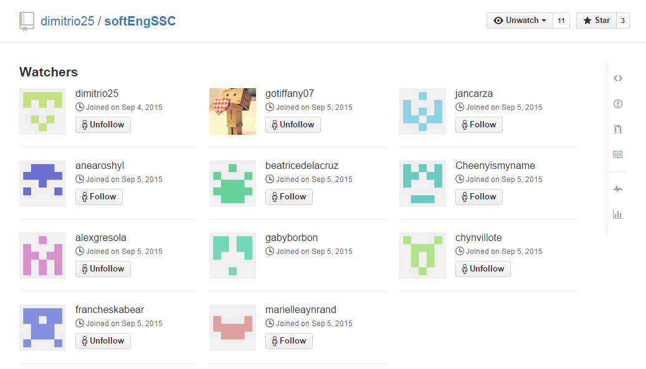

The next step is to upload the documentation to the given repository.

Download the file.

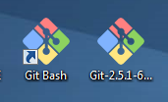

And run it.

Next step is to open the file.

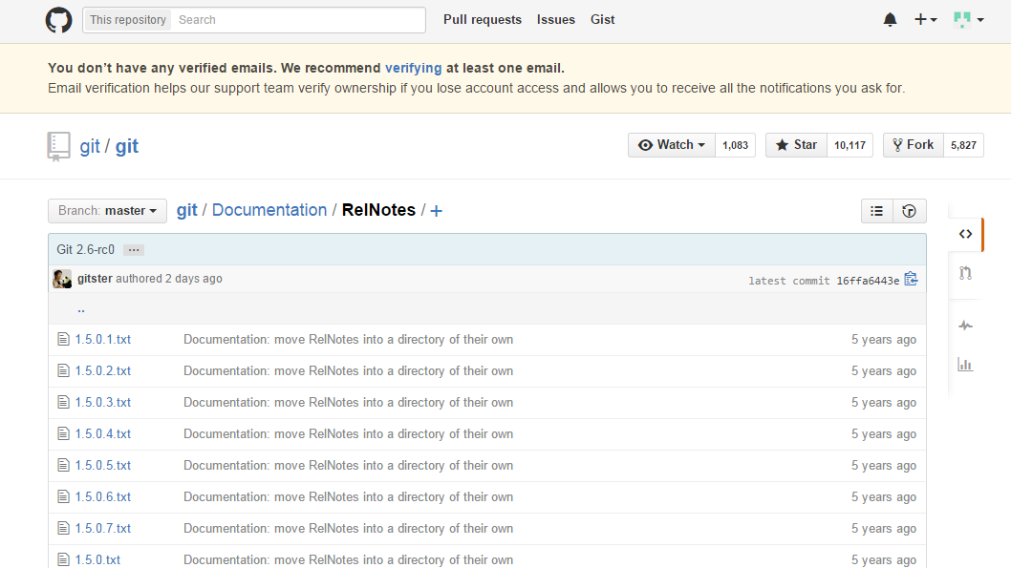

CODES:

404a01@B201-26 MINGW32 ~

$ config --global user.name "gabyborbon"

bash: config: command not found

404a01@B201-26 MINGW32 ~

$ git config --global user.name "gabyborbon"

404a01@B201-26 MINGW32 ~

$ git config --global.email "gabyborbon@yahoo.com"

error: unknown option `global.email'

usage: git config [<options>]

Config file location

--global use global config file

--system use system config file

--local use repository config file

-f, --file <file> use given config file

--blob <blob-id> read config from given blob object

Action

--get get value: name [value-regex]

--get-all get all values: key [value-regex]

--get-regexp get values for regexp: name-regex [value-regex]

--get-urlmatch get value specific for the URL: section[.var] URL

--replace-all replace all matching variables: name value [value_rege x]

--add add a new variable: name value

--unset remove a variable: name [value-regex]

--unset-all remove all matches: name [value-regex]

--rename-section rename section: old-name new-name

--remove-section remove a section: name

-l, --list list all

-e, --edit open an editor

--get-color find the color configured: slot [default]

--get-colorbool find the color setting: slot [stdout-is-tty]

Type

--bool value is "true" or "false"

--int value is decimal number

--bool-or-int value is --bool or --int

--path value is a path (file or directory name)

Other

-z, --null terminate values with NUL byte

--includes respect include directives on lookup

404a01@B201-26 MINGW32 ~

$ git config --global user.email "gabyborbon@yahoo.com"

404a01@B201-26 MINGW32 ~

$ mkdir ~softEngSSC

404a01@B201-26 MINGW32 ~

$ cd ~/softEngSSC

bash: cd: /c/Users/404a01/Downloads/GitPortable/Data/home/softEngSSC: No such fi le or directory

404a01@B201-26 MINGW32 ~

$ mkdir ~/softEngSSC

404a01@B201-26 MINGW32 ~

$ cd ~/softEngSSC

404a01@B201-26 MINGW32 ~/softEngSSC

$ git init

Initialized empty Git repository in C:/Users/404a01/Downloads/GitPortable/Data/home/softEngSS C/.git/

404a01@B201-26 MINGW32 ~/softEngSSC (master)

$ git add Capstone Proposal (BORBON).docx

bash: syntax error near unexpected token `('

404a01@B201-26 MINGW32 ~/softEngSSC (master)

$ git remote add origin https://github.com/dimitrio25/softEngSSC.git

404a01@B201-26 MINGW32 ~/softEngSSC (master)

$ git pull origin master

remote: Counting objects: 167, done.

remote: Compressing objects: 100% (93/93), done.

remote: Total 167 (delta 30), reused 0 (delta 0), pack-reused 66

Receiving objects: 100% (167/167), 27.28 MiB | 237.00 KiB/s, done.

Resolving deltas: 100% (46/46), done.

From https://github.com/dimitrio25/softEngSSC

* branch master -> FETCH_HEAD

* [new branch] master -> origin/master

404a01@B201-26 MINGW32 ~/softEngSSC (master)

$ git add .

404a01@B201-26 MINGW32 ~/softEngSSC (master)

$ git commit -m 'capstone file'

[master feeb61a] capstone file

1 file changed, 0 insertions(+), 0 deletions(-)

create mode 100644 Borbon_Capstone Proposal.docx

404a01@B201-26 MINGW32 ~/softEngSSC (master)

$ git push -u origin master

Username for 'https://github.com': gabyborbon

Password for 'https://gabyborbon@github.com':

To https://github.com/dimitrio25/softEngSSC.git

! [rejected] master -> master (fetch first)

error: failed to push some refs to 'https://github.com/dimitrio25/softEngSSC.git'

hint: Updates were rejected because the remote contains work that you do

hint: not have locally. This is usually caused by another repository pushing

hint: to the same ref. You may want to first integrate the remote changes

hint: (e.g., 'git pull ...') before pushing again.

hint: See the 'Note about fast-forwards' in 'git push --help' for details.

404a01@B201-26 MINGW32 ~/softEngSSC (master)

$ git pull origin master

remote: Counting objects: 10, done.

remote: Compressing objects: 100% (7/7), done.

remote: Total 10 (delta 3), reused 9 (delta 2), pack-reused 0

Unpacking objects: 100% (10/10), done.

From https://github.com/dimitrio25/softEngSSC

* branch master -> FETCH_HEAD

4767c40..951b6cc master -> origin/master

Merge made by the 'recursive' strategy.

Carza_Website1.rar | Bin 0 -> 414282 bytes

Mayoca_Midterm2.docx | Bin 0 -> 13831 bytes

2 files changed, 0 insertions(+), 0 deletions(-)

create mode 100644 Carza_Website1.rar

create mode 100644 Mayoca_Midterm2.docx

404a01@B201-26 MINGW32 ~/softEngSSC (master)

$ git commit -m 'capstone file'

On branch master

nothing to commit, working directory clean

404a01@B201-26 MINGW32 ~/softEngSSC (master)

$ git push origin master

Username for 'https://github.com': gabyborbon

Password for 'https://gabyborbon@github.com':

Counting objects: 5, done.

Delta compression using up to 4 threads.

Compressing objects: 100% (5/5), done.

Writing objects: 100% (5/5), 68.64 KiB | 0 bytes/s, done.

Total 5 (delta 2), reused 0 (delta 0)

To https://github.com/dimitrio25/softEngSSC.git

951b6cc..8c9b82b master -> master

404a01@B201-26 MINGW32 ~/softEngSSC (master)

$