Avert landslide: Website with Animation about Landslide

Preparedness Tips

A Capstone Proposal Presented to the Department of Information Technology

School of Arts and Science

St. Scholastica’s College, Manila

In Partial Fulfillment of the Requirements in Capstone I (METRES)

**Beatrice A. Dela Cruz**

**March 2015**

**Table of Contents**

**Chapter I: Introduction**

Background of the Study 4

Significance of the Study 5

Statement of the Problem 6

Objectives 6

**Chapter II: Review of Related Literature**

Natural disasters 7

Role of internet and technology on natural disasters 10

Website as a source of communication tool 10

Synthesis 11

**Chapter III: Study Framework**

Information Theory 12

Information Richness Theory 12

Theoretical Framework 13

Conceptual Framework 14

Operational Framework 15

**Chapter IV: Methodology**

1. Research Methodology

Research Design and Methods 16

Variable and Measures 16

Research Instruments 17

Units of Analysis 17

Data Gathering 17

Data Analysis 17

1. Project Development 18

**References** 19

**Chapter I: Introduction**

**Background of the Study**

Natural disasters are hard to predict because it comes unexpectedly and unavoidable. A natural disaster is any sudden event that is catastrophic caused by nature of the earth. (Basicplanet, n.d.) Landslide is one class of a natural disaster. According to BBC (n.d.),

“A landslide is the movement of rocks and soil down a slope and, when a large slide occurs in an area of dense human habitation, large numbers of people can be killed. In January 2011 mudslides in south-eastern Brazil killed more than 400 people.”

The disturbances in the natural stability of a slope can trigger landslides. Activities such as constructing a building can also increase the chance of an event. For decades, the environment of the Philippines has been experiencing major natural disasters, a fast-growing population and practices that have affect the country’s land, air and water. As the country's population continues to grow, many are settling in landslide-prone areas. IRIN (2010) stated that one of the most disaster-prone countries in the world is the Philippines because landslides risks are increasing. (Para. 1)

Creating a website that aims to give information about landslides will be a good project in this study. Technology is around all the time, computers and cellular phones are used every day, in many different ways. People can search the web and be updated. But the most important thing is recognizing an upcoming hazard and knowing what to do to prepare beforehand and aid recovery after the event.

**Significance of the Study**

The significance of this informative website is to give benefits to the target audience, other researchers and to the researcher itself.

1. **The target audience:** This study has significance to the target audience because it can help them to understand more about landslides. The website also contains info graphic banner of safety measures.
2. **The IT students:** The IT students could have significance in the study because it could be related to their research when they need a reference in creating a website most especially if it is about natural disasters.
3. **Other researchers:** This study has significance to other researchers because it can help them if there is relevance in their research on natural disasters and be able to know more on landslide.

**Statement of the Problem**

The purpose of this study is to help the user gain knowledge on how to be prepared during a landslide. Reading the information and watching the videos/animations in the website, this study aims to do the following question/s:

1. How will the website inform people to recognize what to do before, during and after landslide?

**Objectives**

The main objective of this study is to provide an interactive and informative website about landslide. Using a website to promote awareness on landslide is a great way to help the users.

**Chapter II: Review of Related Literature**

Technology has changed people’s lives. The gadgets that are people using today helps to make life easier and more convenient. The computer nowadays is a basic need for all humans, most especially the internet. According to Beal (n.d.), a global network connecting millions of computers is what internet made for. The exchanges of data, news and opinions are linked for more than 190 countries. Internet Live Stats (n.d.) cited,

“As of December 30, 2014, there was an estimated 3,037,608,300 internet users worldwide. The number of Internet users represents nearly 40 percent of the world's population. The largest number of Internet users by country is China, followed by the United States and India”.

Hence, the internet is a tool of communication. People use the internet to look and search for websites that can be useful in providing basic information that is needed.

**Natural disasters**

According to D’Urso (2015), it is said that as of the 100 cities with the greatest exposure to natural hazards, 21 were located in the Philippines, 16 in China, 11 in Japan and 8 in Bangladesh which is according to research. (Para. 3) The four Asian nations are exposed to natural disasters. Moreover, one classification of natural disaster is landslides. National Geographic (n.d.) stated that landslide is the movement of rock, earth, or debris down a sloped section of land. (Para. 1) Landslides can happen suddenly or move slowly over a long period of time. The causes of a landslide are rain, earthquakes, volcanoes, or other factors that makes an unstable slope.

Mara (2012) said that after a deadly mudslide struck the Philippines and claimed at least 27 lives; the government of the Philippines has shut down all mines threatened by landslide near a remote town on the southern island of Mindanao. (Para. 1) Some people may not be aware of what the environment are capable of because thousands of people die every year from natural hazards. On the other hand, the researcher aims to make a website that provides information about landslides on how to prevent and be prepared on landslides.

Before a Landslide

According to American Red Cross (n.d.), the things to do to protect yourself, your family and your property from the effects of a landslide are the following:

1. Learn about evacuation plans and local emergency response.
2. Talk to everyone in your household about what to do if a landslide occurs.
3. Create and practice an evacuation plan for your family.
4. Assemble and maintain an emergency preparedness kit.
5. Become familiar with the land around where you live and work so that you understand your risk in different situations.
6. Watch the patterns of storm water drainage on slopes near your home, especially where runoff water converges.

During a Landslide

During a severe storm, stay alert and awake. Many deaths from landslides occur while people are sleeping. Achieve Solutions (n.d.) cited what to do during a landslide are the following:

1. Listen to local news stations on a battery-powered radio for warnings of heavy rainfall.
2. Listen for unusual sounds that might indicate moving debris, such as trees cracking or boulders knocking together.
3. Move away from the path of a landslide or debris flow as quickly as possible. The danger from a mudflow increases near stream channels and with prolonged heavy rains. Mudflows can move faster than you can walk or run. Look upstream before crossing a bridge and do not cross the bridge if a mudflow is approaching.
4. Avoid river valleys and low-lying areas.
5. Curl into a tight ball and protect your head if escape is not possible.

After a Landslide

After the landslide it is very important to stay aware of what is occurring around the community. If a radio or television is available, one must watch the news and know where the danger areas are. It is imperative that one stays away from danger zones because there may be after effects where other slides can occur. Also, if one feels comfortable and ambitious then he or she must replace the damaged ground in order to prevent further landslides. Even though landslides are natural and occur often, it is important that the public is aware of the situation and it can be as prepared as possible in case the hazard does occur. (GEOL 105 Natural Hazards, n.d.)

**Role of internet and technology on natural disasters**

With the power of technology today, everything becomes easy and fast with just one click away. Everything becomes possible and convenient as well. The Internet is the largest computer network in the world which connecting millions of computers. (GCFlearnfree, n.d.) The Internet contains billions of web pages created by people and companies from around the world, making it a limitless place to locate information and entertainment. In emergency situations, social media are there to transmit information all over the web. According to Technadar (n.d.), there is an estimated 76 percent of Americans on 2010 have used social media to let their families know they're ok, during a disaster. (Para. 2) The internet and technology transform the world. Because anywhere people go there is Wifi and internet connection that could interconnect social media sites.

**Website as a source of communication tool**

Many things were invented and things have changed as time passed by. Through the use of technology, work became faster and easier as well. With just one click, different tasks became comfortable to use and to look for. According to Media Temple (n.d.), a website is a collection of related material that contains text, images, and may also include video, audio or other media. Moreover, websites are created to provide data and information for the users and viewers. The content of the website should be relevant to the topic so that users and viewers would gain more knowledge on what they are looking for, and apply all the elements or contents that the website provides. They are also created to attract the attention of users and viewers of the World Wide Web.

There are other sites about landslides but all are just showing texts on what to do if landslides occur. The researcher aims to make an informative and interactive website that will provide knowledge on landslides for the users especially for the target audience.

**Synthesis**

The Internet is one of the greatest inventions of the century. It has become the most powerful tool for people around the world. Information is the biggest advantage that Internet offers. Internet is a virtual treasure trove of information. Nowadays, people have computers, laptops, cell phones, and tablets. Through these devices, internet can be easily accessed by many. Almost everyone can visit the avert landslides website which is the project of this study to find out information about landslides, how to be safe, the do's and don’ts during landslides and what to do before, during or after a landslide. Being aware and prepared is a must. Especially for the people who don’t know what will be the damages that their country may encounter. There will be comments/suggestions on the website for the researcher will know if the website is effective or not. Moreover, Adobe Dreamweaver will be use to develop the website. And there will be simple animation using Adobe Flash on how landslides occur.

**Chapter III: Study Framework**

**Information Theory**

The first theory that can support this study for the researcher’s capstone project is Information theory. According to Encyclopaedia Britannica (n.d.), the birth of modern information theory was when Claude Shannon published “A Mathematical Theory of Communication” in 1948. Information theory is about conditions and parameters affecting the transmission and processing of information. (Para. 1) The theory is explained to how will be the flow of information through communication signals. The quickest and easiest way to find and show information is through internet. The website that the researcher will create is one way to transmit information to users since people nowadays are fond of using the internet.

One of the features of the researcher’s capstone project is email updates for the users that are using the website. It fits with Information theory because it is a process that transmits information between people and machines.

**Information Richness Theory**

The last theory that is related to this study for the researcher’s capstone project is Information Richness Theory by Richard L. Daft and Robert H. Lengel. Information richness is defined by Daft and Lengel as the ability of information to change understanding within a time interval. (Media Richness Theory, n.d.) Therefore, a website should not only be a media rich in information but a straightforward and easy to understand information as well. The website will be interactive and informative because the researcher will provide pictures, videos and animations so that the website will be rich. The Information Richness theory can completely support this study for the website could be useful to all the users, most especially for the users who need tips and what to prepare when landslide comes.

*Theoretical Framework*

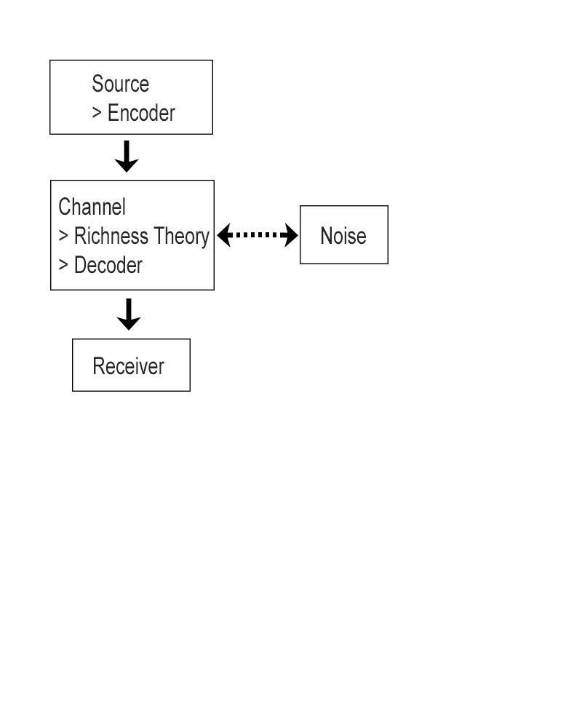

**Figure 1. Theoretical Framework**

The theoretical framework of this study as shown in Figure 1 is composed of Information Theory and Information Richness Theory. The theories that are present in this study are all user-centered, which means that the study is based on the needs of the users. All the basis of the information will be from the users. First, the source and the encoder for the project is the researcher. After that is Channel, richness theory and decoder is in it for the researcher has to analyze what should put on the website which needed data gathering from the internet, books and journals. Then, the noise would be the errors of the website. It is drawn broken lines for the project may or may not have noise. Lastly, the receiver is the one who will see and will be using the website.

*Conceptual Framework*

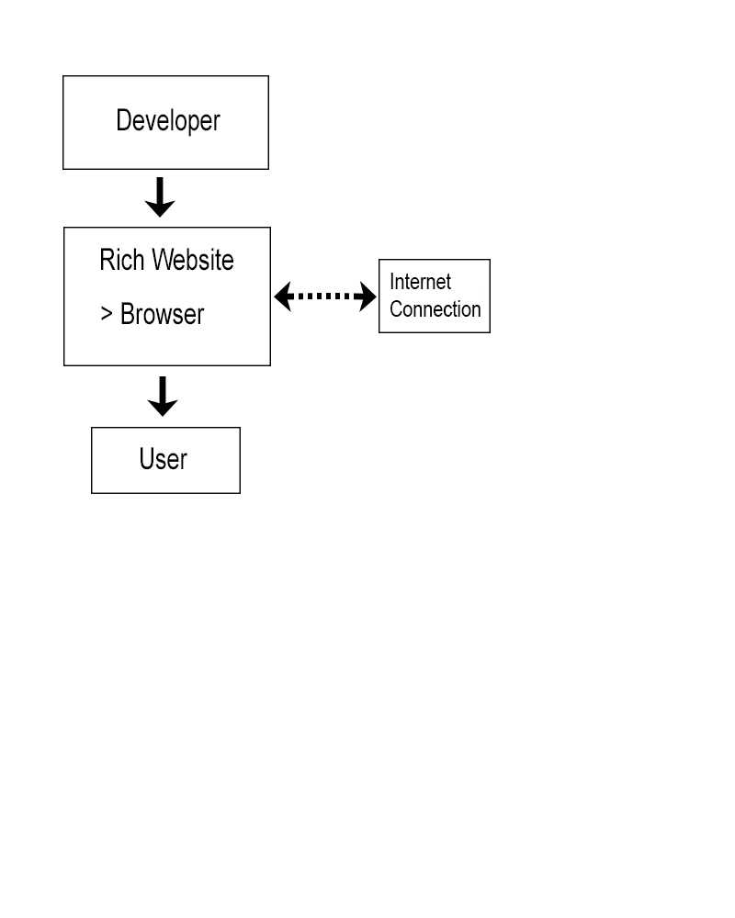

**Figure 2. Conceptual Framework**

As shown in Figure 2 is the conceptual framework of the study. The researcher will be responsible for the development of the website. And to view the rich website, you will need a browser but a noise of internet connection might interfere. While the user, is an individual who has access to the Internet at home or anywhere.

*Operational Framework*

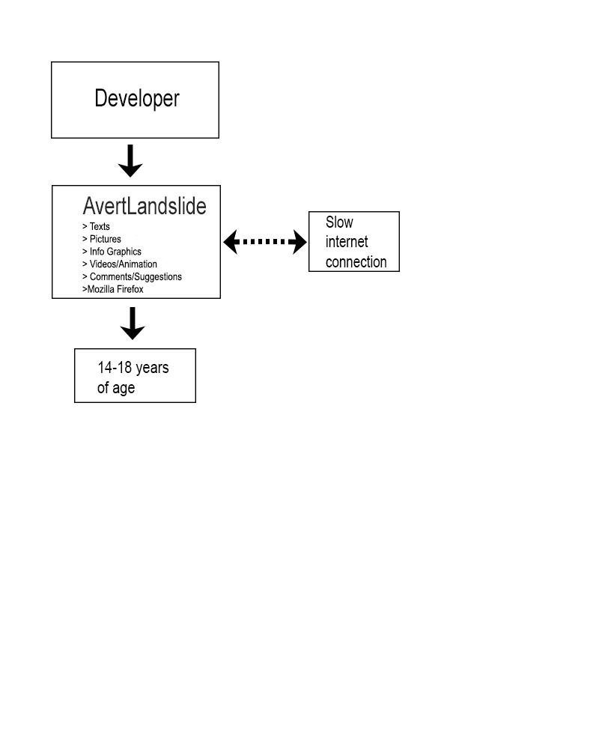

**Figure 3. Operational Framework**

Figure 3 shows the operational framework of the study. The researcher as the developer will build the website entitled Avert Landslide which will have texts, pictures, info graphics, videos, animations and comments/suggestions box for the researcher will have knowledge whether the website is useful to the users. The software will be using are Adobe Dreamweaver, Adobe Photoshop, Adobe Flash and Adobe Premiere to make the informative and interactive website effective to users. The users and the target audience 14-18 years of age may encounter slow internet connection, if that happens the website will not load.

**Chapter IV: Methodology**

1. **Research Methodology**

**Research Design and Methods**

The aim of this study is to create an informative and interactive website about landslide. In order to provide the user’s needs, the researcher will have quantitative research. The researcher will conduct a quantitative method through a survey that will cover questions about the user’s needs and expectations in a website. The gathered data will be used as basis for the design of the website and all the information that will be shown. It is important for the researcher to consider the user’s needs as the main factor in creating the website. The website will not only contain interactive designs but also information that will help the users about landslide prevention­.

**Variable and Measures**

Variables and measures will be used since the method chosen is the quantitative method.

|  |  |
| --- | --- |
| Age (variable) | 14 – 18 years old (measures) |
| Internet Connection (variable) | Has or has no internet connection (measures) |
| Knowledge (variable) | Has o has no knowledge of users on landslide (measures) |

**Research Instruments**

Surveys will be done to know the interests of the users and to be able to acquire the needed information for the improvement of the project. The researcher will conduct an online and personal survey so that the respondent can participate regardless of their unavailability. The survey will cover questions if the respondent has internet connection, if the respondent has knowledge on landslide, if creating a website that could provide them information when a landslide comes is a big help to users and if yes what are the features they would want to see in the website.

**Units of Analysis**

The researcher will be needed 14 – 18 years old students and choose them randomly to gather data on landslide.

**Data Gathering**

A random sampling will be given to ages 14 – 18 years old from September to October 2015. The online survey will be composed of questions that will answer the user’s needs on the website. After the survey is completed, the researcher will summarize all the answers.

**Data Analysis**

The data on the quantitative method, which are the surveys that will be conducted for the project, will be organized and it could be analyzed in a simpler form through percentage graphs. Other comments that were relevant for the project will also be noted for it could help the development of the website.

1. **Project Development**

In creating this project, there are some skills, hardware and software materials are needed. The skills are creating an animated landslide and more by using a Pen Tablet, also video editing and audio editing skills to have an interactive website. A laptop or computer is needed as a workspace for the project. Also, USB’s are needed to store all the data and the project itself to avoid losing the files. For the software, the programs needed are Adobe Flash, Adobe Photoshop, Adobe Premiere and Adobe Dreamweaver. Adobe Flash will be use for creating animations. Adobe Photoshop and Adobe Premiere will be for editing visuals and videos. Adobe Dreamweaver will be for building the website efficiently. After having the requirements done, the next step for this project is how the website will be done. First, the data should be gathered first. The Information for the topic itself and the target audience should be taken consideration in the data gathering. After that, think of the functionality and richness of the project and on how it would satisfy the users. Plan on the layout of the website and it should be an effective design for 14 - 18 years of age. Next is plan on the actual outcome of the product and analyze if the output would satisfy the wants and needs of the user most especially the target audience. Make the project after planning on what to do and the researcher should make sure if the website has meet and achieve the objective of the project.

**References:**

*Achieve Solutions.* (n.d.). Retrieved January 28, 2015, from Achieve Solutions: https://www.achievesolutions.net/achievesolutions/en/Content.do?contentId=17630

*American Red Cross.* (n.d.). Retrieved January 28, 2015, from American Red Cross: http://www.redcross.org/prepare/disaster/landslide#accessibletabscontent0-1

*Basic Planet.* (n.d.). Retrieved December 23, 2014, from Basic Planet: http://www.basicplanet.com/landslide/

*BBC.* (n.d.). Retrieved December 23, 2015, from BBC: http://www.bbc.co.uk/science/earth/natural_disasters/landslide

Beal, V. (n.d.). Retrieved January 21, 2015, from Webopedia: http://www.webopedia.com/TERM/I/Internet.html

D'Urso, J. (n.d.). Retrieved January 22, 2015, from Reuters: http://www.reuters.com/article/2015/03/04/us-global-disasters-cities- idUSKBN0M01JX20150304

*Encyclopaedia Britannica.* (n.d.). Retrieved March 3, 2015, from Encyclopaedia Britannica: http://www.britannica.com/EBchecked/topic/287907/information-theory

*GCFLearnFree.* (n.d.). Retrieved January 24, 2015, from GCFLearnFree: http://www.gcflearnfree.org/internet101/1.3

*GEOL 105 Natural Hazards.* (n.d.). Retrieved January 23, 2015, from GEOL 105 Natural Hazards: http://geol105naturalhazards.voices.wooster.edu/before-during-and-after-a-landslide/

*Internet Live Stats.* (n.d.). Retrieved January 23, 2015, from Internet Live Stats: http://www.internetlivestats.com/internet-users/#trend

*IRIN.* (n.d.). Retrieved December 24, 2015, from IRIN: http://www.irinnews.org/report/90967/philippines-landslide-risk-increasing

Mara, D. (n.d.). Retrieved January 26, 2015, from Deutsche Welle: http://www.dw.de/philippines-orders-shutdown-of-risky-mines-after-deadly- landslide/a-6692558

*Media Richness Theory.* (n.d.). Retrieved March 4, 2015, from Campus-adr: http://www.campus- adr.net/ODRmodule/media_richness_theory.html

*Media Temple.* (n.d.). Retrieved January 25, 2015, from Media Temple: http://kb.mediatemple.net/questions/152/What+is+a+website%3F#all/-what-is-a- website--*National Geographic.* (n.d.). Retrieved January 25, 2015, from National Geographic:http://education.nationalgeographic.com/education/encyclopedia/landslid e/?ar_a=1

*Technadar.* (n.d.). Retrieved January 25, 2015, from Technadar: http://www.techradar.com/news/internet/dealing-with-disaster-how-social-media-is- helping-save-the-world-1203809

|  |  |
| --- | --- |
| Capstone Project Title: | Proponent : Dela Cruz |
| Avert Landslides: Website with Animation about Landslide Preparedness Tips | Contact No.: 09052137014 |
|  | Adviser: Ms. Andong |

|  |  |
| --- | --- |
| Panel Members | Comments, Suggestions |
| Ms. Andong | Change the Capstone Project Title |
| Ms. Sermento |  |
| Mr. Dan Caneo | He suggested a website that could be my guide when I start making my animation |