Diaz, Samantha D.

404A

Midterm Activity

**HOW TO USE GITHUB (www.github.com)**

**SIGN UP**

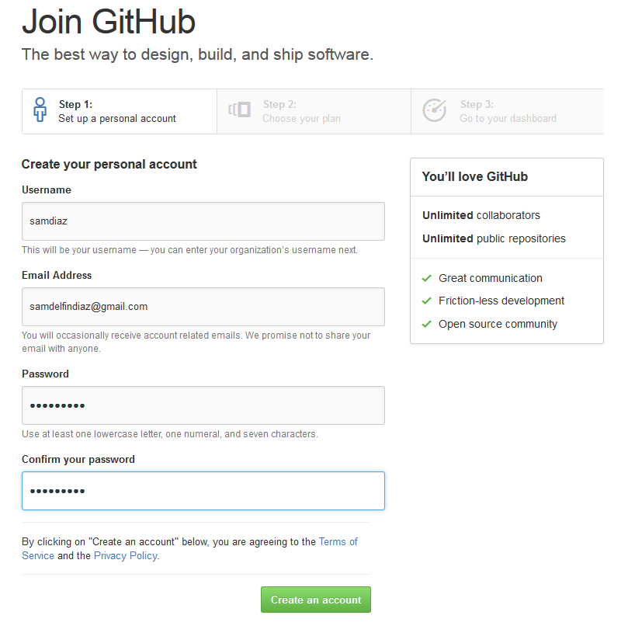

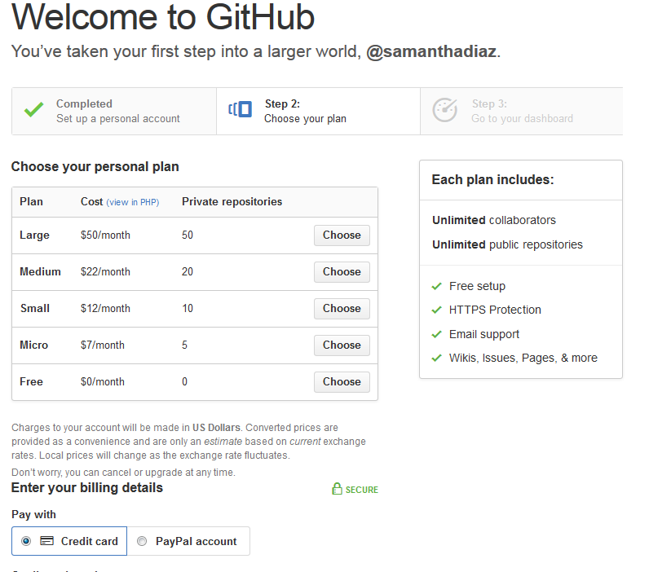

**CREATE YOUR OWN REPOSITORY AS SHOWN**

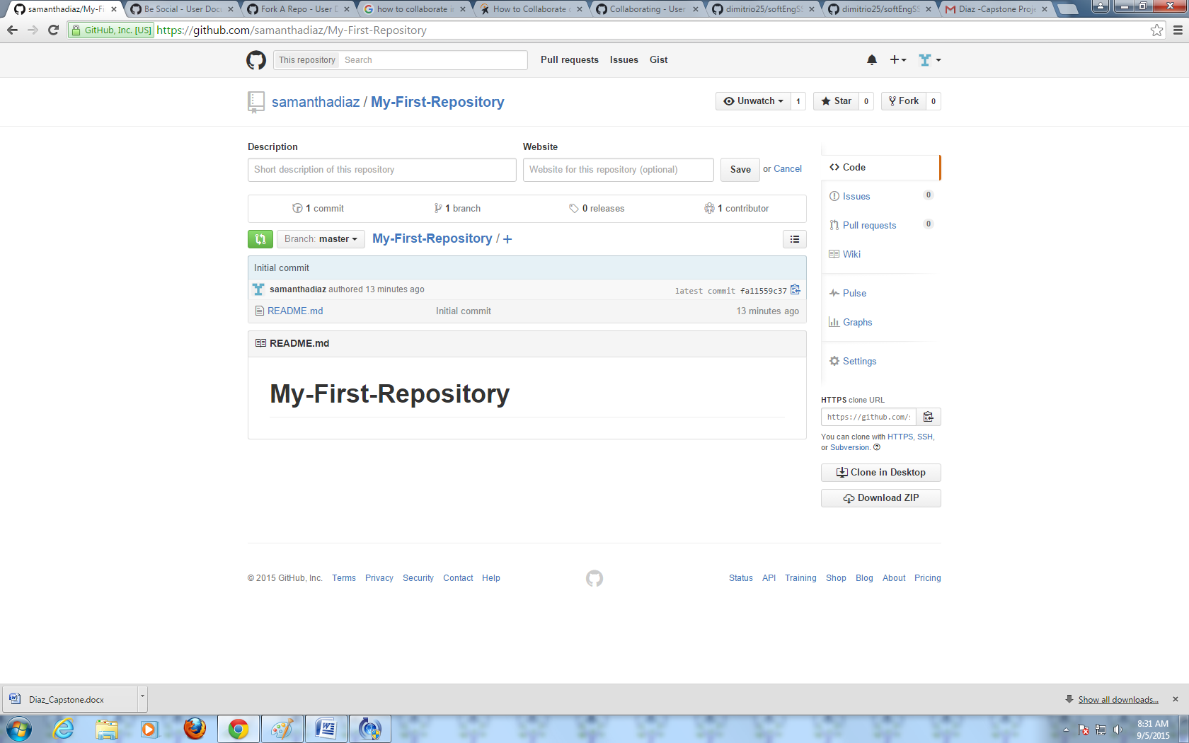

**COLLABORATE BY SEARCHING BY USERNAME, FULL NAME OR EMAIL**

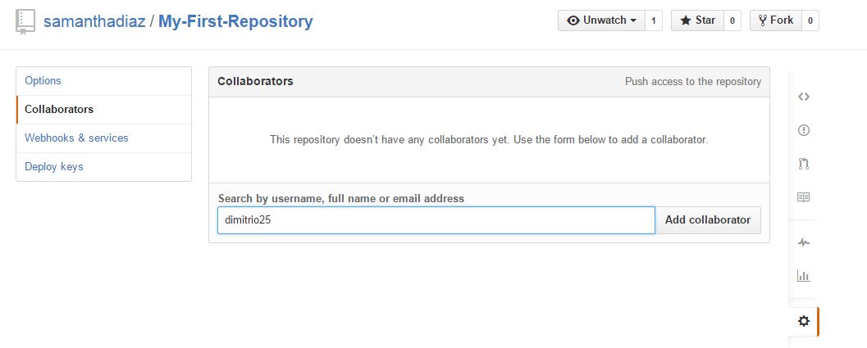

**CLICK THE FOLLOW BUTTON ON THE UPPER RIGHT SIDE OF THE PAGE**

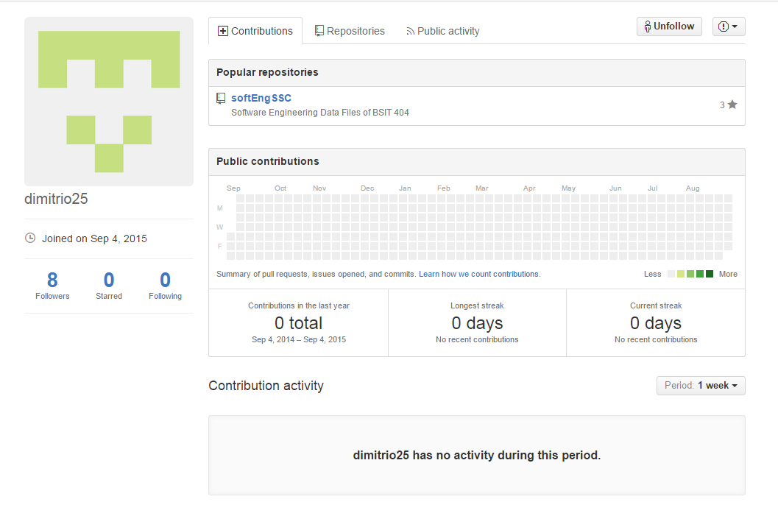

**ON THE REPOSITORY PAGE, CLICK THE WATCH BUTTON ON THE UPPER RIGHT SIDE**

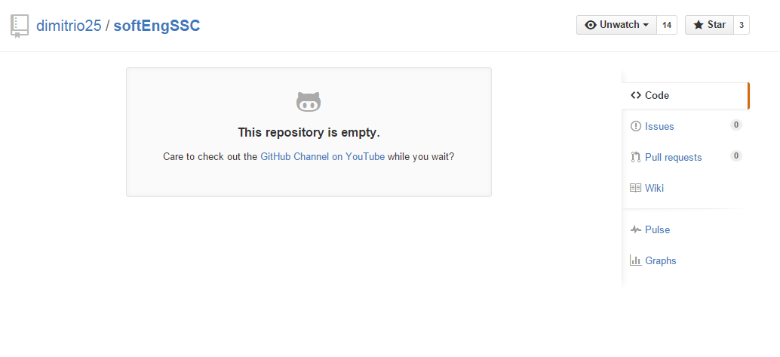

**DOWNLOAD GITHUB ON YOUR DESKTOP**

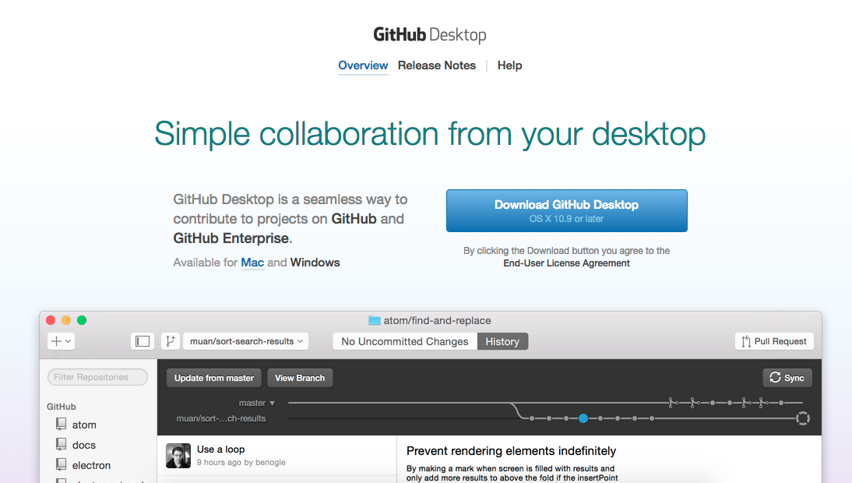

**COMPLETE THE SETUP**

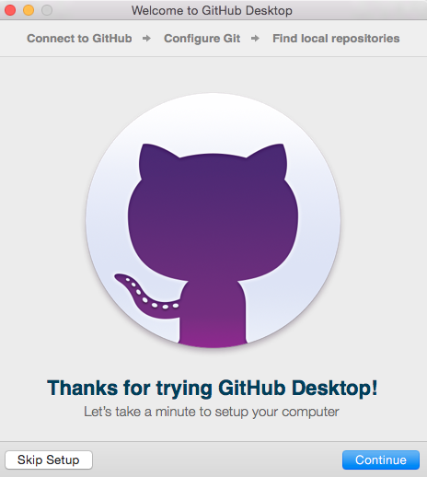

**SIGN IN USING YOUR ACCOUNT**

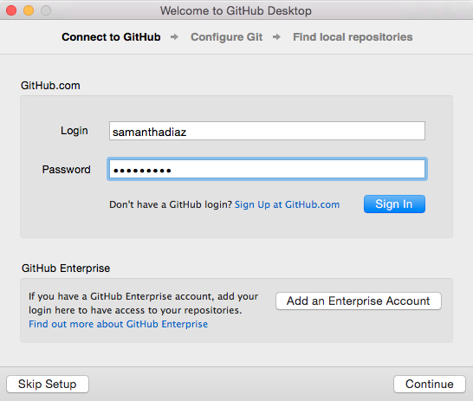

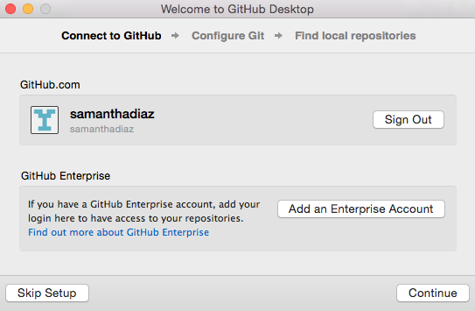

**CONFIGURE GIT**

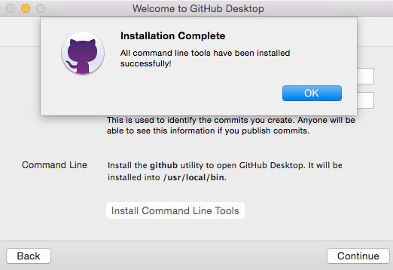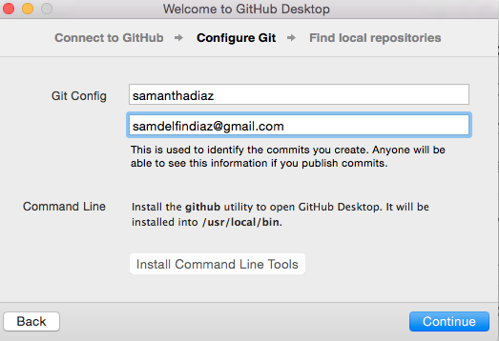

**CLICK THE ‘+’ BUTTON ON THE UPPER LEFT CORNER, AND CHOOSE A REPOSITORY**

