1. Open <https://github.com/>
2. Type the desired username, email address, and password

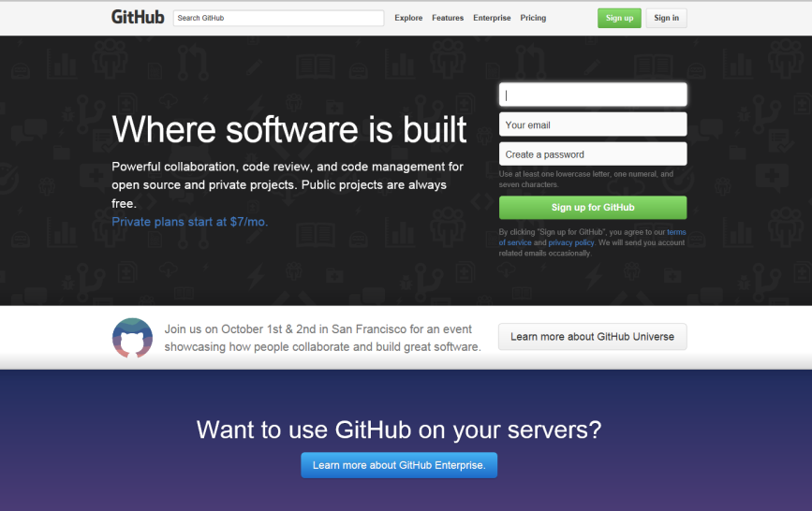

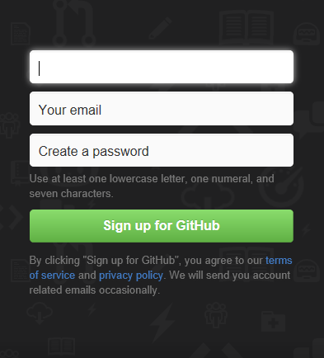

1. Verify the email



1. Follow dimitrio25

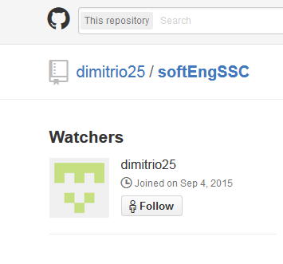



1. Add repository







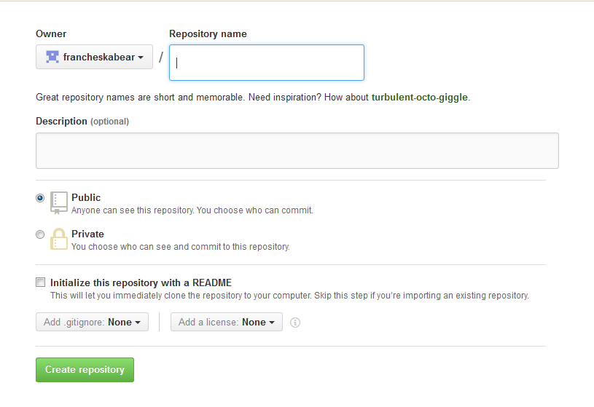

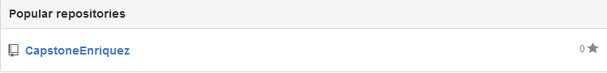

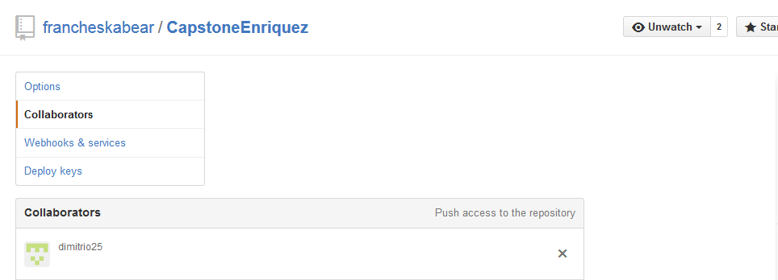

1. Uploading of file

MIDTERM

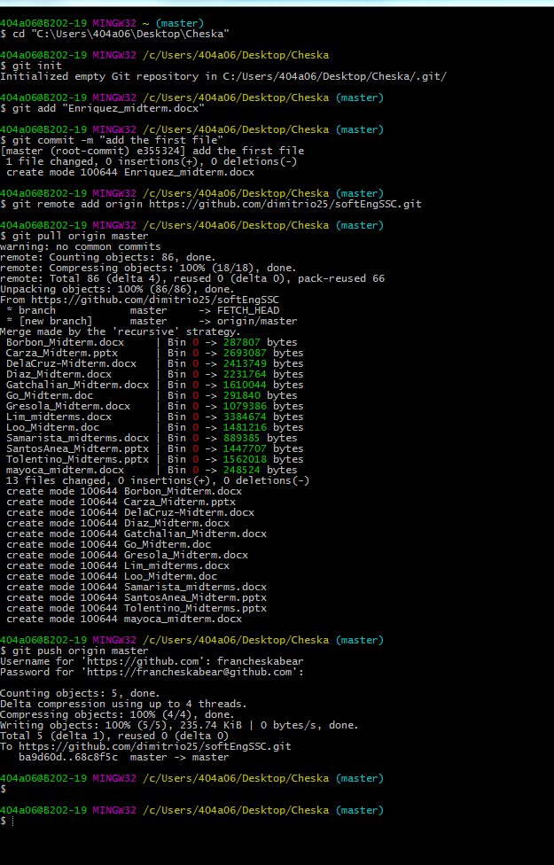

CAPSTONE

1. 404a06@b201-29 MINGW32 ~
2. $ cd "C:\Users\404a06\Desktop\Enriquez"
3. 404a06@b201-29 MINGW32 /c/Users/404a06/Desktop/Enriquez (master)
4. $ git init
5. Reinitialized existing Git repository in C:/Users/404a06/Desktop/Enriquez/.git/
6. 404a06@b201-29 MINGW32 /c/Users/404a06/Desktop/Enriquez (master)
7. $ git add "Enriquez_capstone.docx"
8. 404a06@b201-29 MINGW32 /c/Users/404a06/Desktop/Enriquez (master)
9. $ git commit -m "add first file"
10. On branch master
11. nothing to commit, working directory clean
12. 404a06@b201-29 MINGW32 /c/Users/404a06/Desktop/Enriquez (master)
13. $ git remote add origin https://github.com/dimitrio25/softEngSSC.git
14. 404a06@b201-29 MINGW32 /c/Users/404a06/Desktop/Enriquez (master)
15. $ git pull origin master
16. warning: no common commits
17. remote: Counting objects: 125, done.
18. remote: Compressing objects: 100% (52/52), done.
19. remote: Total 125 (delta 15), reused 0 (delta 0), pack-reused 66
20. Receiving objects: 100% (125/125), 24.57 MiB | 141.00 KiB/s, done.
21. Resolving deltas: 100% (31/31), done.
22. From https://github.com/dimitrio25/softEngSSC
23. * branch master -> FETCH_HEAD
24. * [new branch] master -> origin/master
25. Merge made by the 'recursive' strategy.
26. Borbon_Midterm.docx | Bin 0 -> 287807 bytes
27. Carza_Midterm.pptx | Bin 0 -> 2693087 bytes
28. Chung_Midterm | 1 +
29. DelaCruz-Midterm.docx | Bin 0 -> 2413749 bytes
30. Diaz_Midterm.docx | Bin 0 -> 2231764 bytes
31. Enriquez_midterm.docx | Bin 0 -> 257419 bytes
32. Gatchalian_Capstone.docx | Bin 0 -> 128556 bytes
33. Gatchalian_Midterm.docx | Bin 0 -> 1610044 bytes
34. Go_Midterm.doc | Bin 0 -> 291840 bytes
35. Gresola_Midterm.docx | Bin 0 -> 1079386 bytes
36. Lim_midterms.docx | Bin 0 -> 3384674 bytes
37. Loo_Midterm.doc | Bin 0 -> 1481216 bytes
38. Mayoca_Capstone1.docx | Bin 0 -> 305636 bytes
39. Samarista_midterms.docx | Bin 0 -> 889385 bytes
40. SantosAnea_Capstone.pdf | Bin 0 -> 592116 bytes
41. SantosAnea_MidtermFinalVersion.pptx | Bin 0 -> 1453825 bytes
42. Suarez.docx | Bin 0 -> 3070621 bytes
43. Tolentino_Midterms.pptx | Bin 0 -> 1562018 bytes
44. Villote_MT.txt | 6 ++++++
45. Villote_Midterm.docx | Bin 0 -> 2464240 bytes
46. mayoca_midterm.docx | Bin 0 -> 248524 bytes
47. 21 files changed, 7 insertions(+)
48. create mode 100644 Borbon_Midterm.docx
49. create mode 100644 Carza_Midterm.pptx
50. create mode 100644 Chung_Midterm
51. create mode 100644 DelaCruz-Midterm.docx
52. create mode 100644 Diaz_Midterm.docx
53. create mode 100644 Enriquez_midterm.docx
54. create mode 100644 Gatchalian_Capstone.docx
55. create mode 100644 Gatchalian_Midterm.docx
56. create mode 100644 Go_Midterm.doc
57. create mode 100644 Gresola_Midterm.docx
58. create mode 100644 Lim_midterms.docx
59. create mode 100644 Loo_Midterm.doc
60. create mode 100644 Mayoca_Capstone1.docx
61. create mode 100644 Samarista_midterms.docx
62. create mode 100644 SantosAnea_Capstone.pdf
63. create mode 100644 SantosAnea_MidtermFinalVersion.pptx
64. create mode 100644 Suarez.docx
65. create mode 100644 Tolentino_Midterms.pptx
66. create mode 100644 Villote_MT.txt
67. create mode 100644 Villote_Midterm.docx
68. create mode 100644 mayoca_midterm.docx
69. 404a06@b201-29 MINGW32 /c/Users/404a06/Desktop/Enriquez (master)
70. $ git push origin master
71. Username for 'https://github.com': francheskabear
72. Password for 'https://francheskabear@github.com':
73. To https://github.com/dimitrio25/softEngSSC.git
74. ! [rejected] master -> master (fetch first)
75. error: failed to push some refs to 'https://github.com/dimitrio25/softEngSSC.git'
76. hint: Updates were rejected because the remote contains work that you do
77. hint: not have locally. This is usually caused by another repository pushing
78. hint: to the same ref. You may want to first integrate the remote changes
79. hint: (e.g., 'git pull ...') before pushing again.
80. hint: See the 'Note about fast-forwards' in 'git push --help' for details.
81. 404a06@b201-29 MINGW32 /c/Users/404a06/Desktop/Enriquez (master)
82. $ git pull origin master
83. remote: Counting objects: 10, done.
84. remote: Compressing objects: 100% (8/8), done.
85. remote: Total 10 (delta 3), reused 9 (delta 2), pack-reused 0
86. Unpacking objects: 100% (10/10), done.
87. From https://github.com/dimitrio25/softEngSSC
88. * branch master -> FETCH_HEAD
89. f639f28..c78f48e master -> origin/master
90. Merge made by the 'recursive' strategy.
91. LooanalynCapstone.zip | Bin 0 -> 1051215 bytes
92. finalthesisproposal.docx | Bin 0 -> 46657 bytes
93. 2 files changed, 0 insertions(+), 0 deletions(-)
94. create mode 100644 LooanalynCapstone.zip
95. create mode 100644 finalthesisproposal.docx
96. 404a06@b201-29 MINGW32 /c/Users/404a06/Desktop/Enriquez (master)
97. $ git push origin master
98. Username for 'https://github.com': francheskabear
99. Password for 'https://francheskabear@github.com':
100. Counting objects: 7, done.
101. Delta compression using up to 4 threads.
102. Compressing objects: 100% (7/7), done.
103. Writing objects: 100% (7/7), 37.56 KiB | 0 bytes/s, done.
104. Total 7 (delta 2), reused 0 (delta 0)
105. To https://github.com/dimitrio25/softEngSSC.git
106. c78f48e..8d0737c master -> master
107. 404a06@b201-29 MINGW32 /c/Users/404a06/Desktop/Enriquez (master)
108. $