**Table of Contents**

**Chapter 1: Introduction……………………………….………………………..p. 2-7**

Background of the Study………………………………………………..…p. 2

Significance of the Study……………………………………………….....p. 6

Statement of the Problem……………………………………………….…p. 7

Objectives…………………………………………………………………...p. 7

**Chapter 2: Review of Related Literature……………………………....…...p. 8-17**

Internet as a tool of Gathering Information………………………..……..p. 8

Natural Calamities…………………………………………………………..p. 9

Flood in the US……………………………………………………………...p. 11

Flood in the Philippines………………………………………….………….p.11

Possible Effect of Flood……………………………………………………p. 12

Synthesis……………………………………………………………….……p. 13

Definition of Terms………………………………………………………….p. 14

**Chapter 3: Framework………………………………………………………p. 18-25**

Information Theory………………………………………………………….p. 18

Information Richness Theory……………………………………………...p. 18

Integration of Information Theory and Information Richness…………..p. 20

Theoretical Framework…………………………………………………….p. 21

Conceptual Framework………………………………………………….…p. 23

Operational Framework…………………………………………………….p. 25

**Chapter 4: Methodology…………………………………………………..…p. 27-30**

Research Design and Method…………………………………………….p. 27

Variables and Measures………………………………………………..…p. 27

Research Instruments……………………………………………………..p. 27

Units of Analysis & Sampling…………………………………………..…p. 28

Data Gathering……………………………………………………………..p. 28

Data Analysis…………………….………………………………………....p. 28

Scope & Limitation…………………………………………………………p. 29

Project Development Methodology………………………………………p. 29

**References…………………………………………………………………..…p. 30-33**

**Chapter 1**

**Introduction**

**Background of the study**

Internet is the biggest sensation of this generation. Everyone uses or least knows internet. The internet provides the users many things like information about a celebrity, a movie review or just simply playing a game. In this generation, users can find a solution to a problem using internet. Google.com is the most famous website today. Google is a search engine that can help users find what they want to find easily (http://marketingland.com/). According to Beal, V. (n.d.) “The Internet is a global [network](http://www.webopedia.com/TERM/N/network.htm) connecting millions of [computers](http://www.webopedia.com/TERM/C/computer.htm). More than 190 countries are linked into exchanges of [data](http://www.webopedia.com/TERM/D/data.htm), news and opinions.” Gil, P (n.d) said that “The Internet is a broadcast medium for the every person.” Every device today can access internet easily with the use of WiFi or Wireless Fidelity. Any user with a gadget can us internet any time they want. (Gil, P, n.d.)

The website Philippine-islands.ph describe the Philippines as an archipelago that is divided in three island groups namely, Luzon, Visayas and Mindanao. The Philippines is known for its fantastic beaches like Boracay Island, Palawan Island and many more. It is also known for its people who are kind and hospitable. The Philippines is located in South-East Asia situated in western Pacific Ocean. Philippines is one of the tropical climate country where there is only 2 weathers, it is sunny and rainy season. (http://www.philippine-islands.ph/)

Little did people know that the Philippines is always pummelled by countless tropical storms. Brown (2013) reported that eight or nine tropical storms make landfall in the Philippines each year, with another 10 entering Philippine waters. These tropical storms becomes stronger and stronger each year due to the Climate Change. The storms caused many devastating calamities including Landslides, Storm Surges and Floods. These calamities affected millions of infrastructure, traumatizing thousands of Filipinos and killing hundreds of innocent lives. (Brown, S, 2013)

Flood is the most common disaster in the Philippines. Philippine Atmospheric, Geophysical and Astronomical Services Administration (PAG-ASA) defined flood as “flood simply denotes a progressive abnormal increase in the elevation of the surface level of stream flow until it reaches a maximum height from which the level slowly drops to what is its normal level.” The most popular floods that happened in the Philippines is the Ondoy. Typhoon Ondoy, which goes by the international name of Typhoon Ketsana, ravaged the Philippines from September 23, 2009 to September 30, 2009. (proquest.com, 2009)

Filipino Former President Gloria Macapagal-Arroyo said the storm was the worst to hit Manila in over 40 years and has left over 80% of the city underwater. ([US Fed News Service, Including US State News](http://search.proquest.com/pubidlinkhandler/sng/pub/US+Fed+News+Service,+Including+US+State+News/ExactMatch/29619/DocView/472901566/fulltext/F8E90CBD1A4AE8PQ/1?accountid=34320), 2009). That day marked the downhill of the Philippines. The disaster left the Filipinos devastated and scarred for weeks. (proquest.com, 2009)

According Bernardo (2010), almost 300 people died during the unexpected flood and almost ₱9 Billion worth of infrastructures were destroyed. It was the darkest moments for us Filipinos but we remained standing tall. (Bernardo, J, 2010)

After the Typhoon Ondoy, Filipinos were so traumatized that every time the rain drops they panic. Little did the Filipinos know that Typhoon Ondoy was just a beginning. After Typhoon Ondoy, Typhoon Reming dominated the Philippines once again. And then came along Typhoon Frank to Typhoon Yolanda to Typhoon Milenio. After all this disasters, the Filipinos still keeps its faith and chins up. Proving to everybody that whatever problem or calamities may come, we still stand up and move on. (Bernardo, J, 2010)

After just how many years, Yolanda came along. This Typhoon is the most devastating of all. Everybody taught that it was just a flood but after a couple of hours a Storm Surge was declared. Typhoon Yolanda pummelled the Visayas region of the Philippines. Typhoon Yolanda is known for its international name as Typhoon Haiyan. Typhoon Yolanda landed in the Philippines last November 2, 2013 to November 11, 2013. GMA News reported that 6,300 casualties were declared six months after the Typhoon struck. Up until now, the infrastructures of Tacloban is still under construction. Many people donated for the victims of the Typhoon. Almost ₱700 Million were donated for the victims. Even schools donated for a great cause. People all over the world donated kinds and things. (GMA News, 2014)

Nowadays, people are lucky enough to have an internet that would give us information about anything. Each year, technologies gets easier to handle. The government of the Philippines decided to do something about it. A technology that can be handy and informative at the same time.

After all these disasters, the Philippines learned that we have to be prepared for something bigger. We cannot blame the Climate Change every time there is a calamity. We have to brace ourselves and be ready for what is going to happen to us.

The Filipinos realized that they have to be informed every time a storm will enter the Philippine Area of Responsibility. The Department of Public Works and Highways (DPWH) will partner with the Department of Science and Technology (DOST) and the University of the Philippines (UP) Training Center for Applied Geodesy and Photogrammetry in its infrastructure planning for roads, bridges, and flood control projects. ([Targeted News Service](http://search.proquest.com/pubidlinkhandler/sng/pubtitle/Targeted+News+Service/$N/29620/DocView/1477738311/fulltext/542BAAD4512B4E73PQ/8?accountid=34320), 2014)

This collaboration of agencies and school is about the launching of the “Project Noah”. NOAH stands for Nationwide Operational Assessment of Hazards. Project Noah by DOST uses advanced science and technology, state-of-the-art instruments and methods to construct high resolution hazard maps and information through different media and communication platforms such as those tools mentioned above and Google maps.(Project Noah Philippines, 2012).

Project Noah is a mobile application where we can be updated with our weather. This application consists of a map where you can change its view of Precipitation, Probability of rain, Weather Outlook and PAGASA Cyclone Update. This can be download through our mobile phones and tablets. It is an information in our pocket. Being aware of our surroundings help us survive and be alive. (Dungo, 2012)

Our safety is important. Prevention is better than cure as some people say. Information can be useful to people to help minimize casualties. Everybody deserves to be alive and be informed.

**Significance of the Study**

The victims of Typhoon Ondoy is the inspiration to this study. Everybody witnessed the brutality of the Typhoon. Ondoy traumatized every Filipino living in the country. This study will give information to the people on how to survive during floods.

The Significance of this Interactive yet Informative website is to give the users enough information on surviving Floods. An Interactive website will be used to give out the information. Website is the most common reliable source of information needed by the users.

The website will be helpful to its user because not only it will be informative but entertaining. Being informed is the most powerful tool of surviving. With the use of the website, the dissemination of the information will be easy for everybody uses internet.

**Statement of the Problem/s**

The main research problem in this study how can the website ‘Flooded with information’ inform the users about surviving floods?

**Objectives**

1. To create an informative website on surviving floods.
2. To provide basic information on surviving floods through website.

**Chapter 2**

**Review of Related Literature**

Floods is a kind of Natural Disaster. In this chapter, the researcher will discuss the importance of knowing how to survive the floods and how the information will be disseminated to the people especially to the target audience of the researcher.

**Internet as a tool of gathering information**

Technology is very much helpful nowadays. It contains many information that people need. With the help of the internet, the users can easily find the answers to user’s questions. With just a click of a button, the information needed is presented in front of their eyes. The faster the internet is, the faster the information arrives. (Rich, 2011)

There are many types of things users can find with the help of the internet. You can play games, search for a recipe, download music, watch movies or communicate with people. Facebook is the one of the websites users can use for communicating people. Even a million miles away from each other. Users can simply add that person then the user can message him/her. (Rich, 2011)

But with all these advantages, internet also has disadvantages. The information the users may get in the internet may be a lie. There is also a big possibility that the users may get spam or viruses in the website you may visit. Many viewers were victims of these unbelievably crime. There are also hackers in the internet. They hack the user’s mobile or account and from there they can get the user’s personal information. They can withdraw money from these information and they may know the user’s address and they can surprisingly steal from the user’s houses. So be careful in what information to put in especially on the online profiles. (Rich, 2011)

With these innovative things, we can simply find anything online. It can also be helpful in situations. A user can search for the basic needs for example, surviving disasters etc.

Technology, generally, keeps developing year after year. The longer it gets, the easier the technology is. Impeller (2014) reported that there will be a technology in which the water flow during floods will be more efficient. The Impeller Company launched, last October, the more innovated Xylem technology that will help the government control flood situations in flood-prone areas in Metro Manila. (Impeller, 2014)

**Natural Calamities**

There are many types of natural calamities. For example landslides, earthquake, typhoon and many more. Natural calamities happens when nature gets back to the people of the Earth. People around the globe experiences one of these Natural Calamities at least once or twice. Natural calamities are not a joke. People get traumatized, people get lost and people get killed. It is very hard to get over these disasters. According to Guha-Sapir et al.(2012), there were 14 disasters that were struck in Asia in the year of 2012. These disasters were consists of 8 floods, 3 typhoons, 2 droughts and 1 food shortage. 90. 5% were all Asian victims and 15.6% of these victims were Filipinos. (Guha-Sapir et al., 2012)

Filipinos are known for its smiling attitude but when it comes to disasters especially floods, they become serious. Every year, people experience at least 15 typhoons that causes floods. Casualties who were affected by floods are getting higher and higher each year. (http://www.emdat.be/country_profile/index.html)

All calamities are unforgettable. Especially, when we experience it ourselves. The most unforgettable calamity is when the typhoon Yolanda struck the Philippines. The whole country was awakened with a strong and bewildering wind. The Philippine Atmospheric, Geophysical and Astronomical Services Administration (PAGASA) spotted a cyclone as big as the country days before the typhoons’ landfall. People all around the world helped us without hesitating. Even kids donating for our country. The country was very down at that time. People were devastated, everybody crying and worrying for their loved ones from afar. (Or, 2010)

**Flood in the US**

Philippines and the US are very much different countries. The United States is more advanced in the Philippines particularly in the field of Technology. Innovation in the US is faster than in the Philippines. They have the most advanced technology that can detect different kinds of storms and other calamities that threatens their country. (Dickey, 2013)

Even in the United States, floods occur. Last December, the state of California was flooded by a Low Pressure Area that was spotted around California. According to Floodlist (2014), Heavy rains caused the flood and landslide in the state. US National Weather Service said that a record amount of rain fell in downtown Los Angeles for December 2, beating the previous high for that date, set in 1961.

This proves that everybody in the world has big possibility of being the victim of flood. Because of the Climate Change that the Earth is currently experiencing, different kinds of disasters are threatening the lives of the people living in the Earth. Many of the organizations are trying to save the world with a goal of preventing the ice caps to melt even more.

**Flood in the Philippines**

Floods are very common in the Philippines. During the year 2014, the Philippines welcomed the year with a Tropical Depression that left millions of people homeless. CNN news (2014) reported that nearly 900,000 people were affected by the Tropical Depression ‘Agaton’. The Tropical Depression struck the East of Mindanao last year with a wind intensity of 55kph.

At that time, Filipinos were not prepared for another flood due to Typhoon Yolanda that left us devastated and most of us homeless. Yolanda made a landfall mid-November whilst ‘Agaton’ struck the Philippines first week of January. Filipinos were still in the midst of grieve during the destruction of ‘Agaton’.

Floods are very dangerous not only for the lives of the people but for the livelihood. During these floods, livelihood were also affected. Many establishments were destroyed especially crop farmers. Overly watered crops causes the crops to drown and die. (Hume, 2014)

**Possible Effects of Flood**

Every disaster there is a possible outcome or effect on people. Health is important for us. The Medecins Sans Frontieres (n.d.) reported that after the catastrophic flood that happened on August 2012, Filipinos had 36 cases of leptospirosis recorded in Bulacan Province alone. The MSF observed this water-borne disease for any possible growth on the cases. The MSF also helped purify the water that the affected people were given.

**Synthesis**

In this study, the researcher will help inform the users through website. The researcher will provide information in surviving actual floods. This study will help the target audience be aware of disasters, primarily floods.

Floods are common in this country. The researcher will identify the possible and alternative ways on surviving floods that can be helpful to people especially, the target audience. The researcher will use the latest technology to disseminate the information that is needed for future references. The researcher believes that Internet is powerful enough for information dissemination and will be helpful to the users especially, the target audience.

The study will tackle the possible situations that can happen during floods. The researcher will inform its users that floods aren’t that easy to get by with. The researcher will use the internet as a tool for giving out basic information to the users.

The researcher will also try to disseminate the information that the researcher wants to give to the people, not only the target audience. From there, the researcher will know the effectiveness of the information that she has disseminated.

**Definition of terms**

**Address Bar** - a narrow, horizontal space in the window of a web browser that issued to display the address of a website.

**Animation** - the process of preparing animated cartoons.

**Browser** - Also called Web Browser. A software program that allows the user to find and read encoded documents in a form suitable display, especially such a program for use on the World Wide Web.

**Climate Change** - a long-term change in the earth’s climate, especially a change due to an increase in the average atmospheric temperature.

**Codes**  - the symbolic arrangement of statements or instructions in a computer program in which letters, digits, etc. are represented as binary numbers; the set of instructions in such a program.

**Disaster**  - a calamitous event, especially one occurring suddenly and causing great loss of life, damage, or hardship, as a flood, airplane crash, or business failure.

**Earthquake** - a series of vibrations induced in the earth’s crust by the abrupt rupture and rebound of rocks in which elastic strain has been slowly accumulating.

**Facebook** - the name of a social-networking service and website, launched in 2004.

**Google** - a brand name of a leading Internet search engine, founded in 1998.

**Hack** - to circumvent security and break into (another’s server, website, or the like) with malicious intent.

**HTML** - Hyper Text Mark-up Language: a set of standards, a variety of SGML, used to tag the elements of a hypertext document. It is the standard protocol for formatting and displaying documents on the World Wide Web.

**Hyperlink** - a word, phrase, picture, icon, etc. in a computer document on which a user may click to move to another part of the document or to another document.

**Innovation**  - something new or different introduced.

**Internet** - a vast computer network linking smaller computer networks worldwide (usually preceded by *the*). The internet includes commercial, educational, governmental, and other networks, all of which the same set of communications protocols.

**Landslide** - the downward falling or sliding of a mass of soil, detritus, or rock on or from a steep slope.

**Natural Calamities** - a great misfortune or disaster, as a flood or serious injury.

**Online** - operating under the direct control of, or connected to, a main computer.

**Search Engine** - a computer program that searches documents, especially on the World Wide Web, for a specified word or words and provides a list of documents in which they are found.

**Tropical Depression** – an atmospheric low-pressure system originating in the tropics, specifically, a tropical cyclone in which the maximum sustained wind speed is 38 miles per hour (62 kilometres per hour) or less.

**Typhoon**  - a tropical cyclone or hurricane of the western Pacific area and the China seas.

**Website** - a connected group of pages on the World Wide Web regarded as a single entity, usually maintained by one person or organization and devoted to a single topic or several closely related topics.

**Chapter 3**

**Framework**

**Information Theory**

The first theory that can support this study is the Information Theory. Encyclopedia Britannica (n.d.) defined Information Theory as a mathematical representation of the conditions and parameters affecting the transmission and processing of information. Information Theory provides the process of how the information is being carried from the source to the receiver. (Encyclopedia Britannica ,n.d.)

Yeung (n.d.) stated that in a communication system, we try to convey information from one point to another, very often in a noisy environment. Communication system is connected to Information Theory because the theory is the process where a person is trying to communicate to another person. It shows the way the information that is being processed and received with the interference of a noise. (Yeung, n.d.)

**Information Richness Theory**

The second theory that can support this study is the Information Richness Theory. According to Schiefelbein (2012), Media Richness Theory describes how and why particular media are selected to deliver a message. Media Richness or Information Richness Theory determines how visually good a media can be. It depends on how creative and how the information was presented in the media.

The least media consists of information that is presented with purely text-only. The rich medium, on the other hand, consists of varieties of cues that makes the media powerful and visually attractive. Schiefelbein (2012) also said *“Studies show that a richer distance education environment, in terms of media-rich communication technologies available for instructor and student use, yields higher rates of student satisfaction and instructor-to-student, student-to-instructor, and student-to-student communication.”*  Some would disagree but the media depends on how the information is being transmitted and how the users understand it.

**Integration of Information Theory and Information Richness Theory**

In this study, the researcher’s main objective is to inform the users how to survive during floods. The Information Theory would help the researcher achieve this objective. The researcher will understand how the information is being transmitted to the users especially, the target audience. The Information Richness Theory will help the researcher create the website and be more creative to encourage other people to use the website.

These two theories will provide the researcher enough knowledge on how the website will be created and how the users will understand its objective.

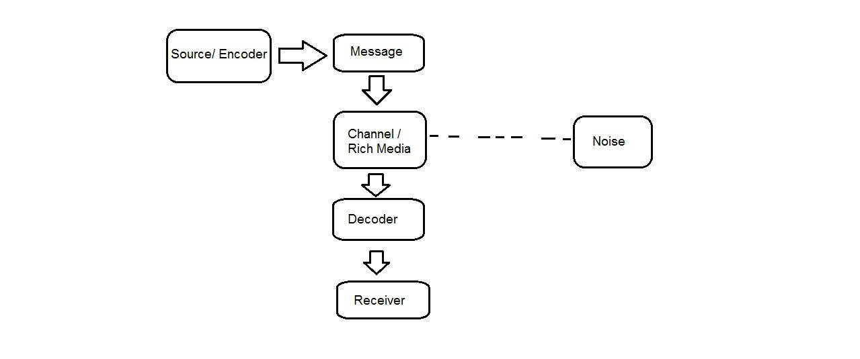

Figure 1: Theoretical Framework

**Theoretical Framework**

Figure 1 shows how the two theories were combined as one to make a framework. The source or the encoder is the one that will create the message that will be transmitted to the receiver of the message. Once the message is created, it will be translated into the channel or the product that the researcher will create. Noise is the one that can interfere in transmitting the message to the receiver. The noise may or may not occur during the transmission of the message. The decoder will show the information that was transmitted. From the decoder, the Receiver will read and understand the message that was transmitted.

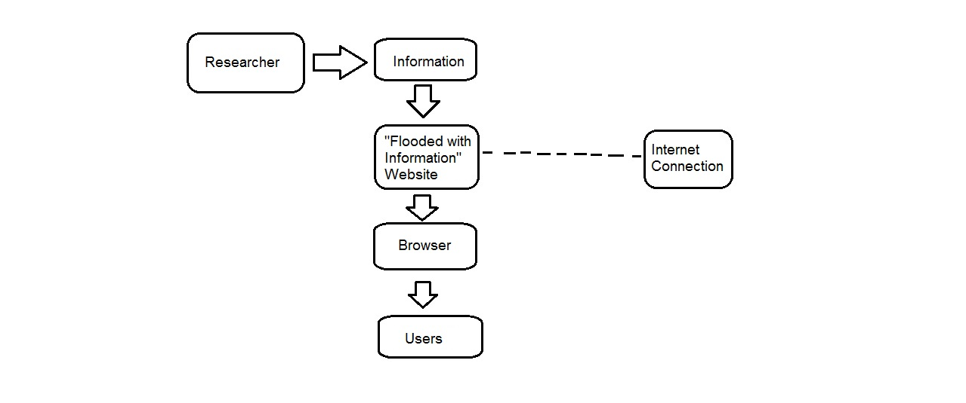

Figure 2: Conceptual Framework

**Conceptual Framework**

In the Conceptual Framework, the terms that was used in the Theoretical is changed into a more detailed one. The researcher is the one that will transmit the message. The message is the information that will be displayed on the “Flooded with Information” website. The Internet Connectivity can hinder the transmission of the information on being transmitted. Once the website already has the information that the researcher gave, the browser will display the information that was given by the researcher. When the browsers displays the information, the users will read and will understand the content of the information.

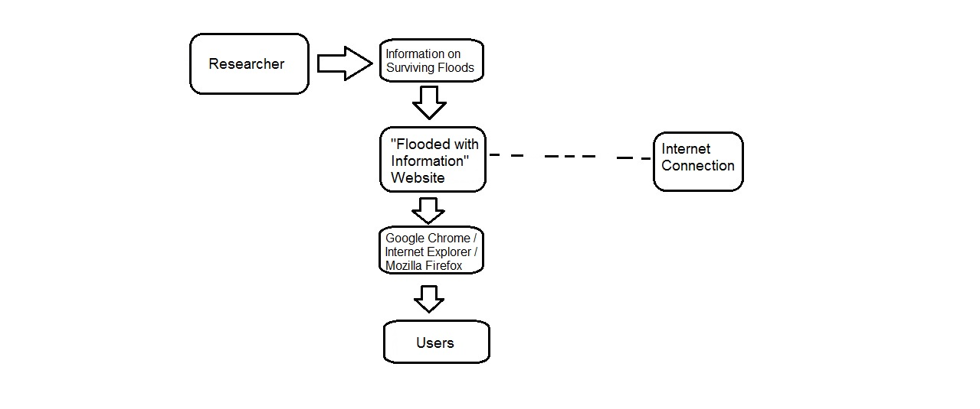

Figure 3: Operational Framework

**Operational Framework**

The Operational Framework is more detailed than the Conceptual Framework. The researcher is the one that created the message. The message will consist of information on surviving floods that will be shown in the “Flooded with Information” website. The Internet Connection may or may not hinder the transmission of the message. The website will be displayed in different Browsers for example, Google Chrome, Internet Explorer, Mozilla Firefox and many more. Once the message is displayed the users will then read the information about surviving floods.

**Chapter 4**

**Methodology**

**Research Design and Method**

The researcher will use the Quantitative method. To be specific, the researcher will distribute a survey questionnaire to the participants to know how informative the website ‘Flooded with Information’ will be.

**Variables and Measures**

The researcher will be using age, ranging from 13 years old to 18 years old, sex, whether male or female, and lastly, year level, ranging from grade 8 to grade 12. These information will be used as the variables of the research. From these information, the researcher will determine if the participants from different age and year level has enough knowledge about surviving floods.

**Research Instruments**

The researcher will provide survey questionnaires to be given to the participants. The researcher will be using survey questionnaire to determine how deep the participants know all about floods and how to survive it and to know if the website will be effective for them.

**Units of Analysis and Sampling**

The study will be using high school students specifically, grades 8 to 12 or ages 13-18, as correspondents. From these, it will determine if age or year level has enough knowledge about floods and how to survive it. The researcher will also use random sampling method to be able to choose correspondents randomly.

**Data Gathering**

The survey will be conducted on August to September 2015. The researcher will conduct these surveys to 3 different schools around Parañaque City. The correspondents selected from the schools will determine on how well they know floods and the basic instructions on surviving floods.

**Data Analysis**

The researcher will be using descriptive statistics to summarize all the data that was gathered from the survey. The percentage of variables will be computed fairly and honestly.

**Scope and Limitations**

The study will cover information on surviving floods only. The researcher will develop a website not a mobile app. The website will be composed of a game and written information about surviving during floods only.

**Project Development Methodology**

The researcher will use different soft wares that will help to create the proposed website such as Adobe Photoshop, Adobe Dreamweaver, Adobe Flash Professional and Adobe Premier Pro. The website will be composed of textual information, a situational game where a player can choose what situation is the right thing to do to survive, and an instructional video at the end of the game. The correspondents will help me improve the website and make it better and more helpful.

**References**

## Brown, S. (2013). Country on Earth. Retrieved from http://world.time.com/2013/11/11/the-philippines-is-the-most-storm-exposed-country-on-earth/.

## Philippine Atmospheric, Geophysical and Astronomical Services Administration. (2009). Flood. Retrieved from http://pagasa.dost.gov.ph/index.php/learning-tools/flood?showall=1&limitstart=.

With the Second Killer Typhoon Fast-Approachong, Sen. Schumer urges State Department to double emergency funding to Philippines after Typhoon Ondoy devastates nation. (2009, Oct 02). *US Fed News Service, Including US State News.* Retrieved from <http://search.proquest.com/docview/472901566?accountid=34320>

## Bernardo, J. (2010). Typhoon Ondoy Death Toll in the Philippines: Killer Mall or Killer Corruption Figured?. Retrieved from <http://forthephilippines.blogspot.com/2010/02/typhoon-ondoy-death-toll-in-philippines.html>.

## DPWH to use DOST's/UPS project NOAH and DREAM data for planning. (2014, Jan 15). *Targeted News Service* Retrieved from <http://search.proquest.com/docview/1477738311?accountid=34320>

|  |
| --- |
| Dungo, F. (2012). *Project Noah Philippines*. Retrieved from http://philpad.com/project-noah-philippines-dost-project-for-flood-rain-and-weather-assessment/. |

## GMA News. (2014). NDRRMC: Yolanda death toll hits 6,300 mark nearly 6 months after typhoon. Retrieved from http://www.gmanetwork.com/news/story/357322/news/nation/ndrrmc-yolanda-death-toll-hits-6-300-mark-nearly-6-months-after-typhoonMcgee, M. (2013, December 16). Google is Most Visited Site of 2013, Despite Big Drops in Desktop Traffic [Nielsen]. Retrieved March 2, 2015, from http://marketingland.com/google-is-most-visited-site-of-2013-despite-big-drops-in-desktop-traffic-nielsen-68235

## Gil, P. (n.d.). What is the 'Internet'?. Retrieved March 2, 2015, from http://netforbeginners.about.com/od/i/f/What-Is-The-Internet.htm

## Philippine Islands. (n.d.). Geography of the Philippines. Retrieved March 2, 2015, from http://www.philippine-islands.ph/en/geography_of_the_philippines.html

|  |  |  |
| --- | --- | --- |
| DAVIES, R. (2014). *Evacuations and Flood Warnings in California after Day of Record Rain*. Retrieved from http://floodlist.com/america/usa/flood-warnings-california. | | |
| Yahoo Southeast Asia Newsroom. (2014). *Updates: Tropical storm Mario in PH*. Retrieved from https://ph.news.yahoo.com/updates--typhoon-mario-in-ph-005016970.html. |

## Chiu, P. D. (2014). *IN PICTURES: Typhoon Glenda whips through Luzon*. Retrieved from http://www.gmanetwork.com/news/story/370527/news/specialreports/in-pictures-typhoon-glenda-whips-through-luzon.

## Hume, T. (2014). *45 dead, more than 260,000 displaced in Philippines flooding*. Retrieved from http://edition.cnn.com/2014/01/22/world/asia/philippines-agaton-flooding-landslides/.

## UMBAO, E. (2014). *Low Pressure Area “Agaton” Spotted East of Mindanao to Enter PAR*. Retrieved from http://philnews.ph/2014/01/10/lpa-agaton-spotted-east-mindanao-enter-par/.

## Gustafson, A. (2011). *Adaptive Web Design: Crafting Rich Experiences with Progressive Enhancement*. Chattanooga,Tennessee, USA: Easy Readers, LLC.

|  |
| --- |
|  |

## Dass-Brailsford, P. (2010). *Crisis and Disaster Counseling: Lessons learned from Hurricane Katrina and other Disasters*. Thousand Oaks, CA, USA: SAGE Publications, Inc. .

## Or, E. (2010). *After the Storm: Stories of Ondoy*. Mandaluyong City, Philippines: Anvil Publishing, Inc.

## Adobe Creative Team. (2013). *Adobe Dreamweaver CC Classroom in a Book*. San Jose, CA, USA: Adobe Press.

## Rich, M. (2011). Student Research in a Web 2 World. Learning to use new Technology to Gather Primary Data, 9(1), 78-86. Retrieved from [www.ejbrm.com](http://www.ejbrm.com).

Impeller. (2014, October 29). Xylem technology to help protect the Philippines against monsoon flooding. Retrieved from <http://impeller.xyleminc.com/en/construction-and-mining/2014/10/29/xylem-technology-to-help-protect-the-philippines-against-monsoon-flooding/>

Guha-Sapir, D., Hoyois, P., & Below, R. (2013). Annual Disaster Statistical Review 2012: The numbers and trends. Belgium: Ciaco Imprimerie, Louvain-la-Neuve.

The International Disaster Database. (n.d.). Natural Disasters. Retrieved from http://www.emdat.be/country_profile/index.html

Dickey, J. (September 3, 2013). Advances in Weather Radar Since AccuWeather Was Born. Retrieved from http://www.accuweather.com/en/features/trend/advances-in-weather-radar-sinc/1184648

Medecins Sans Frontieres . (n.d.). Philippines: Preventing outbreak of water-borne diseases in flood aftermath. Retrieved from http://www.msf.ie/article/philippines-preventing-outbreak-water-borne-diseases-flood-aftermath

## Encyclopedia Britannica. (n.d.). Information Theory. Retrieved from http://www.britannica.com/EBchecked/topic/287907/information-theory

## Yeung, R. (n.d.). A First Course in Information Theory. New York, USA: Plenum Publishers.

|  |
| --- |
| Scheifelbein, J. (April 10, 2012). *Media Richness and Communication in Online Education.*Retrieved from http://www.facultyfocus.com/articles/online-education/media-richness-and-communication-in-online-education/ |