To start:

1. Open [www.gethub.com](http://www.gethub.com)



1. Type a username, email and password to create account



1. You will receive an email that will verify the account

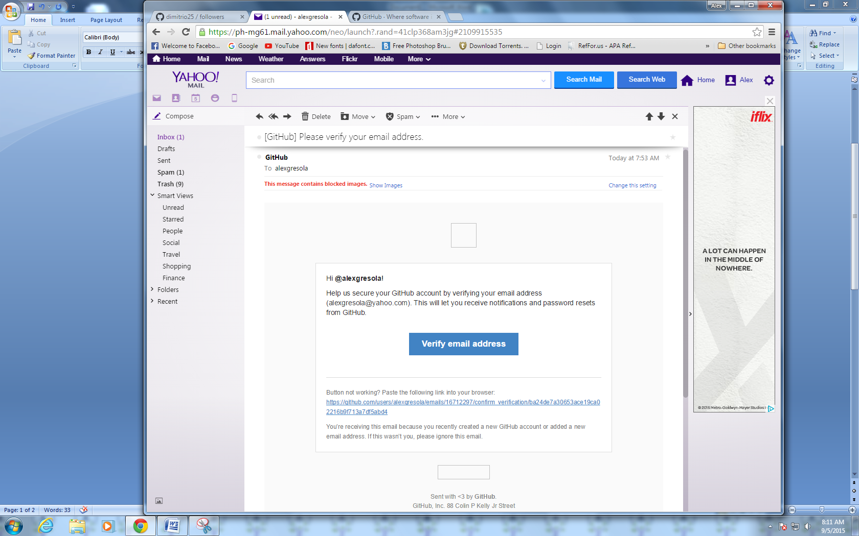

1. Click verify



To become a collaborator:

1. Find the account that you want to add

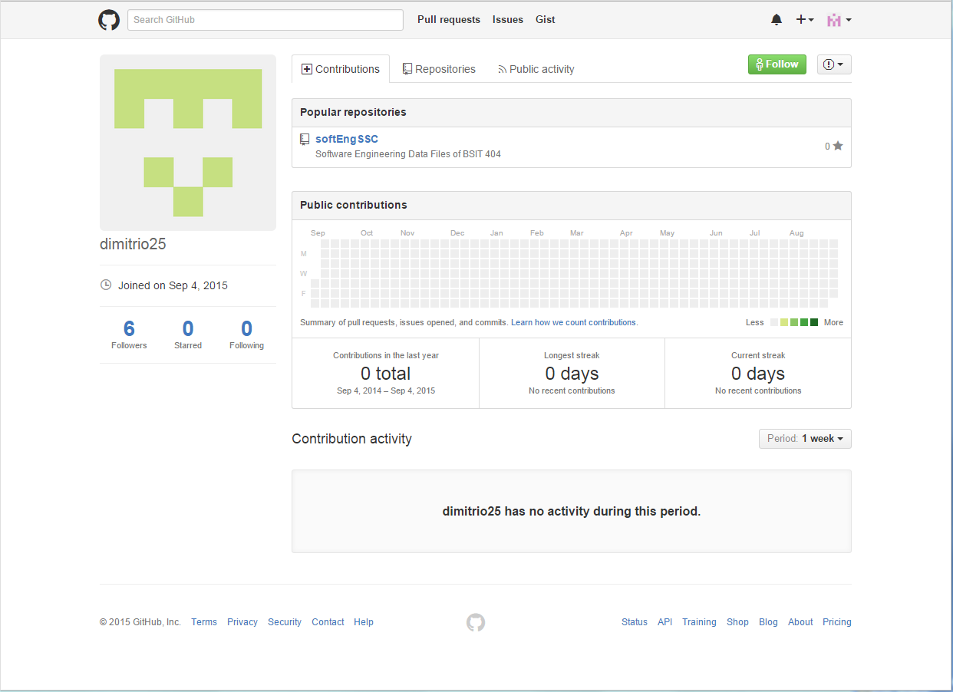

1. Click Follow

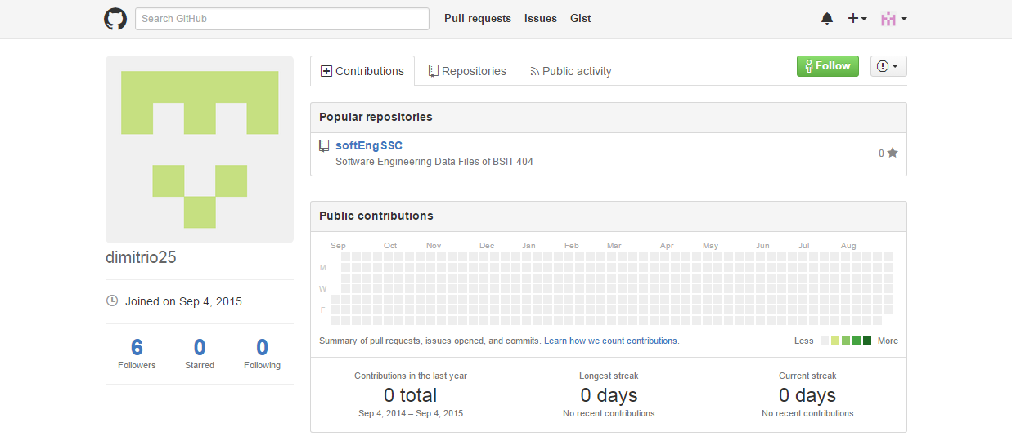

1. To see if you already followed that account the Follow button will change to Unfollow

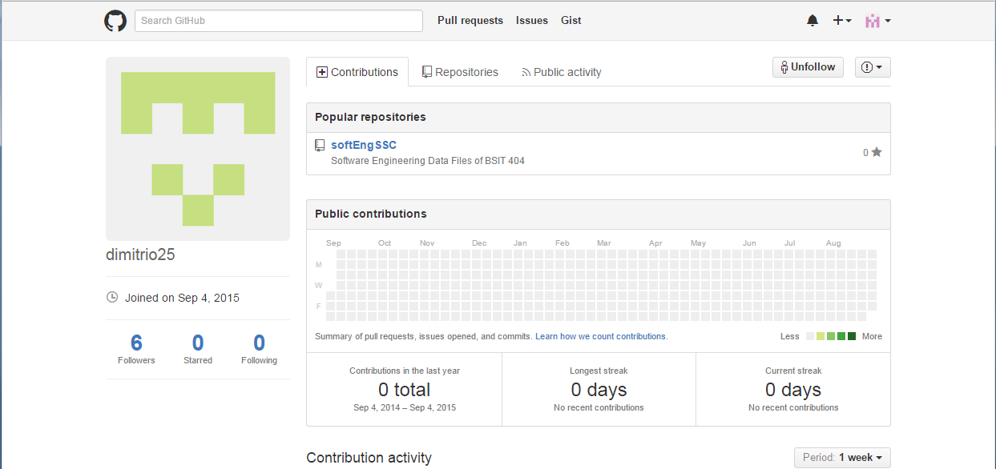

1. To be a watcher in that Account click the Watch button

