The Truth about Hydrological Drought

A Capstone Proposal Presented to the Faculty of the Arts and Sciences

BSIT Program

St. Scholastica’s College, Manila

In Partial Fulfilment of the

Requirements for the Degree

Of Bachelor of Science in Information

Technology with Interactive Multimedia Design

And Animation

Krisha Jannelle O. Mayoca

**Table of Content**

1. Introduction
2. Background of the Study 1
3. Significance of the Study 3
4. Statement of the Problem 3
5. Objectives 3
6. Review of Related Literature 5
7. Study Frameworks 13
8. Theoretical Framework 16
9. Conceptual Framework 18
10. Operational Framework 19
11. Methodology
12. Research design and Methods 21
13. Variables and Measures 21
14. Research Instrument 22
15. Units of Analysis and Sampling 22
16. Data Gathering 22
17. Data Analysis 22
18. Scope and Limitations 23
19. Project Development Methodology 23
20. References 24

**Chapter 1**

**Introduction**

**Background of the study**

In today’s world, technology has been an influence to people to make the people’s lives easier and it is convenient to the people these days on using internet. A lot of programs have been created and developed with the help of the technology. Computer programs may help the users to access easier especially now in this generation; there are many soft ware and programs that have been developed. “Technology advances show people a more efficient way to do things, and these processes get results. For example, education has been greatly advanced by the technological advances of computers.” (Belcher, 2015) and because of the technology advancement, they are able to search more on what they want to search especially in disasters days. There are people that they are searching for a specific topic. Websites gives credibility to the users.

“The Internet has had an amazing impact on almost every facet of our lives. With it, we are able access to new ideas, more information, unlimited possibilities, and a whole new world of communities.” (The Internet Society n.d.) Nowadays, most people can’t live without internet especially in the social networking sites such as Facebook, Twitter and Instagram. But these social networking sites can inform us what was happening in the world especially in the Philippines.

# Every year, the Philippines is experiencing a lot of typhoons. People were used and always prepared when typhoon is coming. “Philippines is 3rd most disaster-prone country” (Quismundo, 2012) because of the typhoons, volcanic eruptions, and etc. “Flooding is the world’s most expensive type of natural disaster because the damage can be so extensive.” (Kids connect 2015) when flooding, the dams releases waters due to flood. When the wind is so strong, there are many damages in the houses and plants. But there is an opposite of excess in water, it is called drought, water shortage.

"Drought is caused by not only lack of precipitation and high temperatures but by overuse and overpopulation." (Wolchover 2014). It affects the rice production because of the El Nino. Also, it causes too the climate change. People don’t know when drought will come so they have to prepare for it.

“There are a lot of factors that make a great website, one of them are graphics. By no means can graphics make up for weak content but they can help to make the content that you have more appealing.” (Elespacio Web, 2010) Website should have a graphics. Graphics is important also in doing a website because people these days are observant when it comes in the design. With a good design and attractive website will make users contented and also the content of the website.

Generally, this paper will be in focus on the use of website. A website that will inform what hydrological drought is and avoiding water deficiency on the country especially the one that really affected of the drought.

**Significance of the study**

The significance of this website is to give information to the teenagers. This website will be helpful because people these days don’t know why they have this disaster especially now, they are experiencing a lot of disasters and to know more about hydrological drought. Having a website of hydrological drought will be an effective solution to the users to know more about hydrological drought.

1. **Teenagers**: the significance of the website to the students is to give information about hydrological drought. They will be seeing some pictures of droughts, places that are really affected by drought, and animation how droughts form. They will benefit from this website because it will give those lessons, values and knowledge.

**Statement of the problem**

1. How does the Website give information about hydrological drought to the teenagers?

**Objectives**

The objective of this project is to create a website about Hydrological Droughts. Using a website, it can inform users what Hydrological Drought is.

The study has the following objectives:

1. To be able to give information about hydrological drought to the teenagers using the website.

* How hydrological drought is happening
* Hydrological cycle
* Cause and effects of hydrological drought
* Drought preparedness

1. To show how hydrological drought happen using animation.

With regards to this, the researcher wants to inform the teenagers about hydrological drought and because this will help to the users to have an idea what hydrological drought is and they will benefit from it.

**Chapter 2**

**Review of Related Literature**

The review of literature for this study focuses on the information about hydrological drought. The purpose of this study is to give information and also to spread the information that will help to know more about the topic and gain more knowledge about the hydrological drought. The aim of this study is to provide knowledge and understanding about drought phenomenon using the website.

**How the technology will help when disaster comes**

**“**Technology is beginning to dominate many aspects of the emergency management profession. This is particularly evident during disaster response.” (Holdeman, 2014) technology would be helpful even if people can’t contact their mayor or officials, this technology can help and see what they can do to survive when disaster comes. He added that the role of technology in emergency management is to connect, inform and ultimately save the lives of those impacted by disasters.

**Natural Disaster**

Melcher (nd) defined a natural disaster as “an event defined as the impact of an extreme natural event on an exposed, vulnerable society.” (p. 13). She added that disaster has an effect to the people that includes a loss of life. “Catastrophic event that is caused by nature or the natural processes of the earth.” (basic planet, nd). It really affects the people worldwide. An example of natural disaster is drought.

**Drought**

“Drought is the lack of rain over various time periods, or measured impacts such as reservoir levels or crop losses. Because of the various ways drought is measured, an objective drought definition has yet to be produced upon which everyone can agree.” (Earth observatory, nd) it is stated that drought has an impact to people especially to the farmers that their crops is drying and eventually die. “Drought is defined by the delicate balance between water supply and demand. Whenever human demands for water exceed the natural availability of water, the result is drought.” (West, 2015) if people continue to waste water, definitely people can experience drought.

**Hydrological Drought**

**“**Hydrological Drought occurs when water reserves in aquifers, lakes and reservoirs fall below an established statistical average.” (West, 2015) he added that hydrological drought can happen even during times of average or above average precipitation, if human demand in water is high and the usage of water is high too, there is a possibility that the water can lowered the reserves.

**Hydrologic Cycle**

This is the summary of hydrologic cycle from the University of Illinois.

The hydrologic cycle begins with the [evaporation](http://ww2010.atmos.uiuc.edu/%28Gh%29/wwhlpr/evaporation.rxml?hret=/guides/mtr/hyd/smry.rxml) of water from the surface of the ocean. As moist air is lifted, it cools and water vapor [condenses](http://ww2010.atmos.uiuc.edu/%28Gh%29/wwhlpr/condensation.rxml?hret=/guides/mtr/hyd/smry.rxml) to form clouds. Moisture is [transported](http://ww2010.atmos.uiuc.edu/%28Gh%29/wwhlpr/water_transport.rxml?hret=/guides/mtr/hyd/smry.rxml) around the globe until it returns to the surface as [precipitation](http://ww2010.atmos.uiuc.edu/%28Gh%29/wwhlpr/precip_hyd.rxml?hret=/guides/mtr/hyd/smry.rxml). Once the water reaches the ground, one of two processes may occur; 1) some of the water may evaporate back into the atmosphere or 2) the water may penetrate the surface and become [groundwater](http://ww2010.atmos.uiuc.edu/%28Gh%29/wwhlpr/groundwater.rxml?hret=/guides/mtr/hyd/smry.rxml). Groundwater either seeps its way to into the oceans, rivers, and streams, or is released back into the atmosphere through [transpiration](http://ww2010.atmos.uiuc.edu/%28Gh%29/wwhlpr/transpiration.rxml?hret=/guides/mtr/hyd/smry.rxml). The balance of water that remains on the earth's surface is [runoff](http://ww2010.atmos.uiuc.edu/%28Gh%29/wwhlpr/runoff.rxml?hret=/guides/mtr/hyd/smry.rxml), which empties into lakes, rivers and streams and is carried back to the oceans, where the cycle begins again.

Lake effect [snowfall](http://ww2010.atmos.uiuc.edu/%28Gh%29/wwhlpr/snow_hyd.rxml?hret=/guides/mtr/hyd/smry.rxml) is good example of the hydrologic cycle at work. Below is a vertical cross-section summarizing the processes of the hydrologic cycle that contribute to the production of lake effect snow. The cycle begins as cold winds (horizontal blue arrows) blow across a large lake, phenomena that occurs frequently in the late fall and winter months around the Great Lakes.

|  |  |
| --- | --- |
|  | [Evaporation](http://ww2010.atmos.uiuc.edu/%28Gh%29/wwhlpr/evaporation.rxml?hret=/guides/mtr/hyd/smry.rxml) of warm surface water increases the amount of moisture in the colder, drier air flowing immediately above the lake surface. With continued evaporation, water vapor in the cold air [condenses](http://ww2010.atmos.uiuc.edu/%28Gh%29/wwhlpr/condensation.rxml?hret=/guides/mtr/hyd/smry.rxml) to form ice-crystal clouds, which are [transported](http://ww2010.atmos.uiuc.edu/%28Gh%29/wwhlpr/water_transport.rxml?hret=/guides/mtr/hyd/smry.rxml) toward shore. |

By the time these clouds reach the shoreline, they are filled with snowflakes too large to remain suspended in the air and consequently, they fall along the shoreline as [precipitation](http://ww2010.atmos.uiuc.edu/%28Gh%29/wwhlpr/precip_hyd.rxml?hret=/guides/mtr/hyd/smry.rxml). The intensity of lake effect snowfall can be enhanced by additional lifting due to the [topographical features](http://ww2010.atmos.uiuc.edu/%28Gh%29/wwhlpr/hyd_orographic.rxml?hret=/guides/mtr/hyd/smry.rxml) (hills) along the shoreline. Once the snow begins to melt, the water is either absorbed by the ground and becomes [groundwater](http://ww2010.atmos.uiuc.edu/%28Gh%29/wwhlpr/groundwater.rxml?hret=/guides/mtr/hyd/smry.rxml), or goes returns back to the lake as [runoff.](http://ww2010.atmos.uiuc.edu/%28Gh%29/wwhlpr/runoff.rxml?hret=/guides/mtr/hyd/smry.rxml)

**How Hydrological Drought is happening?**

"Within the Hydrological cycle, groundwater is normally the last to react to a drought situation, unless surface water is mainly fed by groundwater." (Tallaksen et al, nd) this is when groundwater is not receiving enough water from the precipitation.

**Causes of Hydrological Drought**

**“**[The cause of droughts](http://geography.about.com/od/globalproblemsandissues/a/drought.htm) is easily understood, but hard to prevent. Depending on the location, crop failures, famine, high food prices, and deaths can occur. One of the scariest parts of a drought is the onset time. Unlike other forms of severe weather or [natural disasters](http://weather.about.com/od/floods/qt/natural_disasters.htm), droughts often develop slowly.” (Oblack 2014) she added that another factor that can affect water supply is a change in water quality. People cannot avoid droughts especially when it is hot season and sometimes, planters are used when drought is coming. Lack of water resources has an effect to the planters.

“Droughts are caused by a depletion of precipitation over time. Unlike a dry spell, prolonged lack of rain will cause regions around the world to slowly dry out. Because of the slow onset of droughts, their cost is often only estimated. Frequently, droughts are [billion dollar weather events](http://weather.about.com/od/severestorms/a/billionstorms.htm) and are one of the top three threats to population in the world” (Oblack, 2014).

**Effect of Hydrological Drought**

“Water is one of the most essential commodities for human survival, second only to breathable air. So when there is a drought, which by definition means having too little water to meet current, demands, conditions can become difficult or dangerous very quickly.” (West, 2015). That’s why water is important to human living, without water, people cannot survive when disaster came.

“Effects of climate change on crop yields are likely to vary from region to region across the globe. Changes in climate may affect food loss through changes in temperature, precipitation, soil moisture and soil fertility, length of growing season and increasing probability of extreme climatic conditions. A loss of nutritional production, therefore, can raise number of people at risk of hunger*.*” (Ciograsp, nd) as stated above, it’s not only the water that affects the world but also, the needs of the human especially food crops. Some people are depending on their plant but they cannot avoid when drought is coming to their plant.

**Drought Preparedness**

It is important to be prepared in case of drought in the community.

Some of the guidelines of The American Red Cross(2015).

**Indoor Water Conservation Tips**

**General**

* Never pour water down the drain when there may be another use for it. Use it to water your indoor plants or garden.
* Make sure your home is leak-free. Take a reading of the water meter. Wait 30 minutes without using any water and then take a second reading. If the meter reading changes, you have a leak!
* Repair dripping faucets by replacing washers. One drop per second wastes 2,700 gallons of water per year!

**Long Term Indoor Water Conservation**

* Retrofit all household faucets by installing aerators with flow restrictors.
* Consider installing an instant hot water heater on your sink.
* If you are considering installing a new heat pump or air-conditioning system, the new air-to-air models are just as efficient as the water-to-air type and do not waste water.
* When purchasing a new appliance, choose one that is more energy and water efficient.

**Outdoor Water Conservation Tips**

**General**

* If you have a well at home, check your pump periodically. If the pump turns on and off while water is not being used, you have a leak..

**Long Term Outdoor Conservation**

* Plant native and/or drought-tolerant grasses, ground covers, shrubs and trees. They don’t need water as frequently and usually will survive a dry period without watering.
* Install water efficient irrigation devices, such as micro and drip irrigation and soaker hoses.
* Use mulch to retain moisture in the soil. Mulch also helps control weeds that compete with landscape plants for water.

**In the Community**

* Participate in public water conservation meetings conducted by your local government, utility or water management district. Support projects that lead to an increased use of reclaimed wastewater.
* Follow water conservation and water shortage rules in effect, which may limit hours or prohibit use of water for certain tasks. You’re included in the restrictions even if your water comes from a private well.
* Patronize businesses that practice water conservation, such as restaurants that only serve water upon request.

**Synthesis**

The information about hydrological drought is a way to know the user about what the is hydrological drought about. This information is important not only in disaster days but also in everyday lives. Internet Connection has a big attachment to the people nowadays, but when disaster came, this website will help the people what is hydrological drought about and some tips to be ready.

Hydrological drought is one of the natural disasters; the website about ‘The Truth about Hydrological Drought’ will be containing information about hydrological drought, how hydrological drought form or cycle, animations and photos and tips on how to be prepared when drought comes.

**Chapter 3**

**Framework**

There are three theories that it is relevant and helpful for the topic. These are: Information Theory by Claude Shannon (1948), Information Richness Theory also known as Media Richness Theory by [Richard L. Daft](http://en.wikipedia.org/wiki/Richard_L._Daft) and Robert H. Lengel (1984) and Network and Analysis Theory also known as Network theory and Social network analysis by Georg Simmel and Emile Durkheim (n.d).

**Information Theory**

“Transmission of the message involved sending information through electronic signals.” (University of twente, 2015) university of twente added that Shannon and Weavers’ goal was to “discover how communication messages could be converted into electronic signals most efficiently, and how those signals could be transmitted with a minimum of error.” This method is to deliver the information to the users who will visit or access the website.

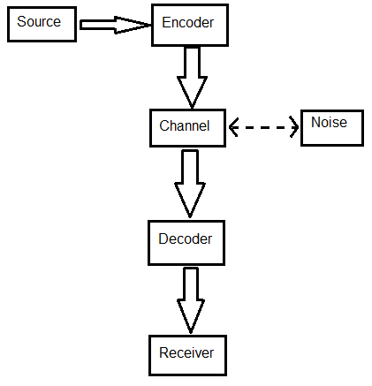

**Information Richness Theory**

“Media Richness Theory provides a framework for describing a communication medium's ability to reproduce the information sent over it without loss or distortion. For example, a phone call will not be able to reproduce visual social cues such as gestures. This makes it less rich (as a communication medium) than video conferencing, which is able to communicate gestures to some extent, but more rich than email.” (Warters, ND). This Theory shows that how communication can apply to this project.

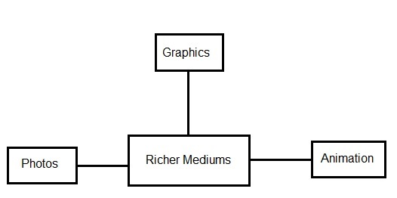

**Network and Analysis Theory**

“Network analysis (social network theory) is the study of how the social structure of relationships around a person, group, or organization affects beliefs or behaviours. (University of twente, 2015) This theory shows that the connections of user to other users.

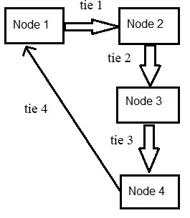

**Figure 3.0 - Theoretical Framework**

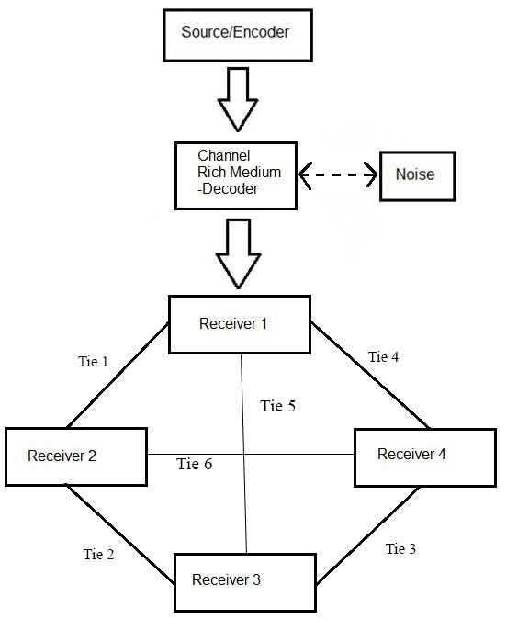

In figure 3.0, these are the combinations of three theories; Information Theory, Information Richness Theory and Network and Analysis Theory. This framework shows the flow of passing the information.

In the Information Theory, the model starts with the source and encoder, the one who is transmitting the information, the channel and decoder where the message travels, the noise is the problems or difficulties affecting the message, and last, the receiver, the one who receives the information. The noise that connects to the channel has broken lines shows that the noise may not be present or may have a problem.

In the Information Richness Theory, there are two types of medium or media, rich medium and lean medium. The researcher uses the rich medium because it is useful and effective.

In Network and Analysis Theory, Nodes is the individual actors and the Ties are the relationship between the actors. (Theorizeit, 2014) the receiver and node are same and the ties are the connections.

**Figure 3.1 - Conceptual Framework**

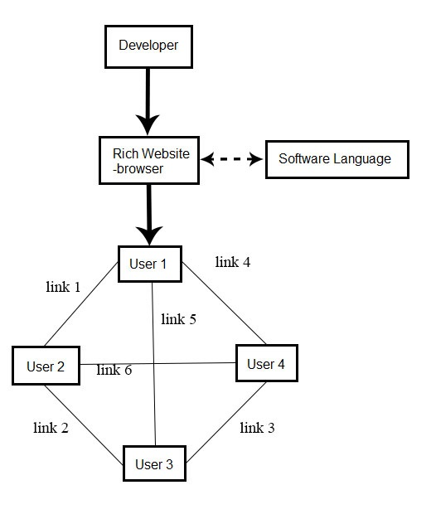

In Figure 3.1, the elements that used in Theoretical Framework were replaced. The source and encoder will be the Developer, the channel will be the rich website, the decoder will be the browser, the noise will be the software languages that will be use in creating a website, and the receiver will be the user and the ties that connect to the user will be the links.

**Figure 3.2 - Operational Framework**

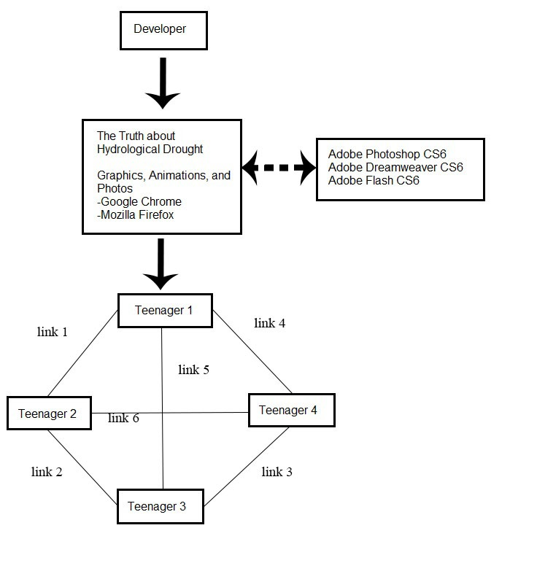

In Figure 3.2, the concepts are more specific. The source and encoder is still the developer, the rich website will be the truth about hydrological drought, and under the rich website are the lists of rich media: graphics, animation and photos and the browsers are Google chrome and Mozilla Firefox. The software languages that will be using are Adobe Dreamweaver CS6, Adobe Photoshop CS6, and Adobe Flash CS6. These Adobe products will need to build the website. . The fourth box under the website is the user which is teenager and the boxes that connect to the teenager are the nodes, these are the connections of the teenager. The researcher will be needing some of the nodes which is the teenagers to test if the website is helpful or not and also, to inform the users about hydrological drought.

The researcher chose these three theories because it is helpful for her to build the website.

For information theory, it is helpful for building the website and to inform the users about hydrological drought.

For Information Richness theory, to apply the graphics and animation for the website and to catch the attention of the users.

And for Network and Analysis Theory, help the researcher to find out the website if it is helpful or not.

**Chapter 4**

**Methodology**

1. **Research Design and Methods**

The aim of the study is to create an informative website about hydrological drought to satisfy the needs of the user and to help them by informing about hydrological drought with the use of quantitative method. The researcher will conduct using quantitative method through surveys that will cover questions about the needs in the websites, and user’s needs.

The researcher is intended to use this kind of method because it will provide the information to the researcher about the needs of website and the wants of users.

**Variables and Measures (Quantitative)**

Variables Measures

* Teenagers 13 to 19 years old
* Gender both

**Research Instruments**

As stated above, the research method that the researcher will use is the quantitative method. The research instrument that will be using is the survey questionnaires. These questionnaires will be distributing to the target audience which is the teenagers.

**Units of Analysis and Sampling**

Individuals specifically teenagers from 13 to 19 years old will be conducting surveys. The researcher will be using random sampling.

**Data Gathering**

The survey will be conducting from August to October 2015 to the teenagers with the age of 13 to 19 years old. The questionnaires will be distributed to the respondents.

**Data Analysis**

In analyzing the data gathered from the survey, the researcher will use the descriptive statistics. Each answer from the survey will tabulate and get the percentages. This will help to analyze all the data gathered from the survey.

**Scope and Limitations**

The study will contain the information about hydrological drought. The study will focus on the information on hydrological drought, why hydrological is happening and some tips on how to conserve water to avoid water deficiency. The target audience will be the teenagers with the age of 13 to 19 years old.

1. **Project Development Methodology**

The researcher will gather information about hydrological drought. By doing a website, it must have a knowledge requirement of hydrological drought such as information about hydrological drought, animation on how droughts form, photos of places that are prone in drought, and tips on how on how will they conserve water. Software requirements for the website would be Adobe Dreamweaver CS6, Adobe Photoshop CS6 and Adobe Flash CS6. The design of the website would be graphics, animations, and buttons. And the output will be the website.

**References:**

AmericanRedCross (2015). Drought Preparedness and Water Conservation. Retrieved from,

http://www.redcross.org/prepare/disaster/drought

Basic planet (nd). Natural Disaster. Retrieved from,

http://www.basicplanet.com/natural-disasters/

Belcher, L. (2015). Advantages and disadvantages of technology, Retrieved from,

<http://smallbusiness.chron.com/advantages-disadvantages-technology-advances-12579.html>

Ciograsp(nd). The Climate Impacts: Global and Regional Adaptation Support Platform, retrieved from,

http://www.pik-potsdam.de/cigrasp-2/ic/slr/food_loss.html

Conde, C (2010). Philippines 'Bracing for the Worst' in Drought. Retrieved from,

http://www.nytimes.com/2010/02/20/world/asia/20phils.html?_r=0

EarthObservatory(nd). Drought. The Creeping Disaster, Retrieved from,

<http://earthobservatory.nasa.gov/Features/DroughtFacts/>

Elespacio web(2010). The importance of graphics on a website. Retrieved from,

http://www.elespacioweb.com/the-importance-of-graphics-on-a-website.php

Ferris, E. (2010). Natural Disasters, Conflict, and Human Rights: Tracing the Connections. retrieved from,

http://www.brookings.edu/research/speeches/2010/03/03-natural-disasters-ferris

Internet Society (ND). The Internet, Retrieved from,

http://www.internetsociety.org/internet

Holdeman, E (2014). Technology Plays an Increasing Role in Emergency Management, retrieved from

<http://www.emergencymgmt.com/training/Technology-Increasing-Role-Emergency-Management.html>

KidsConnect (2015). Natural Disasters Facts. Retrieved from,

<https://kidskonnect.com/science/natural-disasters/>

Melcher, R(). Natural Disaster Risk Management and Financing Disaster Losses in Developing , retrieved from,

https://books.google.com.ph/books?id=onaqFvzPKzoC&pg=PA13&lpg=PA13&dq=natural+disaster+definition+articles&source=bl&ots=KiMP4TyC9w&sig=qe3phWlOxTDISKcdrWT2J9lCyc&hl=en&sa=X&ei=8wgFVbmfG6XZmAXH9oKQBg&ved=0CCEQ6AEwATgU#v=onepage&q=natural%20disaster%20definition%20articles&f=false

Nistor, S.(2012).

http://wearepropeople.com/blog/best-web-design-and-web-development-articles-of-may-2012

Oblack, R. (2014). What causes drought, retrieved from,

<http://weather.about.com/od/drought/f/droughts.htm>

Quismundo, T (2012).

http://globalnation.inquirer.net/52858/philippines-is-3rd-most-disaster-prone-country-new-study-shows/

Ready(2013). Drought. retrieved from,

http://www.ready.gov/drought

Schiefelbein, J (2012). Media Richness and Communication in Online Education. Retrieved from:

<http://www.facultyfocus.com/articles/online-education/media-richness-and-communication-in-online-education/>

Scott, S (2015). The importance of Technology in the workplace. Retrieved from,

http://smallbusiness.chron.com/importance-technology-workplace-10607.html

Tallaksen et al(nd). Hydrological Drought: Processes and Estimation Methods for Streamflow and Groundwater. retrieved from,

https://books.google.com.ph/books?id=kIzevi9O8gIC&pg=PA6&lpg=PA6&dq=hydrological+drought+definition&source=bl&ots=3Oos_A7AUg&sig=gOwufkrHZHYsHMIPQvmgON7Qdys&hl=en&sa=X&ei=-RkFVeWHO8S4mAWS4IHIDw&sqi=2&ved=0CGQQ6AEwCw#v=onepage&q=hydrological%20drought%20definition&f=false

Theorizeit(2014). Social Network Theory. Retrieved from,

http://is.theorizeit.org/wiki/Social_network_theory

University of Illinois(2010).Hydrologic Cycle, Retrieved from

http://ww2010.atmos.uiuc.edu/%28Gh%29/guides/mtr/hyd/home.rxml

Utwente (2015). Netwotk Theory and Analysis. Retrieved from,

http://www.utwente.nl/cw/theorieenoverzicht/Theory%20Clusters/Communication%20Processes/Network%20Theory%20and%20analysis_also_within_organizations-1/

Warter (ND). Media Richness Theory, Retrieved from:

<http://www.campus-adr.net/ODRmodule/media_richness_theory.html>

West, L (2015). What is Drought? retrieved from,

http://environment.about.com/od/environmentalevents/a/whatisdrought.htm

Wolchover, N (2014). What is Drought? Retrieved from,

http://www.livescience.com/21469-drought-definition.html