Christine Eden C. Villote

404A BSIT

Open [www.github.com](http://www.github.com)

Create account

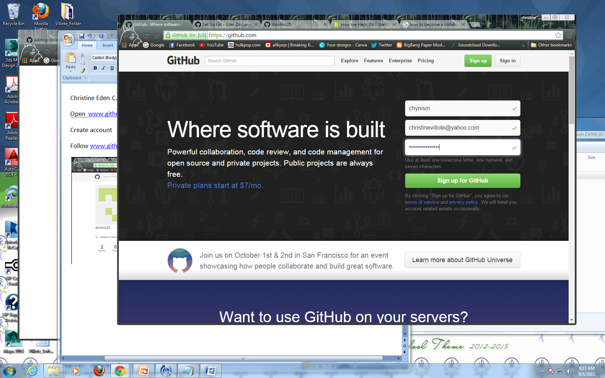

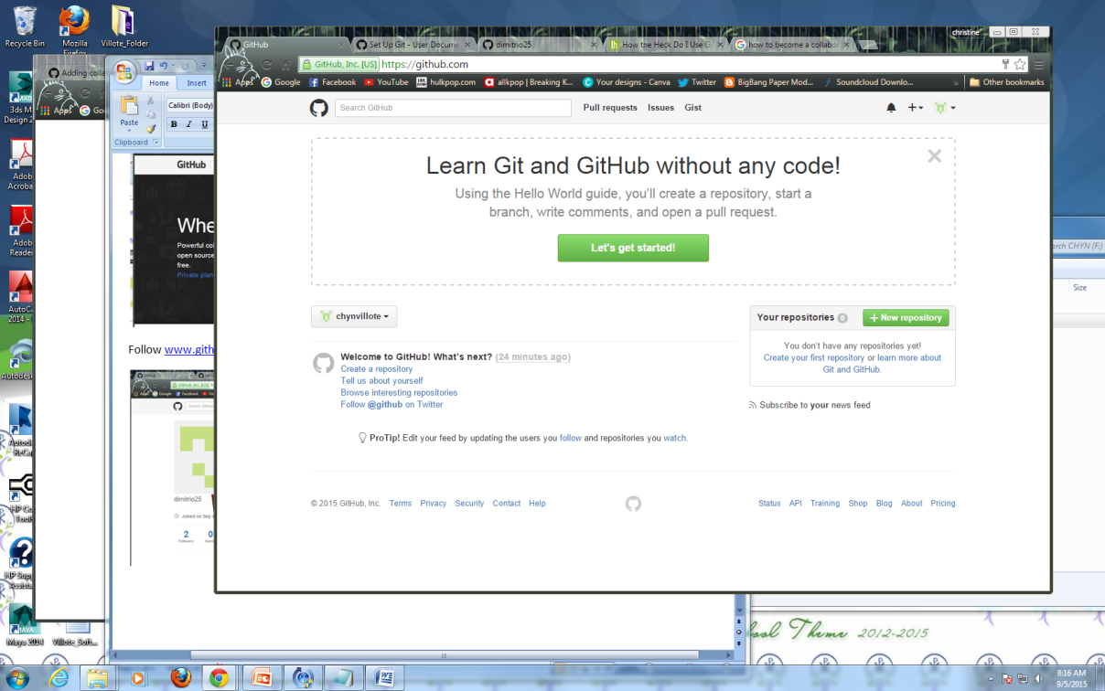

Collaborate with [www.github.com/dimitrio25](http://www.github.com/dimitrio25)

