Tiffany Go
404a
- First go to www.github.com
- Then create an account
- Use the free version
- Now, you have an account in www.github.com

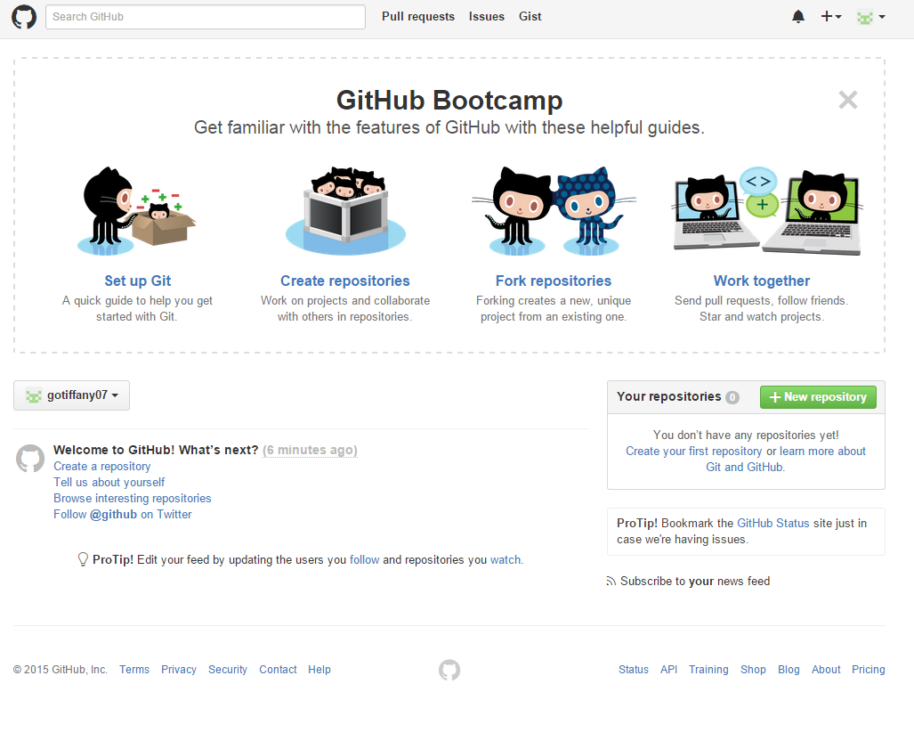

- Enter the collaborators name in the search engine
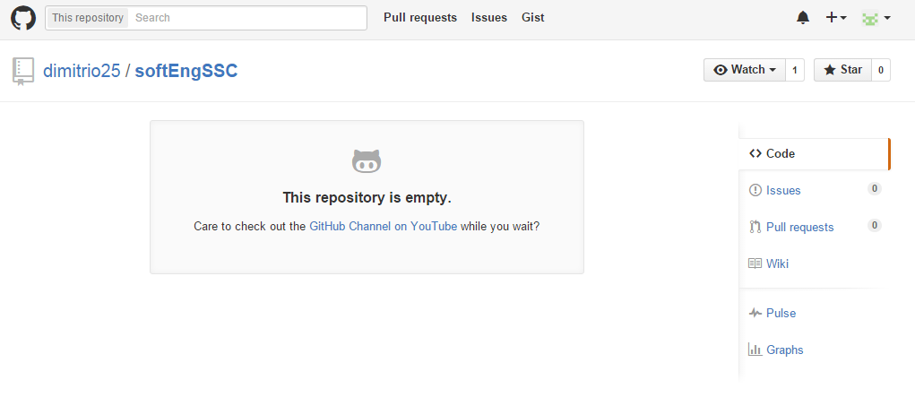
- First, you have to click the button named “unwatch” so you can see the watchers of the repository. Then click follow.
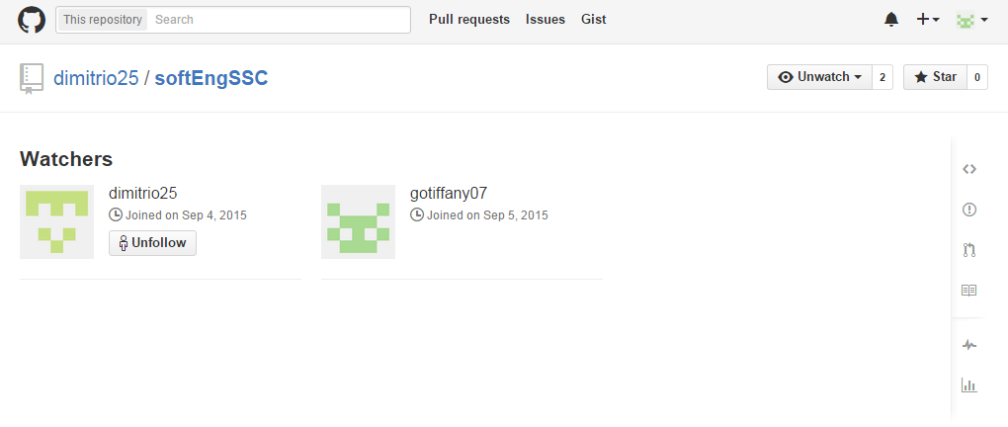

- To know that you are in the repository go to the right corner of the page then click settings.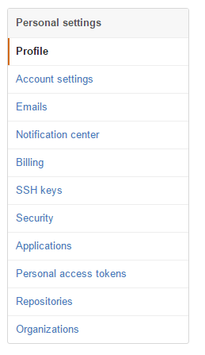
- Go to repository and you can see if you are in it or you can just leave.
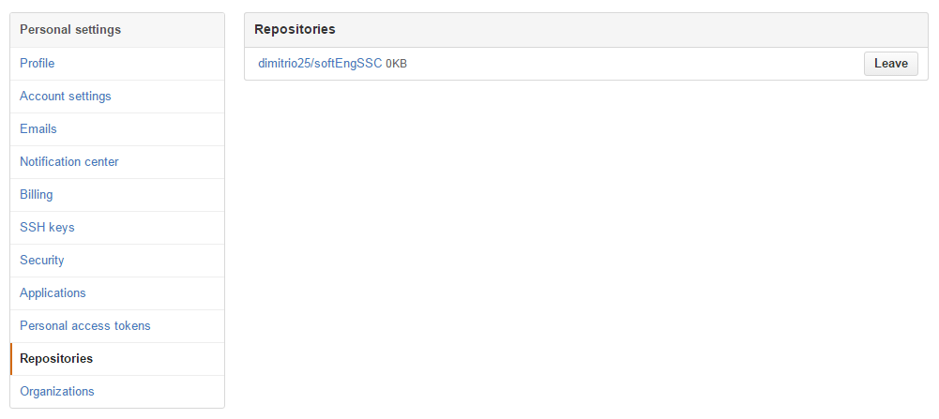
- Download gitbash
- After installing gitbash, open it.
- Add cd documents/Github
- Add git init
- Add git add .
- Add git commit –m ‘add first file’
- Add git remote add origin https://github.com/gotiffany07/Go_Capstone.git
- Add git pull https://github.com/gotiffany07/Go_Capstone.git
- Add git push https://github.com/gotiffany07/Go_Capstone.git

