PCA compression of EEG

Predict fMRI from past values too

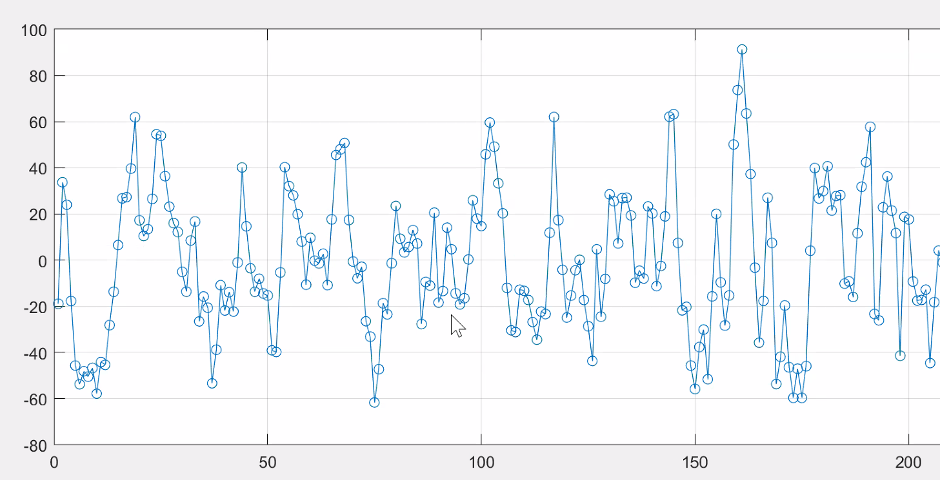

Also compress fMRI with PCA?

Test univariate correlations:

