
ΕΘΝΙΚΟ ΜΕΤΣΟΒΙΟ ΠΟΛΥΤΕΧΝΕΙΟ
ΣΧΟΛΗ ΗΛΕΚΤΡΟΛΟΓΩΝ ΜΗΧΑΝΙΚΩΝ ΚΑΙ ΜΗΧΑΝΙΚΩΝ ΥΠΟΛΟΓΙΣΤΩΝ
Ακαδημαϊκό έτος 2023-2024

ΤΙΤΛΟΣ
ΑΝΑΦΟΡΑ ΓΙΑ ΤΗΝ 1^{Η} ΑΣΚΗΣΗ

Δημήτρης Δαμιανός – 03119825
BHMA 1: Σημειώσεις
onetwothree1 (male): wave + sperctogram (one-two-three)
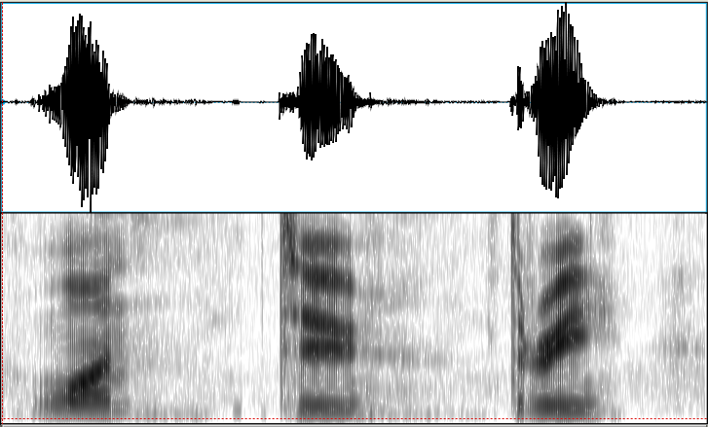
‘α’: επιλογη απο την κυμματομορφη (oσο καλυτερα γινεται)
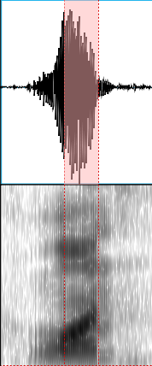

134.6824979341298 Hz (mean pitch in SELECTION)
725.0769950175517 Hz (mean F1 in SELECTION)
1164.9388581031794 Hz (mean F2 in SELECTION)
2213.3930678485553 Hz (mean F3 in SELECTION)

‘ου’:
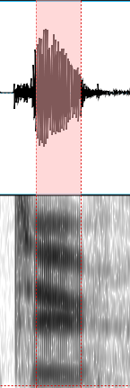

128.240009932973 Hz (mean pitch in SELECTION)
397.8368799116636 Hz (mean F1 in SELECTION)
1768.2866985682329 Hz (mean F2 in SELECTION)
2349.1902532322383 Hz (mean F3 in SELECTION)
‘ι’:
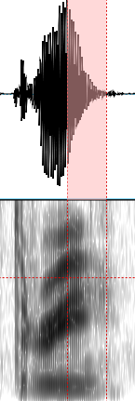

133.64706102818317 Hz (mean pitch in SELECTION)
433.5770907821576 Hz (mean F1 in SELECTION)
2120.825774630416 Hz (mean F2 in SELECTION)
2640.117429883207 Hz (mean F3 in SELECTION)

onetwothree8 (female):
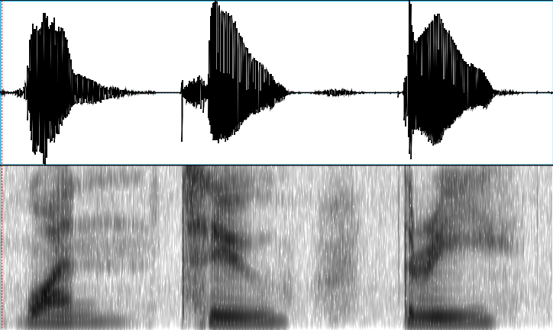
‘a’:
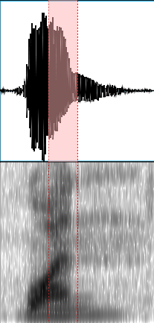

177.42169135962047 Hz (mean pitch in SELECTION)
765.2088246291313 Hz (mean F1 in SELECTION)
1501.7763574434637 Hz (mean F2 in SELECTION)
2878.8347802669446 Hz (mean F3 in SELECTION)

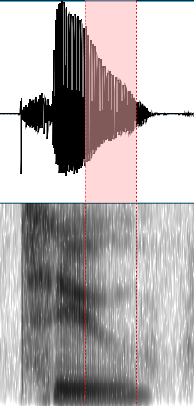
‘ou’:

183.29647553114708 Hz (mean pitch in SELECTION)
331.71804259067125 Hz (mean F1 in SELECTION)
1591.0699677086313 Hz (mean F2 in SELECTION)
2703.6593913957413 Hz (mean F3 in SELECTION)

‘i’:
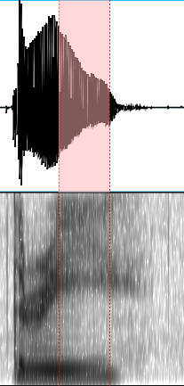

176.31587305738395 Hz (mean pitch in SELECTION)
333.37988710531846 Hz (mean F1 in SELECTION)
1689.2938749151253 Hz (mean F2 in SELECTION)
2957.1843648763224 Hz (mean F3 in SELECTION)

