### Potential Target Journals

1. **Cell Systems** Brief Report / **Report**

* Brief Reports are concise manuscripts with no more than **two** display items (figures and tables) accompanied by ~**1,500 words** of main text.
* **Reports may present no more than four display items (figures and tables) and ~2,500 words of main text**.

### MSB Reports

The total character count (including spaces) for Reports, excluding the Methods section, tables and Expanded View material, but including title page, abstract, figure legends and references should not exceed 22,000 characters (the exact character count to be stated on the title page). Reports have, in principle, a maximum of 3 Figures.

### Plos Comp Bio

1. **Molecular Cell Short Article**

The Short Article format is intended for concise, highly provocative, fully validated findings. Short Articles are organized like Research Articles, but they typically report a single main conceptual point. The main text of Short Articles should not exceed **38,000 characters** (including spaces). They may contain up to **4 display items (figures or tables).**

**Reserve flux capacity in the *Escherichia coli* pentose phosphate pathway enables rapid responses to oxidative stress**

Dimitris Christodoulou, Hannes Link, Tobias Fuhrer, Karl Kochanowski, Luca Gerosa, Uwe Sauer

**So far, ~2600 words / ~18000 characters**

**Abstract**

To counteract oxidative stress and build-up of reactive oxygen species (ROS), bacteria evolved various defense mechanisms. The primary defense is reduction of ROS through antioxidant systems that must be regenerated through the redox cofactor NADPH. To sustain continued ROS reduction, NADPH formation must be increased by increasing flux through replenishing metabolic pathways such as the pentose phosphate (PP) pathway. Here we investigate the mechanism that enables the rapid initial increase in NADPH supply by exposing growing *E. coli* to hydrogen peroxide and quantifying the immediate metabolite dynamics. To systematically infer active regulatory interactions, we developed a framework that evaluates in parallel ensembles of thousands of kinetic models of glycolysis and PP pathway, each with different combinations of regulation mechanisms. In addition to the known inactivation of the GAP dehydrogenase by ROS, our results reveal the important allosteric inhibition of the first PP pathway enzyme by NADPH. We find that this NADPH feedback inhibition acts as a valve, maintaining a below maximum capacity PP pathway flux under non – stress conditions. Relieving this inhibition rapidly increases PP pathway flux upon oxidative stress. Cells with reduced capacity in rapidly rerouting their flux through the PP pathway are more sensitive to oxidative stress.

**Introduction**

Bacteria continuously experience environmental challenges, ranging from nutrient fluctuations to physicochemical stresses. A frequent aerobic challenge is oxidative stress because respiratory metabolism produces also so-called reactive oxygen species (ROS) that chemically damage cellular components (Imlay 2013; Mishra & Imlay 2012). To counter the detrimental effects, cells evolved a set of metabolic and other responses that detoxify the ROS and alleviate acute damages both on short and longer time scales (Baez & Shiloach 2013; Blanchard et al. 2007; Greenberg & Demple 1989; Mishra & Imlay 2012; Rui et al. 2010a; Shimizu 2013; Brumaghim et al. 2003; Grant 2008; Krüger et al. 2011; Ralser et al. 2009).

In the facultative aerobe *Escherichia coli*, the long-term defense against ROS is coordinated by the transcription factors OxyR and the SoxRS (Zheng & Storz 2000; Seo et al. 2015), where OxyR responds mostly to the ROS hydrogen peroxide (H2O2)(Nunoshiba et al. 1992). Since gene expression-based responses require minutes to become effective (Chechik et al. 2008), immediate responses must rely on already present anti-oxidative systems such as superoxide dismutase, catalases, glutathione peroxidase and non-enzymatic antioxidants like reduced glutathione to scavenge ROS (Finkel 2003; Kohen & Nyska 2002). In steady state the pool of reduced glutathione is continuously replenished through redox reactions in central metabolism, but upon sudden oxidative stress the cellular redox state must be stabilized immediately to circumvent disruption of biochemical reactions and potential death. *E. coli* and other organisms increase the reduction rate of NADP+ to NADPH mainly by rerouting their glycolytic flux into the pentose phosphate (PP) pathway (Ralser et al. 2007b; Rui et al. 2010b; Kuehne et al. 2015; Anastasiou et al. 2011). The prevailing model stipulates that direct oxidation of lower glycolytic enzymes blocks glycolytic flux, such that accumulating intermediates passively cause the rapid rerouting into the PP pathway (Ralser et al. 2007a; Ralser et al. 2009). It is not clear however if this blockage is sufficient to achieve the rapid flux rerouting. Indeed, inconsistent with this model, at least in mammalian cells, hexoses levels did not increase prior to accumulation of PP pathway intermediates (Kuehne et al. 2015).

To understand the combination of flux regulating mechanisms necessary to achieve the immediate replenishment of NADPH for glutathione reduction upon sudden oxidative stress in *E. coli*, we determined the dynamic metabolome and 13C-tracer response up to one minute after exposure to H2O2. For data interpretation we developed a computational framework that evaluates ensembles of thousands of kinetic models of glycolysis and PP pathway, each with different combinations of regulation mechanisms. Our computational framework was implemented using concepts from parallel computing, allowing the efficient evaluation of thousand structurally distinct kinetic models. This enables us to identify unbiased novel interactions and quantitatively assess their function in a network context. By rigorous testing of these models against the data, we identify the most relevant molecular interactions required for the rapid flux rerouting from glycolysis to the PP pathway. Our results challenge the current model for this flux rerouting and reveal a large reserve capacity in the PP pathway under normal steady state growth conditions.

**Results**

**The immediate metabolic response of *E. coli* to H2O2****stress**

To identify the time scale of the immediate oxidative stress response, we challenged *E. coli* cultures growing exponentially on glucose with 1 mM H2O2 using a variant of the filter cultivation method, (Fig 3B) (Yuan et al. 2008; Link et al. 2013) and followed the dynamics of 30 intracellular metabolites for up to 1 minute. The continuous increase of aconitate up to six-fold together with the decrease of succinate, succinyl-CoA, and malate in the TCA cycle (Sup Fig 3) are consistent with the strong reduction of isocitrate dehydrogenase activity upon exposure to oxidative stress (Murakami et al. 2006; Sandoval et al. 2011), and the strong reduction in the redox cofactor NADPH level indicate its use in the cellular ROS defense (Fig 2A). Most PP pathway intermediates responded maximally already within 5 seconds of H2O2 exposure and well ahead of glycolytic intermediates (Fig 2A). In glycolysis hexose phosphates levels remained constant, but fructose-1,6 bisphosphate (FBP) and phosphoenolpyruvate (PEP) gradually increased and decreased in the first 30 seconds, respectively. The most rapid response within 5 seconds was observed for all PP pathway intermediates, most pronounced for 6-phosphogluconate (6PG) in the oxidative branch of the PP pathway. Increasing PP pathway intermediate and FBP levels and decreasing PEP levels upon oxidative stress are consistent with observations from yeast and mammalian cells (Ralser et al. 2009; Kuehne et al. 2015).

To elucidate the oxidative stress-triggered flux changes that underlie the rapid metabolite dynamics, we repeated the experiment by perfusing cells on the filter with H2O2 and [1-13C]glucose and quantified the dynamic isotope distribution by LC-MS/MS (Link et al. 2013). The relative change of flux through the PP pathway was estimated from the ratio of unlabeled versus labeled fructose-6-phosphate (F6P). Since the C-1 of glucose is liberated as CO2 in the oxidative PP pathway, increasing proportions of PP pathway flux relative to glycolysis will lead to a dilution of F6P labeled at position 1 with unlabeled F6P (Fig 2B). During unstressed growth approximately 13% of glucose catabolism is through the PP pathway and increases to 35% about one minute after oxidative stress (Fig 2B). A similarily strong and rapid PP pathway flux increase for rapid regeneration of NADPH to fuel the glutathione system has been reported in other organisms (Rui et al. 2010b; Kuehne et al. 2015). This flux rerouting occurs well before *E. coli* can change enzyme abundance, and hence suggests either substrate or allosteric regulation. Since hexose phosphate levels remain constant during this timeframe, the previously postulated block in glycolytic flux and substrate-mediated overflow into the PP pathways (Ralser et al. 2007a) cannot be the only explanation and does not appear to be relevant for the immediate response. Instead, our results strongly suggest an increase of the PP pathway flux, which, in conclusion, means that *E. coli* does not use the full flux capacity of the oxidative PP pathway enzymes during growth on glucose, something we tested and confirmed with *in vitro* experiments (Supplementary Material, Sup. Fig. XX). This result is consistent with the discrepancy between *in vitro* determined enzyme activities in the oxidative PP pathway (Fuhrer et al. 2005; Sauer et al. 2004) and the about 50% lower actual intracellular fluxes reported previously (Fuhrer et al. 2005; Sauer et al. 2004; Gerosa et al. 2015) (a view that is also consistent with recent findings [Davidi, in case it is out soon]).

**Model-based identification of mechanisms that enable rapid adaptation to oxidative stress**

How does *E. coli* rapidly mobilize this “reserve flux capacity” in the PP pathway? To identify the mechanism, we developed a 12 ordinary differential equation model of glycolysis and PP pathway with 12 metabolites and 26 reactions that represents glutathione detoxification of ROS by the oxidation of NADPH (Fig 1). Kinetics of reversible and irreversible reactions were modeled with mass action and Michaelis-Menten laws, respectively. The binding constants (KM) were randomly sampled in a 0.1-10 range around their literature value to account for potential parametric uncertainty, and maximum reaction rates (Vmax) were calculated from flux distributions during steady state growth on glucose, as was described before (Link et al. 2013) (Supplementary Material). If inhibition of glyceraldehyde 3-phosphate dehydrogenase (GAPDH) was sufficient to explain metabolite dynamics and flux rerouting (Ralser et al. 2007a; Ralser et al. 2009), amending the above model with direct ROS inhibition of lower glycolysis should capture the experimentally determined metabolite dynamics. While this amended base model indeed captured glycolysis dynamics to some extent (SupFig XX), it failed entirely to describe the PP pathway dynamics, suggesting that, akin to mammalian cells (Kuehne et al. 2015), inhibition of GAPDH is necessary but not sufficient.

To identify putative missing allosteric regulation, we systematically tested activation and inactivation of each reaction by each of the 12 metabolites through adding a power law term that affects the maximum reaction rate. Thus we generated and ensemble of about 12000 structurally different models, each consisting of the base model with GAPDH inhibition by ROS plus two putative allosteric interactions. As above, the kinetic parameters KM and Vmax were randomly sampled 2000 times around their literature values for each model, thus requiring 24 million simulations in total. High number of simulations is often one of the main bottlenecks for such systematic evaluations of structural and parametric uncertainties in kinetic models (Link et al. 2014). To overcome this limitation and enable these computations at a reasonable time frame, we exploited concepts from parallel computing and developed a scalable parallel computational framework that allows us to perform thousands of simulations in parallel (Fig 3D, Supplementary Material). Using our parallel framework, we tested all 12000 models for their capacity to describe the metabolite dynamics after exposure to H2O2 stress. We evaluated the biological relevance and ranked individual interactions based on how often they occurred in models that improved the base model (frequency) and on the information content of the best model carrying this interaction (score). To quantify the information content, we made use of the Akaike information criterion that quantifies the capacity to describe the data and penalizes for additional interactions/parameters (Turkheimer et al. 2003).

Our results indicate that the oxidative branch of the PP pathway, namely enzymes glucose-6-phosphate dehydrogenase (G6PDH) and phosphogluconate dehydrogenase (GND), are the main targets of regulation with glycolytic enzymes phosphofructokinase and phosphoenolpyruvate carboxylase being two other prominent targets. In particular, many models that include metabolite regulation of G6PDH that achieves increase in the activity of this enzyme, manage to improve the base model. The most prominent interaction that achieves this seems to be NADPH inhibition of G6PDH. This interaction improved the base model with every one of the 144 pairs it was evaluated with, explaining the experimental data to a great extent when accompanied by the less frequently occurring putative FBP activation of GND (Figure 4A). However, our framework reveals that there are also other interactions that are able to perform similarly well with NADPH inhibition on G6PDH, e.g. activation of G6PDH by FBP or inhibition by S7P. This is an inherent limitation of our method: interactions that can have a similar effect (i.e. increase the activity of an important enzyme) can achieve a high score. To cope with this limitation, we condense all the information from the 24 million simulations and rank the different interactions, by performing a non-parametric statistical method, rank product analysis (Breitling et al. 2004) (Supplementary Material). (Perhaps in supplement: We compute the rank of every interaction based on the geometric mean of the different ranks this interaction achieved in frequency and score.). The results of our analysis reveal that NADPH inhibition of G6PDH is the top interaction, with FBP activation of the same enzyme following (Supplementary Material). To further elucidate which interactions are most relevant in vivo, we performed a separate analysis of 162 models with only single putative regulatory interactions in addition to ROS inactivation of GAPDH, where we randomly sampled the parameter space 20000 times. Now we asked whether a model containing only one interaction can explain the data after the perturbation. Confirming our previous findings, inhibition of G6PDH by NADPH was again the best model topology being able to explain the PP pathway metabolite dynamics well (Figure 4A, SuppTable XX). This is because the rapid drop of NADPH levels (Fig 2A) alleviates inhibition of G6PDH to exploit the reserve capacity of the PP pathway, which, in turn, stabilizes NADPH levels within 15 seconds (Fig 4A, SupFigXX). Finally, we validated the reported NADPH inhibition of G6PDH (Sanwal 1970)(Olavarría et al. 2012) with an in vitro enzyme analysis and determined its kinetic parameters (Sup. Fig XX), while at the same time we showed that FBP has no effect on G6PDH (Supplementary Material, Toby’s measurements).

Besides identification of key allosteric regulation and quantification of their relevance for the short-term response to oxidative stress, our main result is that the PP pathway flux during unstressed growth on glucose is actively reduced by the combination of NAPDH inhibition and non-saturated G6P concentrations (Supplementary Material). Since the “reserve flux capacity” was readily released during the initial oxidative stress response, we hypothesized that *E. coli* invests resources during normal growth to maintain the capacity for rapid stabilization of NADPH levels until transcriptional or other regulatory mechanisms are implemented. Thus, cells lacking such plasticity in the PP pathway are expected to be more sensitive to oxidative stress. To test this hypothesis, we used a glucose-6-phosphate isomerase deletion mutant (Δ*pgi*) that is blocked in upper glycolysis and hence relies exclusively on the PP pathway for glucose metabolism. As expected, the G6PDH-catalyzed *in vivo* flux through the PP pathway is very close to its apparent Vmax (Supplementary Material), leaving minimal plasticity for the Δ*pgi* mutant. Since slowly growing cells are intrinsically more tolerant to stresses (Claudi et al. 2014; Gilbert et al. 1990), one could expect the slow-growing Δ*pgi* strains to be even more tolerant to oxidative stress. However, consistent with our hypothesis the Δ*pgi* mutant was more sensitive to H2O2-mediated oxidative stress; *i.e.* the minimal inhibitory concentration was 10 mM compared to 20mM for the wild-type (Figure 4B and Supplementary Material). Sensitivity of Δ*pgi* mutants had been observed when cells were exposed to oxidative stress (Valdivia-González et al. 2012)(Byrne et al. 2014), however we here offer a mechanistic explanation of this observed sensitivity.

**Discussion**

By combining dynamic metabolomics, 13C labeling experiments, and computational modeling, we identified the key metabolic mechanisms responsible for the immediate resistance to oxidative stress in *E. coli*. During normal, unstressed growth, cells invest into a higher flux capacity of the oxidative PP pathway for the reduction of NADPH from NADP+. This reserve capacity can be utilized within seconds, primarily through the release of NADPH inhibition of G6PDH to instantaneously increase the PP pathway flux by at least 35%. Thus, a valve-like mechanism enables a rapid passive response to any type of condition that depletes NADPH levels, such as the glutathione-dependent defense against ROS. We demonstrated that cells lacking such plasticity are much less tolerant to oxidative stress, probably because they cannot rapidly and adequately reroute their flux.

Our findings highlight the importance of small molecule regulation in metabolism and the difficulty in understanding their overall function in a dynamic network context. Although in yeast and mammalian cells the metabolic response to oxidative stress was hypothesized to be caused mostly by GAPDH inhibition, we find that for *E. coli* it is a necessary interaction, but definitely not sufficient. We reveal the important regulatory functional role of the previously identified, but not functionally characterized, interaction of NADPH inhibition on G6PDH and connect it with the oxidative stress response. However, we also connect it with a more general fundamental tradeoff cells face: effective regulation of enzymes by small molecules comes at a cost (Reznik, Christodoulou et al in case it is out soon), which in our case is the reserve flux capacity at steady state. The function of the product feedback inhibition of G6PDH by NADPH we identified here, could be also related to the intrinsic capacity of cells for tolerance (Brauner et al. 2016) against oxidative stress, a finding that could help us better understand how cells operate and orchestrate their regulatory circuits.

To enable systematic mapping of allosteric interactions and to identify their functional relevance, we had to develop a more efficient computational algorithm that could allow the execution of millions of simulations at a reasonable time frame. We developed such a partially scalable framework using principles from parallel computing, allowing us to exhaustively explore most possible structural combinations for our system. Beyond allosteric regulation of enzymes by small molecules, approach and algorithm are applicable to any type of kinetic modeling where dynamic data have to be interpreted mechanistically, for example in understanding kinase or transcription factor regulation.

## Author contributions

## D.C., H.L., and U.S. conceived and designed the study. D.C. and H.L. performed the dynamic experiments. D.C. designed and implemented the parallel ensemble modelling algorithm, performed the computational analyses and wrote the manuscript. T.F. performed the in vitro experiments and analysis of G6PDH activity. K.K. assisted with experiments and L.G. with computational analyses. U.S. supervised the study and wrote the manuscript. All authors read and approved the final manuscript.

## Acknowledgements

We thank Elad Noor, Andreas Kuehne and Nicola Zamboni for fruitful discussions and helpful suggestions. This work was partly funded by the Swiss Initiative in Systems Biology (SystemsX.ch) IPhD fellowship to DC.

**Figures**

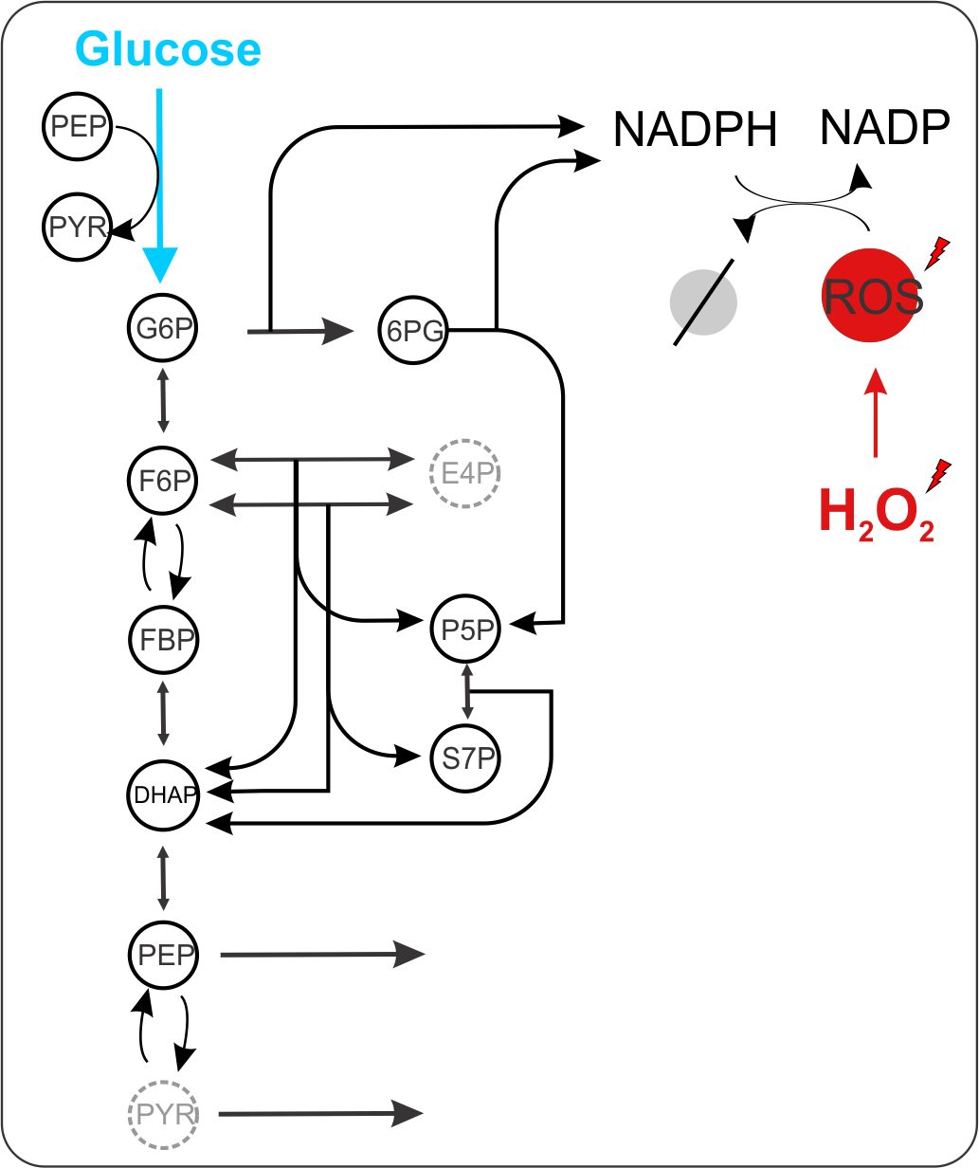

Figure 1

----------------------------------- ALTERNATIVE FIGURE 1 ---------------------------------

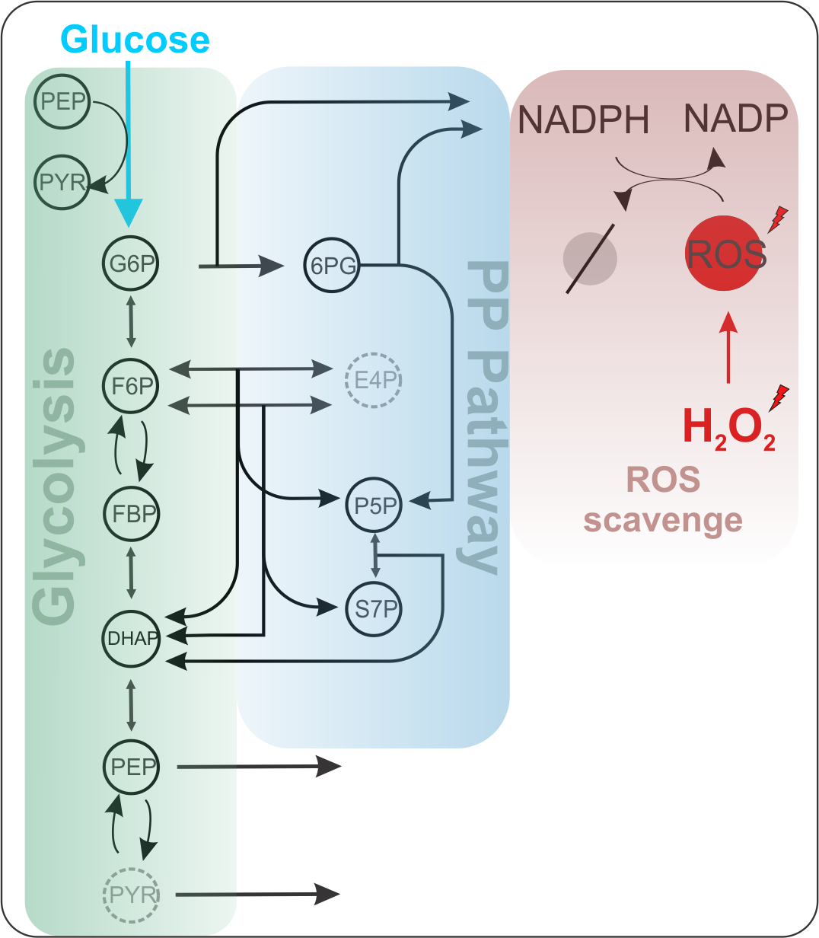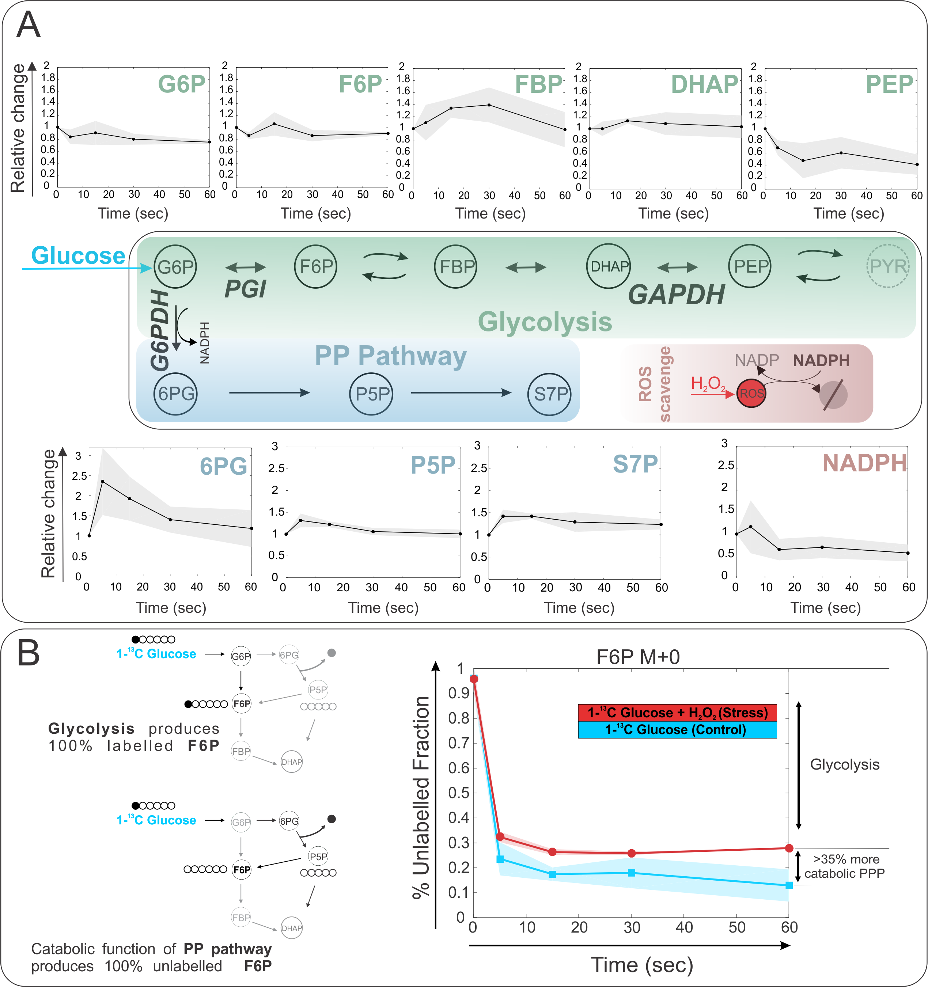 Figure 2

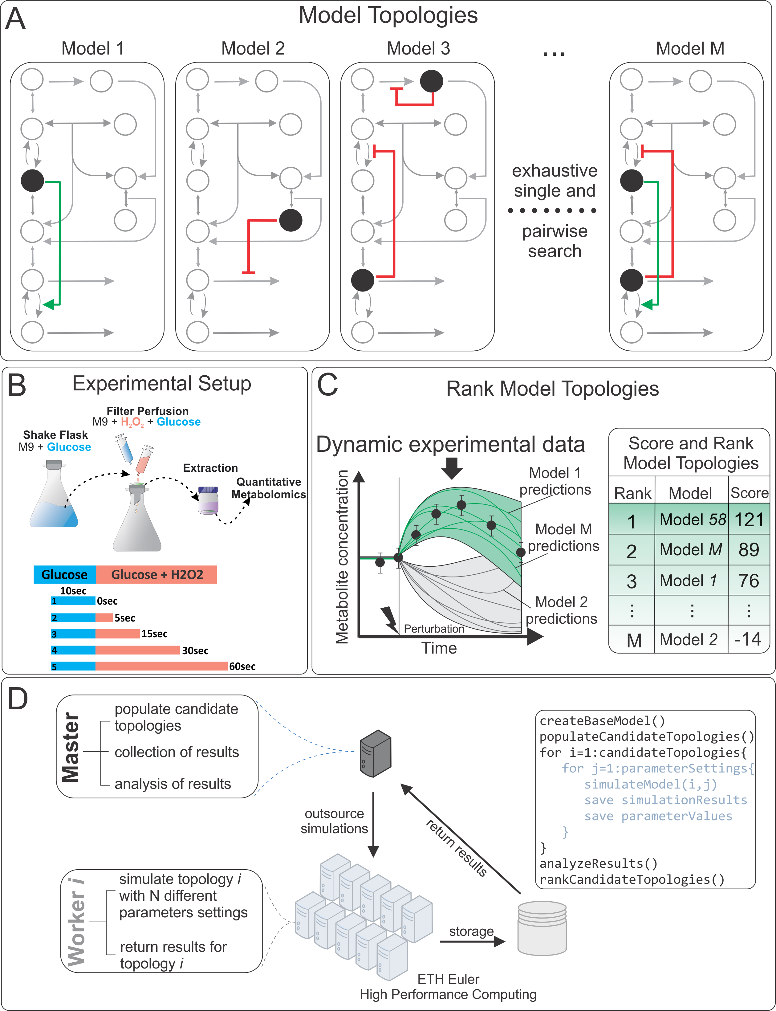

Figure 3

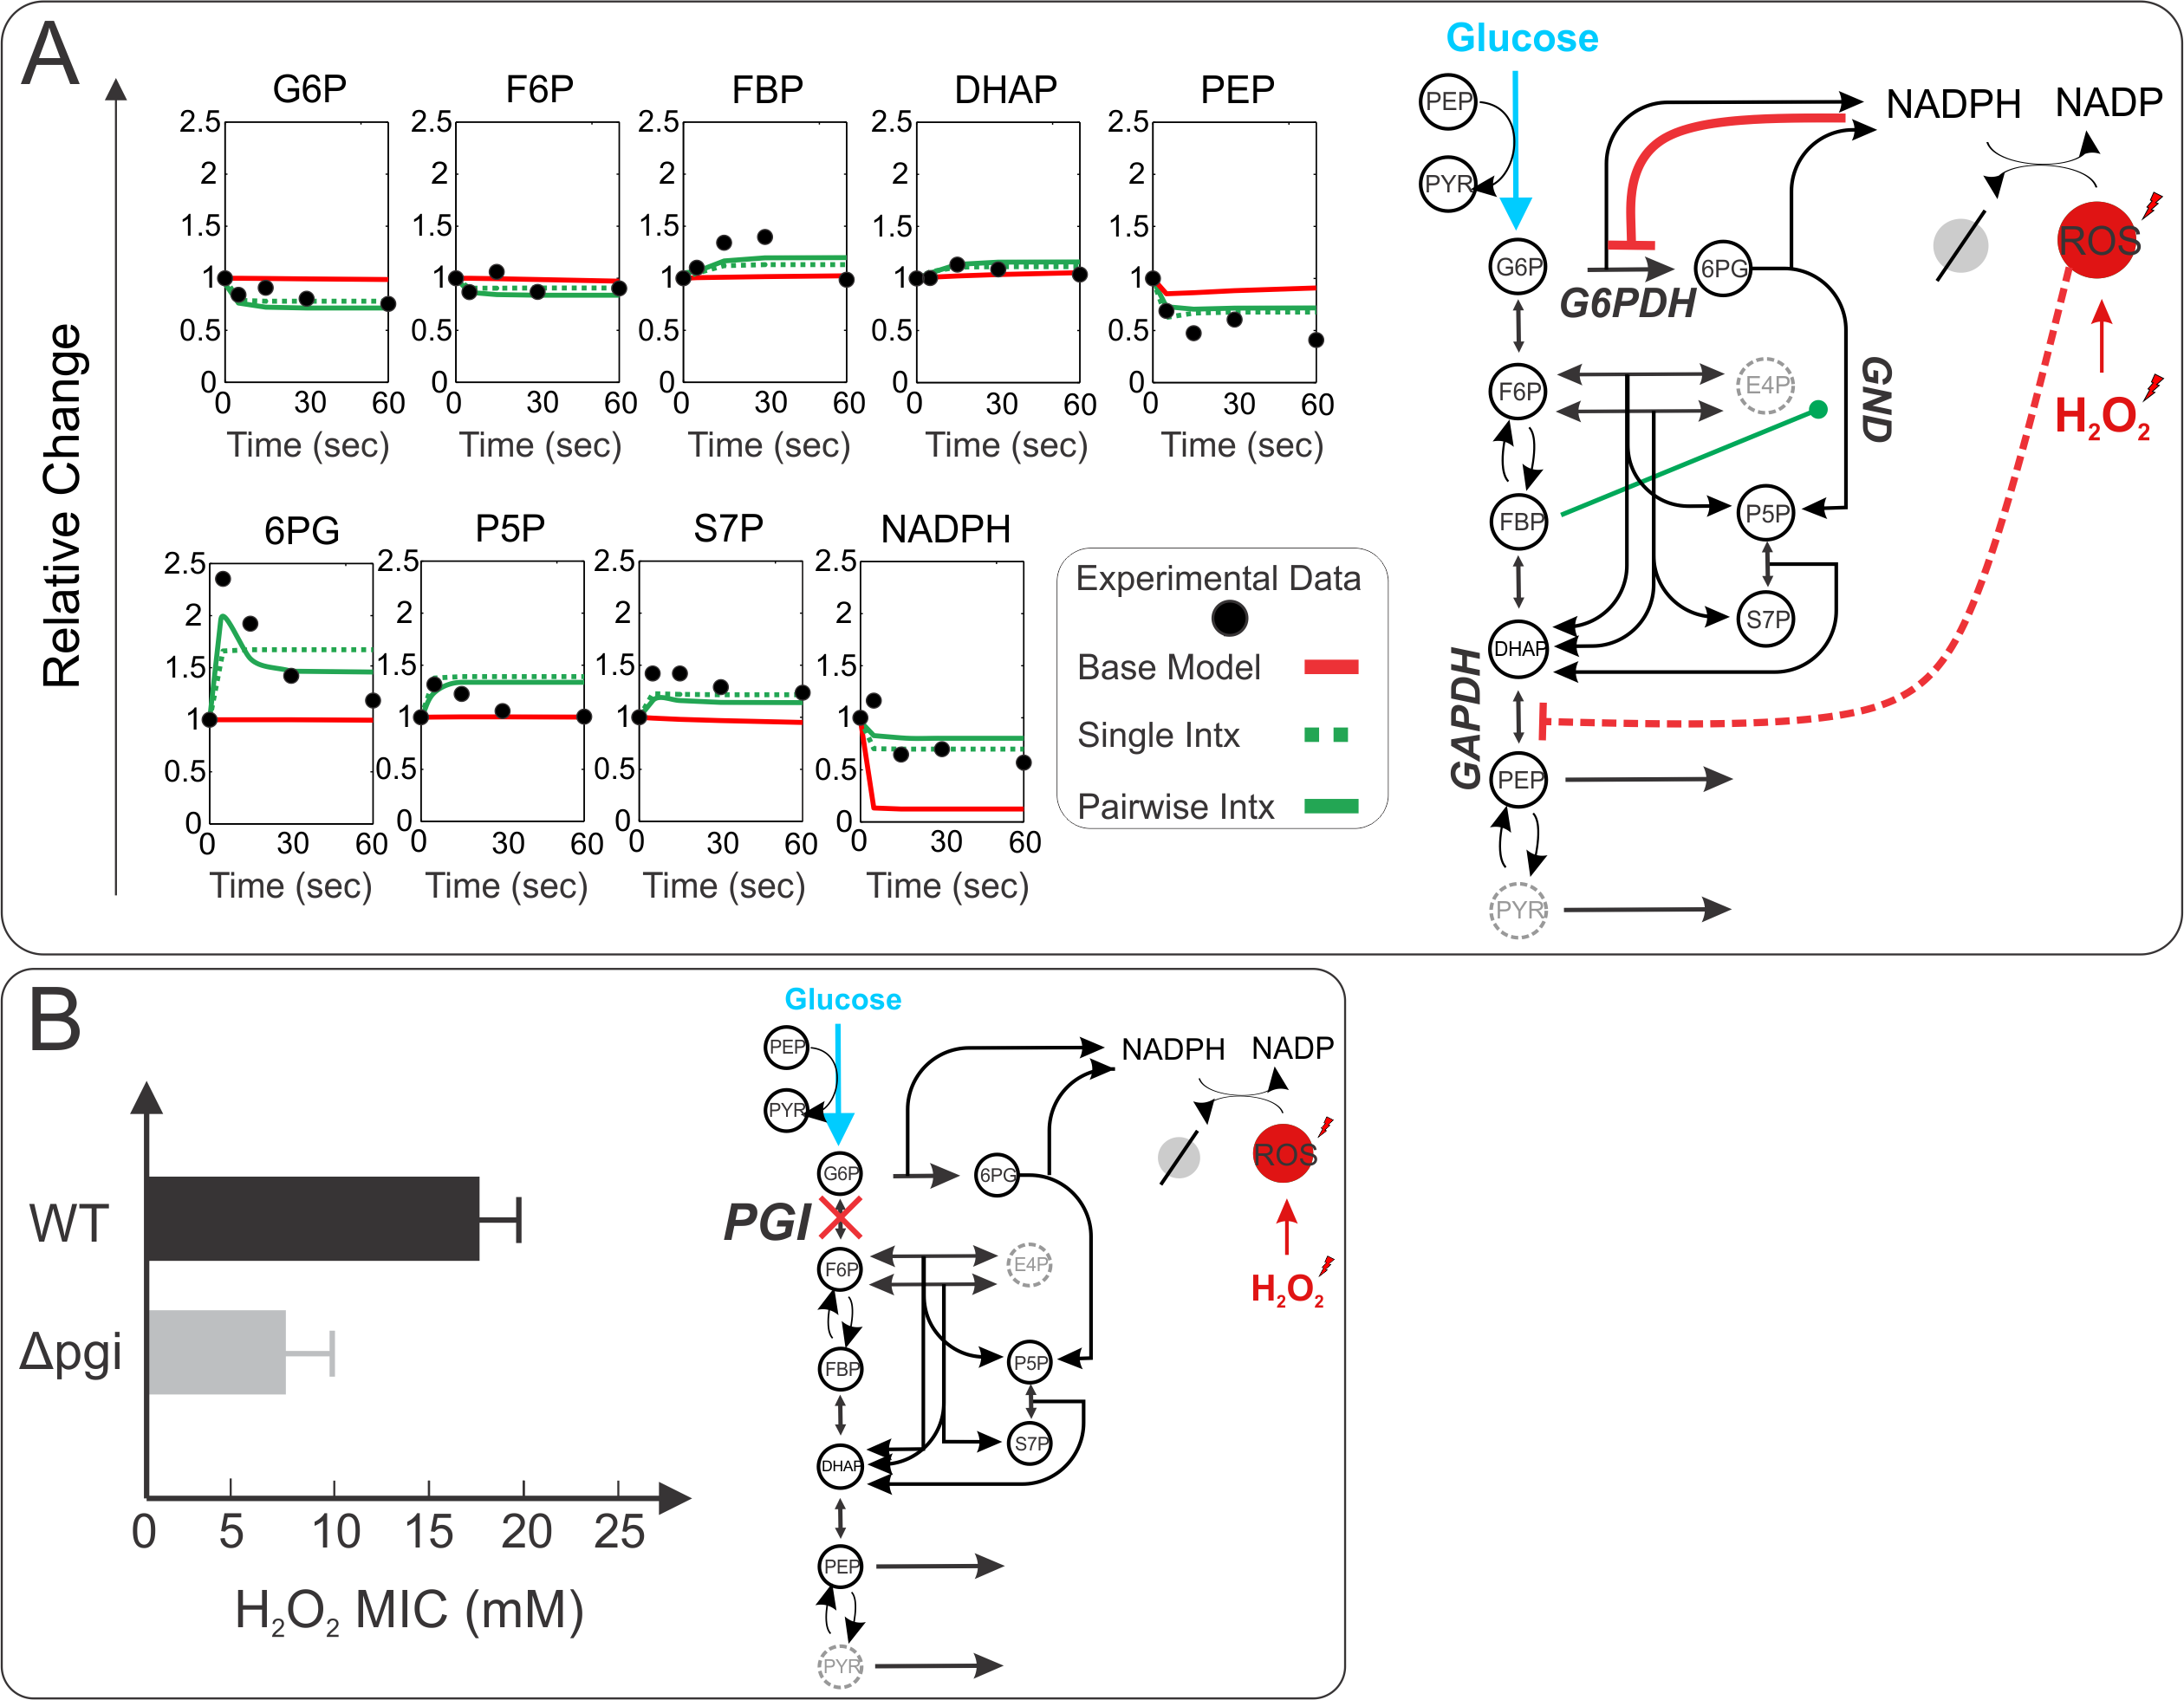

Figure 4

**References**

Anastasiou, D. et al., 2011. Inhibition of pyruvate kinase M2 by reactive oxygen species contributes to cellular antioxidant responses. *Science (New York, N.Y.)*, 334(6060), pp.1278–83. Available at: http://www.pubmedcentral.nih.gov/articlerender.fcgi?artid=3471535&tool=pmcentrez&rendertype=abstract [Accessed April 9, 2015].

Baba, T. et al., 2006. Construction of Escherichia coli K-12 in-frame, single-gene knockout mutants: the Keio collection. *Molecular systems biology*, 2, p.2006.0008.

Baez, A. & Shiloach, J., 2013. Escherichia coli avoids high dissolved oxygen stress by activation of SoxRS and manganese-superoxide dismutase. *Microbial cell factories*, 12, p.23. Available at: http://www.pubmedcentral.nih.gov/articlerender.fcgi?artid=3605374&tool=pmcentrez&rendertype=abstract [Accessed July 10, 2014].

Blanchard, J.L. et al., 2007. Rapid changes in gene expression dynamics in response to superoxide reveal SoxRS-dependent and independent transcriptional networks. *PloS one*, 2(11), p.e1186. Available at: http://www.pubmedcentral.nih.gov/articlerender.fcgi?artid=2064960&tool=pmcentrez&rendertype=abstract [Accessed June 18, 2014].

Brauner, A. et al., 2016. Distinguishing between resistance, tolerance and persistence to antibiotic treatment. *Nature Reviews Microbiology*, 14(5), p.320. Available at: http://www.nature.com/nrmicro/journal/v14/n5/abs/nrmicro.2016.34.html [Accessed April 13, 2017].

Breitling, R. et al., 2004. Rank products: a simple, yet powerful, new method to detect differentially regulated genes in replicated microarray experiments. *FEBS Letters*, 573(1-3), pp.83–92. Available at: http://www.ncbi.nlm.nih.gov/pubmed/15327980 [Accessed June 13, 2017].

Brumaghim, J.L. et al., 2003. Effects of Hydrogen Peroxide upon Nicotinamide Nucleotide Metabolism in Escherichia coli: CHANGES IN ENZYME LEVELS AND NICOTINAMIDE NUCLEOTIDE POOLS AND STUDIES OF THE OXIDATION OF NAD(P)H BY Fe(III). *Journal of Biological Chemistry*, 278(43), pp.42495–42504. Available at: http://www.jbc.org/cgi/doi/10.1074/jbc.M306251200 [Accessed October 11, 2016].

Byrne, R.T. et al., 2014. Escherichia coli genes and pathways involved in surviving extreme exposure to ionizing radiation. *Journal of bacteriology*, 196(20), pp.3534–45. Available at: http://www.ncbi.nlm.nih.gov/pubmed/25049088 [Accessed October 12, 2016].

Chechik, G. et al., 2008. Activity motifs reveal principles of timing in transcriptional control of the yeast metabolic network. *Nature Biotechnology*, 26(11), pp.1251–1259. Available at: http://dx.doi.org/10.1038/nbt.1499 [Accessed April 14, 2015].

Claudi, B. et al., 2014. Phenotypic Variation of Salmonella in Host Tissues Delays Eradication by Antimicrobial Chemotherapy. *Cell*, 158(4), pp.722–733. Available at: http://www.ncbi.nlm.nih.gov/pubmed/25126781 [Accessed April 13, 2017].

Finkel, T., 2003. Oxidant signals and oxidative stress. *Current Opinion in Cell Biology*, 15(2), pp.247–254. Available at: http://www.sciencedirect.com/science/article/pii/S0955067403000024 [Accessed June 4, 2015].

Fuhrer, T., Fischer, E. & Sauer, U., 2005. Experimental identification and quantification of glucose metabolism in seven bacterial species. *Journal of bacteriology*, 187(5), pp.1581–90. Available at: http://www.ncbi.nlm.nih.gov/pubmed/15716428 [Accessed December 22, 2016].

Gerosa, L. et al., 2015. Pseudo-transition Analysis Identifies the Key Regulators of Dynamic Metabolic Adaptations from Steady-State Data. *Cell Systems*, 1(4), pp.270–282. Available at: http://www.cell.com/article/S2405471215001465/fulltext [Accessed October 26, 2015].

Gilbert, P., Collier, P.J. & Brown, M.R., 1990. Influence of growth rate on susceptibility to antimicrobial agents: biofilms, cell cycle, dormancy, and stringent response. *Antimicrobial agents and chemotherapy*, 34(10), pp.1865–8. Available at: http://www.ncbi.nlm.nih.gov/pubmed/2291653 [Accessed April 13, 2017].

Grant, C.M., 2008. Metabolic reconfiguration is a regulated response to oxidative stress. *Journal of biology*, 7(1), p.1. Available at: http://jbiol.com/content/7/1/1 [Accessed July 10, 2014].

Greenberg, J.T. & Demple, B., 1989. A global response induced in Escherichia coli by redox-cycling agents overlaps with that induced by peroxide stress. *Journal of bacteriology*, 171(7), pp.3933–9. Available at: http://www.pubmedcentral.nih.gov/articlerender.fcgi?artid=210145&tool=pmcentrez&rendertype=abstract [Accessed July 11, 2014].

Imlay, J.A., 2013. The molecular mechanisms and physiological consequences of oxidative stress: lessons from a model bacterium. *Nature reviews. Microbiology*, 11(7), pp.443–54. Available at: http://dx.doi.org/10.1038/nrmicro3032 [Accessed May 23, 2014].

Kohen, R. & Nyska, A., 2002. Oxidation of Biological Systems: Oxidative Stress Phenomena, Antioxidants, Redox Reactions, and Methods for Their Quantification. *Toxicologic Pathology*, 30(6), pp.620–650. Available at: http://tpx.sagepub.com/content/30/6/620 [Accessed June 5, 2015].

Krüger, A. et al., 2011. The pentose phosphate pathway is a metabolic redox sensor and regulates transcription during the antioxidant response. *Antioxidants & redox signaling*, 15(2), pp.311–24. Available at: http://www.ncbi.nlm.nih.gov/pubmed/21348809 [Accessed January 22, 2014].

Kuehne, A. et al., 2015. Acute Activation of Oxidative Pentose Phosphate Pathway as First-Line Response to Oxidative Stress in Human Skin Cells. *Molecular cell*. Available at: http://www.cell.com/article/S1097276515004566/fulltext [Accessed July 22, 2015].

Link, H., Christodoulou, D. & Sauer, U., 2014. Advancing metabolic models with kinetic information. *Current Opinion in Biotechnology*, 29, pp.8–14. Available at: http://www.ncbi.nlm.nih.gov/pubmed/24534671 [Accessed February 17, 2014].

Link, H., Kochanowski, K. & Sauer, U., 2013. Systematic identification of allosteric protein-metabolite interactions that control enzyme activity in vivo. *Nature biotechnology*, 31(4), pp.357–61. Available at: http://www.nature.com/nbt/journal/v31/n4/full/nbt.2489.html?WT.ec_id=NBT-201304 [Accessed October 22, 2015].

Mishra, S. & Imlay, J., 2012. Why do bacteria use so many enzymes to scavenge hydrogen peroxide? *Archives of biochemistry and biophysics*, 525(2), pp.145–60. Available at: http://www.pubmedcentral.nih.gov/articlerender.fcgi?artid=3413786&tool=pmcentrez&rendertype=abstract [Accessed July 10, 2014].

Murakami, K. et al., 2006. Oxidative inactivation of reduced NADP-generating enzymes in E. coli: iron-dependent inactivation with affinity cleavage of NADP-isocitrate dehydrogenase. *Archives of Microbiology*, 186(5), pp.385–392. Available at: http://link.springer.com/10.1007/s00203-006-0153-1 [Accessed April 5, 2017].

Nikolaev, Y. V. et al., 2016. Systematic Identification of Protein–Metabolite Interactions in Complex Metabolite Mixtures by Ligand-Detected Nuclear Magnetic Resonance Spectroscopy. *Biochemistry*, 55(18), pp.2590–2600.

Nunoshiba, T. et al., 1992. Two-stage control of an oxidative stress regulon: the Escherichia coli SoxR protein triggers redox-inducible expression of the soxS regulatory gene. *Journal of bacteriology*, 174(19), pp.6054–60. Available at: http://www.pubmedcentral.nih.gov/articlerender.fcgi?artid=207670&tool=pmcentrez&rendertype=abstract [Accessed August 5, 2015].

Olavarría, K., Valdés, D. & Cabrera, R., 2012. The cofactor preference of glucose-6-phosphate dehydrogenase from Escherichia coli- modeling the physiological production of reduced cofactors. *FEBS Journal*, 279(13), pp.2296–2309. Available at: http://doi.wiley.com/10.1111/j.1742-4658.2012.08610.x [Accessed July 8, 2016].

Ralser, M. et al., 2007b. Dynamic rerouting of the carbohydrate flux is key to counteracting oxidative stress. *Journal of biology*, 6(4), p.10. Available at: http://www.pubmedcentral.nih.gov/articlerender.fcgi?artid=2373902&tool=pmcentrez&rendertype=abstract [Accessed February 24, 2014].

Ralser, M. et al., 2007a. Dynamic rerouting of the carbohydrate flux is key to counteracting oxidative stress. *Journal of biology*, 6(4), p.10. Available at: http://jbiol.com/content/6/4/10 [Accessed April 30, 2014].

Ralser, M. et al., 2009. Metabolic reconfiguration precedes transcriptional regulation in the antioxidant response. *Nature biotechnology*, 27(7), pp.604–5. Available at: http://dx.doi.org/10.1038/nbt0709-604 [Accessed April 8, 2014].

Rui, B. et al., 2010a. A systematic investigation of Escherichia coli central carbon metabolism in response to superoxide stress. *BMC systems biology*, 4(1), p.122. Available at: http://www.biomedcentral.com/1752-0509/4/122 [Accessed April 8, 2014].

Rui, B. et al., 2010b. A systematic investigation of Escherichia coli central carbon metabolism in response to superoxide stress. *BMC systems biology*, 4, p.122. Available at: http://www.pubmedcentral.nih.gov/articlerender.fcgi?artid=2944137&tool=pmcentrez&rendertype=abstract [Accessed August 6, 2015].

Sandoval, J.M. et al., 2011. Glucose-6-Phosphate Dehydrogenase Protects Escherichia coli from Tellurite-Mediated Oxidative Stress V. D. Appanna, ed. *PLoS ONE*, 6(9), p.e25573. Available at: http://dx.plos.org/10.1371/journal.pone.0025573 [Accessed April 5, 2017].

Sanwal, B.D., 1970. Regulatory mechanisms involving nicotinamide adenine nucleotides as allosteric effectors. 3. Control of glucose 6-phosphate dehydrogenase. *The Journal of biological chemistry*, 245(7), pp.1626–31. Available at: http://www.ncbi.nlm.nih.gov/pubmed/4392411 [Accessed July 8, 2016].

Sauer, U. et al., 2004. The soluble and membrane-bound transhydrogenases UdhA and PntAB have divergent functions in NADPH metabolism of Escherichia coli. *The Journal of biological chemistry*, 279(8), pp.6613–9. Available at: http://www.ncbi.nlm.nih.gov/pubmed/14660605 [Accessed December 22, 2016].

Seo, S.W. et al., 2015. Genome-wide Reconstruction of OxyR and SoxRS Transcriptional Regulatory Networks under Oxidative Stress in Escherichia coli K-12 MG1655. *Cell Reports*, 12(8), pp.1289–1299. Available at: http://www.sciencedirect.com/science/article/pii/S2211124715008190 [Accessed April 13, 2017].

Shimizu, K., 2013. Regulation Systems of Bacteria such as Escherichia coli in Response to Nutrient Limitation and Environmental Stresses. *Metabolites*, 4(1), pp.1–35. Available at: http://www.mdpi.com/2218-1989/4/1/1/htm [Accessed April 14, 2014].

Turkheimer, F.E., Hinz, R. & Cunningham, V.J., 2003. On the undecidability among kinetic models: from model selection to model averaging. *Journal of cerebral blood flow and metabolism : official journal of the International Society of Cerebral Blood Flow and Metabolism*, 23(4), pp.490–8. Available at: http://www.ncbi.nlm.nih.gov/pubmed/12679726 [Accessed November 1, 2015].

Valdivia-González, M., Pérez-Donoso, J.M. & Vásquez, C.C., 2012. Effect of tellurite-mediated oxidative stress on the Escherichia coli glycolytic pathway. *BioMetals*, 25(2), pp.451–458. Available at: http://link.springer.com/10.1007/s10534-012-9518-x [Accessed October 12, 2016].

Yuan, J., Bennett, B.D. & Rabinowitz, J.D., 2008. Kinetic flux profiling for quantitation of cellular metabolic fluxes. *Nature protocols*, 3(8), pp.1328–40. Available at: http://www.pubmedcentral.nih.gov/articlerender.fcgi?artid=2710581&tool=pmcentrez&rendertype=abstract [Accessed June 7, 2015].

Zheng, M. & Storz, G., 2000. Redox sensing by prokaryotic transcription factors. *Biochemical Pharmacology*, 59(1), pp.1–6. Available at: http://www.sciencedirect.com/science/article/pii/S0006295299002890 [Accessed April 13, 2017].

**Supplementary Material**

In vitro studies ----- Toby

Results

Km values were from measurements were glucose-6-phosphate concentrations were varied from 50 μM to 400 μM, while the NADP+ concentrations were between 20 μM and 150 μM. The resulting Km values for NADP+ and glucose-6-phsophate are listed in Table 1. Ki values of NADPH were determined with one substrate kept at a constant concentration, while the second substrate was varied at different constant inhibitor concentrations. According to the determined sequential ordered bi-bi-mechanism it was expected that NADPH will inhibit competitively in respect to NADP+ and mixed non-competitive with respect to glucose-6-phosphate [1]. To determine the respective inhibition constants, reaction velocities were determined under different NADPH concentrations (150, 75 and 0 μM), the glucose-6-phosphate concentration was held at 400 μM and NADP+ was varied from 10 to 60 μM or alternatively NADP+ was held at 40 μM and glucose-6-phosphate was varied from 50 to 400 μM. The resulting inhibition constants and intracellular concentrations are indicated in Table 1.

|  |  |  |
| --- | --- | --- |
| Table 1 Experimentally determined kinectic parameters and intracellular metabolite concentrations | | |
|  | Own data  [μM] | Olavarria et al [5]  [μM] |
| ***Substrate Km*:** |  |  |
| NADP+ | 23 | 7.5 ± 0.8 |
| glucose-6-phosphate | 136 | 174 ± 11 |
| ***NADP+ dissociation Ki*:** |  |  |
| NADP+ | 90 | 19 ± 4 |
| ***NADPH inhibition Ki*:** |  |  |
| Kic,NADP+ | 35 | 14 ± 2 |
| Kic,glucose-6-phosphate | 100 | 101 ± 9 |
| ***Intracellular Concentrations*** |  |  |
| **wild-type** |  |  |
| Glucose-6-phosphate | 289 ± 2 | 801 |
| NADP+ | 581 ± 13 | 21-210 |
| NADPH | 191 ± 20 | 24-220 |
| **Δ*pgi*** |  |  |
| Glucose-6-phosphate | 3301 ± 41 | - |
| NADP+ | 400 ± 31 | - |
| NADPH | 211 ± 9x | - |

For the initial rate predictions using intracellular metabolite concentrations shown in Figure 2, the rate laws (equations 1 & 2) describing the forward reaction in the presence of both educts and products were used that were previously published for glucose-6P dehydrogenase in *E. coli* (1). Only the forward reaction with NADPH inhibition was simulated since the 6P-gluconolactone produced reacts rapidly further to 6P-gluconate and in addition is very instable [2].

**Methods**

*Quantification of intracellular metabolite concentrations*

All measurements were carried out on an Agilent 1100 Series HPLC system coupled with an Applied Biosystems / MDS SCIEX 4000 Q TRAP™. Data were recorded and analyzed with Analyst Software Version 1.4.2 Build 1228. Chromatographic separation was achieved on a Phenomenex Hydro RP 150 mm x 2.1 mm x 4 μm column at 40°C using an adapted version of a published protocol [3]. Briefly, the injected volume was 8 µl, and the mobile phase at a flow rate of 200 µl/min was directly introduced into the mass spectrometer via electro spray ionization (ESI). The gradient profile was linear with two phases (Table 1), where solution A was 10 mM tributylamine and 15 mM acetate in H2O (pH 4.95) and solution B was 100 % methanol. Multiple reaction monitoring (MRM) settings were optimized individually for each metabolite except 6P-gluconolactone for which the MRM settings were adapted from 6P-gluconate [3].

|  |  |  |  |
| --- | --- | --- | --- |
| **Table 1** - Gradient profile applied for the LC-MS/MS method | | | |
| Step | Total time (min) | Eluent A (vol.%) | Eluent B (vol.%) |
| 1 | 0 | 100 | 0 |
| 2 | 15 | 45 | 55 |
| 3 | 27 | 34 | 66 |
| 4 | 28 | 0 | 100 |
| 5 | 33 | 0 | 100 |
| 6 | 35 | 100 | 0 |
| 7 | 55 | 100 | 0 |

*Characterization of Glucose-6-phosphate dehydrogenase*

Glucose-6-phosphate dehydrogenase was overexpressed in 50 ml LB medium with 0.1 mM IPTG and 25 mg/L chloramphenicol at 37°C and 250 rpm from an overexpression plasmid obtained from the ASKA clone collection [4]. Cells were harvested by centrifugation and the pellet was washed twice with 2 ml 0.9% NaCl with 10 mM MgSO4. The pellet was then resuspended in 4 ml ice cold 100 mM Tris-HCl pH 7.5, 5 mM MgCl2 supplemented with Protease-Inhibitor (Complete EDTA-free, Roche) and 1 mM DTT. Cells were disrupted by passage through a precooled French press mini cell at 1000 PSI and the crude extract was subsequently centrifuged for 30 min at 23000 x g and 4°C to obtain a clear cell lysate. The lysate was then loaded on a 1ml HisTrap HP columns from Amersham Biosciences. The column was washed with 12 volumes of wash buffer (20 mM NaH2PO4 pH 7.5, 500 mM NaCl, 10 mM Imidazole, 15 mM β-Mercaptoethanol) and then the protein was eluted using increasing imidazole concentrations. Fractions containing pure protein were buffer-exchanged against 100 mM Tris-HCl pH 7.5, 10 mM MgCl2 and 15 mM β-Mercaptoethanol using 25 kD Spectra-Por Float-A-Lyzer.

All enzyme assays were run at 30°C in 100 mM Tris HCl pH7.5 and 10 mM MgCl2 on a Spectramax Plus spectrometer (Molecular Devices). Absorbance was recorded at 340 nm with 2 second interval single measurements in 1 ml cuvettes. Purified enzyme was equilibrate with cofactor until absorbance at 340 nm was stable. The measured absorbance curve over time was regressed with a second order polynomial to determine the initial velocity at the time point when the second substrate was added and the sample was mixed. The Km values for NADP+ and glucose-6P and the Ki value for NADPH were then obtained by varying respective substrate or inhibitor concentrations and analysis by primary and secondary Lineweaver-Burk plots assuming a sequential two-substrate mechanism [1]:

|  |  |
| --- | --- |
|  | (1) |

Inhibition by NADPH was determined to be competitive with respect to NADP+ which can be included by the following inhibitory terms (1):

|  |  |
| --- | --- |
|  | (2) |

**Supplemental Figures**

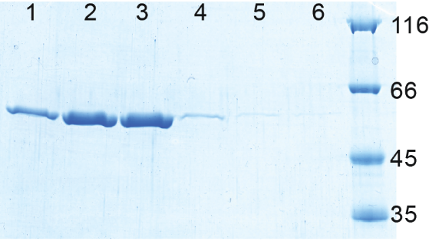

**Suppl. Figure 1** SDS-PAGE of overexpressed and His-Tag purified glucose-6P dehydrogenase (~56.8 kD including His-Tag). The pure enzyme was eluted with different imidazole concentrations (lanes 1 to 6: 100-200, 200, 200-300, 300, and twice 500 mM imidazole). Fractions in lane 2 and 3 were pooled for further analysis.

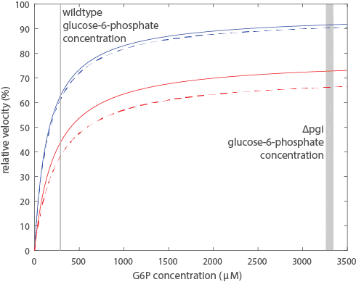

**Suppl. Figure 2** Simulated initial reaction velocities for glucose-6-phosphate dehydrogenase using rate laws without NADPH inhibition (blue lines, Equation 1) and with NADPH inhibition (red lines, Equation 2). Experimentally determined kinetic parameters and intracellular cofactor concentrations were used (Table 1). Intracellular concentrations from wildtype and from pgi knockout are shown with solid and dashed lines respectively. Actual intracellular glucose-6-phosphate concentrations for wildtype and *pgi* knockout are indicated by the grey bars.

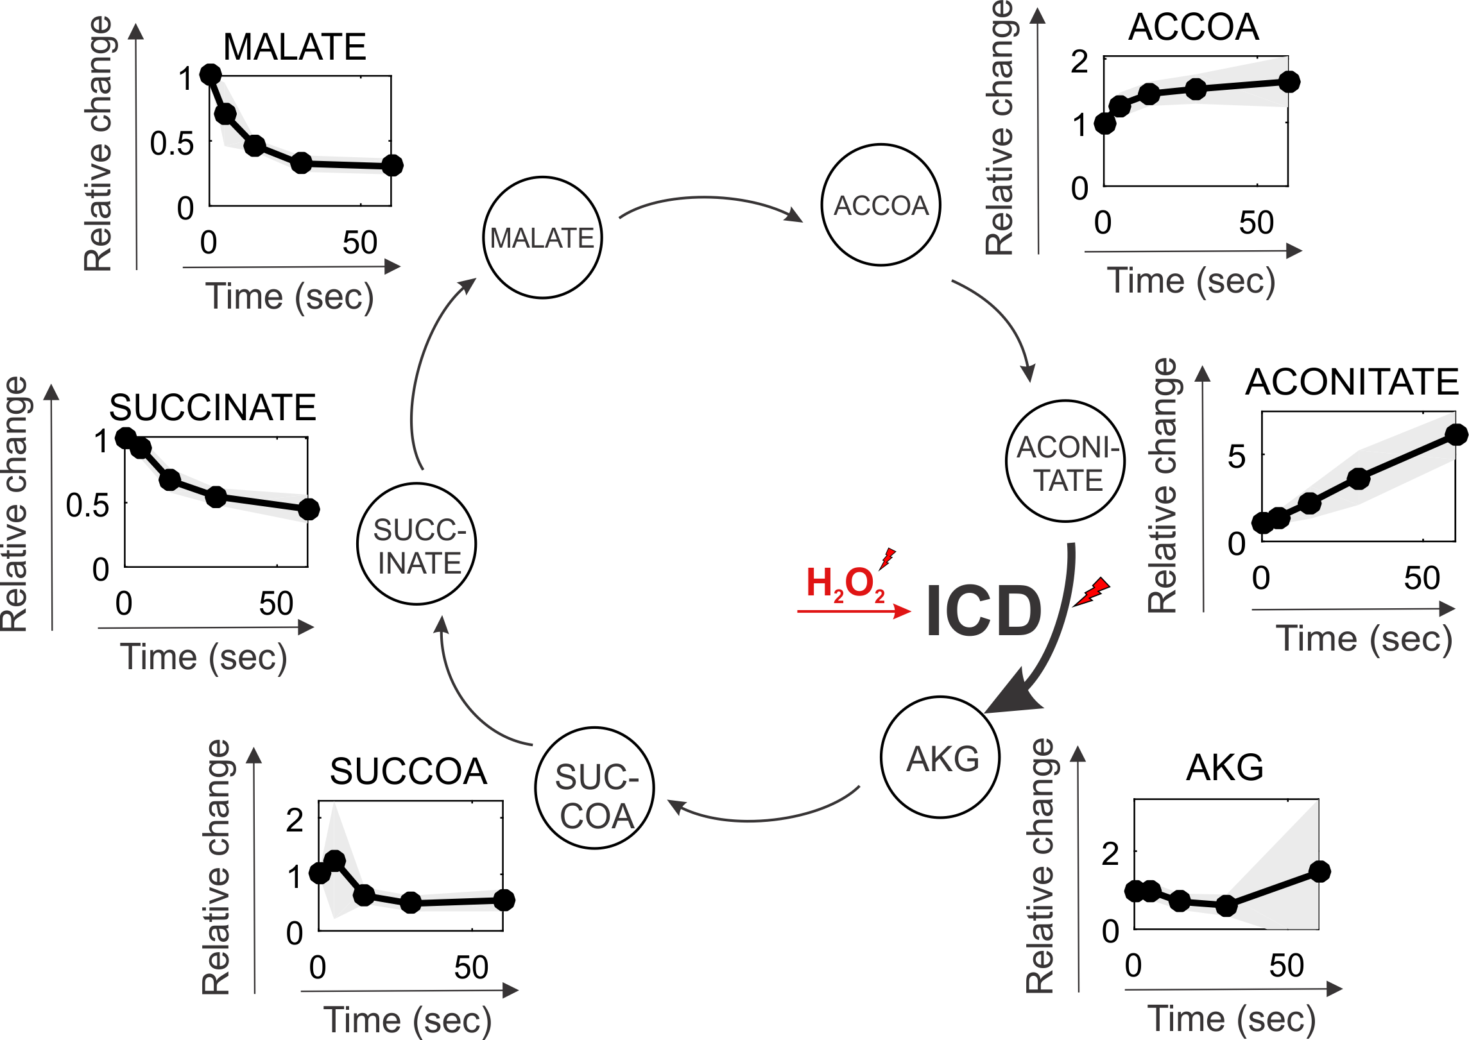

**Suppl. Figure 3**

**References**

1) Chassagnole, C., et al., *Dynamic modeling of the central carbon metabolism of Escherichia coli.* Biotechnology and Bioengineering, 2002. **79**(1): p. 53-73.

2) Bauer, H. P., T. Srihari, J. C. Jochims, and H. W. Hofer. 1983. 6-phosphogluconolactonase. Purification, properties and activities in various tissues. Eur. J. Biochem. 133:163-168.

3) Luo, B., K. Groenke, R. Takors, C. Wandrey, and M. Oldiges. 2007. Simultaneous determination of multiple intracellular metabolites in glycolysis, pentose phosphate pathway and tricarboxylic acid cycle by liquid chromatography-mass spectrometry. J. Chromatogr. A 1147:153-164.

4) Kitagawa, M., T. Ara, M. Arifuzzaman, T. Ioka-Nakamichi, E. Inamoto, H. Toyonaga, and H. Mori. 2005. Complete set of ORF clones of Escherichia coli ASKA library (a complete set of Escherichia coli K-12 ORF archive): unique resources for biological research. DNA Res. 12:291-299.

5) Karel Olavarrı´a, Diego Valde´ s and Ricardo Cabrera, The cofactor preference of glucose-6-phosphate dehydrogenase from Escherichia coli – modeling the physiological production of reduced cofactors. FEBS Journal 279 (2012) 2296–2309

**Methods section on zwf titration strain**

*Strain construction*

The *zwf* titration strain was constructed as follows. First, the *zwf* gene was cloned into the IPTG-titratable expression plasmid pTrc99KK (Link et al. 2013) (primer 1: GCCTCGAGATGGCGGTAACGCAAACAGCC, primer 2: CGGGATCCTTACTCAAACTCATTCCAGGAACG), yielding plasmid pTrc99KK-*zwf*. This plasmid was then transformed into a *zwf* deletion strain obtained from the Keio collection (Baba et al. 2006). To exclude adverse effects on oxidative stress resistance merely due to protein overexpression, the *zwf* deletion strain was also transformed with a N-terminal his-tagged GFP titration plasmid, pTrc99KK-GFP:N-term HT, which was obtained from (Nikolaev et al. 2016).