Download and Process Earthquake Data with ObsPy and Python

Code to used ObsPy in order to search for earthquake events and subsequently download them, process them and plot them on the map.

For further information please follow me in the below links

LinkedIn: <https://www.linkedin.com/in/dimitris-dais/>

Email: [d.dais@pl.hanze.nl](mailto:d.dais@pl.hanze.nl)

ResearchGate: <https://www.researchgate.net/profile/Dimitris_Dais2>

Research Group Page: <https://www.linkedin.com/company/earthquake-resistant-structures-promising-groningen>

Add link to YouTube video

# get_events.py

Code to get earthquake events from 2010-01-01 until 2020-04-25 from the Netherlands

It will store the info of the events in an excel file

It will plot the events on the map

To run the code please update the following folder paths according to your system:

**os.environ['PROJ_LIB']**

**folder_output**

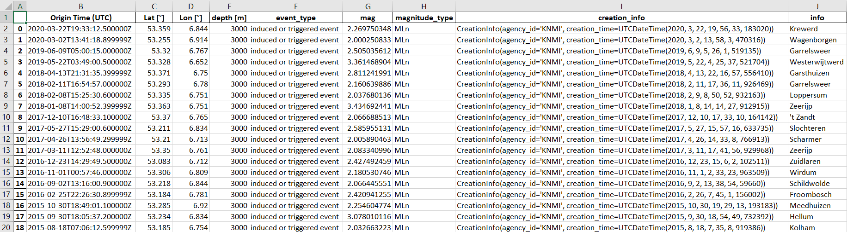

Figure 1: Store the info of the events in an excel file with get_events.py

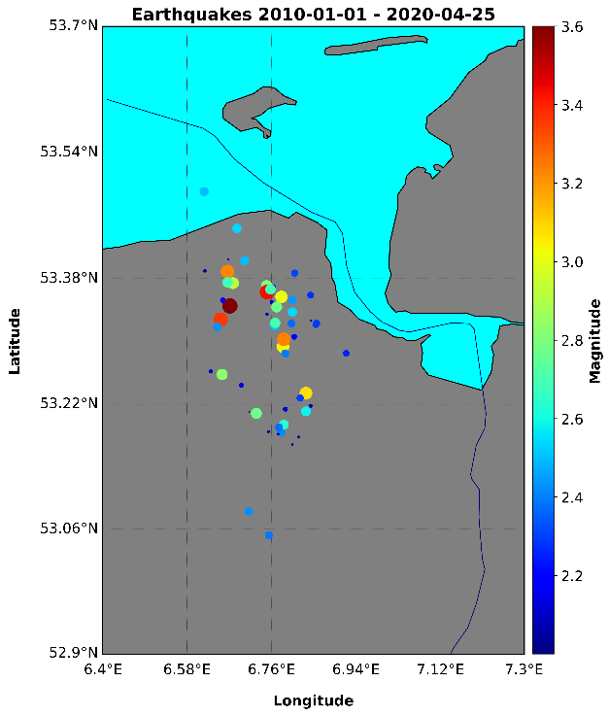

Figure 2: Plot the events on the map with get_events.py

# download_events.py

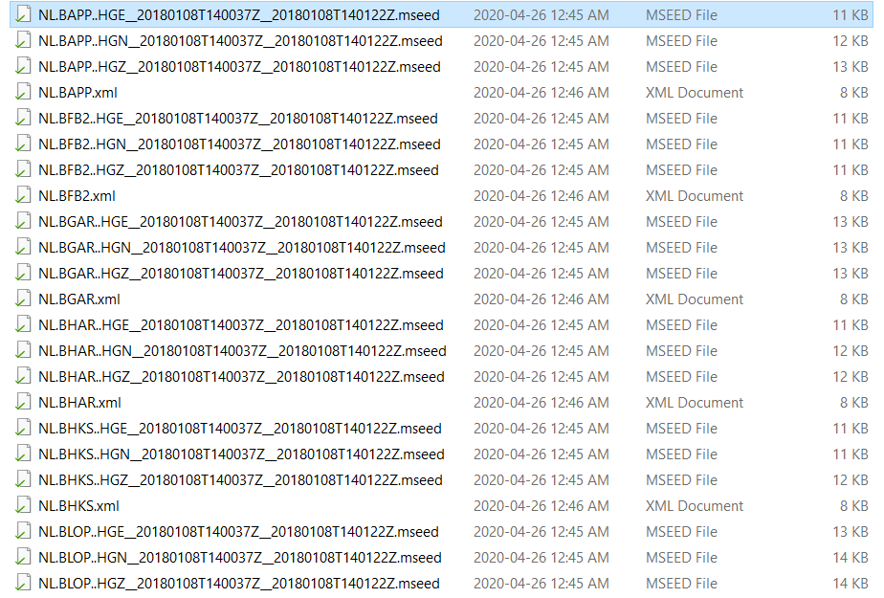

Figure 3: The mseed and xml files as downloaded from the download_events.py

# process_data.py

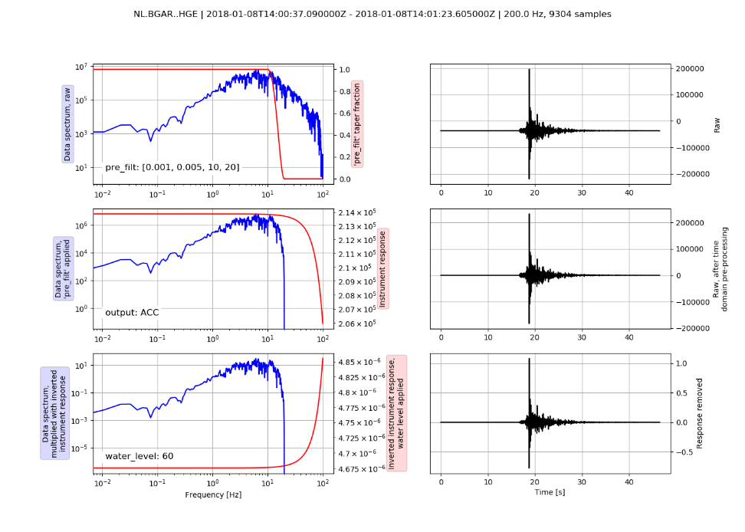

Figure 4: The plot prepared for the removal of the instrumental response from the process_data.py

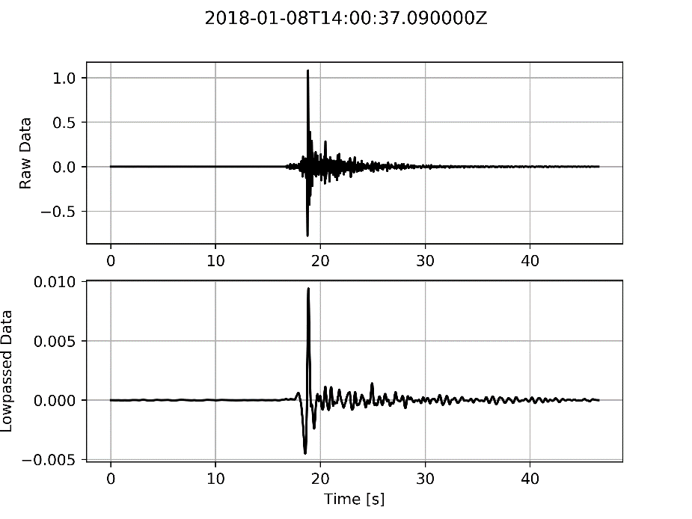

Figure 5: The plot prepared with the raw and the filtered data from the process_data.py