The Design document contains:

* Graphical illustration of the main menu
* Flowcharts
* Structure chart
* UML Diagrams
* Plan for testing the product

This document includes the phases of the development and the design of the final product. It shows the preliminary design of the product, and will be given to my client before the development of the product in order to determine whether the product satisfies all he needs. (The discussion based on the design phase is found in the appendix)

**Graphical illustration of the main menu**

The below image illustrates the main menu that will show up when the client starts operating the program.

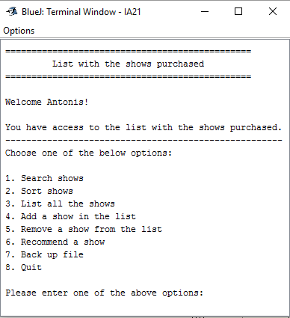

The menu includes the options available which allow the client to decide what to do next.

When the client chooses one of the eight options, then the program will output new options. In other words, each option of the main menu hides other options.

**Example:**  Client chooses option 6.

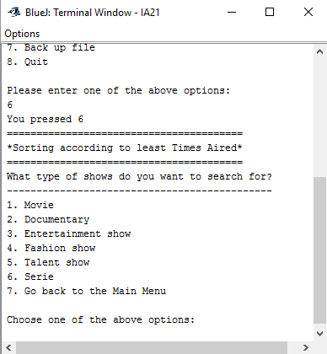

Antonis enters the number 6. The program will recommend shows according to their type*. The program asks the client to enter which type of show he does want.

*Explanation: The type of each show is determined by the first five characters of the identification code of a show. For example; the identification code of each movie begins with MOVIE while the id of each TV serie with SERIE.

**Flowchart of the main menu**



**Flowchart of the main menu** (illustrating the methods of each option)

Graphic representation of an organized chart: the purpose of constructing a flowchart is to provide the structure of the algorithm in a more simplistic and organized language.

Since the flowcharts with many details are not that visible, I decided to make one flowchart for each option independently.

The below flowchart illustrates the eight options provided by the main menu:



Each option of the main menu will provide new choices to the user. According to the option chose, the client will have to decide what he would like to do afterwards. For each option, there will be a specific method that uses certain complex algorithms in order to meet the expectations of the client.

* Flowchart for **option 1** as an **example**



**Structure chart**

The below chart illustrates the general concept of how the main menu will be structured and shows the breakdown of the program to its lowest manageable levels.



The use of this chart enables the programmer to divide the program to sub-programs. This reduces complexity and reduces the probability of a possible error to occur. It also allows the programmer to visualize the design of the whole program and the methods that should be used

Thus, the programmer is able to see what methods he should construct for each option provided in the main menu and write a record of task as well as a planning form that enables him to construct a preliminary design of the product.

**UML Diagrams**

The below UML diagram illustrates the planning design of the artifacts of the product.

**Diagram 1:** Proposed class of the main menu

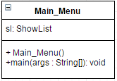

**Diagram 2:** Proposed object of Show

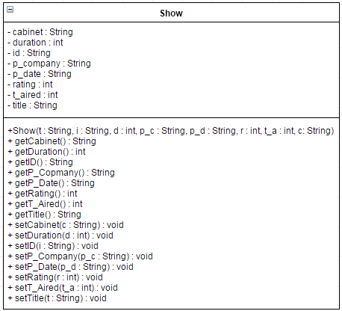

**Diagram 3:** Proposed class of reading data from file and write new data to file

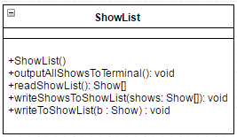

**Diagram 4:** Proposed class of Search method

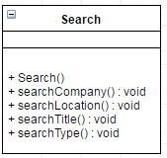

**Diagram 5:** Proposed class of Sort method

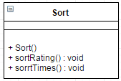

**Diagram 6:** Proposed class for inputting a show with validation

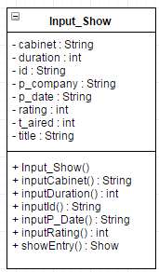

**Diagram 7:** Proposed class of adding a new show in the list

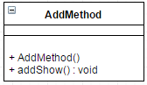

**Diagram 8:** Proposed class of removing a show from the list

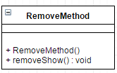

**Diagram 9:** Proposed class of recommending few shows after sorting the shows according to times aired

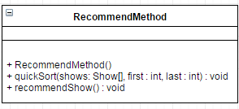

**Plan for testing the product**

The below table shows how the success criteria are tested through the design process. Such strategy is used in order to determine whether the basic functionalities of the product meet the needs of my client.

|  |  |  |  |
| --- | --- | --- | --- |
| **Success Criteria** | **Test Type** | **Nature of Testing** | **Example** |
| Check the functionality of the methods | Alpha testing  Unit testing | Ensure that each method used works satisfactorily | Each method will be run separately to see if it can meet the desired results |
| Add a show | Validation testing | Write and save data to the file | A new show is added in the list with all the details required |
| Delete a show | Alpha testing | Functionality of deleting data from the file | A show is delete from the list by entering its name |
| Search shows | User testing | Functionality of the methods used to search data from the list | Search according to title |
| Search according to type |
| Search according to production company’s name |
| Find the location of the DVD of the show |
| Recommend a show | Alpha testing  Beta testing | Find data according to specific characteristics  Check whether the method satisfies the needs of the client | List shows according to specific type, rating, and times aired |
| List all shows | Alpha testing | Functionality of the method to read data from the file and output file’s data | A list with the shows and their details appears in the terminal |
| Sort shows | Alpha testing  Unit testing | Sort data according to specific characteristic | Sort shows according to rating (ascending/descending order) |
| Sort shows according to times aired (ascending/descending order) |
| Start the program | Alpha testing  Unit testing | Check whether the program starts properly and Decryption method works | After starting the program, the file with the shows stored is decrypted automatically |
| Quit the program | Check whether “Quit” works | Encrypt data of the main file | Every time the client chooses to exit from the program, the file is automatically encrypted |
| Check whether the Encryption method works |
| Check functionality | Dry-run testing | Fix any bugs/errors that may occur in the code | If any unpredicted result occurs, I will run again the algorithm of each method to find the error |
| Final product | End-user testing | After the program is been completed, the client will test the product and provide feedback | Ensure that to see whether the proposed product meets client’s needs and expectations |

An **example** of alpha testing to be used for validating data input is:

**Field: ID**

|  |  |
| --- | --- |
| Normal Data | An ID that consists of 5 letters (characters) and 5 numbers |
| Abnormal Data | An ID of which the 5 characters do not meet the required type* |
| Extreme Data | An ID that uses less/more than 5 letters and numbers |

*The first 5 letters are: MOVIE, SPORT, DOCUM, MUSIC, ENTER, FASHI, TALEN, SERIE

* MOVIE stands for movies
* SPORT stands for sports
* DOCUM stands for documentaries
* MUSIC stands for musical shows
* ENTER stands for entertainment shows
* FASHI stands for fashion shows
* TALEN stands for talent shows
* SERIE stands for series