DELIVERABLES

Part 1 - Lightning Presentation
- Requirements: You should present from a prepared deck that explains the following:
  - The Problem: What's the background and scope of the project idea? What problem are you attempting to address or solve? Who may it matter to?
  - Data: What data exists to help solve this problem? Where is it coming from? What does the data look like? What is the observation?
  - Hypotheses: Given the problem and data you're aware of, what do you believe is the solution? What does success look like?
- Detailed Breakdown: Your presentation must:
  - Explain three potential projects, including: a problem statement, a hypothesis, and potential data sets
  - Be 2-3 minutes in duration
  - Demonstrate familiarity with the domain of the data
- Bonus:
  - High level data points can help show the "improvement" scope that's available
  - Cite similar/previous work that will better inform your strategy that can be taken

Part 2 - Project Design Writeup
- Requirements:
  - Well-articulated problem statement with "specific aim" and hypothesis, based on your lightning talk
  - An outline of any potential methods and models
  - Detailed explanation of extant data available (ie: build a data dictionary or link to pre-built data dictionaries)
  - Describe any outstanding questions, assumptions, risks, caveats
  - Demonstrate domain knowledge, including specific features or relevant benchmarks from similar projects
  - Define your goals and criteria, in order to explain what success looks like
- Bonus:
  - Consider alternative hypotheses: if your project is a regression problem, is it possible to rewrite it as a classification problem?
  - "Convert" your goal metric from a statistical one (like Mean Squared Error) and tie it to something non-data people can understand, like a cost/benefit analysis, etc.

Problem

What problem are you attempting to address or solve
For this project I want to investigate the relationship between:
- Economic Freedoms
- Social freedoms
and prosperity of different countries and if there are strong correlations between the above. For many people it seems that these are not only correlated , but strongly. There is the opinion that whenever one improves the others will follow no matter what an opinion which lately as we live in a more and more multi-polar world is still strong although some cracks have started to show.
I also want to experiment with forecasting tools such as Facebook’s Prophet to see how these correlations are likely to evolve in the following years if things continue as they are: will we have a more free world, a more prosperous one?

For whom this project matters
For people interested or curious in economical and social dynamics, civil liberties and freedoms, those who want to approach different business cultures or societies. Some personal interest derives from my intention to relocate abroad for a couple of years: Should I expect to find a situation similar to the one that I have been accustomed to in the last ten years I have lived in Britain or encounter something radically different if I choose to say relocate to Singapore?

Background
The idea originated from discussions that I had with friends and perceptions that I have seen circulating about global politics. A good shake up occurred from articles such as: “We Aren’t the World” -
and reading the book from the chief editor’s of the Economist: “The fourth revolution – the global race to reinvent the state” where different approach of organising the state are being discussed from different continents such as Britain, Singapore, and China. Another point of inspiration was the book and lectures of Daron Acemoğlu on “Why Nations Fail”.

Data
Data will be acquired from publicly available data sets and international independent sources. Where data is not available for every variable that will be studied the most available subset will be used: If we have GDP data for all countries (A, B, C, D, etc.), economic freedom data for countries A, B, C and social liberty data for countries A, B, D then the analysis will be conducted only for A, B.

GDP
Will use the World Bank which provides a dataset available here:
http://data.worldbank.org/indicator/NY.GDP.PCAP.CD

How does the data look like, what is the observation
Data available to be downloaded as a CSV:
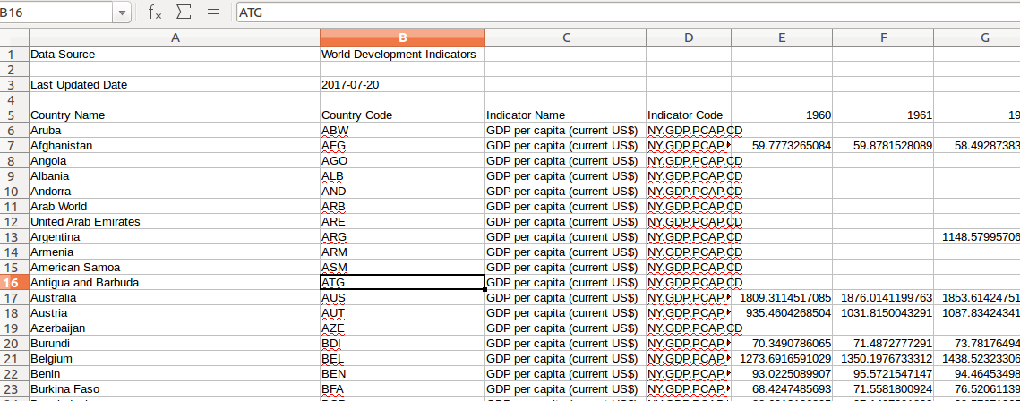
The following observations will be used:
- Country Name
- Country Code
- Specific years
Along with the data two data dictionaries are provided explaining how some metrics are calculated as well as some assumptions. Most important elements from there will be copied over to the final deliverable.
Later on the observations might expand to include other indicators.
Data are provided for different countries from 1960 up to 2016. Since it is the most extensive dataset we will choose which years to use based on other data sets. Also there is only one metric provided, GDP per capita in USD.
Data will be checked for non available or illegal values.

Economic Freedom
For economic freedom decided to use the economic freedom ranking provided from Frazer institute:
https://www.fraserinstitute.org/economic-freedom/dataset?year=2014&page=dataset&min-year=2&max-year=0&filter=1&most-free=1&quartile2=1&quartile3=1&least-free=1

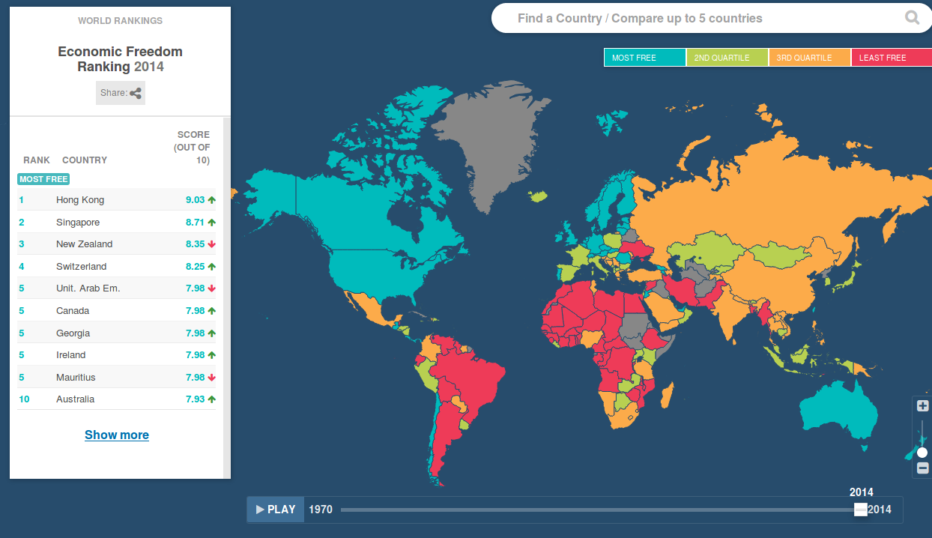
Data are provided for different countries from 1970 up to 2014. If we have to use one year the latest one will be chosen or an average of the last 5 years.

How does the data look like, what is the observation
Researchers can download all the available data in XLS format. Opening it looks like the following screenshot:
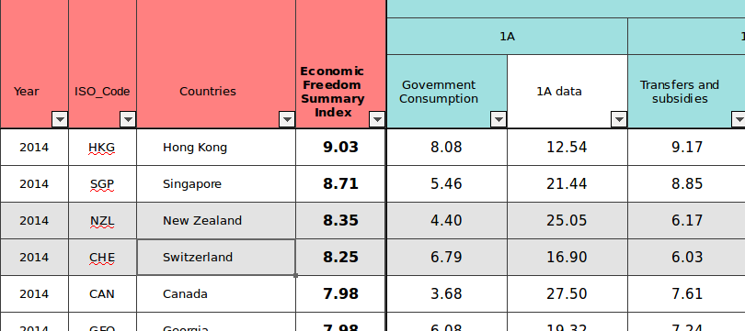
Initially the following observations will be used:
- Year
- ISO Code
- Country
- Economic Freedom Summary Index
Later on the observations might expand to include other indicators.
Data will be checked for non available or illegal values.
Last available year for this data set is 2014.

Social freedoms
Social freedoms are the most difficult to define compared to other metrics. There are many approaches to measuring social freedoms some more suitable than others. There is for example the “CIRI human rights data project” whose work though stops in 2014, or the work of the Cato institute, while Frazer institute also generates a related report. Wanting to have a different source decided to use the “Democracy Index 2016” compiled from The Economist’s Intelligence Unit available here:
https://www.eiu.com/public/topical_report.aspx?campaignid=DemocracyIndex2016
The report needs registration to be downloaded and is not in CSV or XLS output. This means that some scrapping is required probably from the tabular data in the Wikipedia page of the report.

How does the data look like, what is the observation
https://en.wikipedia.org/wiki/Democracy_Index as it can be seen here:

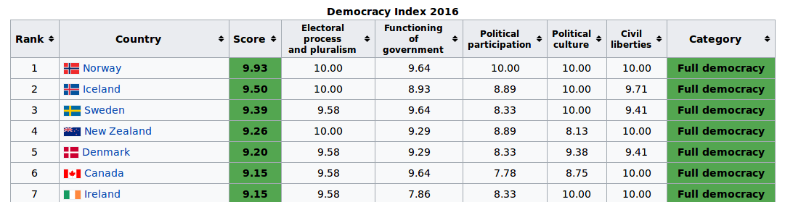
Initially the following observations will be used:
- Country
- Score

Unfortunately there is no ISO code for countries so some attention is needed while matching with other data sets.
Later on the observations might expand to include other indicators such as “civil liberties”.
Data will be checked for non available or illegal values.
One issue with this dataset is that it covers only 169 countries which limits the analysis to them. Maybe a good idea would be to produce two results sets one with the Democracy Index included and one without. The only year that could be retrieved like that is 2016 (last year as of when writing this document)

Hypotheses
Given the problem and data you're aware of, what do you believe is the solution? What does success look like?
Text place-holder.

Appendix

Other links
https://en.wikipedia.org/wiki/List_of_freedom_indices

Observations
From Economist’s report:
“The ‘democratic recession’ worsened in 2016, when no region experienced an improvement in its average score and almost twice as many countries (72) recorded a decline in their total score as recorded an improvement (38). Eastern Europe experienced the most severe regression. The 2016 Democracy Index report, Revenge of the ‘deplorables’, examines the deep roots of today's crisis of democracy in the developed world, and looks at how democracy fared in every region.”

Collateral for presentation
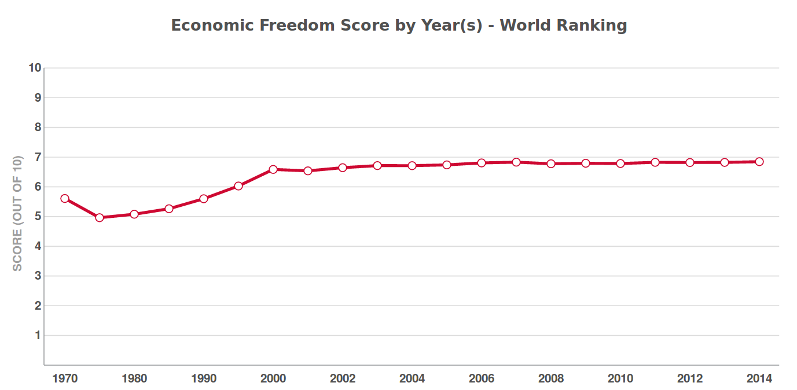

https://facebookincubator.github.io/prophet/
We Aren’t the World - Joe Henrich and his colleagues are shaking the foundations of psychology and economics—and hoping to change the way social scientists think about human behavior and culture: https://psmag.com/social-justice/joe-henrich-weird-ultimatum-game-shaking-up-psychology-economics-53135
One example: https://www.youtube.com/watch?v=IRAkz13cpsk
http://www.humanrightsdata.com/

