**dimitrisss Appendix**

First of all, we need to add the correct module to each router. The one we will need for our case is the WIC-2T, which will give us two serial ports. In order to add the module, we need to make sure that the switch is off and to remember in which place we will put the module because it will make a difference for the configuration later. We continue to do that for all the routers.

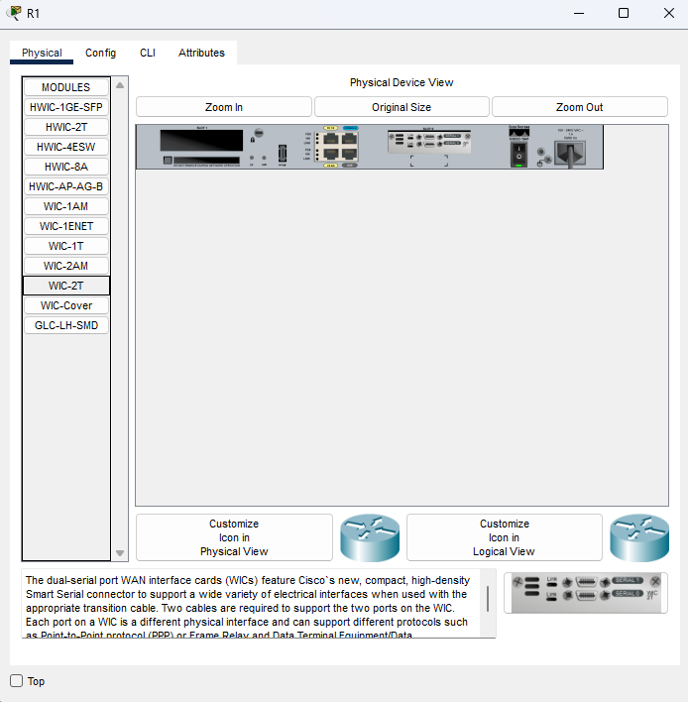

Then we will connect the PCs to the switches by using straight-copper Ethernet.

Photo

After that, we will connect the switch to the router again using the straight-copper Ethernet cable. We will use the Fa0/0 port from the router and the port Fa0/1 from the switch.

photo

Now it's time to connect the routers all together, and we will use the serial interfaces that we added before to the routers. In order to connect the routers, we will need a special cable called Serial DCE. I should also mention that it is important to remember what serial is connected to the router because it plays a crucial role in the configuration.

photo

R1:

Now we will need to configure R1, our main router. First, we will go to cla and add the commands "line con 0" and "logg syn" in order not to get live updates for the router and be challenging to see.

photo

Then we need to change the name of the router, and we will do that by writing this command: "Host R1"

Photo

***We do the same for the other Routers***

**Now we will configure the f0/0 and the serial for each router**

**R1:**

After that, we will need to configure the port Fa0/0 on the router.

Photo

Now we do the S0/0/0 port

Now S0/0/1 port

**R2:**

will configure the port Fa0/0 on the router.

Now we do the S0/0/0 port

Now S0/0/1 port

**R3:**

will configure the port Fa0/0 on the router.

Now we do the S0/0/0 port

Now S0/0/1 port

**R4:**

will configure the port Fa0/0 on the router.

Now we do the S0/0/0 port

Now S0/0/1 port

**R5:**

will configure the port Fa0/0 on the router.

Now we do the S0/0/0 port

Now S0/0/1 port

**Now let's talk about OSPF, the following photos are the config for OSPF.**

R1:

 R3:

R4:

 R5:

*WE haven’t finished with OSPF yet we will need to add the VLANS Ips later…*

**Now lets configure the Switches**

First we do the following

1. We add the command line con 0 and change the name of the switch

1. Then we shut up all the lines and anable only those that will use

(I forgot to get a crennshot of that|)

Command: int range f0/1-24

***We do that for all switches***

**Now lets add the vlans:**

**S1:**

Add vlans

Ans now assign ports

**S2:**

Add vlans

Ans now assign ports

**S3:**

**S4:**

**S5:**

**Now lets configure the routers for the vlans**

**R1:**

**R3:**

**R4:**

**R5:**

**Now its time to add the Vlans on the OSPF**

**R1:**

**R2:**

**R3:**

**R4:**

**R5:**

**Now lets configure the DHCP**

**R1:**

**R2:**

**R3:**

**R4:**

**R5:**

**Now lets put the ACL**

**EXAMPLE**

***YOU CAN SEE ANALYTICAL ALL THE ACCESS LISTS HERE:***



**Now lets talk about wireless**

We will use two of those in each branch.

This is the config for the public

This is the config for the private

The config for the mobile devices (Public)

The config for the Laptop that is connected to the secure network

First of all, we need to change the module and add a wifi card to the laptop

And then this is the config

Now I will provide you with screenshots of the running-configuration of each router:

**R1:**

**R2:**

**R3:**

**R4:**

**R5:**

**Now some test to check if it is working**

**Here is vlan20 to vlan 20**

**Now Vlan10 to Vlan 20**

**vlan20 to vlan30**

**vlan40 to vlan 40**

