Laboratory for Maritime Transport

Economics of Maritime Transport III: Environmental and Safety Analysis

**Operational Planning of Oil Spill management in the tactical level**

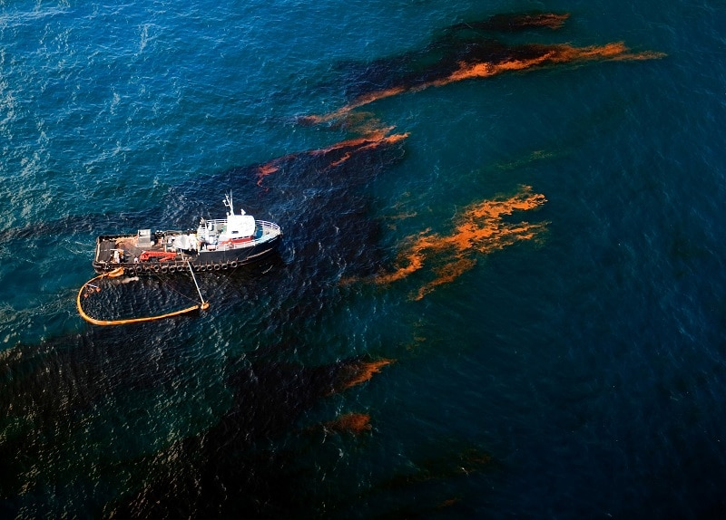

**Authors:**

Nikolaos Kougiatsos, N.A.M.E (NTUA)

Dimitris Tsoumpelis, N.A.M.E (NTUA)

Dimitris Lygnos, N.A.M.E (NTUA)

**February 2020**

**ABSTRACT**

**Operational Planning of Oil Spill management in the tactical level**

**Nikolaos Kougiatsos, Dimitris Tsoumpelis and Dimitris Lygnos**

**School of Naval Architecture and Marine Engineering**

**National Technical University of Athens, Greece**

In this paper, both the environmental consequences and the means for the suppression of a potential oil spill are discussed. Moreover, a genetic algorithm for optimizing the operational procedure in such cases is proposed in the following paragraphs.

**INTRODUCTION**

Nowadays, the trend of maximizing ships’ tanks’ capacity by simultaneously reducing their speed can sometimes lead to unpleasant outcomes. In the case of tankers, the reduced speed means more time outside of port in an unpredictable and sometimes dangerous environment. At the same time, the increase in oil tanks’ capacity leads to an overall greater risk assumed in case of ship loss or capsizing.

Oil spills at sea have been happening over the course of previous years at an overall declining rate either due to ship collisions or due to grounding. Some of them had grave environmental and financial consequences like in the case of Amoco Cadiz (1978) [1] where 220880 m3 of oil were approximately spilled outside of the coast of Britanny, France. It is estimated that the cost of the lost payload was around $25 million and a total of $85.2 million was ordered to Amoco Corp by a federal judge as a compensation to the community 10 years after the accident [2].

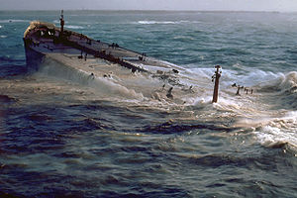

Fig.1 The sinking of Amoco Cadiz (1978) [1]

As one can see from history, preventative measures are taken after the accidents themselves. This also happened in the case of MARPOL where a total of six annexes, namely:

Annex I Prevention of pollution by oil &oily water (1983)

Annex II Control of pollution by noxious liquid substances in bulk (1987)

Annex III Prevention of pollution by harmful substances carried by sea in packaged form (1992)

Annex IV Pollution by sewage from ships (2003)

Annex V Pollution by garbage from ships (1988)

Annex VI Prevention of air pollution from ships (2005)

, have been established to prevent environmental pollution induced by ships. The measures described in MARPOL are in the form of ship design instructions addressed to the naval architect or the shipyard stuff and aim in the minimization of oil discharge into the ocean and marine pollution in general.

**How does an oil spill develop in time?**

D. Tsoump

**OIL SPILL MANAGEMENT SYSTEMS & PROCEDURES**

Systems for oil spill suppression have been developed over the course of years such as skimmers, booms, oil dispersants, in situ burning, skimmer vessels, and bioremediation.

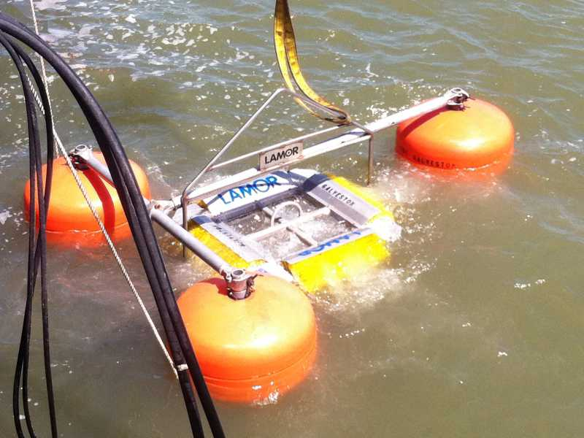

Fig.2 Skimmer (weir) in use

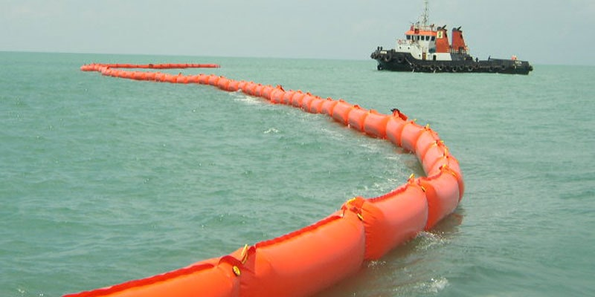

Fig.3 Boom in use

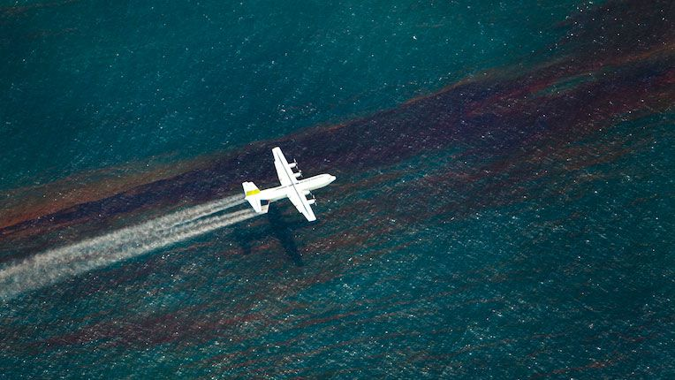

Fig.4 Oil dispersants deployment by air

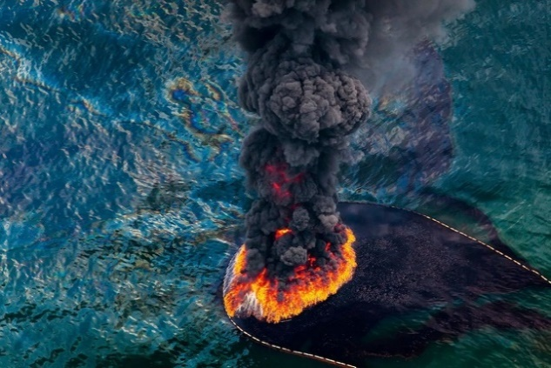

Fig.5 In situ burning of oil

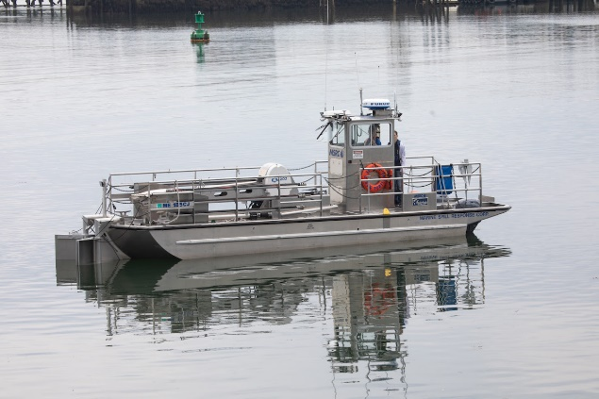

Fig.6 Skimmer vessel at sea

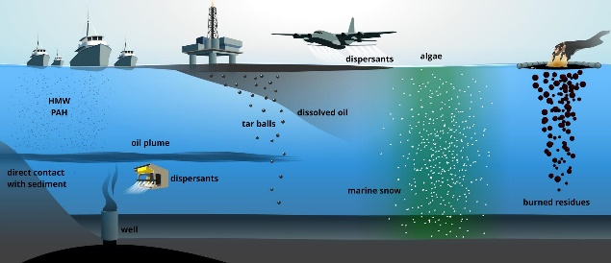

Fig.7 Bioremediation process

Although the existence of such systems and procedures is indeed valuable, the decision maker needs to take into account their limitations in usage as well as other financial criteria before deciding on the final distribution of equipment needed in the scenario in question.

D. Lygnos

**HOW TO CHOOSE THE APPROPRIATE EQUIPMENT**

N.Kougiatsos

**STATISTICAL DATA**

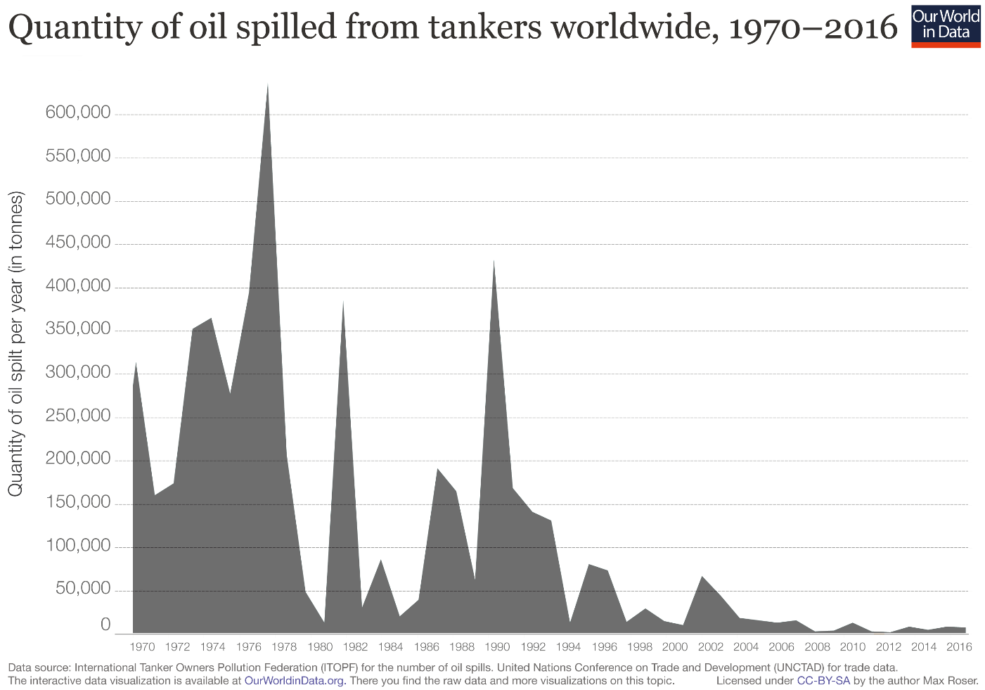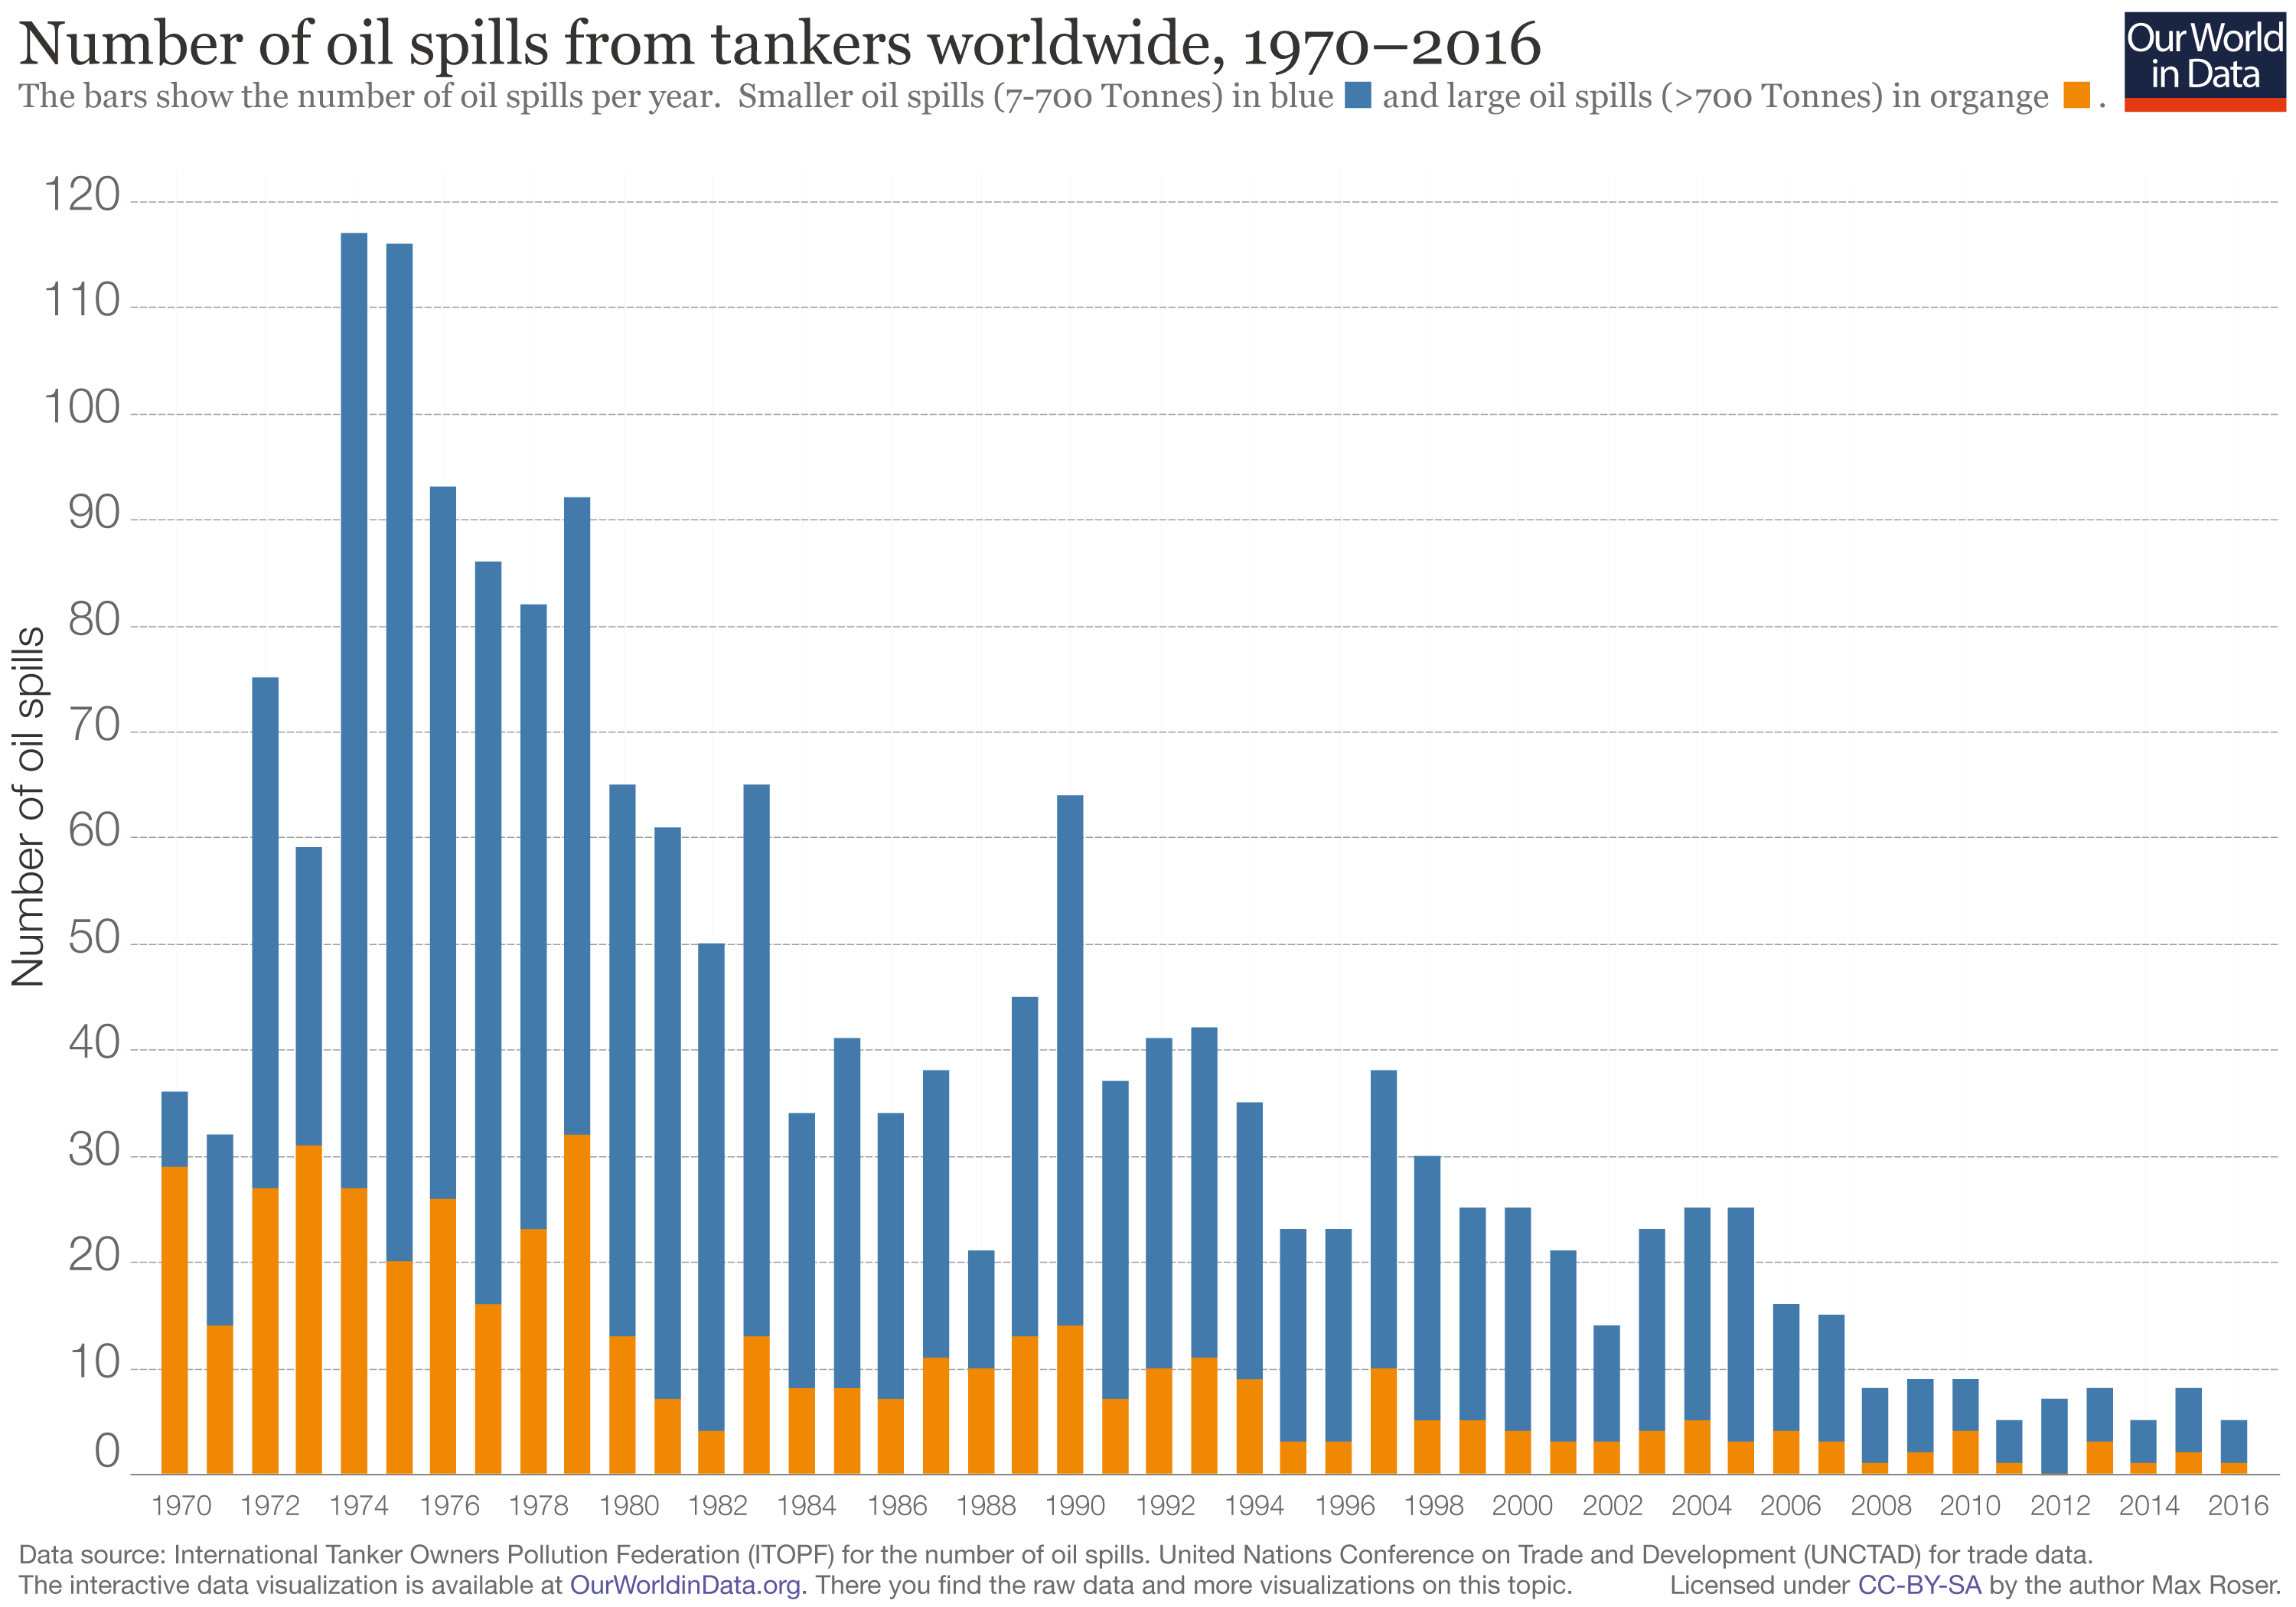

Fig.8 Sea Oil Spills in the years 1970-2016 [3]

D.Tsoump

**PROBLEM FORMULATION**

N.Kougiatsos

**GENETIC ALGORITHM**

N.Kougiatsos& D.Tsoump

**CASE STUDY – THE PRESTIGE OIL SPILL**

D.Lygnos

**RESULTS**

N.Kougiatsos& D.Tsoump& D.Lygnos

**CONCLUSION**

D.Tsoump& D.Lygnos

**REFERENCES**

**[1]** Wikipedia

**[2]** Amoco Must Pay $85 Million in French Oil Spill**,** [Los Angeles Times](https://www.latimes.com/archives/la-xpm-1988-01-12-mn-35089-story.html), 1988

**[3]** [Our World in Data](https://ourworldindata.org/oil-spills)