Diploma Projects Management App
Sprint Report
SoftWeb
Vlachos Dimitris 2641

Versions History
Date | Version | Description | Author
 | 1.0 |  | Vlachos Dimitris

Introduction
This document provides information concerning the 3 sprint of the project.

Purpose

Document Structure
The rest of this document is structured as follows. Section 2 describes out Scrum team and specifies the this Sprint's backlog. Section 3 specifies the main design concepts for this release of the project.

Scrum team and Sprint Backlog

Scrum team
Product Owner | Zarras Apostolos
Scrum Master | ....
Development Team | ....

Sprints
<List below the sprints that you performed and the user stories that have been realized in each Sprint>
Sprint No | Begin Date | End Date | Number of weeks | User stories
1 | 01/03/2023 | 29/03/2023 | 4 | U1, U2, S1, P1, P2
2 | 30/03/2023 | 27/04/2023 | 4 | P3, P4, S2, S3, S4
3 | 28/04/2023 | 17/05/2023 | 3 | P5, P6, P7, P8, P9

Use Cases
<Specify the concrete Use Cases that describe the interaction of the user with the applications, as derived from the abstract user stories. Give a UML Use Case diagram and the detailed use case descriptions.>

Create Account
Use case ID | UC1
Actors | Professor, Student
Pre conditions | -
Main flow of events | - The use case starts when the user hits button “Create Account”  - The application requests role, username and password  - User gives role, username and password  - User hits “Create” button  - The application creates a new user with provided credentials
Alternative flow 1 | If the user doesn’t provide some of the info, the application shows an appropriate message and the use case starts from the beginning
Alternative flow 2 | If the user provides a username that already exists, the application shows an appropriate message and the use case starts from the beginning
Alternative flow 3 | If the user hits the “Cancel” button, the use case stops and the application shows the initial screen.
Post conditions | The application has created a new user

Login
Use case ID | UC2
Actors | Professor, Student
Pre conditions | The application has at least one user registered
Main flow of events | - The use case starts when the user hits “Login” button  - The application requests username and password  - User gives username and password  - User hits “Login” button  - The application logins the user  - The application shows to user the appropriate menu depending on his role
Alternative flow 1 | If the user doesn’t provide some of the info, the application shows an appropriate message and the use case starts from the beginning
Alternative flow 2 | If the user provides a username and a password that don’t match, the application shows an appropriate message and the use case starts from the beginning
Alternative flow 3 | If the user hits the “Cancel” button, the use case stops and the application shows the initial screen.
Post conditions | The application has logged in a user and shows the appropriate menu

Set profile info
Use case ID | UC3
Actors | Professor, Student
Pre conditions | - The application has at least one user registered  - The application has one user logged in
Main flow of events | - The use case starts when the user hits the button “Edit profile”  - The application request for profile info depending on user’s role  - User gives the provided info  - The application updates users info
Alternative flow 1 | If the user doesn’t provide some of the info, the application shows an appropriate message and the use case starts from the beginning
Alternative flow 2 | If the user hits the “Cancel” button, the use case stops and the application shows the initial screen.
Post conditions | Application has updated user’s info

Show list of subjects
Use case ID | UC4
Actors | Student
Pre conditions | - The application has at least one student registered  - The application has one student logged in
Main flow of events | - The use case starts when the user hits the button “List of subjects”  - The application shows the list of available subjects
Alternative flow 1 | -
Alternative flow 2 | -
Post conditions | Application has showed the list of available subjects

Show description
Use case ID | UC5
Actors | Student
Pre conditions | - The application has at least one student registered  - The application has one student logged in  - The application has showed the list of subjects
Main flow of events | - The use case starts when the user hits the button “Description”  - The application shows the description of the selected subject
Alternative flow 1 | -
Alternative flow 2 | -
Post conditions | Application has showed the description of a subject

Apply for a subject
Use case ID | UC6
Actors | Student
Pre conditions | - The application has at least one student registered  - The application has one student logged in  - The application has showed the list of subjects  - The application has showed the description of a subject
Main flow of events | - The use case starts when the user hits the button “Apply”  - The application checks that the user has set profile information  - The application adds an application object to the list of subject  - The application shows a message to user for success
Alternative flow 1 | If the application fails because the subject is not available anymore, the application shows an appropriate message.
Alternative flow 2 | If the user hasn’t set his profile information, the application shows an appropriate message.
Post conditions | The user has applied for a subject

Show list of available subjects
Use case ID | UC7
Actors | Professor
Pre conditions | - The application has at least one professor registered  - The application has one professor logged in
Main flow of events | - The use case starts when the user hits the button “List of available subjects”  - The application shows the list of available subjects
Alternative flow 1 | -
Alternative flow 2 | -
Post conditions | Application has showed the professor’s list of available subjects

Add subject
Use case ID | UC8
Actors | Professor
Pre conditions | - The application has at least one professor registered  - The application has one professor logged in  - The application has showed the professor’s available subject list
Main flow of events | - The use case starts when the user hits the button “Add subject”  - The application requests title and objectives  - Professor gives title and objectives  - The application add a new subject to the list
Alternative flow 1 | If the user doesn’t provide some of the info, the application shows an appropriate message and the use case starts from the beginning
Alternative flow 2 | If the user hits the “Cancel” button, the use case stops and the application shows the list of available subjects
Post conditions | Professor has added a new subject

Delete subject
Use case ID | UC9
Actors | Professor
Pre conditions | - The application has at least one professor registered  - The application has one professor logged in  - The application has showed the professor’s available subject list  - The professor has added at least one subject
Main flow of events | - The use case starts when the user hits the button “Delete”  - The application deletes the subject
Alternative flow 1 | -
Alternative flow 2 | -
Post conditions | Professor has deleted one subject from the list of available subjects

Show list of applications
Use case ID | UC10
Actors | Professor
Pre conditions | - The application has at least one professor registered  - The application has one professor logged in  - The application has showed the professor’s available subject list  - The professor has added at least one subject
Main flow of events | - The use case starts when the user hits the button “List of applications”  - The application shows the list of applications for that subject
Alternative flow 1 | -
Alternative flow 2 | -
Post conditions | The application has showed the list of applications for a subject

Assign subject
Use case ID | UC11
Actors | Professor
Pre conditions | - The application has at least one professor registered  - The application has one professor logged in  - The application has showed the professor’s available subject list  - The professor has added at least one subject  - The subject has at least one application  - Application has showed the list of applications
Main flow of events | - The use case starts when the user hits on of button “Assign by ” buttons  - The application assigns the subject by the selected algorithm  - The application shows a message with the assignee  - The application shows the list of unassigned subjects
Alternative flow 1 | If the user hits the “Cancel” button, the use case stops and the application shows the list of available subjects
Alternative flow 2 | -
Post conditions | Professor has assigned a subject to a student

Show list of assigned subjects
Use case ID | UC12
Actors | Professor
Pre conditions | - The application has at least one professor registered  - The application has one professor logged in
Main flow of events | - The use case starts when the user hits the button “List of assigned subjects”  - The application shows the list of assigned subjects
Alternative flow 1 | -
Alternative flow 2 | -
Post conditions | The professor has showed the list of assigned subjects

Set grades
Use case ID | UC13
Actors | Professor
Pre conditions | - The application has at least one professor registered  - The application has one professor logged in  - Professor has assigned at least one subject  - The application has showed the list of assigned subjects
Main flow of events | - The use case starts when the user hits the button “Set grades”  - The application requests implementation, report and presentation grade  - Professor gives implementation, report and presentation grade  - Professor hits the button “Set grades”  - The application updates the grades to subject
Alternative flow 1 | If the user doesn’t provide some of the info, the application shows an appropriate message and the use case starts from the beginning
Alternative flow 2 | If the user hits the “Cancel” button, the use case stops and the application shows the list of assigned subjects
Post conditions | The user has updated the grades for a subject

Calculate grade
Use case ID | UC14
Actors | Professor
Pre conditions | - The application has at least one professor registered  - The application has one professor logged in  - Professor has assigned at least one subject  - The application has showed the list of assigned subjects
Main flow of events | - The use case starts when the user hits the button “Set grades”  - Professor hits the button “Calculate grade”  - The application calculates the overall grade for subject
Alternative flow 1 | If the user hits the “Cancel” button, the use case stops and the application shows the list of assigned subjects
Alternative flow 2 | -
Post conditions | Professor has calculated the grade for a subject

Design

Architecture
<Specify the overall architecture for this release in terms of a UML package diagram.>
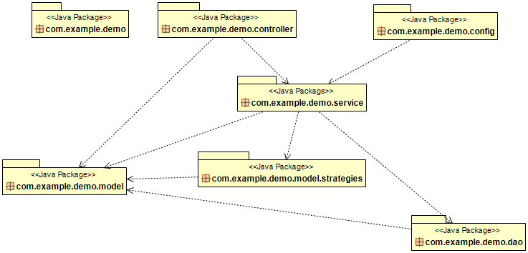
Εικόνα 1Package diagram

Design
<Specify the detailed design for this release in terms of UML class diagrams.>
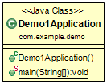

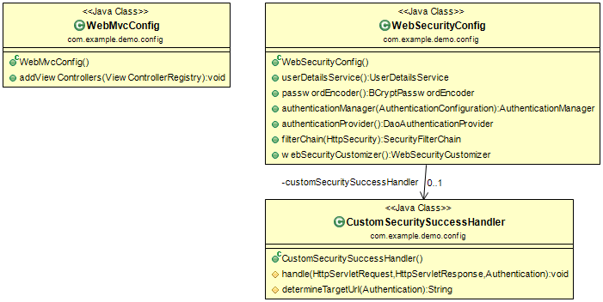
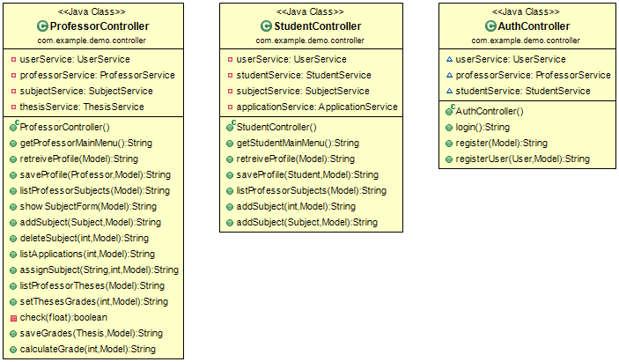

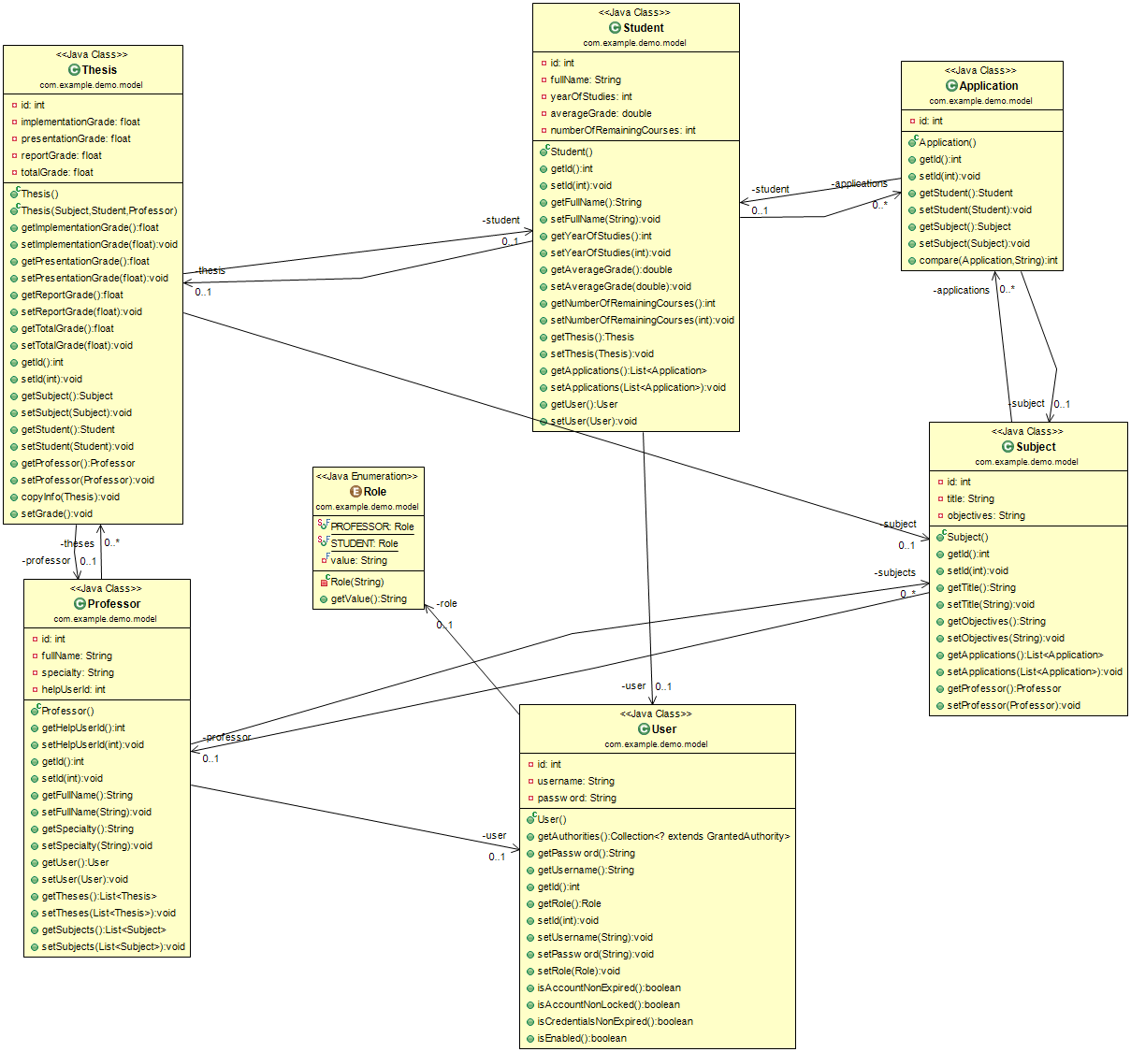

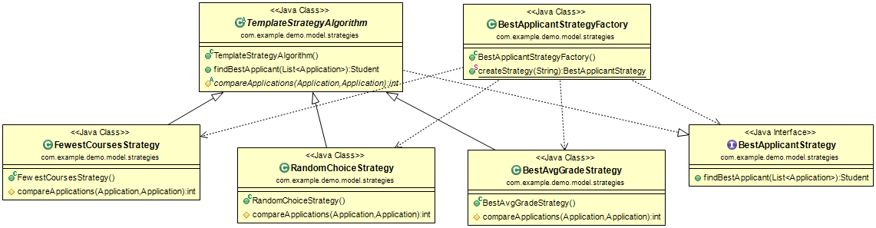
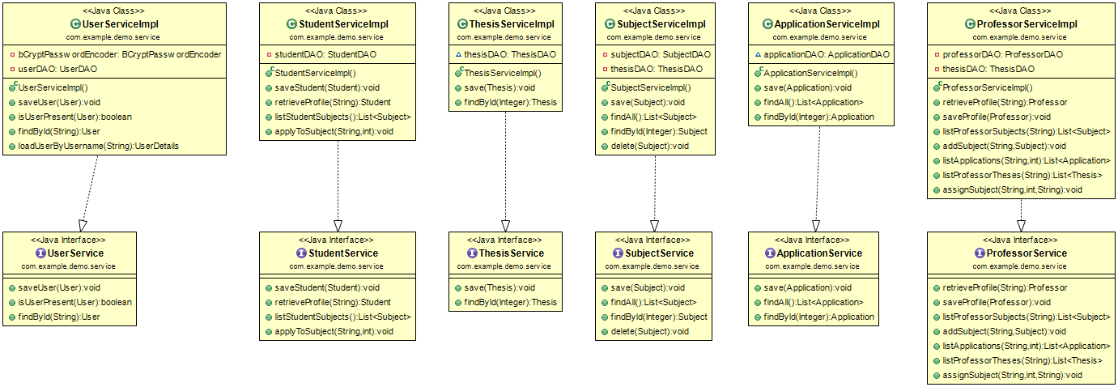

<Document the classes that are included in this release in terms of CRC cards according to the template that is given below.>

Class Name: Demo1Application
Responsibilities:  - Entry point of web application | Collaborations:

Class Name: AuthController
Responsibilities:  - Register new user  - Authenticate user | Collaborations:  - com.example.demo.model.User  - com.example.demo.model.Professor  - com.example.demo.model.Student  - com.example.demo.service.UserService  - com.example.demo.service.ProfessorService  - com.example.demo.service.StudentService

Class Name: ProffessorController
Responsibilities:  - Handles requests from View  - Uses services to reply to request for professor:  - Return main menu  - Edit profile  - Retrieve list of subjects  - Add subject  - Retrieve list of applications  - Assign a subject to student  - Retrieve list of assigned subjects  - Set grades for a thesis  - Calculate total grade for a thesis | Collaborations:  - com.example.demo.model.Application  - com.example.demo.model.Professor  - com.example.demo.model.Subject  - com.example.demo.model.Thesis  - com.example.demo.model.User  - com.example.demo.service.ProfessorService  - com.example.demo.service.SubjectService  - com.example.demo.service.ThesisService  - com.example.demo.service.UserService

Class Name: StudentController
Responsibilities:  - Handles requests from View  - Uses services to reply to request for student:  - Return main menu  - Edit profile  - Retrieve list of subjects  - Retrieve description  - Apply to a subject | Collaborations:  - com.example.demo.model.Student  - com.example.demo.model.Subject  - com.example.demo.model.User  - com.example.demo.model.Application  - com.example.demo.service.ApplicationService  - com.example.demo.service.StudentService  - com.example.demo.service.UserService  - com.example.demo.service.SubjectService

Class Name: ApplicationDAO
Responsibilities:  - Saves to database entities of Application  - Retrieves from database entities of Application | Collaborations:  - com.example.demo.model.Application

Class Name: ProfessorDAO
Responsibilities:  - Saves to database entities of Professor  - Retrieves from database entities of Professor | Collaborations:  - com.example.demo.model.Professor

Class Name: StudentDAO
Responsibilities:  - Saves to database entities of Student  - Retrieves from database entities of Student | Collaborations:  - com.example.demo.model.Student

Class Name: SubjectDAO
Responsibilities:  - Saves to database entities of Subject  - Retrieves from database entities of Subject | Collaborations:  - com.example.demo.model.Subject

Class Name: ThesisDAO
Responsibilities:  - Saves to database entities of Thesis  - Retrieves from database entities of Thesis | Collaborations:  - com.example.demo.model.Thesis

Class Name: UserDAO
Responsibilities:  - Saves to database entities of User  - Retrieves from database entities of User | Collaborations:  - com.example.demo.model.User

Class Name: Application
Responsibilities:  - Stores info for a Student application  - Compares two applications based on:  - Average  - Remaining courses | Collaborations:

Class Name: Professor
Responsibilities:  - Stores info for a professor | Collaborations:  - Com.example.model.User

Class Name: Role
Responsibilities:  - Enum for the role of users | Collaborations:

Class Name: Student
Responsibilities:  - Stores info for a student | Collaborations:

Class Name: Subject
Responsibilities:  - Stores info for a subject | Collaborations:

Class Name: Thesis
Responsibilities:  - Stores info for a thesis  - Calculates the total grade of a thesis | Collaborations:

Class Name: User
Responsibilities:  - Stores info for a user | Collaborations:

Class Name: BestApplicantStrategy
Responsibilities:  - interface for best applicant functionality | Collaborations:  - com.example.demo.model.Application  - com.example.demo.model.Student

Class Name: BestApplicantStrategyFactory
Responsibilities:  - Factory class to create object of BestApplicantStrategy type | Collaborations:

Class Name: BestAvgGradeStrategy
Responsibilities:  - Implements BestApplicantStrategy interface using average grade | Collaborations:  - com.example.demo.model.Application

Class Name: FewestCoursesStrategy
Responsibilities:  - Implements BestApplicantStrategy interface using remaining courses | Collaborations:  - com.example.demo.model.Application

Class Name: RandomChoiceStrategy
Responsibilities:  - Implements BestApplicantStrategy interface using randomness | Collaborations:  - com.example.demo.model.Application

Class Name: TemplateStrategyAlgorithm
Responsibilities:  - Class which is a Template for the search part of strategy algorithms | Collaborations:  - com.example.demo.model.Application  - com.example.demo.model.Student

Class Name: ApplicationService
Responsibilities:  - Interface for Application functionality  - Save application  - Retrieve all applications  - Find application by id | Collaborations:  - com.example.demo.model.Application

Class Name: ApplicationServiceImpl
Responsibilities:  - Implements ApplicationService | Collaborations:  - com.example.demo.dao.ApplicationDAO  - com.example.demo.model.Application

Class Name: ProfessorService
Responsibilities:  - Interface for Professor service functionality  - Retrieve profile by username  - Save profile  - Retrieve professor’s available subjects  - Add subject  - Retrieve list of applications  - Retrieve theses  - Assign subject | Collaborations:  - com.example.demo.model.Application  - com.example.demo.model.Professor  - com.example.demo.model.Subject  - com.example.demo.model.Thesis

Class Name: ProfessorServiceImpl
Responsibilities:  - Implementation of ProfessorService | Collaborations:

Class Name: StudentService
Responsibilities:  - Interface for student service functionality  - Retrieve profile by username  - Save profile | Collaborations:  - com.example.demo.model.Student  - com.example.demo.model.Subject

Class Name: StudentServiceImpl
Responsibilities:  - Implementation of StudentService | Collaborations:  - com.example.demo.dao.StudentDAO  - com.example.demo.dao.SubjectDAO  - com.example.demo.model.Student  - com.example.demo.model.Subject

Class Name: SubjectService
Responsibilities:  - Interface for Subject service functionality  - Save subject  - Retrieve all subjects  - Find subject by id | Collaborations:  - com.example.demo.model.Subject

Class Name: SubjectServiceImpl
Responsibilities:  - Implementation of SubjectService | Collaborations:  - com.example.demo.dao.SubjectDAO  - com.example.demo.dao.ThesisDAO  - com.example.demo.model.Subject  - com.example.demo.model.Thesis

Class Name: ThesisService
Responsibilities:  - Interface for Thesis service functionality  - Save thesis  - Find thesis by id | Collaborations:  - com.example.demo.model.Thesis

Class Name: ThesisServiceImpl
Responsibilities:  - Implementation of ThesisService | Collaborations:  - com.example.demo.dao.ThesisDAO

Class Name: UserService
Responsibilities:  - Interface for user service functionality  - Save user  - Checks if user is present  - Find user by id  - Loads user info | Collaborations:  - com.example.demo.model.User

Class Name: UserServiceImpl
Responsibilities:  - Implementation of UserService | Collaborations:  - com.example.demo.dao.UserDAO  - com.example.demo.model.User

