Prototyping

Based on Jeremy’s initial codes, Alex has in mid Feb. developed a prototype that has realised all the basic functionalities of a tower defense game. We may later insert stories and adjust assets to rich the content.
The Github link for our codes of this software: https://github.com/matthewsja/asp8_TowerDefense/
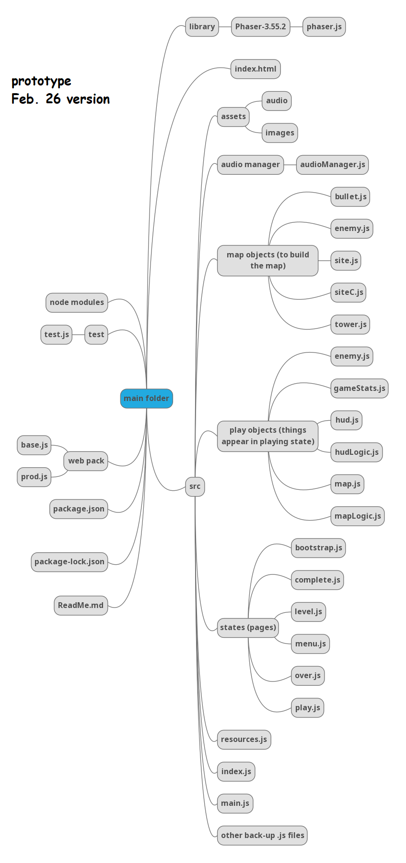 | Here is the structure of the prototype:  All the files are classified into folders so that their arrangement is meaningful.

