Individual reflection

Name: Freda Xiaoyun Yu
Tasks I have done:
Research – Literature review; Market analysis;
SWOT writing;
Questionnaires making; Questionnaires spreading; Data analysis; User testing documents making; User feedback tracking; From user feedback to user story to epics break down;
Gantt charts making; Mind map making; procedure diagram making;
Main story proposing; Page order proposing;
Assets making – composing background music, drawing pictures;
Documents in Github arrangement;
Accessibility testing; Usability testing
Midterm paper writing (>60%); Final-term paper writing (>60%);
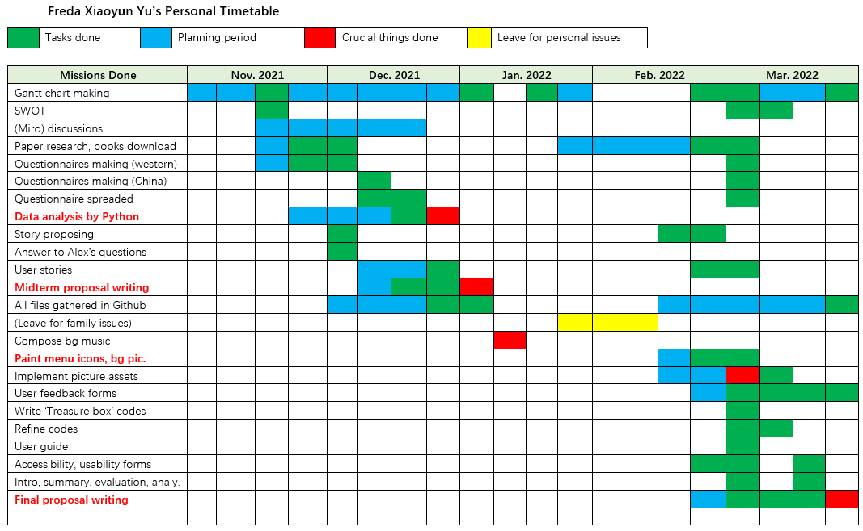
Team Working Evaluation
I deem myself to be capable of completing a big task, but previously I was used to working all the tasks individually. This time I meet such a wonderful opportunity to know the experienced group members and work with them. As I don’t have much experience in computer scale, I should learn from them.
My Strengths | My Weaknesses
- My teammates mainly have programming skills, but I have the ability to arrange tasks from a big scale. Previously when I firstly joined this group, I thougt they would be more experienced than me in task arrangement especially for game project, but after I asked moderately in group, no one responded me. So then I acted as the peripheral-things-manager to make all the plans and documents.  - They don’t have as much ability as I have in data analysis. I have done 3 projects in high school, all using statistics. And I have attended data science courses. Therefore, I am experienced in data handling.  - I have the good habit for backing up files very often. Now it’s the first time that I use Github, and I enjoy using it.  - I’m good at user psychology. I can use emoji to raise the attention of teammates in group chat. I can phrase a good message in order to collect more users to fill in our survey. My questionnaire questions are not too long so users can quickly understand without confusion.  - I am active in group, and I am able to undertake heavy responsibilities. | - I am a stubborn person who will work according to only one route, and I don’t like others to change my work. It’s lucky for me that teammates are all lenient and they support my ideas, so I don’t need to change a lot. It’s time for me to be regretful at the beginning that I was not adaptable to this new group. Otherwise I could have learned more from others.  - I misundestood some technical terms ‘Prototype’, ‘Requirements’, etc., which leads to a low score for our midterm proposal. I should gather teammates to proofread the final.  - My teammates indeed have a much higher ability in programming codes than me. I have learned for the following:  -- Search online for related libraries and study how to use them. There are specific functions and classes for us to reuse.  -- UML and Specification. I have known the format.  -- From the specification, we should separate the files to different folders to form a good hierachy and to maintain a low module coupling level.  -- We can even only write one class in one file to maintain a high module cohesion level.  -- Use exception handling codes to avoid vague bugs.  -- The whole structure of a game software should include many types of files: index.html, index.js, other .js files, a test.js file for debugging, etc.  -- I still need to learn how to build a node.js software, though now I am fluent in using node to run the codes.

Evaluation of own work referencing original proposal
- I have helped our team to successfully built an educational TD game. (1) Educational: the story of environment-protection is raised by me; I proposed the idea of the happy ending page to teach people to give up weapons; I have read lots and lots of research papers for related realm; I have contacted familiar friends who work in education area for suggestions; (2) Game development: I have no experience, but I can understand the initial prototype codes and then make updates to them; I can use Github; I am the art designer; I wrote the bg music; I can do some of the testings; (3) Data analysis: my skills are important for our team to get user feedbacks timely and continuously.
- Agile project: (1) I should plan more when I leave for personal issues; (2) I have notified members whenever I’ve written a new file; (3) I should allocate (mid/) final proposal sub-sections to each individual, so my tasks wouldn’t be heavy; (4) our project goes rather straightforward without too much changes, but I should be flexible in mind for any sudden change.

