Agile Software Project
Oct 2021, Group 8 (Freda) Xiaoyun Yu

(Teammates: Please fill in the blanks with all of our files. I think the sections are enough for the midterm rubric. Also, I am writing the questionnaire and data analysis and user story part. Please write other parts, so we don’t overlap the work! Also I don’t know how to insert PDF files here. Cheers!! - Xiaoyun)

Backgrounds
The recent pandemic, though devastating, has opened a lot of opportunities for distance work and distance collaboration. Now is a better time than ever to be collaborating remotely, as, not only have the tools for this become more readily available, but we, as individuals, are no doubt more experienced and used to this kind of work and collaboration by now. We therefore have the chance to develop computer-related products further.

Specifically, we want to focus on ‘Tower Defense Games’. We hope to create a new TD Game that especially belongs to us.

Aims and Objectives
- To build a Tower Defense (TD) Game which operates on computers.
- To discover the process of making a video game when doing this game project; enjoy the whole process from design to managing.
- To involve all team members into this big task. To maximize the productivity of the team by using each individual’s advantages. Team members can learn from each other to improve their shortages.
- To fully understand the users’ psychology, then make a project which benefits the users.
- For each team member, learn how to manage time and deadlines for each sub-task.
- Learn how to cooperate a task – platforms, meeting arrangement, etc.
- Learn how to do version-controls for a project using git operations or platforms.
- Experience the process to do simiple statistics – questionnaire, data gathering, mathematical analysis, draw conclusions, make expectations.

Background Research

Academic Research (& some Market Research)
- According to Rummell, they are adapting AI to play tower defense games. His start point is to solve the already existing game, instead of creating such a game. However, he acknowledges that AI cannot solve tower defense game as well as a human can do. This may draw a conclusion that our tower defense game encourages creation which differs from other game categories; and also it attracts users by its uniqueness and enjoyment when creating their own arts.
- According to Groeschel and Schäfer, TD games are widely seen in mobile apps. We have seen types of Revenue Models in mobile app design, which may be helpful when we consider entering into the market.
- According to Yu Du, Jian Li, Xiao Hou, Hengtong Lu, etc, they had developed a method to automatically generate levels for one TD game, which means our competitors are faster to generate a new level than us.
- According to Vasudevan Janarthanan, there are indeed serious games with educational theme. He mentions that, playing games can improve players’ self esteem. We think it’s beneficial in both ways – for us, it helps us to attract users since they enjoy such a game; and for users, they indeed are emotionally healthy when playing our game.

Book Reading
- From the books, we know:
The classification of requirements:
(1) Functionality (2) Performance (3) External interface – a. System interface; b. User interface; c. Hardware interface; d. Software interface; e. Communication interface; f. Memory constraints; g. Operations; h. Site adaptation requirements (4) Design constraints (5) Quality attribute.

Market Research

Challenges of working:

Stakeholders:
- End-users. Which may contain: western country users; eastern country users; adults; children; students; leaders; etc.
- Classmates in UoL.
- Teachers in UoL. Of course teachers hope to see the result of our project.
- Production company.
- Competitors in game industry who also make tower defense games.

Timescale of Work
Please refer to the Gantt Chart uploaded here:

Requirements
Requirement analysis tasks:

Deeply discribe the functionality and performance of the software:
Limitations of this software:
User requirements:
Effectiveness:
Systematic elements of this project:
Allocation of info and functionality to elements:

------------------------
Player Experience:
‘A game is an artificial system for generating experieces. ’ - Tynan Sylvester, Designing Games

Fun:
‘We create an artifact that a play interacts with, and cross our fingers that the experience that takes place during that interaction is something they will enjoy. ’ - Jesse Schell, The Art of Game Design

Player Motivations (we need to meet these criteria):
- Master & creativity: We can leave space for users, such as only teaching them a little.
- Progression & power: We can encourage them when they progress to some milestones. Encourage them often. Admire them when they have powerful weapons. Reward them (with stars, weapons, characters) often.
- Complexity & puzzles: We can progressively add difficulties to the game.
- Elegance & aesthetics: We can draw beautiful shapes of maps, ex. in symmetry, with meaningful shapes, with harmonious colours and designs.

Use Case

Formative Testing and Evaluation

Prototyping
Strengths:
Weaknesses:

UML

Basic design and ideas
We should consider these factors when writing codes:
- Damage per second: We can calculate this by using Damage per hit * Attacks per second. Fast / slow may have different pros and cons.
- 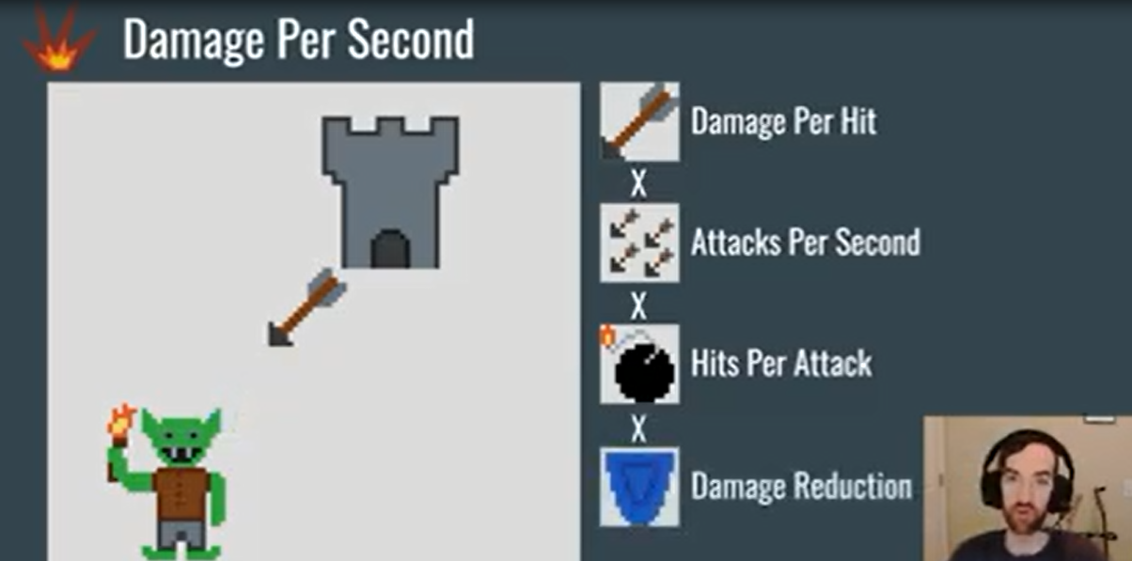
- The shape of maps should be both aesthetic and reasonable (for putting towers).
- Targeting:
- 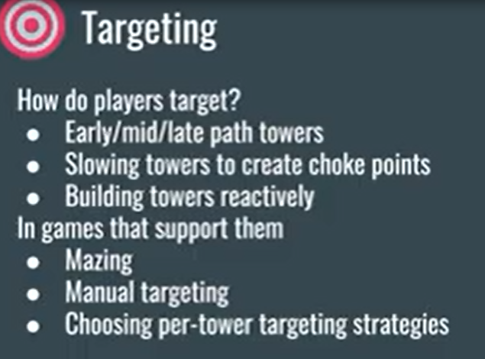
\ 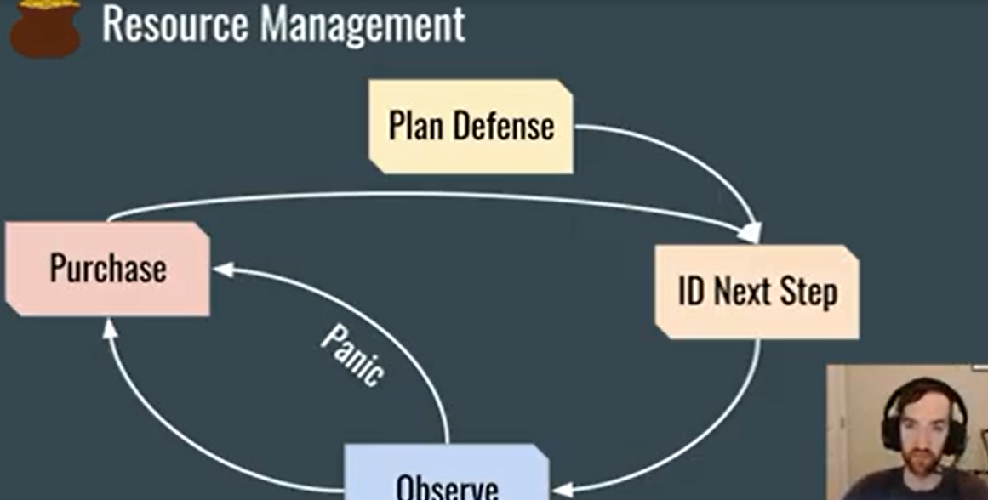
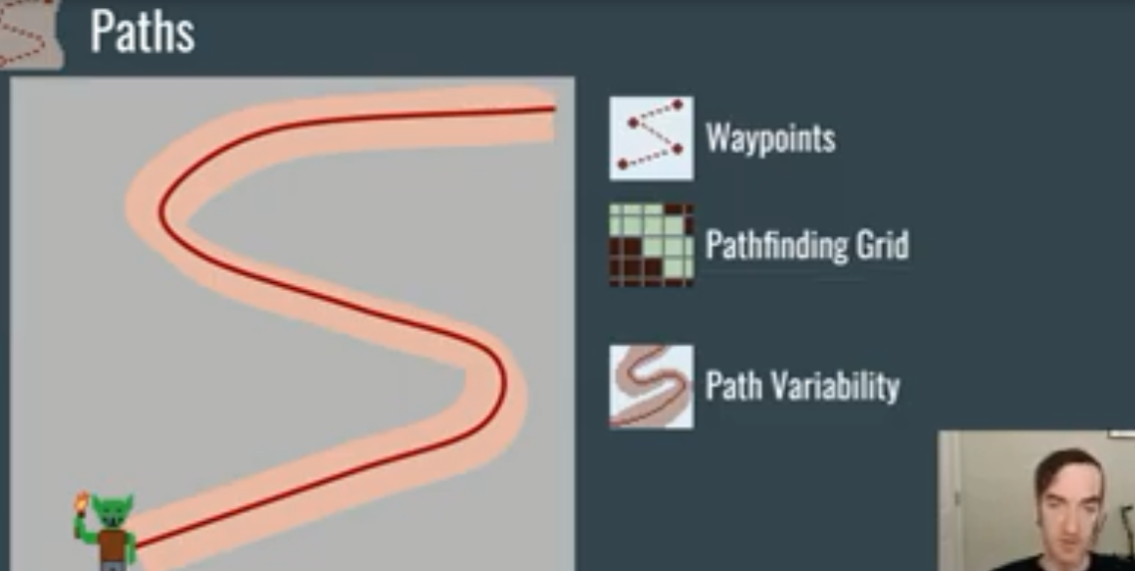

Development Process (with Iterations and Expectations)

Assumption Tests
User tests:
Accessibility testing:
Usability testing:

Evaluation Techniques
The current state:
Expectations:

P. A. Rummell, "Adaptive AI to play tower defense game," 2011 16th International Conference on Computer Games (CGAMES), 2011, pp. 38-40, doi: 10.1109/CGAMES.2011.6000357.
Michael Groeschel, Tim Schäfer, “Analysis of Mobile App Revenue Models Used in the Most Popular Games of the Tower Defense Genre on Google Play”, Asian Journal of Computer and Information Systems (ISSN: 2321 – 5658) Volume 08– Issue 01, February 2020.
Yu Du, Jian Li, Xiao Hou, Hengtong Lu, et al, “Automatic level Generation for Tower Defense Games”, ITNEC 2019.
V. Janarthanan, "Serious Video Games: Games for Education and Health," 2012 Ninth International Conference on Information Technology - New Generations, 2012, pp. 875-878, doi: 10.1109/ITNG.2012.79.

