Market Analysis
Jan. 2022, Xiaoyun Yu

According to Parade website https://parade.com/1056226/marynliles/best-tower-defense-games/ , the top 30 TD games include: Bloons TD 6, Kingdom: Two Crowns, Minion Masters, Bad North, Frontline Zed, Orcs Must Die! 2, Dig or Die, etc.

 | Theme | 2D / 3D, angle of view | Design | Inspirations
1. Bloons TD 6 | Cute, War | Combined / 2D, still | Cute | Online cooperation; Exaggerated weapon effects
2. Kingdom: Two Crowns | Aesthetic | 2D, still | Story-telling; oil painting; Adventure | The paintings are extremely beautiful; no routes for the maps;
3. Minion Masters | War | 3D, still | Simulation | Use lights and shades for each element
4. Bad North | War | 2D, moving | Grey; Viking; melancholic | Simple drawings
5. Frontline Zed | Zombie | 3D, moving | Dark; Simulation | Don’t learn from it! Too horific that it will be banned for teenagers.
6. Orcs Must Die! 2 | War, Monster | 3D, moving | Simulation | The drawings for the background.
7. Dig or Die | Cute | 2D, moving | Jumping | Actually it belongs to Jumping Games.
8. OTTTD: Over The Top Tower Defense | Cute | 3D, moving | High-tech | Towers can move.
9. Aegis Defenders | Cute | 2D, moving | Jumping | Actually it belongs to Jumping Games. Ancient gods become characters.
10. Sleep Tight | Cute | Combined, mostly 2D, moving | Shooting, story-involved | Colourful. Fun for kids.

According to Stream website the hottest-selling TD games -
 | Theme | 2D / 3D, angle of view | Design | Inspirations
Tribes of Midgard | Cute, Aesthetic | 3D, moving | Adventure, Christmas, Tribes, Simulation | Very suitable for kids. Story-telling.
The Riftbreaker | War, Alien | 3D, moving | Simulation | Noisy & Dark. Don’t learn from it.
Plants vs. Zombies GOTY Edition | Cute, Zombie | 2D, still | Cartoon, Casual | Specially written music, very relaxing, suitable for kids.
Creeper World 4 | Very gentle war | Combined, still | Strategy | The map shows the topography of the whole local place. It’s like the professional mission control room during a real war.
Mindustry | Pixel | 2D, still | Base-building, in grids | The weapon and attack designs are simple. It’s more like a puzzle game. The map is very big. In Morandi colours.
Kingdom Rush | Cute, War | 2D, moving | Casual, story-telling | Special bg music, cute characters although in war theme, bright, relaxing

Looking through the top-rated TD games, we find out that most are: (1) in cartoon theme; (2) colourful; (3) casual. We will also make similar features.
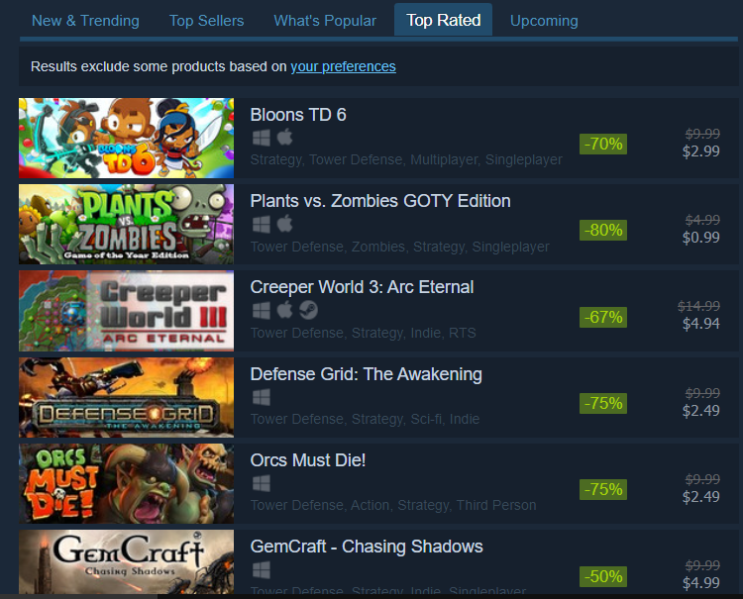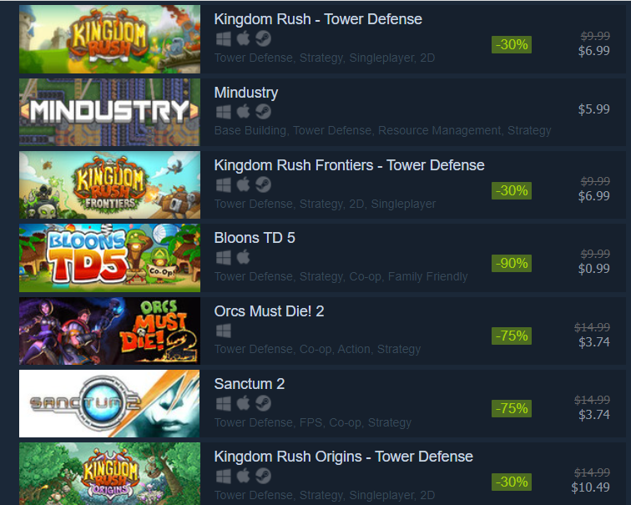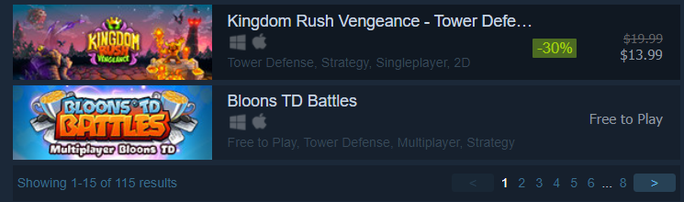

Our competitors’ advanages: (1) have designers who are good at drawing cartoon characters; (2) some of them have built 3D models for each character and the background; (3) are good at arranging the equipment library for towers and characters; (4) are cooperating with music-producing groups; (5) have a good team for propagation; (6) have a good system to arrange money profits from the users.

We must think about something unique that will lead us to win. We can: (1) just like Kingdom Two Crowns, we can have a very attractive story as the main clue; (2) don’t have to draw 3D characters, but should use artistic designs for simple drawings; (3) can win on the background music; (4) should expand our user groups, especially for the students group, so that we can earn money from them; (5) at the end of development, contact the main game platforms to have a test; (6) can win on the educational meanings.

