Phone call; questionnaire.

People tend to give us some information through phone calls, but not through questionnaires, especially when there are open questions that need them to write down words. We should construct as many multiple-choice questions as possible in our questionnaire.

For key stakeholders, we should take priority for them, like making phone calls periodically, and visiting their companies in person, etc.

State our members’ situations and changes for the plan.

‘The only real difference between games and reality is that the stakes are lower with games.’ (Koster, pp.34)

‘games serve as very fundamental and powerful learning tools.’ (Koster, pp.35)

‘Save the Jungle’ - Tower Defense Game

- ASP Group 8, Mar 2022

Contents

Background
Stakeholders
Planning & Research
Research & Novelty
Time Management & Process
People Management
Elements Break-down
Analysis
Feasibility Analysis
Risk Analysis
Prototyping & Iteration
Design
Technological Design
Aesthetic Design
Character Design
System Development
Evaluation
Processes
Product
Summary
Individual Reflection
Appendix
References

Background
Virus, fears, insulation. In 2022, the world is not yesterday. Nature has taken revenge back.
How we wish to turn the clock backwards, to the days when humans had not done such bad things to Nature! How we wish that the Nature is just like hundreds of years ago, when there were no greenhouse effects, loss of rainforests, and rise of sea levels. It’s time to reflect what we humans have done to the Natural environment. We need to apologize to Nature, apologize to the reason that has made the COVID-19 spread.

What if WE are the animals, and OUR ENEMY is human being?
Previously we had the idea to make an educational Tower Defense Game. Now we wish to implement such a story into our game. We set our game setting to be in the jungle or forest, where animals (and plants) build towers to defense against human beings’ invasion to the jungle.
Reasons we choose this story:
1. It is educational. Whoever plays the game, he or she would be largely educated by the environment-protection idea.
2. It is creative. The novelty for our main idea is that we think the partition settlement – animals as our side, and human beings as enemy – is innovative. Seldom has anyone thought of standing in the shoes of others, seldom has anyone considered he or she is the animal, and humans the group is another thing. Once we have changed our perspective to play the game, to defense, to know that the safeguard is tough, then we can realise that we humans have done lots of devastating behaviours to the forest, and perhaps we may stop these bad behaviours just from now on.
3. Characters are from real world. (1) It manifests Nielson’s second usability principle ‘match between system and the real world’. (2) It’s easy to draw characters, since we don’t need to create any new characters out of thin air.
4. It has ecological meaning. (1) We need to apply ecology concepts to set which animal as tower and which human behaviour as enemy. Perhaps in the future we will design more targeted animal-against-enemy pairs based on the animal’s habits. (2)

Stakeholders:
Not everyone can appreciate the meanings of our product. Thus, we should target precisely, so that our product and our energy won’t be wasted.
Since it’s educational, our target groups are students. Since it’s a game, our target groups are young people who are energized. Also, it could be utilised by any environment-protection groups or famous Nature exploration organisations to spread their ideas (or to advertise their groups). It could also be widely used in universities as a case in class, so we should consider teachers within. (Once we have communications with any game platform, it will also be our first-place key stakeholder. )

Planning & Research

Research & novelty
Game collections:
We have searched all through the Internet about similar environment-protection or animal games.
(1) Widely known Pokemon is similar to our settings which includes many game types. However, its idea is always to separate Pokemons (animals) into different teams and fight each other, or fight against the evil organisation Team Rocket. It’s not like our idea to let humans and animals to fight. So we have novelty. In our thoughts, Pokemon provides little meaning other than to realise the surviving rule in Nature.
(2)

Paper collections:

We have searched

Time management & process
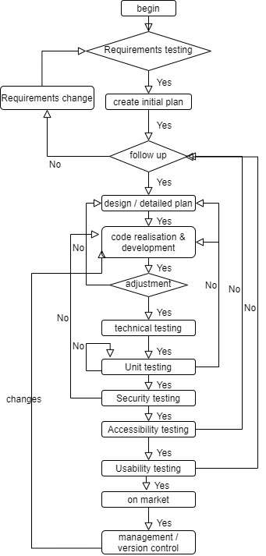 | Left image shows our previously set working flow chart. There is a main branch, and several loops that we may go repeatedly. In fact, ‘Code realisation’ step costs longer time than others.  Below spiral image shows iterations that we have experienced. Milestones and obstacles are marked with red stars, and deadline dates are marked in yellow colour.

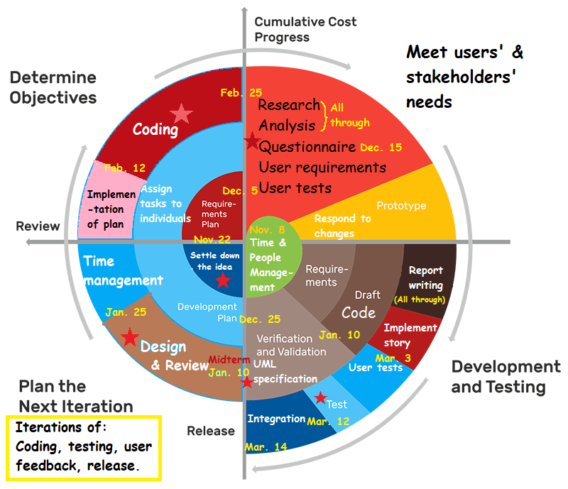
The spiral image just shows broad tasks. We have also written detailed Gantt Charts to allocate subtasks that could be delivered and tracked easily.
Gantt charts:

People management
Name | Roles | Tasks
Alex | Programmer, Organiser, Software engineer | Coding; UML; specification;
Xiaoyun | Designer, Data analyst, Report writer, Time manager | User tests; accessibility test; usability test; research; data analysis
Jeremy | Programmer, Software tester | Initial coding; prototypes;
Dimitri | Programmer, Report writer, Software tester | Coding; report
Sharif | - | -

There are difficulties from our members. Originally there were 5 members, but from the start to the end, Sharif Khan has never appeared. We four members endeavour all of our energy, but there are inevitable obstacles: Xiaoyun had her family issue from late January to middle February; Jeremy needed to look after his family members who were caught with COVID-19, and he always met storms that caused interruption of traffic and electricity; Dimitri caught COVID-19 himself.
To adjust the original plan, Alex has done almost all of the coding, with the help of Jeremy and Dimitri. Xiaoyun would write papers in February and March. We tailored the original aim – abandon the peripheral settings, and to leave questionnaires and user tests rather later to be conducted. Also, we didn’t expect our product could be launched to game platforms before deadline.

Elements break-down
1. User Story Wall
To write codes efficiently, we listed all of the user operations and gave each a weight – to work on basic operations firstly and to postpone the peripherals. To assure the quality of our product to our users, we must complete all the operations listed in ‘Release 1 (basic release)’.
User Story Wall:
User activities | Know the environment |  | Set defense base and play |  | Count scores | Report prob | Make choices and freedom |  | Purchase
Tasks | Read the story | Check map levels | Set towers | Let enemies in | See scores and costs | Feedback to us | Control decorations | Navigate fluently | Buy things & share
Release 1 (basic release) | Can open the game | Check ‘map’ page | Set one tower | Click ‘start’ | See stats when playing | See ‘feedback’ |  | See ‘menu’ in all pages
 | Read intro page | Choose from levels | Upgrade it | See one enemy | See summary after completion | Know who made the game |  | ‘Menu’ after intro page
 |  | From selection to game | See more tower types | See another enemy |  |  |  | Can resume
 |  | Know where can put towers | Can sell any tower | Know enemies’ paths |  |  |  | Can replay
 |  |  | Know towers’ property |  |  |  |  | Can go to the intro
Release 2 | Skip intro | Save previous progress | Treasure box | Can speed up waves |  | Write email directly | Control music or not | Can see treasure box | Share Sc shots to social media
 | Open the game easily | More map bg (grasslands etc.) |  | Treasure box |  | See pop-up for errors & quit | Control volume
Release 3 | See the game in game website | Challenging maps for strategy |  | Based on purchasing, skip waves |  | Can feedback the errors | Change skins |  | Create account
 | See this game’s propagation |  |  |  |  |  | Quit game |  | Tie up a bank card
 |  |  |  |  |  |  |  |  | Developers receive money
 |  |  |  |  |  |  |  |  | Watch other games’ ads

2. UML

3. specification
After settling down the operations we should make, we had a check to the previously written UML and specification document. Finally we started coding, just to implement the functionalities, without aesthetic design.
4. specification

Analysis

Feasibility analysis
1. Technological feasibility:
Among our 4 members, two are experienced programmers, while the other two have little coding experience, so our knowledge range for technology is limited. However, we guess that there is a big possibility that we can find well-made libraries that are especially for making games. Indeed we have found Phaser library which is discussed in other parts.

2. Operational feasibility:
It’s not too promising talking about each member’s time and energy. Need to consider special cases which prevents our member(s) from working for approximately 1 month. To inject flexibility, we plan that each person should complete his or her allocated jobs, whether it’s early or late. And, others have the ability to continously work on anyone’s jobs. We should: (1) backup all the works to Github; (2) notify clearly in Slack group chat which job he has done and where we can find it; (3) ask for any leave in advance.
We anticipate that there would be difficulties when lauching in game platforms – we need to read platform documents, contact with their leader, visit their company since they are our key stakeholder, etc.

3. Financial feasibility:
Unless we have to release our game to game platform, we don’t need to cost a lot, since most are coding jobs. If we only make questionnaires in mainland China, then it’s free; but in western countries which we care more about, questionnaire websites may charge us fees. But it would be small amount, since our project won’t last long.

4. Legal feasibility:
(1) Game platform contract:
Before we get to know the platforms, we will not have any clue about this. Perhaps it doesn’t allow scenes with violence or politics. We are safe since our game is cartoon. We need to be cautious whether our game would be tagged with ‘antihuman’ since it’s a game to prevent human invasion. But we have our reasons: the theme is anti-bad-behaviours, instead of anti-human; behaviours are not equal to the entity; once bad behaviours are corrected, humans would get improved. We are not killing any people. We should not let any human entity to be the enemy. This is what we want to convey.
Potential platforms: TapTap, Apple Game, Google Play,
(2) Laws in different countries:
Many countries have isolated Internet scopes. Since one of our members is in mainland China, we hope to attract Chinese users. We notice that game platforms are separated as ‘mainland China version’ and ‘others’, which means we need to (1) do translations for our game; (2) launch two versions in each platform; (3) use phone numbers and emails in different countries for different accounts. All should be assigned to a professionally organised team to release. If we do the releasing job, we need to plan more.

Risk analysis
Throughout our progress, we are doing risk analysis.
Risk | Solution
Specification risk: (1) might understand wrongly, so the implementations are in wrong diretion; (2) in testing, we might omit some specifications. | Track specification often.
Test cases might be incomplete (exception handling, margins, etc.) | Think roundly.
Some errors are occationally to occur, which might be untracked. | Screen shot often.

Prototyping & Iteration
In order to get a broad idea about what our project should contain, we firstly came up a prototype that could be used. The main idea is to make an environment-protection game to teach users to live harmoniously with Nature.

We then drew some simple designs for each page users may see:
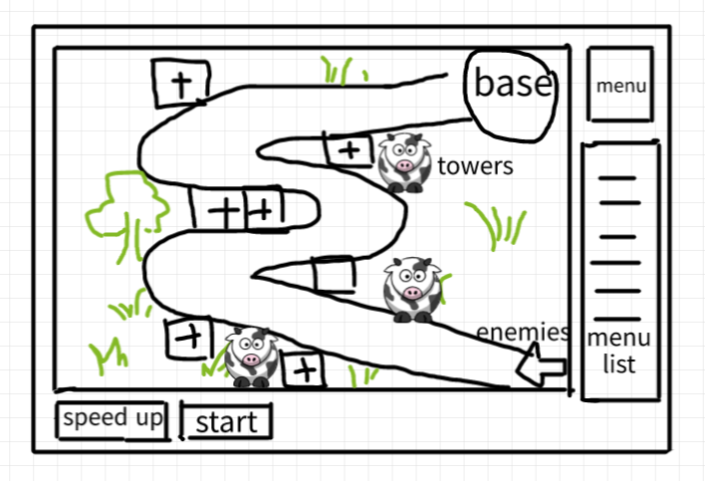 | In the game playing page that we focus on, we plan to put the main map in the center, and leave the menu to the right side. The control for the enemies and the game stats are put below. The ‘+’ positions are available for towers.
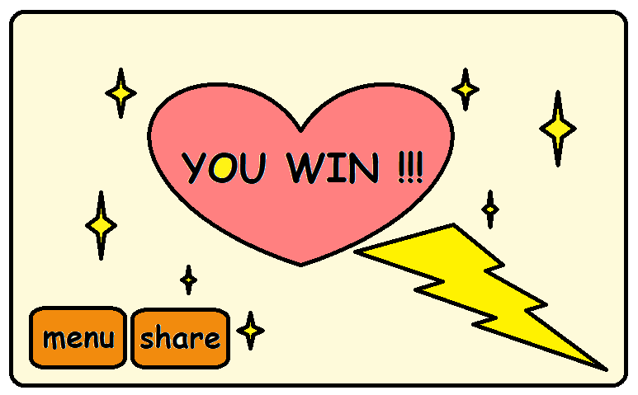 | Level completion page: should be rewarding and encouraging for the players. It should also display the navigation buttons. Can add game stats.

Design

Technological design
We choose Phaser library https://phaser.io/ to aid our development. Phaser is a fast, free and open source HTML5 game framework that supports both WebGL and Canvas rendering modes and can run in any web browser environment.
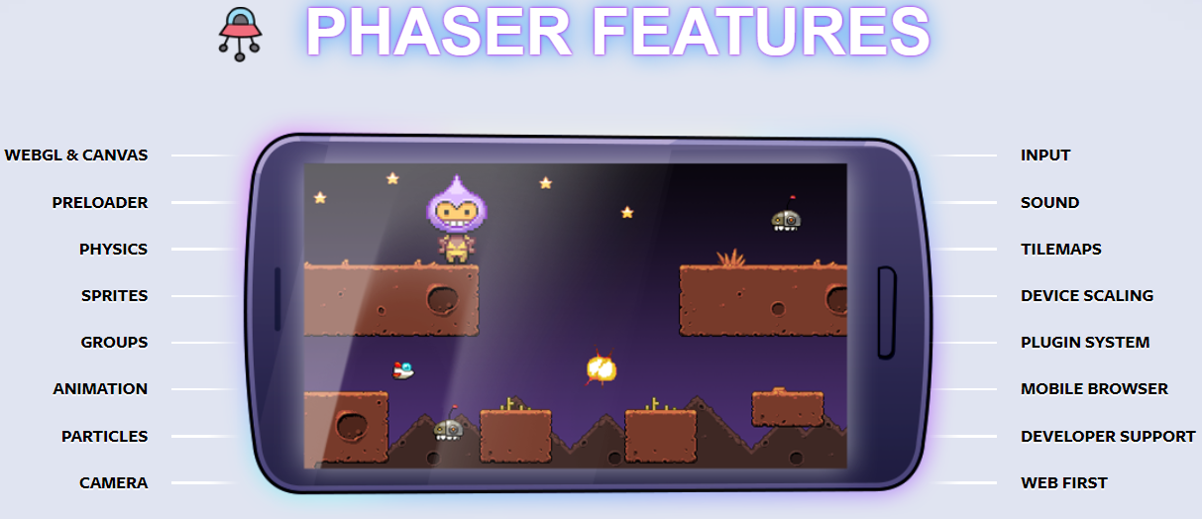
We choose it because: It’s easy to handle tile maps; can implement physics (characters similar to real world); can live show in browsers; it has embedded modules to handle fires and bullets; etc.

Aesthetic design
We use cartoons and stick figures because they look cute and casual. Just simply draw a button in Paint software, and adopt the same style to other buttons.

Character design
Tower types | Evolution 1 | Evolution 2
Poison frog | 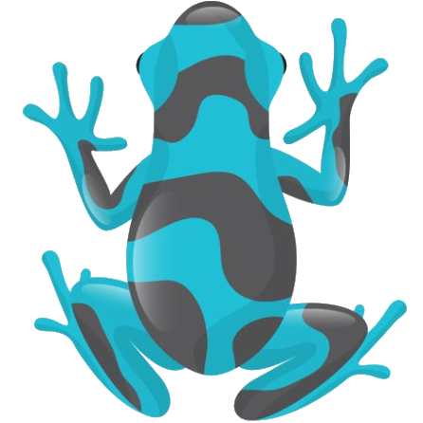 | 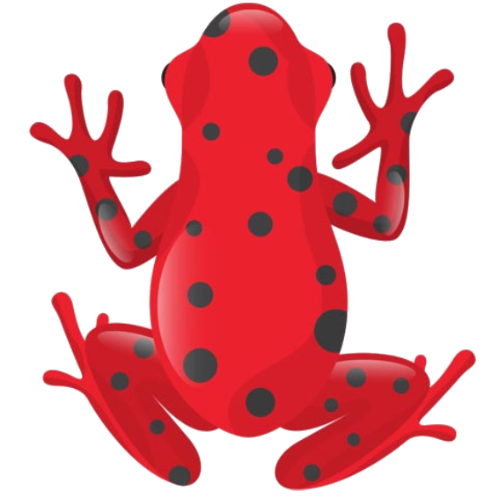
Tiger |  | 
Piranha | 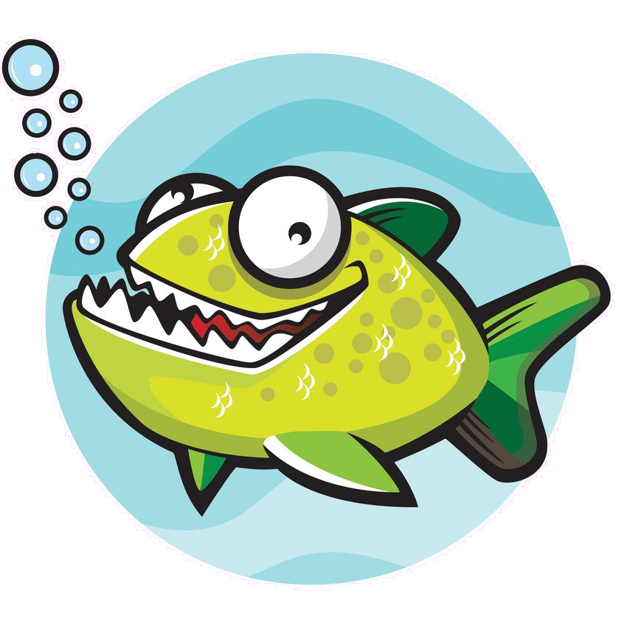 | 
Elephant |  | 
King cobra |  | 
Law (the most powerful and triggers the happy ending) |  | 

Enemy types | Evolution 1 | Evolution 2
Plastic garbage | 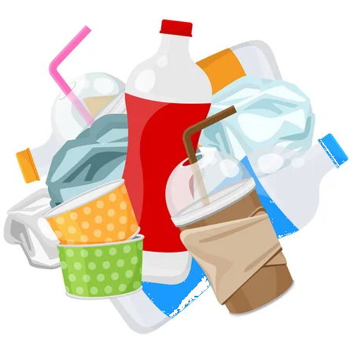
Saw | 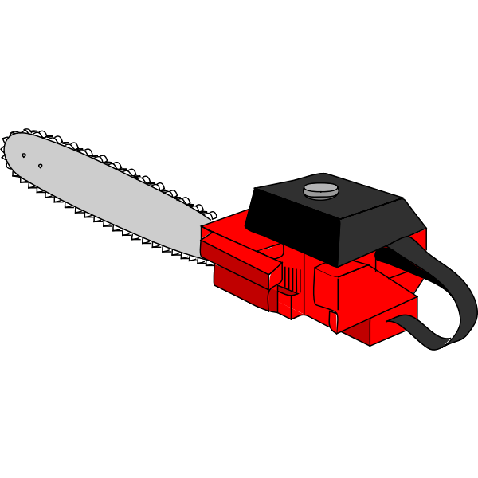
Hunting gun | 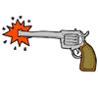

System Development
Show it is User-centered
Codes
Git repo
Agile / straight / test-driven development

Evaluation

Processes:
Advantages | Disadvantages
We have allocated tasks to individuals, so that our work won’t overlap. | We haven’t settled down clear ddl dates in the spiral iteration of working schedule.

Future expectations
Once the product is on market, it is not done. Software tests can reveal errors, but it cannot replace the maintenance step to assure the correctness, completeness, and consistency of the software. We should build a software maintenance schedule in order to follow up the changes to our product.
Should

Product:
Advantages | Disadvantages
We

Future expectations
Should adjust our game to different screens (phone, webpage), and can change the size of canvas.
Should fully explore Phaser features and adopt them.
We can design towers (with weapons) and enemies more targeted, just like in Pokemon, Grass type creatures are afraid of Fire type ones. For example, our Poison Frog can escape from the Hunting Gun, so once put the Poison Frog, it would damage more to the Gun’s HP. Perhaps after adding to more and more towers (creatures), our game can build a universe just like the Pokemon world.
It is also meaningful once we have discovered how each creature can defense against some certain human beings’ weapons. It would be helpful for ecologists to understand how the Earth is resilient to human destructions. These trails would also have positive effects to the education meaning which we emphasize most.

Summary

Individual reflection

Appendix

References

