‘The only real difference between games and reality is that the stakes are lower with games.’ (Koster, pp.34)

‘games serve as very fundamental and powerful learning tools.’ (Koster, pp.35)

‘Save the Jungle’ - Tower Defense Game

- ASP Group 8, Mar 2022

Contents

Background
Aims & Objectives
Stakeholders
Planning & Research
Research & Novelty
Time Management & Process
People Management
Elements Break-down
Analysis
Feasibility Analysis
Risk Analysis
Prototyping & Iteration
Design
Technological Design
Aesthetic Design
Character Design
System Development
Coupling & Cohesion
Testing
User Testing
Usability Testing
Accessibility Testing
Evaluation
Processes
Product
Summary
Individual Reflection
Appendix
A. References
B. Accessibility Testing
C. Usability Testing
D. User Testing Formative
E. User Guide

Background
Virus, fears, insulation. In 2022, the world is not yesterday. Nature has taken revenge back.
How we wish to turn the clock backwards, to the days when humans had not done such bad things to Nature! How we wish that the Nature is just like hundreds of years ago, when there were no greenhouse effects, loss of rainforests, and rise of sea levels. It’s time to reflect what we humans have done to the Natural environment. We need to apologize to Nature, apologize to the reason that has made the COVID-19 spread.

What if WE are the animals, and OUR ENEMY is human being?
Previously we had the idea to make an educational Tower Defense Game. Since Miller in his book mentions the importance of ‘a good story’ (Miller, preface), now we wish to implement such a story into our game. We set our game setting to be in the jungle or forest, where animals (and plants) build towers to defense against human beings’ invasion to the jungle.
Reasons we choose this story:
1. It is educational. Whoever plays the game, he or she would be largely educated by the environment-protection idea.
2. It is creative. The novelty for our main idea is that we think the partition settlement – animals as our side, and human beings as enemy – is innovative. Seldom has anyone thought of standing in the shoes of others, seldom has anyone considered he or she is the animal, and humans the group is another thing. Once we have changed our perspective to play the game, to defense, to know that the safeguard is tough, then we can realise that we humans have done lots of devastating behaviours to the forest, and perhaps we may stop these bad behaviours just from now on.
3. Characters are from real world. (1) It manifests Nielson’s second usability principle ‘match between system and the real world’. (2) It’s easy to draw characters, since we don’t need to create any new characters out of thin air.
4. It has ecological meaning. (1) We need to apply ecology concepts to set which animal as tower and which human behaviour as enemy. Perhaps in the future we will design more targeted animal-against-enemy pairs based on the animal’s habits. (2) Reversely, once we have built our software with a large library of towers and enemies, ecologists might use our project to educate people, or might even learn from our settings. They perhaps will ponder about the old theories from an entirely new perspective – standing from the animals’ side to see humans, or they may find some reasons for some certain animals to survive in the world.

To state why initially we choose to build an educaitonal Tower Defense game, here are the reasons:

Aims & Objectives
(Adjusted parts from midterm are shown in green. )
- On the whole, To build a Tower Defense (TD) Game which operates on computers with an educational theme of environmental protection, by settling animals as towers and human bad behaviours as enemies. (Newly elaborated)
- This game should be educational so that users will understand: (1) humans’ bad behaviours are enemies of the living creatures in Nature; (2) animals need to take much effort to protect their home; (3) there can exist a happy ending where humans and animals live in harmony; (4) although animals have done all they could to defense, the most powerful weapon is still the law settled by humans ourselves. (Newly elaborated)
- To discover the process of making a video game when doing this game project.
- To involve all team members into this big task. To maximize the productivity of the team by using each individual’s advantages. Team members can learn from each other to improve their shortages. Task: draw a Gantt chart, ddl Nov. 26; a new Gantt chart for the second half of work, ddl Jan 20.
- For each team member, learn how to manage time and deadlines for each sub-task.
- Learn how to cooperate a task. Tasks: (1) settle down the platforms, ddl Nov. 30. (2) handle members’ leave requests and arrange works fluently (previously said ‘meeting arrangement’ can be canceled since our communication through Slack is clear enough); (3) understand the full development process and important milestone tasks, ddl Dec. 31.
- Learn how to do version-controls for a project using git operations or platforms. Task: use Github, ddl middle Dec.
- Experience the process to do simiple statistics. Task: (1) make questionnaires, ddl Nov. 30. (2) spread the questionnaires, ddl Dec. 15. (3) data analysis, ddl Jan. 10.
- To fully understand the users’ psychology, then make a project which benefits the users. Tasks: (1) extract user requirements from the data, ddl Dec. 31. (2) continously gather user opinions, ddl March 2022.
- To understand the basic elements and how they interact. Tasks: (1) write a requirement specification, ddl. Dec. 31. (2) draw UML, ddl. Dec. 31.
- To realise the requirement specification into codes. Tasks: (1) initial codes, ddl Dec. 31. (2) full codes, ddl March 2022.
- To do software testings, ddl March 2022, including user testing, usability testing, accessibility testing, etc.
- Understand the importance of telling a good main story through book reading / user preferences. (Newly added)
- To experience how an agile project works in team, to understand what should we do to get users involved, to experience the process of responding quickly, to explore how to take all the changing records timely and tidily. (Newly added)

Stakeholders:
Not everyone can appreciate the meanings of our product. Thus, we should target precisely, so that our product and our energy won’t be wasted.
Since it’s educational, our target groups are students. Since it’s a game, our target groups are young people who are energized. Also, it could be utilised by any environment-protection groups or famous Nature exploration organisations to spread their ideas (or to advertise their groups). It could also be widely used in universities as a case in class, so we should consider teachers within. (Once we have communications with any game platform, it will also be our first-place key stakeholder. )
Key stakeholders | Age | Job | Importance
Students | 6-30 | Primary/secondary/university student | Main
Teachers/educators | 40-60 | Lecturer/organiser/officials in university | Main
Organisations | - | Non-profit/profit environmental protection group | Expectation
Game companies/platforms | - | Leading platforms in game industry | Expectation
Players for the above platforms | Depends | Game users | Expectation

In the process of questionnaire gathering, we have settled ‘age’ question and ‘job’ question in order to identify whether the person is key stakeholders that we should focus on.
According to one interview to an experienced customer manager done by Xiaoyun: (1) People tend to give us some information through phone calls, but not through questionnaires, especially when there are open questions that need them to write down. So we should construct as many multiple-choice questions as possible in our questionnaire. (2) For key stakeholders, we should take priority for them, like making phone calls periodically, and visiting their companies in person, etc.

Planning & Research

Research & novelty
Game collections:

We have searched all through the Internet about similar environment-protection or animal games.
(1) Widely known Pokemon is similar to our settings which includes many game types. However, its idea is always to separate Pokemons (animals) into different teams and fight each other, or fight against the evil organisation Team Rocket. It’s not like our idea to let humans and animals to fight. So we have novelty. In our thoughts, Pokemon provides little meaning other than to realise the surviving rule in Nature.
Callahan et al. also investigated Pokemon, and finally have created a new board game ‘Phylo’. The new game aims at biodiversity conservation, but surely Pokemon itself is rarely educational. We think our work converges with Callahan’s, since we both aims at a ecological game with animals as characters. However, our games advances in human behaviours involved.
(2) Study of ecological games:
Game Name | Type | Features | Comments
Eco | Open World Survival | Learn through play, w/t documents; 3D with vivid scene
Animalia Survival | Simulation; Survival | Play as the animal to survive | Similar view point – stand on the side of animals.
A New Beginning - Final Cut | Adventure | Save the world from the climate cataclysm | Save the world actually don’t need big actions. Just need awareness.
Botanicula | Casual; Exploration | Whole story happens on one tree. | Learn from the funny parts: sounds, design, story.
Flood protection game - Tsai | Casual; educational | Cartoon; simple drawing
Liver defense biological game - Brich | Educational; cartoon; casual | Consistent style; few colour choices; simple shapes; meaningful panels; implemented clinical data | A game need to be straightforward.

Paper collections:

We have searched in many academic websites.
IEEE only includes limited amount of articles about tower defense game, and very few about educational tower defense game. That means, our project is rarely done by computer science area peers.
However in Nature website, we have found much evidences that puch us forward in making educational games:
(1) In this isolation era, people are tend to catch mental illnesses. According to Peters et al., playing video games has a significant efficacy for dyslexia (Peters ‘Dyslexia’ paper). We deem that our game could also help users not only to cure them from already existed mental illness, but can also prevent them from getting down, by immersing themselves in a co-related world that we build. Just as what Krotoski says, there are evidence showing that students playing games often are better at learning than those who don’t (Krotoski, pp. 695).
(2) Games are a creative method in education. Krotoski has stated in his finding that, games is a very valuable way for kids to learn, and surprisingly, players may have learned things ‘even when the educational material underlying the game has flaws’, since the game itself has a wide range of market, and it will encourage its audience to debate about the scientific theory (Krotoski, pp. 695). Therefore, we don’t need to be perfect but still our educational aim would be achieved.

Time management & process
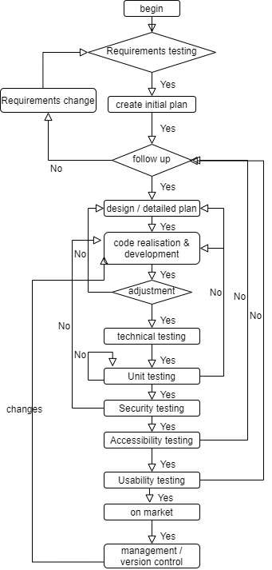 | Left image shows our previously set working flow chart. There is a main branch, and several loops that we may go repeatedly. In fact, ‘Code realisation’ step costs longer time than others.  Below the mind map shows steps and their orders.  Below spiral image shows iterations that we have experienced. Milestones and obstacles are marked with red stars, and deadline dates are marked in yellow colour.

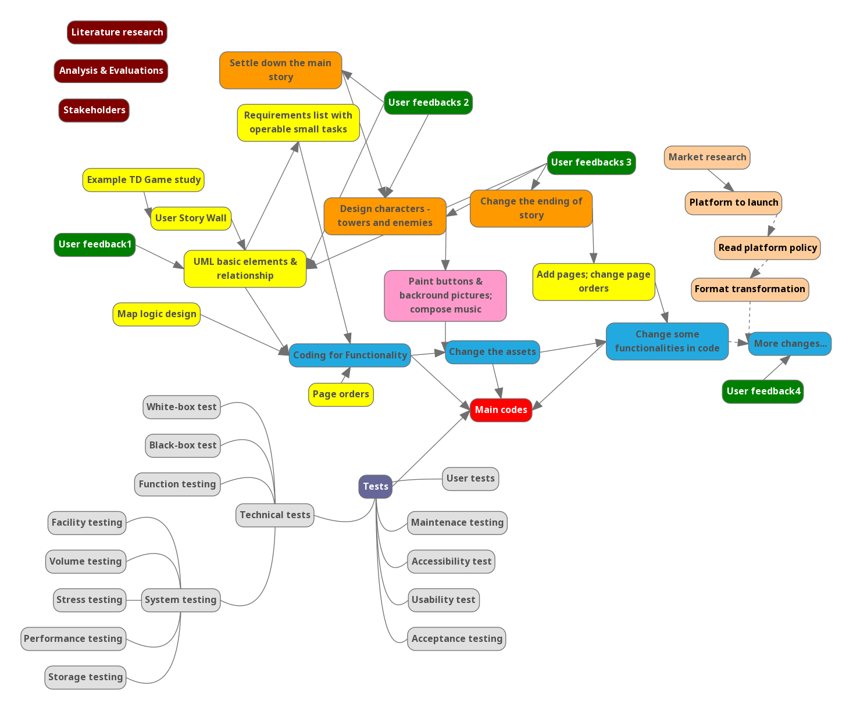

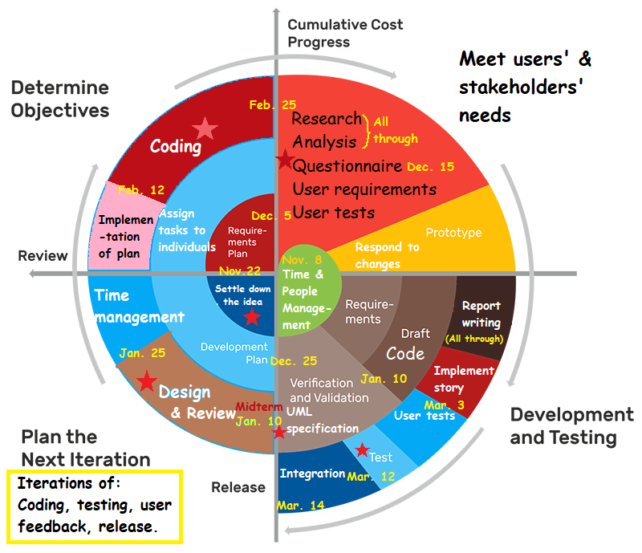
The spiral image just shows broad tasks. We have also written detailed Gantt Charts to allocate subtasks that could be delivered and tracked easily.
Gantt charts:

People management
Name | Roles | Tasks
Alex | Programmer, Organiser, Software engineer | Coding; UML; specification;
Xiaoyun | Designer, Data analyst, Report writer, Time manager | User tests; accessibility test; usability test; research; data analysis
Jeremy | Programmer, Software tester | Initial coding; prototypes;
Dimitri | Programmer, Report writer, Software tester | Coding; report
Sharif | - | -

There are difficulties from our members. Originally there were 5 members, but from the start to the end, Sharif Khan has never appeared. We four members endeavour all of our energy, but there are inevitable obstacles: Xiaoyun had her family issue from late January to middle February; Jeremy needed to look after his family members who were caught with COVID-19, and he always met storms that caused interruption of traffic and electricity; Dimitri caught COVID-19 himself.
To adjust the original plan, Alex has done almost all of the coding, with the help of Jeremy and Dimitri. Xiaoyun would write papers in February and March. We tailored the original aim – abandon the peripheral settings, and to leave questionnaires and user tests rather later to be conducted. Also, we didn’t expect our product could be launched to game platforms before deadline.

Elements break-down
1. User Story Wall
To write codes efficiently, we listed all of the user operations and gave each a weight – to work on basic operations firstly and to postpone the peripherals. To assure the quality of our product to our users, we must complete all the operations listed in ‘Release 1 (basic release)’.
User Story Wall:
User activities | Know the environment |  | Set defense base and play |  | Count scores | Report prob | Make choices and freedom |  | Purchase
Tasks | Read the story | Check map levels | Set towers | Let enemies in | See scores and costs | Feedback to us | Control decorations | Navigate fluently | Buy things & share
Release 1 (basic release) | Can open the game | Check ‘map’ page | Set one tower | Click ‘start’ | See stats when playing | See ‘feedback’ |  | See ‘menu’ in all pages
 | Read intro page | Choose from levels | Upgrade it | See one enemy | See summary after completion | Know who made the game |  | ‘Menu’ after intro page
 |  | From selection to game | See more tower types | See another enemy |  |  |  | Can resume
 |  | Know where can put towers | Can sell any tower | Know enemies’ paths |  |  |  | Can replay
 |  |  | Know towers’ property |  |  |  |  | Can go to the intro
Release 2 | Skip intro | Save previous progress | Treasure box | Can speed up waves |  | Write email directly | Control music or not | Can see treasure box | Share Sc shots to social media
 | Open the game easily | More map bg (grasslands etc.) |  | Treasure box |  | See pop-up for errors & quit | Control volume
Release 3 | See the game in game website | Challenging maps for strategy |  | Based on purchasing, skip waves |  | Can feedback the errors | Change skins |  | Create account
 | See this game’s propagation |  |  |  |  |  | Quit game |  | Tie up a bank card
 |  |  |  |  |  |  |  |  | Developers receive money
 |  |  |  |  |  |  |  |  | Watch other games’ ads
 |  |  |  |  |  |  |  |  | Time limit for minors

2. UML

3. specification
After settling down the operations we should make, we had a check to the previously written UML and specification document. Finally we started coding, just to implement the functionalities, without aesthetic design.
4. specification

Analysis

Feasibility analysis
1. Technological feasibility:
Among our 4 members, two are experienced programmers, while the other two have little coding experience, so our knowledge range for technology is limited. However, we guess that there is a big possibility that we can find well-made libraries that are especially for making games. Indeed we have found Phaser library which is discussed in other parts.

2. Operational feasibility:
It’s not too promising talking about each member’s time and energy. Need to consider special cases which prevents our member(s) from working for approximately 1 month. To inject flexibility, we plan that each person should complete his or her allocated jobs, whether it’s early or late. And, others have the ability to continously work on anyone’s jobs. We should: (1) backup all the works to Github; (2) notify clearly in Slack group chat which job he has done and where we can find it; (3) ask for any leave in advance.
We anticipate that there would be difficulties when lauching in game platforms – we need to read platform documents, contact with their leader, visit their company since they are our key stakeholder, etc.

3. Financial feasibility:
Unless we have to release our game to game platform, we don’t need to cost a lot, since most are coding jobs. If we only make questionnaires in mainland China, then it’s free; but in western countries which we care more about, questionnaire websites may charge us fees. But it would be small amount, since our project won’t last long.

4. Legal feasibility:
(1) Game platform contract:
Before we get to know the platforms, we will not have any clue about this. Perhaps it doesn’t allow scenes with violence or politics. We are safe since our game is cartoon. We need to be cautious whether our game would be tagged with ‘antihuman’ since it’s a game to prevent human invasion. But we have our reasons: the theme is anti-bad-behaviours, instead of anti-human; behaviours are not equal to the entity; once bad behaviours are corrected, humans would get improved. We are not killing any people. We should not let any human entity to be the enemy. This is what we want to convey.
Potential platforms: TapTap, Apple Game, Google Play, Steam, etc.
(2) Laws in different countries:
Many countries have isolated Internet scopes. Since one of our members is in mainland China, we hope to attract Chinese users. We notice that game platforms are separated as ‘mainland China version’ and ‘others’, which means we need to (1) do translations for our game; (2) launch two versions in each platform; (3) use phone numbers and emails in different countries for different accounts. All should be assigned to a professionally organised team to release. If we do the releasing job, we need to plan more.
In addition, many countries have laws to restrict game playing time for minors. According to that, we must plan for: (1) account system – log in page, database; (2) time alerts poping up every 30 min; (4) forced to terminate when certain amount of time reaches.

Risk analysis
Throughout our progress, we are doing risk analysis.
Risk | Solution
Specification risk: (1) might understand wrongly, so the implementations are in wrong diretion; (2) in testing, we might omit some specifications. | Track specification often.
Test cases might be incomplete (exception handling, margins, etc.) | Think roundly.
Some errors are occationally to occur, which might be untracked. | Screen shot often.

Prototyping & Iteration
In order to get a broad idea about what our project should contain, we firstly came up a prototype that could be used. The main idea is to make an environment-protection game to teach users to live harmoniously with Nature.

We then drew some simple designs for each page users may see:
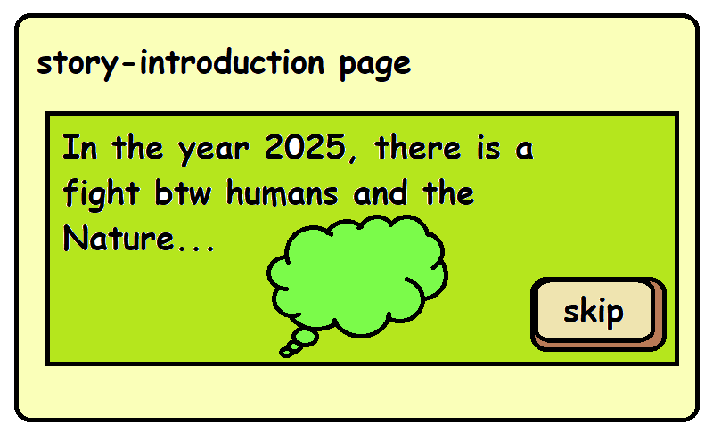 | Story Intro page.
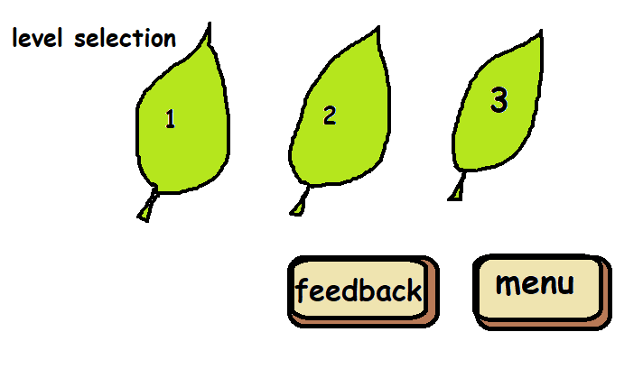 | Level Selection page. We should add jungle elements.
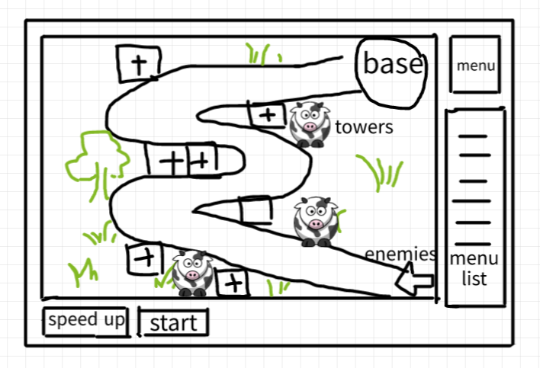 | In the game playing page that we focus on, we plan to put the main map in the center, and leave the menu to the right side. The control for the enemies and the game stats are put below. The ‘+’ positions are available for towers.
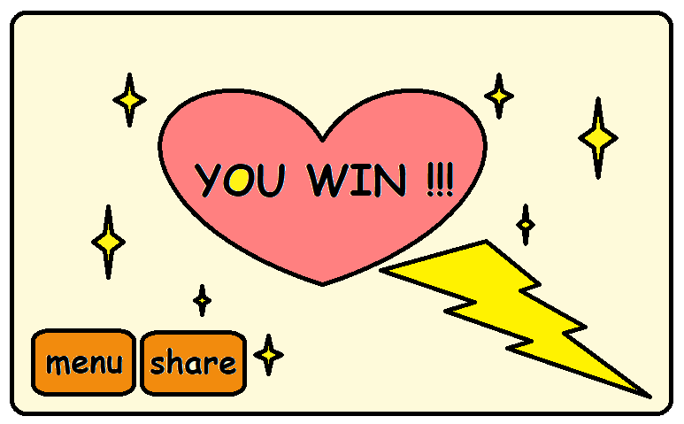 | Level completion page: should be rewarding and encouraging for the players. It should also display the navigation buttons. Can add game stats.
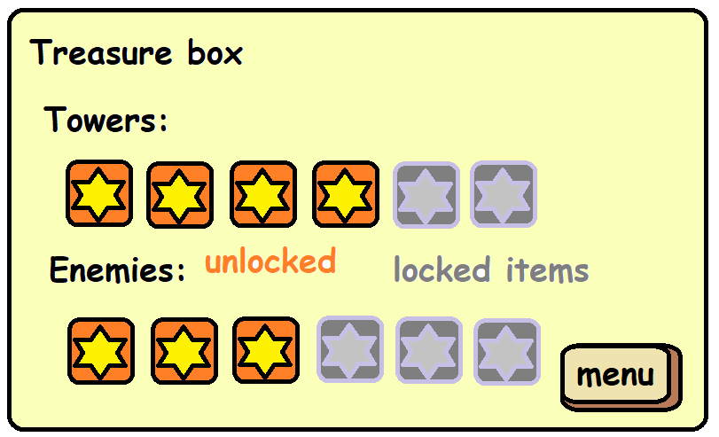 | Treasure Box page. Should show all levels including locked levels (perhaps in developing and users never know but it’s promising).
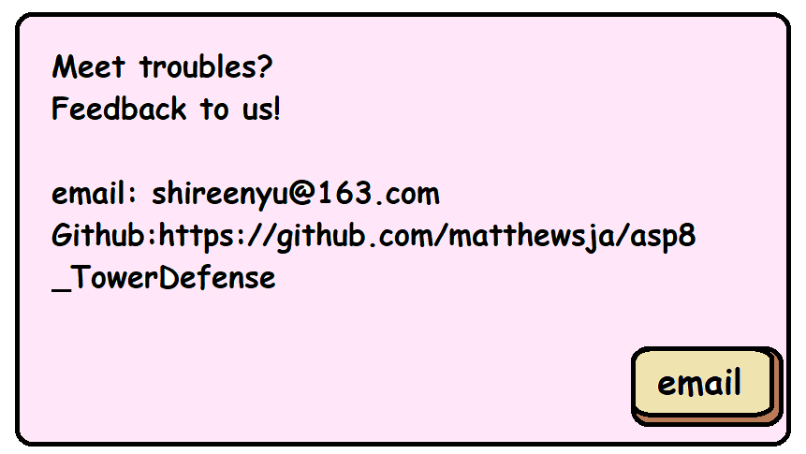 | Feedback Page. Steps are: (1) our information; (2) info + ‘email’ button which pops up email box; (3) info + feedback form which can submit to us.
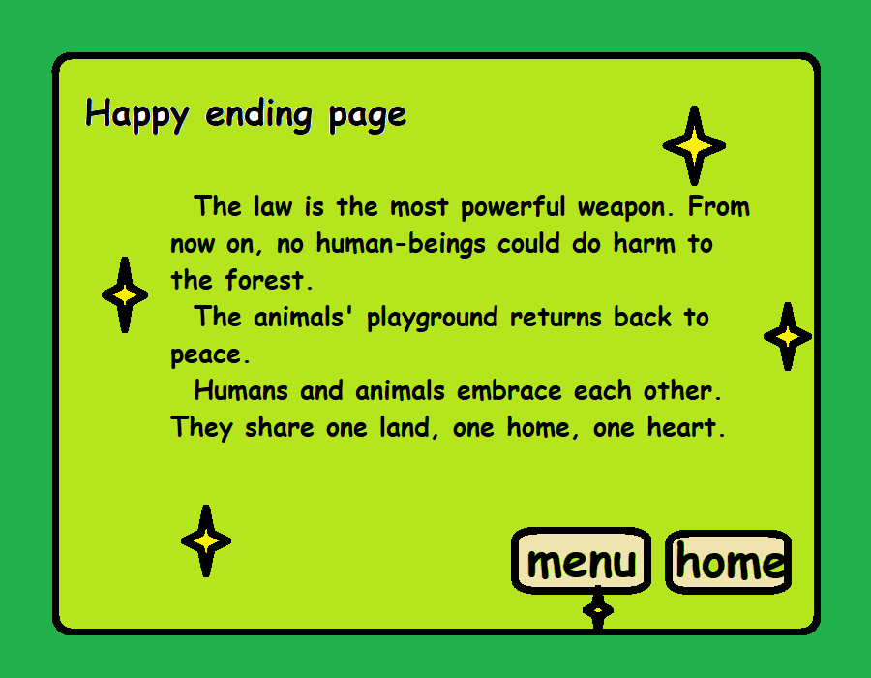 | There should be an ending page, triggered by placing ‘law’ the tower, and the tower has moved humans, then humans give up.  Our idea is to embrace each other and to live harmoniously in the end. This is the best result.
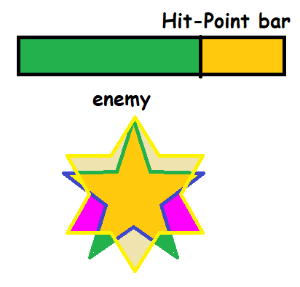 | Enemies should have a Hit-Point bar.

Page order:
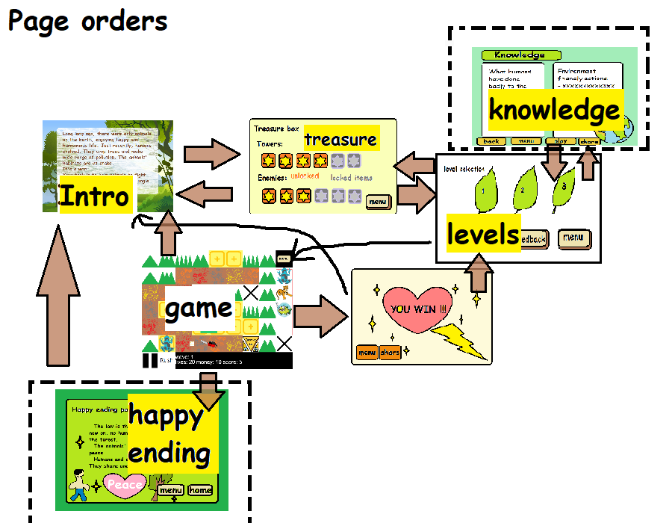

Design

Technological design
Since our time is limited by this programme, we cannot complete all the tasks listed in previous sections. We must complete the tasks listed in ‘Release 1’ in ‘User Story Wall’, before Mar 14, 2022.

We choose Phaser library https://phaser.io/ to aid our development. Phaser is a fast, free and open source HTML5 game framework that supports both WebGL and Canvas rendering modes and can run in any web browser environment.
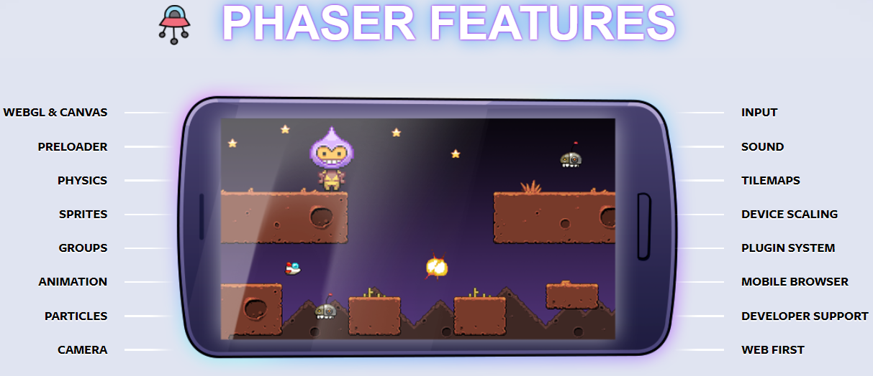
We choose it because: It’s easy to handle tile maps; can implement physics (characters similar to real world); can live show in browsers; it has embedded modules to handle fires and bullets; etc.

Aesthetic design
We use cartoons and stick figures because they look cute and casual. Just simply draw a button in Paint software, and adopt the same style to other buttons.

Character design
Tower types | Evolution 1 | Evolution 2
Poison frog | 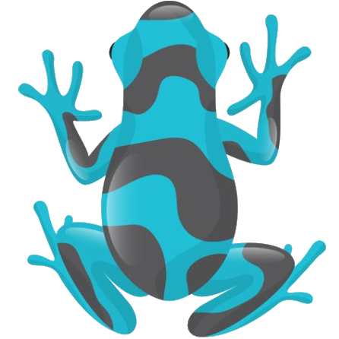 | 
Tiger |  | 
Piranha | 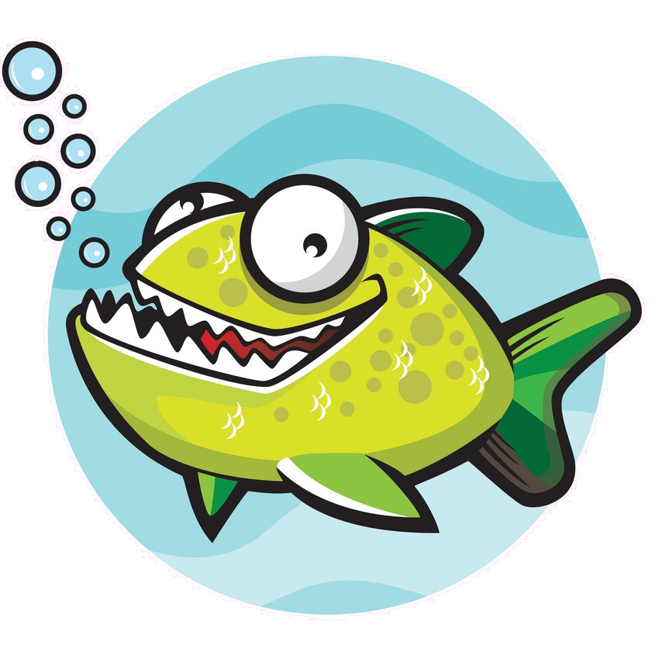 | 
Elephant |  | 
King cobra |  | 
Law (the most powerful and triggers the happy ending) |  | 

Enemy types | Evolution 1 | Evolution 2
Plastic garbage | 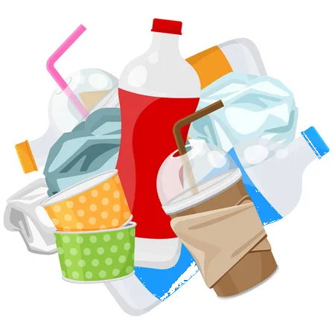
Saw | 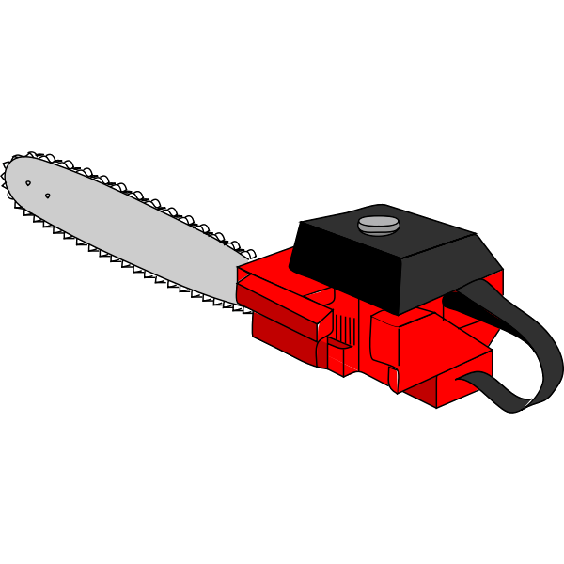
Hunting gun | 

System Development
Show it is User-centered
Codes
Git repo
Agile / straight / test-driven development

Coupling & Cohesion
Coupling:

We have separated our task into several .js files, with each one emphasizing one functionality. To do so, we create separated classes all derived from Phaser.scene class. Unless inside the class we need to use picture assets (background, button design, etc. ), there are rare elements calling data in other .js files.

Indirect Coupling:
There are no direct calling among modules. Example:
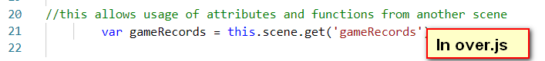  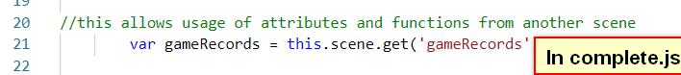 | In src\utilities\gameRecords.js file, we can find no calls for elements in other modules, although in other files, we can see they call this gameRecords class data. gameRecords.js is a rather independent module.

Common-environment Coupling:
Use the same data input. Examples:
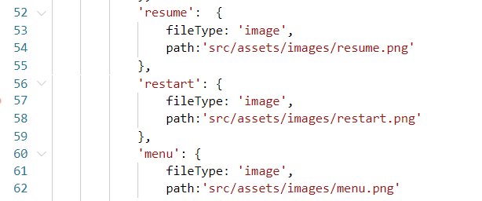  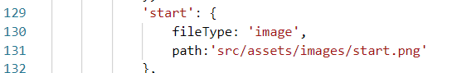  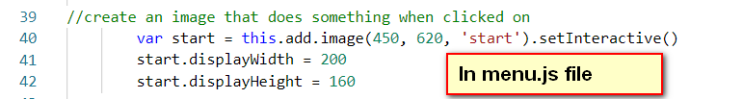  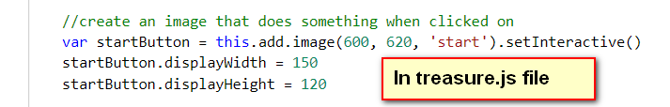 | The .\src\utilities\resources.js file is created in order to load picture, sound, and other assets apart from functionality operations. Several classes (.js files) all use the same picture which is loaded in it.

Data Coupling (Feature Coupling):
Data is transferred from one module to another. To call it ‘Feature Coupling’, since the data type transferred is class or file, instead of a simple data type like int, float, etc. Examples:
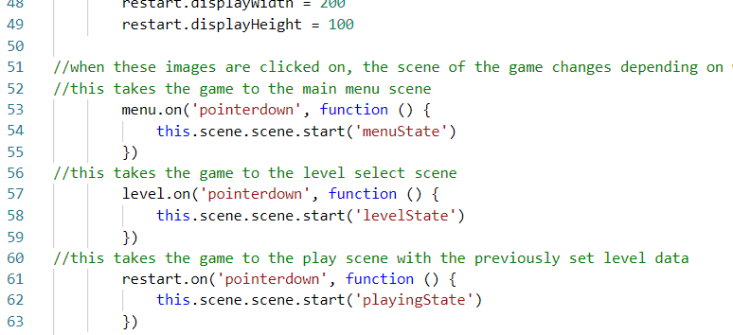  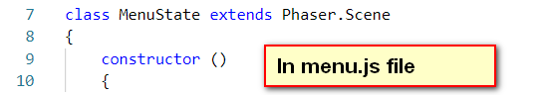 | ./src/states/complete.js, we create three buttons, and insert contents when they are clicked. The pages (states) we will jump to, are nother already created classes ‘menuState’, ‘levelState’, ‘playingState’.  In fact those states are classes in other .js files, which represent all the pages we will see in game.  In fact, each page contains some page directions to other pages. These directions must call classes written in other modules.
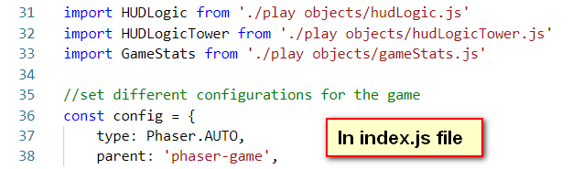 | The index.js file functions as the leader. It imports all the other sub-files, and sets configurations.

Cohesion

Our project uses Functional Cohesion most often, which means inside each module, all the elements contribute to one functionality.
Take .\src\states\level.js file as an example.

Testing

User testing

Usability testing

Accessibility testing

Evaluation

Processes:
Advantages | Disadvantages
We have allocated tasks to individuals, so that our work won’t overlap.  Although members are not in full time, we have arranged all of the elements to be done.  Members are active and willing to help each other and share any burden. | Our work is not effecient. Members sometimes get vacuum in schedule since our main focus in that period might not be them.  We must think about another plan to adjust to the inevitable members’ leaves.
We have conducted necessary basic tests. | It’s not complete; we should avoid testing our own software.
We have users to participate in our whole process, so our product emphasizes the weight of users. | There are lack of long-term users that may reflect their opinions step by step along with our development.
 | We have only done limited amount of tests. We should do more tests, including more types of tests.

Future expectations
Once the product is on market, it is not done. Software tests can reveal errors, but it cannot replace the maintenance step to assure the correctness, completeness, and consistency of the software. We should build a software maintenance schedule in order to follow up the changes to our product.
Should let a professional testing team to handle the testing part, instead of our own, since we might have embedded understanding bias that may cause our product to be easilly understood by us, but hardly understood by users.
We might recruit long-term user representatives to be involved in our complete process of development to get more ‘user recall’, which is a point that Myers emphasizes (Myers, pp. 147).
We should do the following types of test:
According to Myers:’ Examining a program to see if it does not do what it is supposed to do is only half the battle; the other half is seeing whether the program does what it is not supposed to do (Myers, pp. 13). ’ We must take off redundant parts to make our game straigtforward.
We must conduct more types of tests: Black-box test; White-box test; Function testing; System testing (Facility testing; Volume testing; Stress testing; Performance testing; Storage testing; Configuration testing; Compatibililty testing; Installation testing; Reliability testing; Recoverty testing; Maintenace testing; Documentation testing; Procedure testing); Acceptance testing.

Product:
Advantages | Disadvantages
Although we are not experts, we learn from zero and finally have built basic functionalities for a typical tower defense game successfully. | There are more to be modified and added to build a complete tower defense game.

Future expectations
Should adjust our game to different screens (phone, webpage), and can change the size of canvas.
Should fully explore Phaser features and adopt them.
We can design towers (with weapons) and enemies more targeted, just like in Pokemon, Grass type creatures are afraid of Fire type ones. For example, our Poison Frog can escape from the Hunting Gun, so once put the Poison Frog, it would damage more to the Gun’s HP. Perhaps after adding to more and more towers (creatures), our game can build a universe just like the Pokemon world.
It is also meaningful once we have discovered how each creature can defense against some certain human beings’ weapons. It would be helpful for ecologists to understand how the Earth is resilient to human destructions. These trails would also have positive effects to the education meaning which we emphasize most.
More to be done can refer to ‘User Story Wall’ the ‘Release 2’ and ‘Release 3’ parts. To perfect our game, we need to learn from big games (or industries) and build more peripheral functionalities.
We may also design a whole new part called ‘knowledge part’, including knowledge for human damaging to the Nature, and what should we do to be environment-friendly. Once we have added this page, we feel it’s necessary to add a ‘main menu’ page which displays all the buttons to all the pages.
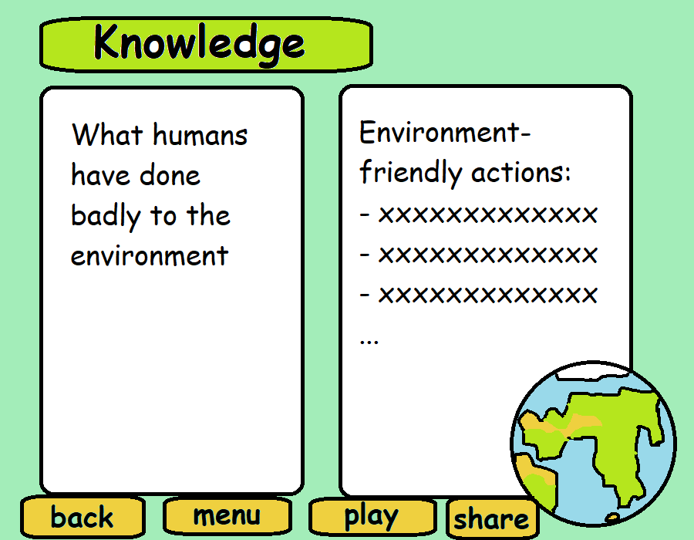
We should build more challeging maps, explore the best solution, in order to increase the difficulty of our game. Users will find it intellectually enjoyable.

Summary
We have successfully built basic functionalities of an educational tower defense game with the story of jungle animals defense against human invasion.

Individual reflection

Appendix

A. References
1. References for this paper:

Brich, Julia et al. ‘LiverDefense: Using a Tower Defense Game as a Customisable Research Tool’. 2015 7th International Conference on Games and Virtual Worlds for Serious Applications (VS-Games), 2015, pp. 1-8, doi: 10.1109/VS-GAMES.2015.7295779.

Callahan, M.M., Echeverri, A., Ng, D. et al. Using the Phylo Card Game to advance biodiversity conservation in an era of Pokémon. Nature Palgrave Commun 5, 79 (2019). https://doi.org/10.1057/s41599-019-0287-9. https://phylogame.org/

Koster, Raph. A Theory of Fun for Game Design. Paraglyph press, USA, 2005.

Krotoski, A. Serious fun with computer games. Nature 466, 695 (2010). https://doi.org/10.1038/466695a

Miller, Donald. Building a StoryBrand Clarify Your Message So Customers Will Listen. HarperCollins Leadership, 2017.

Myers, Glenford J., Corey Sandler, Tom Badgett. The Art of Software Testing. 3rd ed. John Wiley & Sons, Inc., New Jersey, 2012.

Peters, J.L., Crewther, S.G., Murphy, M.J. et al. Action video game training improves text reading accuracy, rate and comprehension in children with dyslexia: a randomized controlled trial. Nature Sci Rep 11, 18584 (2021). https://doi.org/10.1038/s41598-021-98146-x

Tsai, Meng-Han, Yu-Lien Chang, et al. ‘The effectiveness of a flood protection computer game for disaster education’. Springer, 15 March 2015. https://link.springer.com/article/10.1186/s40327-015-0021-7

2. References for our game product:

Picture resources:

Sound resources:

Library resources:

Codes reused:

B. Accessebility testing

C. Usability testing

D. User testing formative

E. User guide for our software

