Module Coupling & Cohesion

Coupling:

We have separated our task into several .js files, with each one emphasizing one functionality. To do so, we create separated classes all derived from Phaser.scene class. Unless inside the class we need to use picture assets (background, button design, etc. ), there are rare elements calling data in other .js files.

Indirect Coupling:
There are no direct calling among modules. Example:
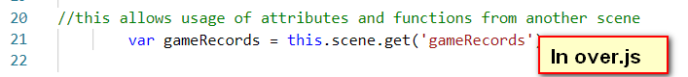  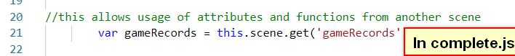 | In src\utilities\gameRecords.js file, we can find no calls for elements in other modules, although in other files, we can see they call this gameRecords class data. gameRecords.js is a rather independent module.

Common-environment Coupling:
Use the same data input. Examples:
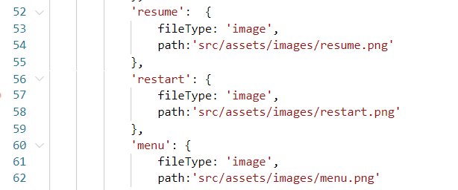  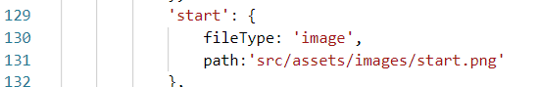  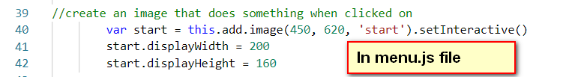  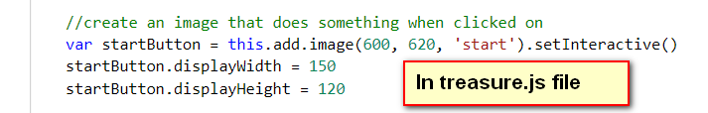 | The .\src\utilities\resources.js file is created in order to load picture, sound, and other assets apart from functionality operations. Several classes (.js files) all use the same picture which is loaded in it.

Data Coupling (Feature Coupling):
Data is transferred from one module to another. To call it ‘Feature Coupling’, since the data type transferred is class or file, instead of a simple data type like int, float, etc. Examples:
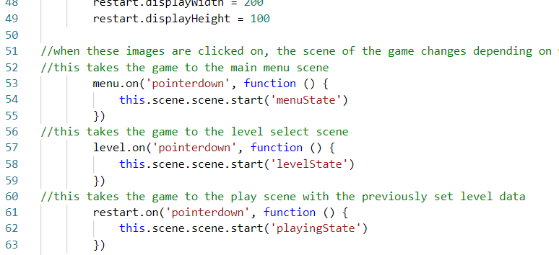  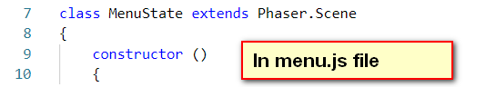 | ./src/states/complete.js, we create three buttons, and insert contents when they are clicked. The pages (states) we will jump to, are nother already created classes ‘menuState’, ‘levelState’, ‘playingState’.  In fact those states are classes in other .js files, which represent all the pages we will see in game.  In fact, each page contains some page directions to other pages. These directions must call classes written in other modules.
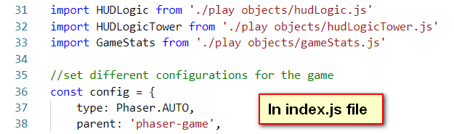 | The index.js file functions as the leader. It imports all the other sub-files, and sets configurations.

Cohesion

Our project uses Functional Cohesion most often, which means inside each module, all the elements contribute to one functionality.
Take .\src\states\level.js file as an example.

