Prototyping

Based on Jeremy’s initial codes, Alex has in mid Feb. developed a prototype that has realised all the basic functionalities of a tower defense game. We may later insert stories and adjust assets to rich the content.
The Github link for our codes of this software: https://github.com/matthewsja/asp8_TowerDefense/
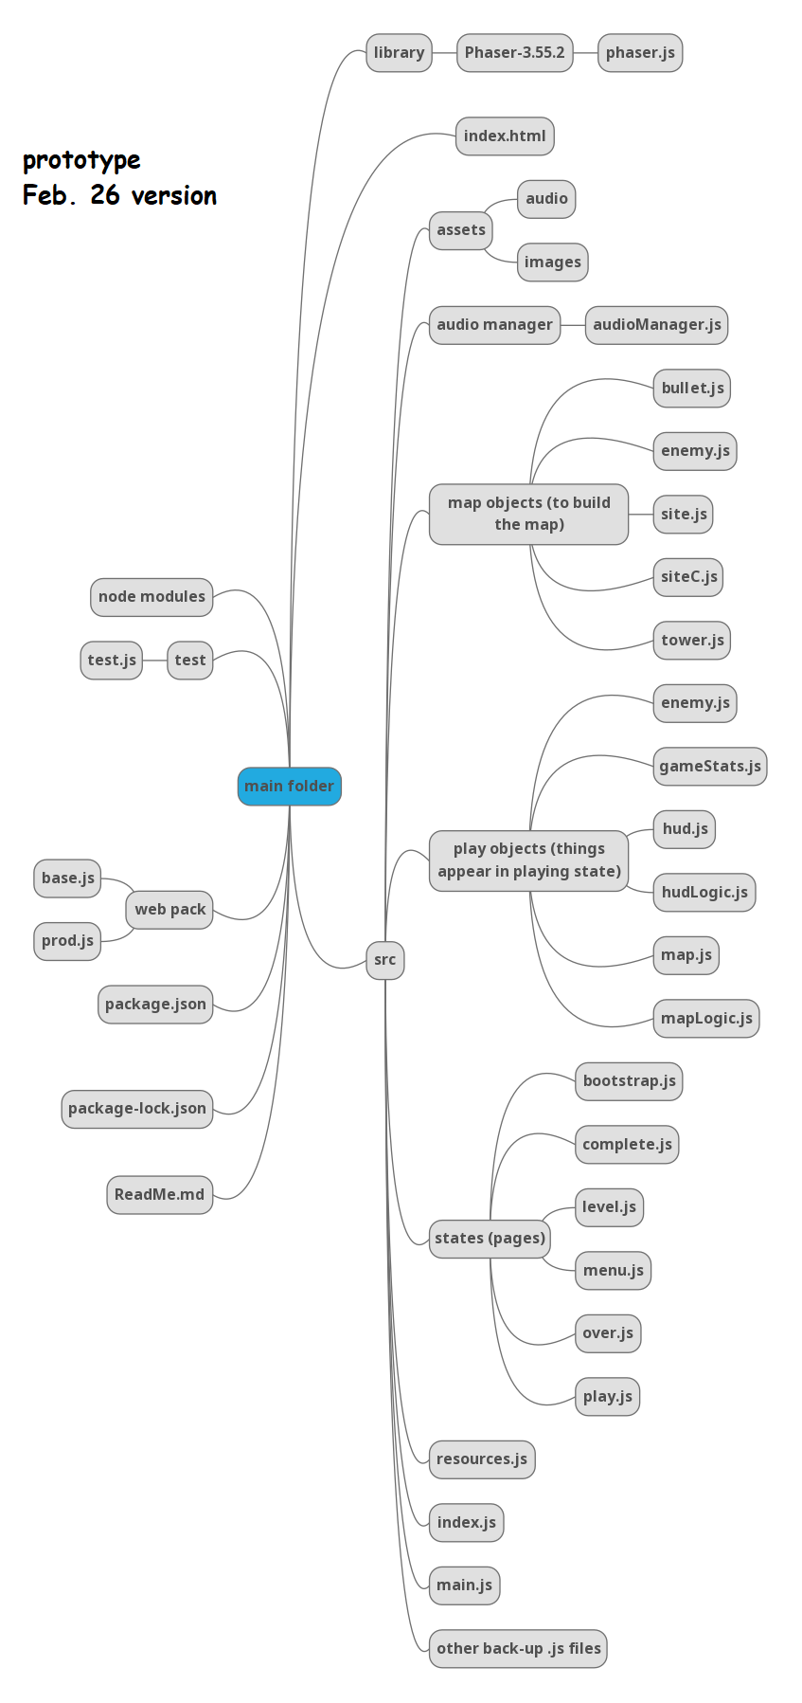 | Here is the structure of the prototype:  All the files are classified into folders so that their arrangement is meaningful and logically consistent.  ‘index.html’ is used to open up the webpage in the browser.  ‘library’ folder contains the Phaser library.  ‘node modules’ lists all of the necessary functionalities of the node.  ‘test’ folder contains the test files that will simplify the debugging process.  ‘web pack’ folder manipulates web-based functionalities.  ‘src’ folder contains all of the crucial codes. ‘assets’ folder contains all of the images and audios that we use. ‘map objects’ folder contains all elements that needed to construct the map in the main play screen – there are: tower, bullet, enemy, and the site. ‘play objects’ folder mainly manipulates interactions that users may trigger and the outcomes to display in the play screen. ‘states’ folder handles the pages that display to users; whenever we need a new page, we add a new file here. ‘resources.js’ file is used to import all of the assets and other .js files. ‘index.js’ and ‘main.js’ files now are rather overlapping.  There are also other back-up .js files contained in the ‘src’ folder that need to be deleted.  There are also package.json files which is used to open this project in Node.js.
Features: can put towers to sites; towers can emit bullets; enemies come in correct path; enemies can be killed; can buy and sell towers; game stats are correct; several waves of different enemies; can select levels but logic is confused; can display game stats and menus but is mixed with the map; 2 types of tower; can change speed but button is not meaningful; has a level-completion page; has a game-over page; use a tile set to construct the map; bg music plays well.
The prototype is perfected by steps: On Feb. 6, Alex updated a change to the HUD to let users change speed; and added some buttons that spawn the enemies in waves instead of individually. On Feb. 7, Jeremy exchanged his opinion about the audioManager file. On Feb. 11, Alex updated a version in which the maps are constructed by tiles to be manipulated more easily; also imported an outside library to handle the enemies’ path. On Feb. 15, Alex add level-selection functionality. On Feb. 18, Alex added AOE towers; also restructured the resource class so all the importing is done in the preload, and has met a problem when writing JSON files to include a dictionary to manipulate the resources. On Feb. 20, Alex added Hit-Point bars for each enemy. Some changes are done in a branch, not merged to main branch yet.

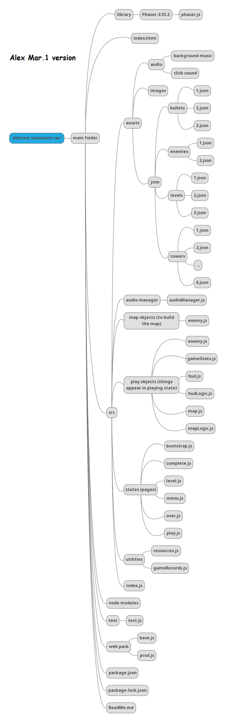 | The Mar.1 version file updates:  Added JSON files inside ‘assets’ to make configurations for each object (levels, bullets, enemies, etc.).  Shortened the ‘map objects’ folder.  Refined the map and HUD logic.  Resource file is restructured.  ‘resouce.js’ file and ‘gameRecords’ files are classified into ‘utilities’ folder.  Features: the menu and other buttons and game stats are separated from the map in the main playing screen; added HP bars; level-selection page is well-displayed; clicking sound; ‘start’ button in the playing page is obvious; 3 types of tower; speed-change buttons are meaningful to new users; level-completion page is meaningul with game stats; game-over page is meaningful; 3 levels are in different difficulties; each object can show description whenever mouse hovers on it.
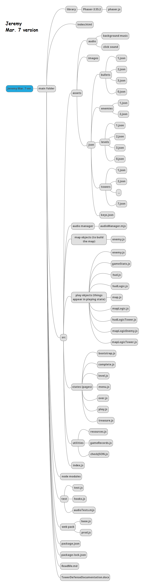 | Mar. 7 version updates:  ‘utilities’ folder newly added ‘checkJSON.js’ file which realised the dictionary functionality for resources mentioned by Alex previously.  Xiaoyun has implemented the environment-protection story by changing the assets.  Xiaoyun has added ‘treasure’ state to summarise all of the towers and enemies for users.  Features: story has been implemented – updated asset pictures; the ‘Law’ tower is added; ‘happy-ending’ screen is made by Jeremy and Xiaoyun, which will be triggered whenever user puts ‘Law’ onto the map; Jeremy also added clicking sounds to all buttons.  On Mar. 4, Jeremy has generated a link for our game to be open easily in any browser. Later he has updated this link based on new versions.

