User Test – Feb 19
Name | Freda Xiaoyun Yu | Gender | female | Age | 27
Job | Computer Science student | Date | Feb. 19, 2022 | Version | Alex early Feb.
Have seen this game before? |  | N | Is one of the developers before? |  | N
Platform working fine? |  | Difficult | Whole speed runs normally? |  | Y
Operations and keys are correctly related? |  | Y | Main story is understandable? |  | ?
Button are understandable? |  | Y | If you have disability, how do you feel about our game? |  | -
Do you think you are always clear with the help of navigation buttons ? |  | Y | Volume control / skin customization? |  | N
Is it fluent for choice of towers or levels? |  | Y | Do you think buttons are in consistent style? |  | Y
Do you think characters are in consistent style? |  | ? | You don’t need to remember any names. Is it true? |  | Y
See tutorials? |  | N | See our contact info? |  | N
Help document? |  | N
Likes
- Wow! The music is melodic. It’s continuous, without too much fluctuation, so that it allows me to concentrate on the game and how I should operate.
- I like the icon in the first page.
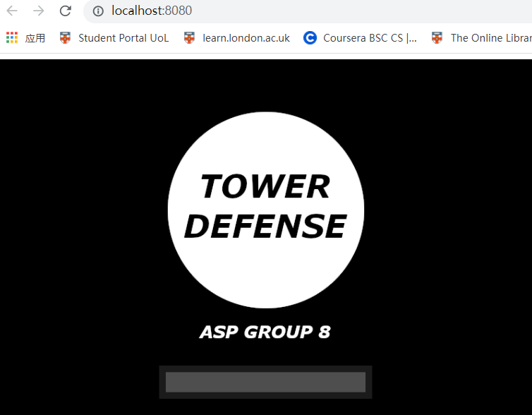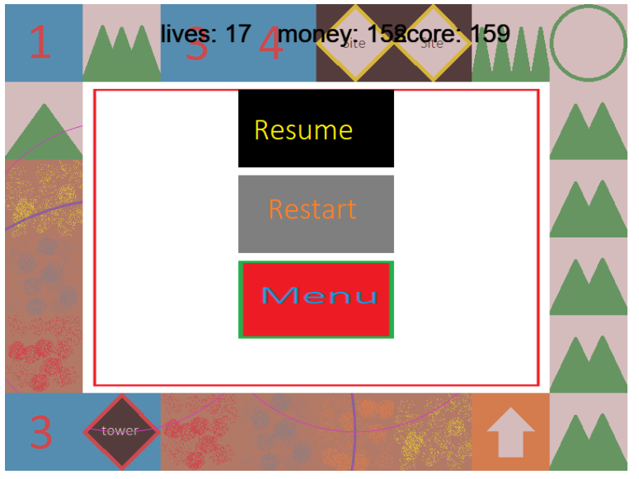
- It’s a surprise that the bullets work well!
- I can see the enemies coming in.
- It’s good to see there is a menu. It’s handy.
Dislikes
How to Open The Game
Firstly I downloaded the zip file from our Github page. Then unzip it.
1. I tried to open it with Brackets, but it cannot show the live window.
2. I tried to open the folder with VSCode, then right click the ‘index.html’ file -> ‘Open With Live Server’. It cannot show anything in the browser.
Then I asked Alex, and he told me I should install Node.js, and type ‘npm install’ in the unzipped folder’s route. Then type ‘npm start’. I spent a while to install these things. As a developer, I know it’s my responsibility to learn how to operate it with Node.js, but as a user, I would expect a more convenient method to open the game. I would expect that, once I open some web page, it will show a link. I click on the link, then it will pop up a window for the game in the browser.
- I cannot identify where the enemies will come. Well, finally I noticed that I should click on the upper left button to let the enemies in. There should some tutorials.
- I do not know where the menu is. It’s just an empty circle.
- I’m not quite sure where I can put towers – places other than the roads and the mountains?

